Xie Zhou 912143385

ECS171 HW2

**Note:**

1. Initial weights are randomized in ann.m.
2. All error’s are calculated using abs(A-B) instead of squared error.
3. --inputdata.m reads data from source file

--converts information to matrix form,

--gets rid of 1st column(useless information)

--and outputs 1484*9 matrix.

--Last column contains numbers instead of class numbers.

**Problem1**:

files: inputdata.m ann.m hidden1node3.m;

run command: hidden1node3

Answers:

1. plot: training set weight change

x-axis—iteration from sample1 to 1039

y-axis—sum of weight change at each iteration

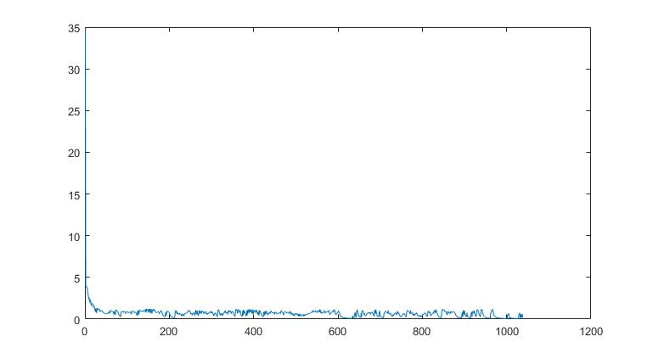

1. plot: training set error change

x-axis—iteration from sample1 to 1039

y-axis—sum of weight change at each iteration

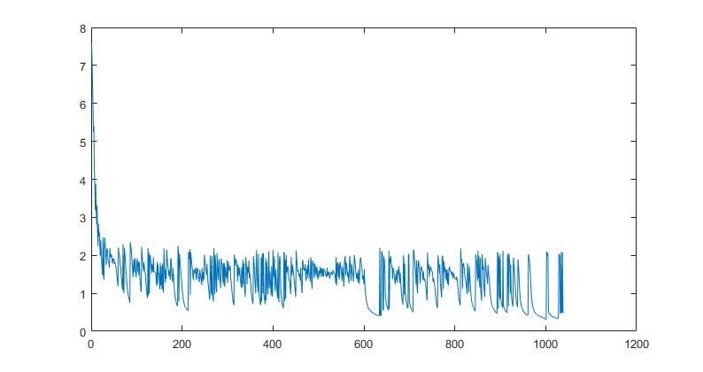

1. testing set prediction outputs

see variable “resultMatrix” in running result. Each row is a sample output

1. plot: testing error

x-axis—testing sample from 1040 to 1484 (1 to 445)

y-axis—testing error (sum of abs(y-prediction)), y is a binary vector

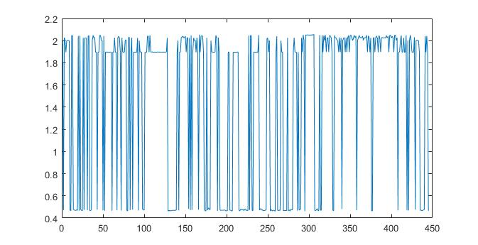

**Problem2**:

files: inputdata.m ann.m p2.m;

run command: p2

Answers:

1. Training error: 2.2316e+3

Training accuracy: 31.20%

1. final activation functions:

layer2 w_0 = 1/(1-e^(-(0.5799 + 0.2050*x1 + 0.0185*x2 + 0.7567*x3 + 0.2863*x4 + 0.2050*x5 + 0.7936*x6 + 0.8179*x7 + 0.2333*x8)))

layer2 a_1 = 1/(1-e^(-(2.4306 + 1.3397*x1 + 1.4137*x2 + 1.3028*x3 + 1.2038*x4 + 1.2391*x5 + 0.8369*x6 + 1.5090*x7 + 0.6184*x8)))

layer2 a_2 = 1/(1-e^(-(0.7457 + 0.2568*x1 + 1.0288*x2 + 0.3887*x3 + 0.2940*x4 + 0.2364*x5 + 0.9021*x6 + 0.1357*x7 + 0.2316*x8)))

layer2 a_3 = 1/(1-e^(-(1.9900 + 1.0449*x1 + 1.4448*x2 + 0.8066*x3 + 1.0059*x4 + 0.9440*x5 + 0.5672*x6 + 0.7562*x7 + 0.2590*x8)))

layer3 a_1 = 1/(1-e^(-(-0.3705*w0 - 0.1689*a_1(layer2) - 0.4609*a_2(layer2) - 0.2373*a_3(layer2))))

layer3 a_2 = 1/(1-e^(-(0.0151*w0 - 0.3841*a_1(layer2) + 0.0524*a_2(layer2) - 0.9907*a_3(layer2))))

layer3 a_3 = 1/(1-e^(-(-0.8521*w0 - 0.8275*a_1(layer2) - 0.3918*a_2(layer2) - 0.0651*a_3(layer2))))

layer3 a_4 = 1/(1-e^(-(-0.8708*w0 - 0.4023*a_1(layer2) - 0.5735*a_2(layer2) - 0.6999*a_3(layer2))))

layer3 a_5 = 1/(1-e^(-(-1.3159*w0 - 1.0144*a_1(layer2) - 0.7337*a_2(layer2) - 0.6985*a_3(layer2))))

layer3 a_6 = 1/(1-e^(-(-1.0290*w0 - 1.0607*a_1(layer2) - 0.6715*a_2(layer2) - 0.2691*a_3(layer2))))

layer3 a_7 = 1/(1-e^(-(-1.0740*w0 - 0.6608*a_1(layer2) - 1.6932*a_2(layer2) - 0.6491*a_3(layer2))))

layer3 a_8 = 1/(1-e^(-(-1.0353*w0 - 0.9082*a_1(layer2) - 0.8234*a_2(layer2) - 1.1014*a_3(layer2))))

layer3 a_9 = 1/(1-e^(-(-1.7476*w0 - 0.9713*a_1(layer2) - 0.9509*a_2(layer2) - 0.7257*a_3(layer2))))

layer3 a_10 =1/(1-e^(-(-1.4387*w0 - 1.0934*a_1(layer2) - 1.1992*a_2(layer2) - 1.0989*a_3(layer2))))

Note: w0 here representions w0*x0 where x0 is the constant 1

**Problem3**:

files: inputdata.m ann.m p3.m;

run command: p3

files for reference: initial_weights_first_round_weights

Answers:

1. reference file has: initial weights, initial a’s, first round weights.

Hand prove: use initial a and w to back propagate and get updated weights

Compare updated weights and first_round_weights (1st iteration of sample 1):

For the 2nd layer weights, hand calculation and computer results are extremely similar

For the 1st layer weights, hand calculation and computer results differ by a very small amount. It is possibly due to rounding error since I didn’t use full floating-point values for my calculation.

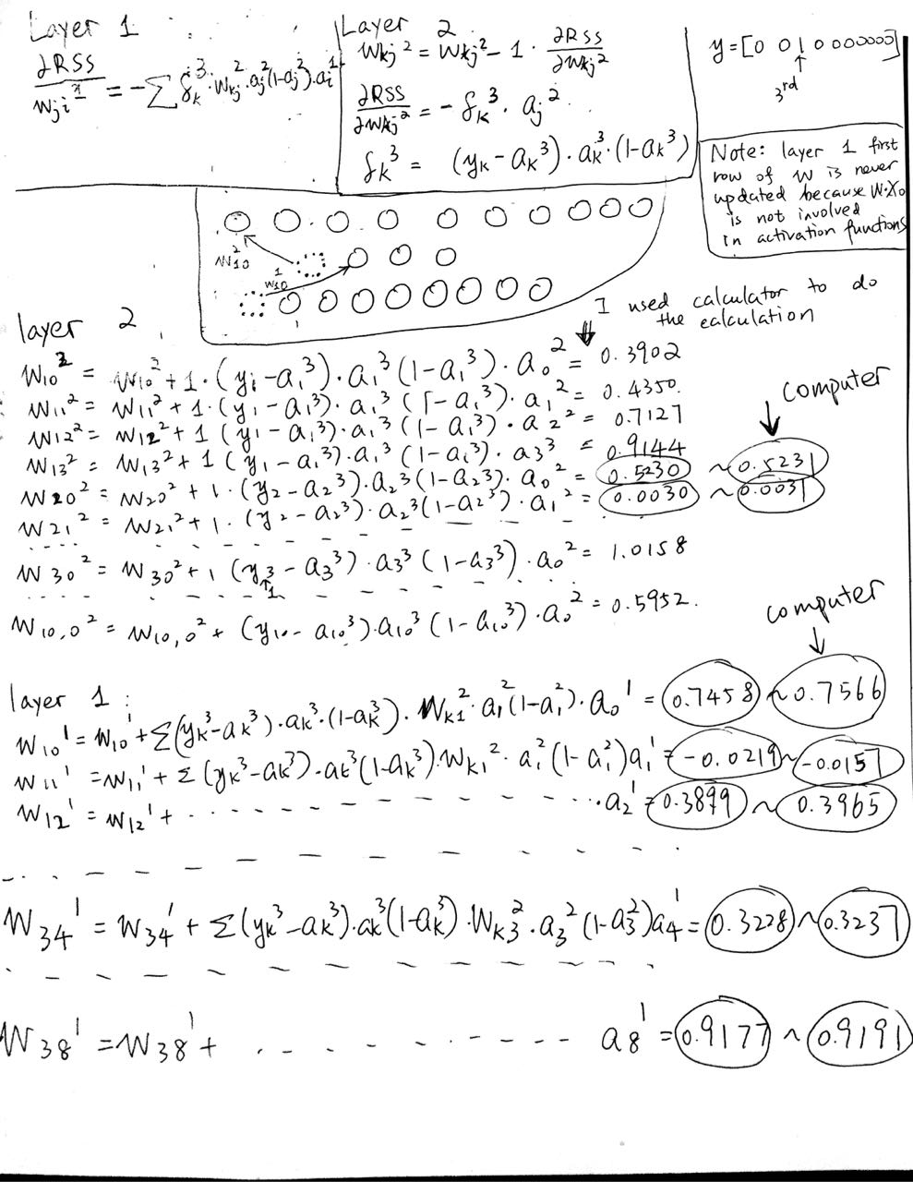

**Problem4**:

files: inputdata.m ann.m p4.m;

run command: p4

Answers:

Call function ann recursively to get 3*4 testing set error matrix

1. Testing set error matrix:

780.5943 750.2627 733.4707 1005.679

777.2998 740.4118 728.7110 1676.981

782.5728 739.3853 892.8145 2780.879

---After running the code for several times and increasing # nodes per hidden layer/# hidden layers, (I tried 10*10 matrix ) I observed that:

a) Larger #nodes per hidden layer, larger error

b) Larger #hidden layers, slightly larger errors (true when learningRate > 1)

c) Larger #hidden layers, less variation for each prediction output (looking at “resultMatrix” for 445 testing samples)

---I think observations could different (especially for “a)”) if we had a larger sample size so that the program could learning better; increasing # hidden layers largely increases complexity of the model (needs more input information).

---Testing accuracy behaves similar to error, being around 0.3281 for most attribute combinations.

2) For our attribute combinations, I picked 3 nodesPerLayer, 3 hiddenLayers for optimal configuration (for prediction in next problem).

**Problem5**:

files: inputdata.m ann.m p5.m;

run command: p5

Answers:

(use 3 nodesPerHiddenLayer, 3 hiddenLayers)

The unknown sample was classified to:

class 1 for most of the time,

class 2 sometimes since the probability is similar to class 1,

other classes very rarely.

--Prediction output shown after running the code.

**Problem6**:

files: inputdata.m p6.m;

run command: p6

Answer:

---For uncertainty, I defined a value called “variation”.

---First, calculate the means for each feature by averaging the inputs from 1484 samples, calling it “feature_avg”.

---Then, given an unknown sample, I took the abs(feature_avg [i]– sample_feature[i]), and then took the sum of the absolute values for 8 features. I called this value “variation”---how far away is the unknown input from the average sample inputs.

---Then for the uncertainty, I divided the variation by the sum of feature_avg, and multiply it by 100 to get the percent uncertainty.

For the previous unknown sample:

Variation(uncertainty): 0.273039

Uncertainty(percent uncertainty): %8.953347