OpenCV & ESP32: face & eyes detection

In this part we will explore the intersection of AI and IoT to create useful application at the edge of the network. Edge computing refers to the practice of processing data and performing computational tasks closer to the source of data generation (ESP32), rather than relying on a centralized cloud infrastructure.

This approach can offer lower latency, reduced bandwidth usage, improved privacy, and offline capabilities.

# Architecture



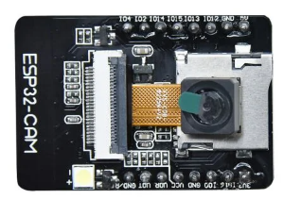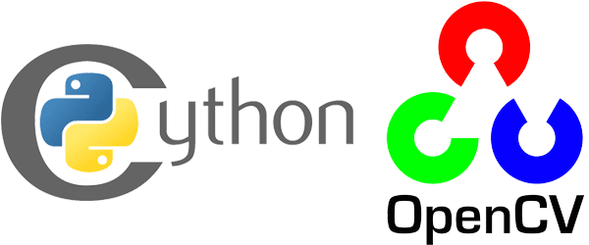

* The both sides are on the same network
* ESP32 capture the frames and streams the frames to the connected client through HTTP Streaming.
* Python script instantiates two models to detect faces & eyes on the frames.

# Python script

This script that uses OpenCV (cv2) and requests libraries to retrieve and process a live video stream from a specified URL. The script detects faces and eyes in the video frames and displays the processed frames in a window.

The code includes a breakdown of each step.