ACCRA TECHNICAL UNIVERSITY
Department of Computer Science

BCS 404: Introduction to Data Science with Python

PROJECT WORK REPORT

Exploratory Data Analysis, Statistical Analysis and Machine Learning
using a Real-World Dataset (Titanic Dataset)

Academic Year: 2025/2026 — Second Semester

Lecturer: Dr. Joseph Dadzie
Course Lecturer, Department of Computer Science
Accra Technical University

Table of Contents
1. Introduction1
2. Dataset Description1
3. Methodology1
4. Results2
4.1 Data Acquisition2
4.2 Data Cleaning2
4.3 Data Visualisation2
4.4 Statistical Analysis6
4.5 Machine Learning Model7
5. Discussion8
6. Conclusion10
7. References10
8. Appendix: Python Code10

1. Introduction
This report presents a complete data science project conducted for the BCS 404: Introduction to Data Science with Python course. The project applies the full data science workflow — data acquisition, cleaning, exploratory visualisation, statistical analysis, and machine learning — to a real-world dataset: the Titanic passenger dataset from Kaggle.
The Titanic dataset records information about the passengers aboard the RMS Titanic, which sank on 15 April 1912 after colliding with an iceberg. It is widely used as an introductory dataset for classification tasks because it contains a rich mix of numerical and categorical features, missing data, and a clear binary outcome variable (survival), making it well suited to demonstrating the tools required by this course: Pandas, NumPy, Matplotlib, Seaborn, and Scikit-Learn.
The objective of this project is to identify the factors most strongly associated with passenger survival, and to build a Logistic Regression model capable of predicting survival from passenger attributes such as class, sex, age, and fare.

2. Dataset Description
The dataset used is the Titanic training dataset (train.csv) from the Kaggle "Titanic — Machine Learning from Disaster" competition (https://www.kaggle.com/competitions/titanic/data). It contains 891 passenger records and 12 columns, described below.
Column | Description
PassengerId | Unique identifier for each passenger
Survived | Survival outcome (0 = No, 1 = Yes) — target variable
Pclass | Ticket / passenger class (1 = 1st, 2 = 2nd, 3 = 3rd)
Name | Passenger's full name
Sex | Passenger's sex (male / female)
Age | Passenger's age in years
SibSp | Number of siblings / spouses aboard
Parch | Number of parents / children aboard
Ticket | Ticket number
Fare | Passenger fare paid (£)
Cabin | Cabin number (mostly missing)
Embarked | Port of embarkation (C = Cherbourg, Q = Queenstown, S = Southampton)

3. Methodology
The analysis followed the standard data science pipeline in a Jupyter Notebook environment using Python 3, with the following libraries: Pandas and NumPy for data manipulation, Matplotlib and Seaborn for visualisation, and Scikit-Learn for machine learning. The workflow comprised:
- Data acquisition and inspection of structure, dimensions, and data types.
- Data cleaning: detecting and handling missing values and duplicate rows.
- Exploratory visualisation of distributions and relationships among key variables.
- Descriptive and correlation-based statistical analysis.
- Training and evaluating a Logistic Regression classifier to predict survival.

4. Results

4.1 Data Acquisition
The dataset was loaded successfully with the following structure:
- Dataset dimensions: 891 rows × 12 columns
- Column names: PassengerId, Survived, Pclass, Name, Sex, Age, SibSp, Parch, Ticket, Fare, Cabin, Embarked
Data types: PassengerId, Survived, Pclass, SibSp and Parch are integers; Age and Fare are floating-point numbers; Name, Sex, Ticket, Cabin and Embarked are text (object/string) fields.

4.2 Data Cleaning
Missing values were detected as follows: Age had 177 missing values (19.9%), Cabin had 687 missing values (77.1%), and Embarked had 2 missing values (0.2%). No duplicate rows were found in the dataset.
Preprocessing decisions:
- Age: imputed using the median age within each Pclass–Sex subgroup, since age varies systematically across class and sex; this is more accurate than a single overall median.
- Embarked: imputed with the mode (Southampton, 'S'), as only 2 records were affected.
- Cabin: 77% missing, too sparse to impute meaningfully. A binary feature HasCabin (1 = cabin recorded, 0 = not recorded) was engineered to retain the socio-economic signal, and the raw Cabin column was dropped.
- Duplicates: none were detected, so no rows were removed on this basis.
After cleaning, the dataset retained all 891 rows with zero missing values across all retained columns.

4.3 Data Visualisation

4.3.1 Histogram of Passenger Ages
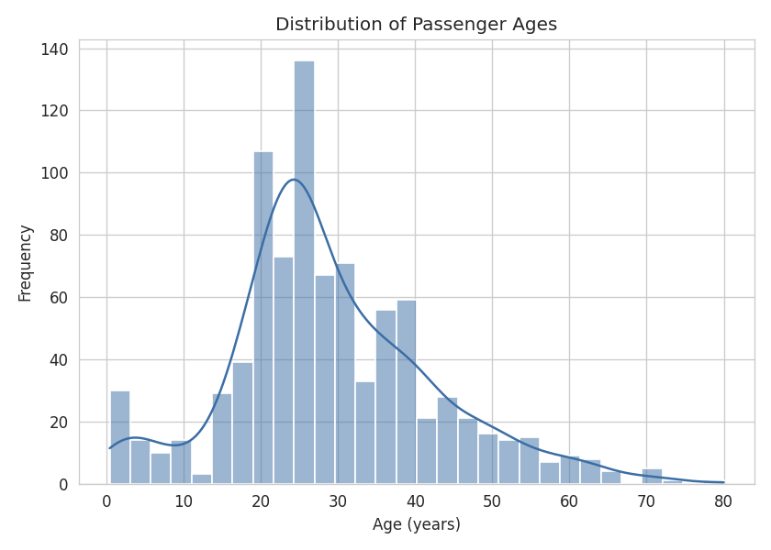
Figure 1: Distribution of passenger ages
Ages are concentrated between roughly 20 and 40 years, peaking in the mid-20s. A smaller secondary peak is visible for infants and young children, and the distribution has a long right tail extending to age 80.

4.3.2 Bar Chart: Passenger Class Distribution
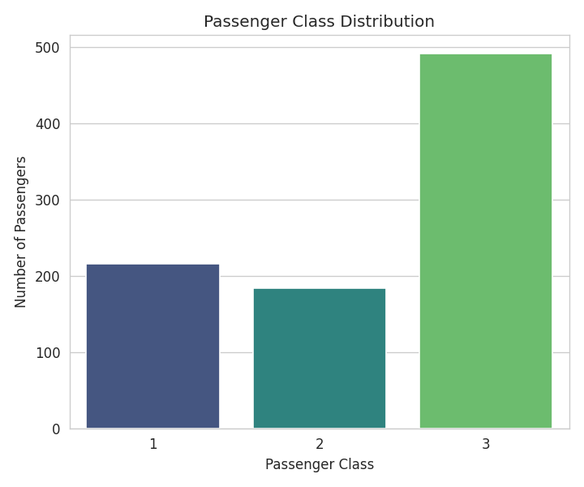
Figure 2: Passenger class distribution
Third class passengers form the largest group (491), followed by first class (216) and second class (184). More than half of all passengers travelled in third class.

4.3.3 Boxplot: Age by Passenger Class
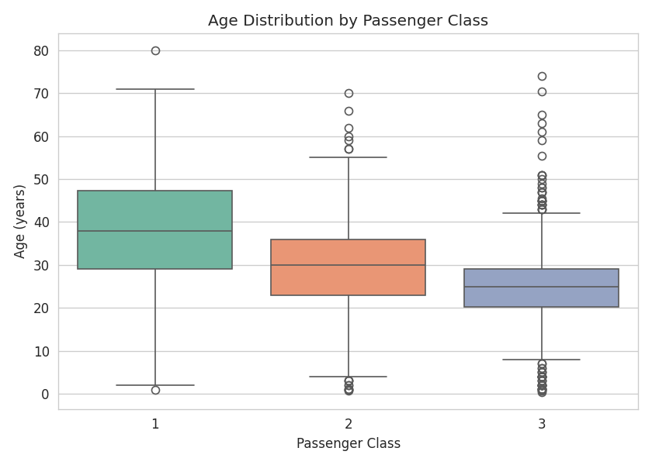
Figure 3: Age distribution by passenger class
Median passenger age decreases as class number increases: first class passengers were, on average, the oldest, while third class passengers were the youngest. First class also shows the widest spread and the most high-age outliers.

4.3.4 Scatter Plot: Age versus Fare
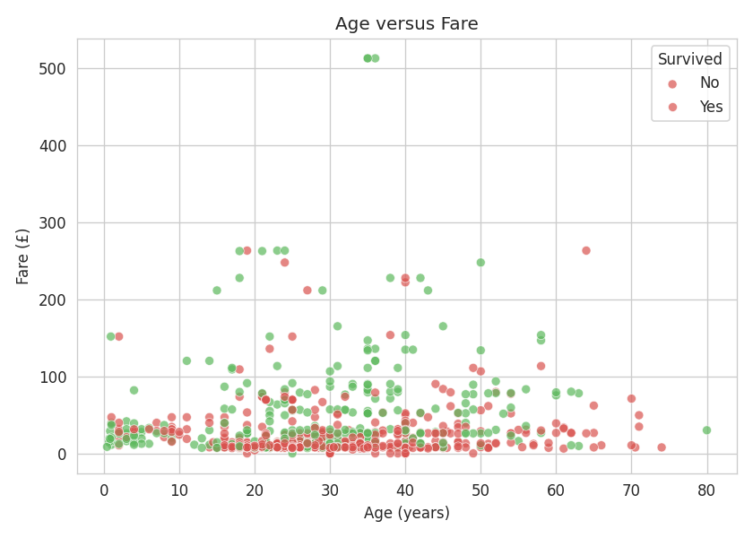
Figure 4: Age versus Fare, coloured by survival
Most passengers paid modest fares across all ages, but a number of high-fare outliers (predominantly first class) appear at various ages. Survivors (shown in green) are noticeably more concentrated among higher-fare passengers.

4.3.5 Correlation Heatmap
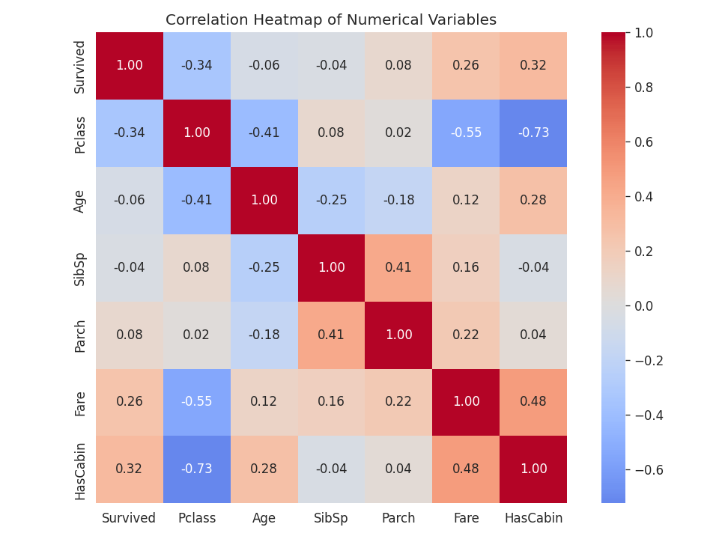
Figure 5: Correlation heatmap of numerical variables
Pclass correlates negatively with Survived (-0.34) and Fare (-0.55): a lower class number (better class) is associated with higher survival and higher fare. The engineered HasCabin variable correlates strongly with Pclass (-0.73) and Fare (0.48), reflecting that cabin numbers were mostly recorded for higher-class tickets.

4.3.6 Pairplot of Selected Numerical Variables
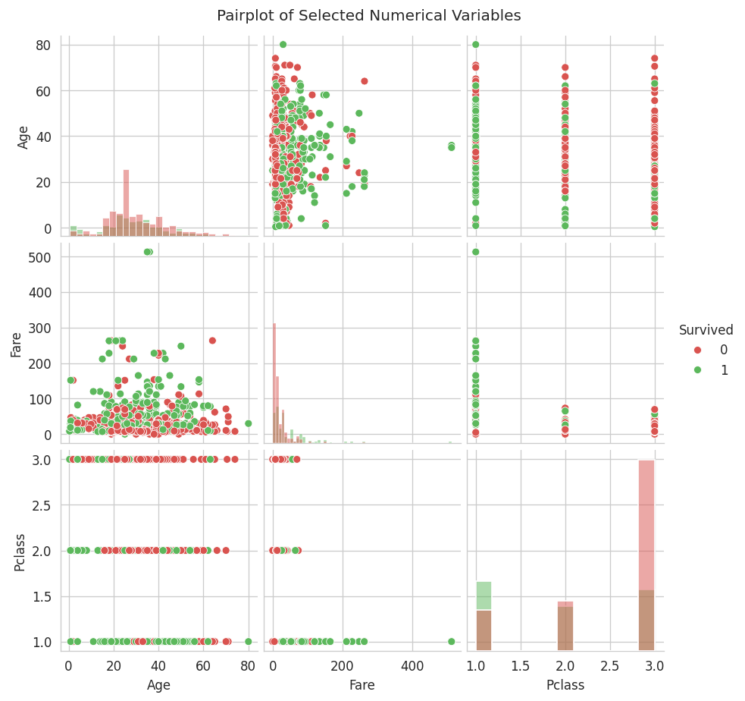
Figure 6: Pairplot of Age, Fare, Pclass and Survived
The pairplot confirms the fare–class relationship (lower Pclass values cluster with higher fares) and shows survivors skewing toward higher fares and better (lower-numbered) passenger classes, while age alone shows weaker separation between survival groups.

4.4 Statistical Analysis

4.4.1 Descriptive Statistics
Statistic | Age | Fare | SibSp | Parch | Pclass
Count | 891 | 891 | 891 | 891 | 891
Mean | 29.11 | 32.20 | 0.52 | 0.38 | 2.31
Std. Dev. | 13.30 | 49.69 | 1.10 | 0.81 | 0.84
Min | 0.42 | 0.00 | 0 | 0 | 1
25% | 21.50 | 7.91 | 0 | 0 | 2
50% (Median) | 26.00 | 14.45 | 0 | 0 | 3
75% | 36.00 | 31.00 | 1 | 0 | 3
Max | 80.00 | 512.33 | 8 | 6 | 3

4.4.2 Frequency Distribution
Variable | Category | Count
Survived | 0 — Did not survive | 549
Survived | 1 — Survived | 342
Pclass | 1st Class | 216
Pclass | 2nd Class | 184
Pclass | 3rd Class | 491
Sex | Male | 577
Sex | Female | 314
Embarked | S — Southampton | 646
Embarked | C — Cherbourg | 168
Embarked | Q — Queenstown | 77

4.4.3 Correlation Analysis
The strongest positive correlation among the original (non-engineered) variables is between SibSp and Parch (r = 0.41) — passengers travelling with siblings or a spouse were also likely to be travelling with parents or children, indicating family groups. The strongest negative correlation is between Pclass and Fare (r = -0.55) — as the passenger class number increases (i.e., class becomes lower/worse), the fare paid decreases sharply. (The engineered HasCabin flag correlates even more strongly with Pclass at r = -0.73, but this is a derived variable rather than an independently measured passenger attribute.)

4.4.4 Three Important Statistical Findings
- Sex was the strongest single predictor of survival: 74.2% of female passengers survived compared to only 18.9% of male passengers, consistent with the historical 'women and children first' evacuation protocol.
- Survival rate declined steadily with passenger class: 63.0% for 1st class, 47.3% for 2nd class, and 24.2% for 3rd class, reflecting unequal access to lifeboats and proximity to the upper decks.
- Fare and class jointly reflect socio-economic stratification: Fare is negatively correlated with Pclass (-0.55) and positively correlated with Survived (0.26), suggesting ticket price acted as a proxy for both social status and survival likelihood.

4.5 Machine Learning Model
A Logistic Regression classifier was trained to predict passenger survival using seven predictor variables: Pclass, Sex (encoded), Age, SibSp, Parch, Fare, and Embarked (encoded). The dataset was split into a training set (712 passengers, 80%) and a testing set (179 passengers, 20%), stratified by the survival outcome to preserve class balance.

4.5.1 Model Accuracy
The model achieved an accuracy of 82.1% (0.8212) on the held-out test set.

4.5.2 Confusion Matrix
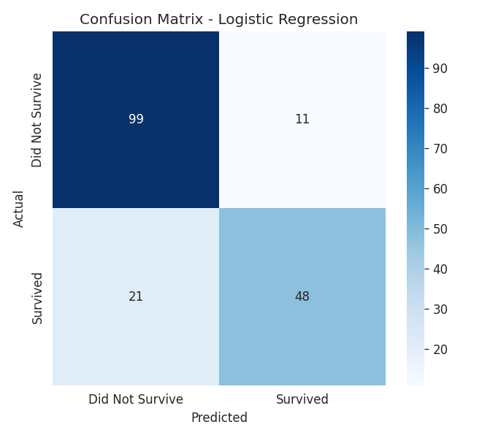
Figure 7: Confusion matrix for the Logistic Regression model
 | Predicted: Did Not Survive | Predicted: Survived
Actual: Did Not Survive | 99 | 11
Actual: Survived | 21 | 48

4.5.3 Classification Report
Class | Precision | Recall | F1-Score | Support
Did Not Survive | 0.82 | 0.90 | 0.86 | 110
Survived | 0.81 | 0.70 | 0.75 | 69
Accuracy |  |  | 0.82 | 179
Macro Avg | 0.82 | 0.80 | 0.81 | 179
Weighted Avg | 0.82 | 0.82 | 0.82 | 179

4.5.4 Discussion of Model Performance
The model correctly classified 147 of 179 test passengers (82.1% accuracy). It performs better at identifying passengers who did not survive (90% recall) than those who did (70% recall), meaning it is somewhat conservative and misses a portion of true survivors (21 false negatives) while rarely misclassifying non-survivors as survivors (11 false positives). Examining the model's coefficients, Sex and Pclass emerged as the strongest predictors — being female and travelling in a lower-numbered (better) class both substantially increased the predicted probability of survival — which is consistent with the statistical findings in Section 4.4.

5. Discussion
Major Findings:
The analysis confirms that survival aboard the Titanic was not random but was strongly shaped by social and demographic factors. Sex was the single most influential factor: women survived at nearly four times the rate of men. Passenger class was the second most influential factor, with first class passengers more than twice as likely to survive as third class passengers. Fare, which is closely tied to class, showed a similar pattern, reinforcing that socio-economic status played a major role in survival outcomes. Age showed a comparatively weak direct correlation with survival overall, though visual inspection suggested a modest survival advantage for very young children.
Statistical Insights:
Descriptive statistics revealed a right-skewed fare distribution (mean fare of £32.20 versus a median of £14.45, with a maximum of £512.33), indicating a small number of very wealthy passengers. The correlation analysis reinforced the class–fare–survival relationship discussed above, while SibSp and Parch correlated moderately with each other, indicating that many passengers travelled as family units rather than alone.
Machine Learning Results:
The Logistic Regression model achieved 82.1% accuracy, a respectable result for a simple linear classifier on this dataset, and its coefficients aligned with the statistical findings — sex and class were the dominant predictors. This agreement between the statistical analysis and the machine learning model strengthens confidence in the conclusions drawn.
Limitations of the Study:
- Age imputation (median by class and sex) is an approximation and may not accurately reflect the true age of individual passengers with missing data, potentially introducing bias into age-related analysis.
- Dropping the raw Cabin column discards potentially useful deck/location information beyond the simple HasCabin flag.
- Logistic Regression assumes a linear relationship between predictors and the log-odds of survival, and does not capture more complex, non-linear interactions between variables (e.g., between age and class) that a more flexible model, such as a Random Forest, might capture.
- The dataset is limited to 891 passengers and reflects the specific circumstances of a single historical event, so the model's conclusions should not be generalised to other disaster scenarios without caution.
Recommendations:
- Future work could compare Logistic Regression against non-linear models (e.g., Random Forest, Gradient Boosting, or Support Vector Machines) to determine whether accuracy improves materially.
- Feature engineering could be extended — for example, extracting titles (Mr., Mrs., Master, etc.) from the Name field, or computing family size from SibSp and Parch — to potentially improve predictive performance.
- Cross-validation (e.g., k-fold) should be used in future iterations to obtain a more robust estimate of model performance than a single train/test split.
- Hyperparameter tuning and regularisation strength adjustment could be explored to reduce the false-negative rate for the 'Survived' class.

6. Conclusion
This project applied the complete data science workflow to the Titanic dataset, from data acquisition through to predictive modelling. The exploratory and statistical analysis revealed that sex and passenger class were the dominant factors influencing survival, findings which were corroborated by the Logistic Regression model's coefficients. The final model achieved 82.1% test accuracy, demonstrating that even a simple linear classifier can meaningfully predict survival outcomes using a small set of demographic and ticket-related features. The exercise reinforced practical competence in Pandas, NumPy, Matplotlib, Seaborn, and Scikit-Learn, and in the broader data science workflow of cleaning, exploring, analysing, and modelling real-world data.

7. References
Kaggle. (n.d.). Titanic — Machine Learning from Disaster. Retrieved from https://www.kaggle.com/competitions/titanic/data
McKinney, W. (2010). Data Structures for Statistical Computing in Python. Proceedings of the 9th Python in Science Conference.
Pedregosa, F. et al. (2011). Scikit-learn: Machine Learning in Python. Journal of Machine Learning Research, 12, 2825–2830.
Waskom, M. L. (2021). Seaborn: Statistical Data Visualization. Journal of Open Source Software, 6(60), 3021.
Hunter, J. D. (2007). Matplotlib: A 2D Graphics Environment. Computing in Science & Engineering, 9(3), 90–95.

8. Appendix: Python Code
The complete Python analysis script (analysis.py) used to produce the results in this report is reproduced below. The fully executed Jupyter Notebook (Titanic_EDA_Analysis.ipynb) is included in the accompanying GitHub repository.
import pandas as pd
import numpy as np
import matplotlib
matplotlib.use("Agg")
import matplotlib.pyplot as plt
import seaborn as sns
from sklearn.model_selection import train_test_split
from sklearn.linear_model import LogisticRegression
from sklearn.preprocessing import LabelEncoder
from sklearn.metrics import accuracy_score, confusion_matrix, classification_report
import json

sns.set_style("whitegrid")
plt.rcParams["figure.dpi"] = 120

OUT = {}

# ---------------- TASK 1: DATA ACQUISITION ----------------
df = pd.read_csv("train.csv")

OUT["shape"] = df.shape
OUT["columns"] = list(df.columns)
OUT["head"] = df.head().to_dict(orient="records")
OUT["dtypes"] = {c: str(t) for c, t in df.dtypes.items()}

# ---------------- TASK 2: DATA CLEANING ----------------
missing_before = df.isnull().sum()
OUT["missing_before"] = missing_before.to_dict()

dupes = df.duplicated().sum()
OUT["duplicates_found"] = int(dupes)

df_clean = df.copy()
df_clean = df_clean.drop_duplicates()

# Age: fill with median (by Pclass+Sex groups) - robust to skew/outliers
df_clean["Age"] = df_clean.groupby(["Pclass", "Sex"])["Age"].transform(
lambda x: x.fillna(x.median())
)
df_clean["Age"] = df_clean["Age"].fillna(df_clean["Age"].median())

# Embarked: fill with mode (only 2 missing)
df_clean["Embarked"] = df_clean["Embarked"].fillna(df_clean["Embarked"].mode()[0])

# Cabin: too many missing (~77%) -> drop column, but create HasCabin flag first
df_clean["HasCabin"] = df_clean["Cabin"].notna().astype(int)
df_clean = df_clean.drop(columns=["Cabin"])

missing_after = df_clean.isnull().sum()
OUT["missing_after"] = missing_after.to_dict()
OUT["shape_after_cleaning"] = df_clean.shape

df_clean.to_csv("titanic_clean.csv", index=False)

# ---------------- TASK 3: VISUALISATION ----------------

# 1. Histogram of Age
plt.figure(figsize=(7, 5))
sns.histplot(df_clean["Age"], bins=30, kde=True, color="#3b6ea5")
plt.title("Distribution of Passenger Ages")
plt.xlabel("Age (years)")
plt.ylabel("Frequency")
plt.tight_layout()
plt.savefig("figs/1_age_hist.png")
plt.close()

# 2. Bar chart of Pclass distribution
plt.figure(figsize=(6, 5))
order = sorted(df_clean["Pclass"].unique())
sns.countplot(x="Pclass", data=df_clean, order=order, palette="viridis")
plt.title("Passenger Class Distribution")
plt.xlabel("Passenger Class")
plt.ylabel("Number of Passengers")
plt.tight_layout()
plt.savefig("figs/2_pclass_bar.png")
plt.close()

# 3. Boxplot of Age by Pclass
plt.figure(figsize=(7, 5))
sns.boxplot(x="Pclass", y="Age", data=df_clean, palette="Set2")
plt.title("Age Distribution by Passenger Class")
plt.xlabel("Passenger Class")
plt.ylabel("Age (years)")
plt.tight_layout()
plt.savefig("figs/3_age_by_pclass_box.png")
plt.close()

# 4. Scatter Age vs Fare
plt.figure(figsize=(7, 5))
sns.scatterplot(x="Age", y="Fare", hue="Survived", data=df_clean, palette=["#d9534f", "#5cb85c"], alpha=0.7)
plt.title("Age versus Fare")
plt.xlabel("Age (years)")
plt.ylabel("Fare (£)")
plt.legend(title="Survived", labels=["No", "Yes"])
plt.tight_layout()
plt.savefig("figs/4_age_fare_scatter.png")
plt.close()

# 5. Correlation heatmap
num_cols = ["Survived", "Pclass", "Age", "SibSp", "Parch", "Fare", "HasCabin"]
corr = df_clean[num_cols].corr()
plt.figure(figsize=(8, 6))
sns.heatmap(corr, annot=True, fmt=".2f", cmap="coolwarm", center=0, square=True)
plt.title("Correlation Heatmap of Numerical Variables")
plt.tight_layout()
plt.savefig("figs/5_corr_heatmap.png")
plt.close()

# 6. Pairplot
pair_cols = ["Age", "Fare", "Pclass", "Survived"]
pp = sns.pairplot(df_clean[pair_cols], hue="Survived", palette=["#d9534f", "#5cb85c"], diag_kind="hist")
pp.fig.suptitle("Pairplot of Selected Numerical Variables", y=1.02)
pp.savefig("figs/6_pairplot.png")
plt.close()

# ---------------- TASK 4: STATISTICAL ANALYSIS ----------------
desc = df_clean[["Age", "Fare", "SibSp", "Parch", "Pclass"]].describe()
OUT["descriptive_stats"] = desc.to_dict()

freq_pclass = df_clean["Pclass"].value_counts().to_dict()
freq_sex = df_clean["Sex"].value_counts().to_dict()
freq_embarked = df_clean["Embarked"].value_counts().to_dict()
freq_survived = df_clean["Survived"].value_counts().to_dict()
OUT["freq_pclass"] = freq_pclass
OUT["freq_sex"] = freq_sex
OUT["freq_embarked"] = freq_embarked
OUT["freq_survived"] = freq_survived

corr_unstack = corr.where(~np.eye(len(corr), dtype=bool)).unstack().dropna()
corr_sorted = corr_unstack.sort_values(ascending=False)
strongest_pos = corr_sorted.index[0], corr_sorted.iloc[0]
strongest_neg = corr_sorted.index[-1], corr_sorted.iloc[-1]
OUT["strongest_positive"] = [str(strongest_pos[0]), float(strongest_pos[1])]
OUT["strongest_negative"] = [str(strongest_neg[0]), float(strongest_neg[1])]

# survival rate by sex / class
OUT["survival_rate_by_sex"] = df_clean.groupby("Sex")["Survived"].mean().to_dict()
OUT["survival_rate_by_class"] = df_clean.groupby("Pclass")["Survived"].mean().to_dict()

# ---------------- TASK 5: MACHINE LEARNING ----------------
ml_df = df_clean.copy()
le_sex = LabelEncoder()
ml_df["Sex_enc"] = le_sex.fit_transform(ml_df["Sex"])
le_emb = LabelEncoder()
ml_df["Embarked_enc"] = le_emb.fit_transform(ml_df["Embarked"])

features = ["Pclass", "Sex_enc", "Age", "SibSp", "Parch", "Fare", "Embarked_enc"]
X = ml_df[features]
y = ml_df["Survived"]

X_train, X_test, y_train, y_test = train_test_split(X, y, test_size=0.2, random_state=42, stratify=y)

model = LogisticRegression(max_iter=1000)
model.fit(X_train, y_train)
y_pred = model.predict(X_test)

acc = accuracy_score(y_test, y_pred)
cm = confusion_matrix(y_test, y_pred)
report = classification_report(y_test, y_pred, target_names=["Did Not Survive", "Survived"])

OUT["ml_accuracy"] = float(acc)
OUT["ml_confusion_matrix"] = cm.tolist()
OUT["ml_classification_report"] = report
OUT["ml_train_size"] = X_train.shape[0]
OUT["ml_test_size"] = X_test.shape[0]
OUT["ml_coefficients"] = dict(zip(features, model.coef_[0].tolist()))

# confusion matrix plot
plt.figure(figsize=(5.5, 5))
sns.heatmap(cm, annot=True, fmt="d", cmap="Blues",
xticklabels=["Did Not Survive", "Survived"],
yticklabels=["Did Not Survive", "Survived"])
plt.title("Confusion Matrix - Logistic Regression")
plt.xlabel("Predicted")
plt.ylabel("Actual")
plt.tight_layout()
plt.savefig("figs/7_confusion_matrix.png")
plt.close()

with open("results.json", "w") as f:
json.dump(OUT, f, indent=2, default=str)

print("DONE")
print(json.dumps(OUT, indent=2, default=str)[:3000])

