Bonnie Turek

Eco 602

Software Downloads Assignment

One Drive

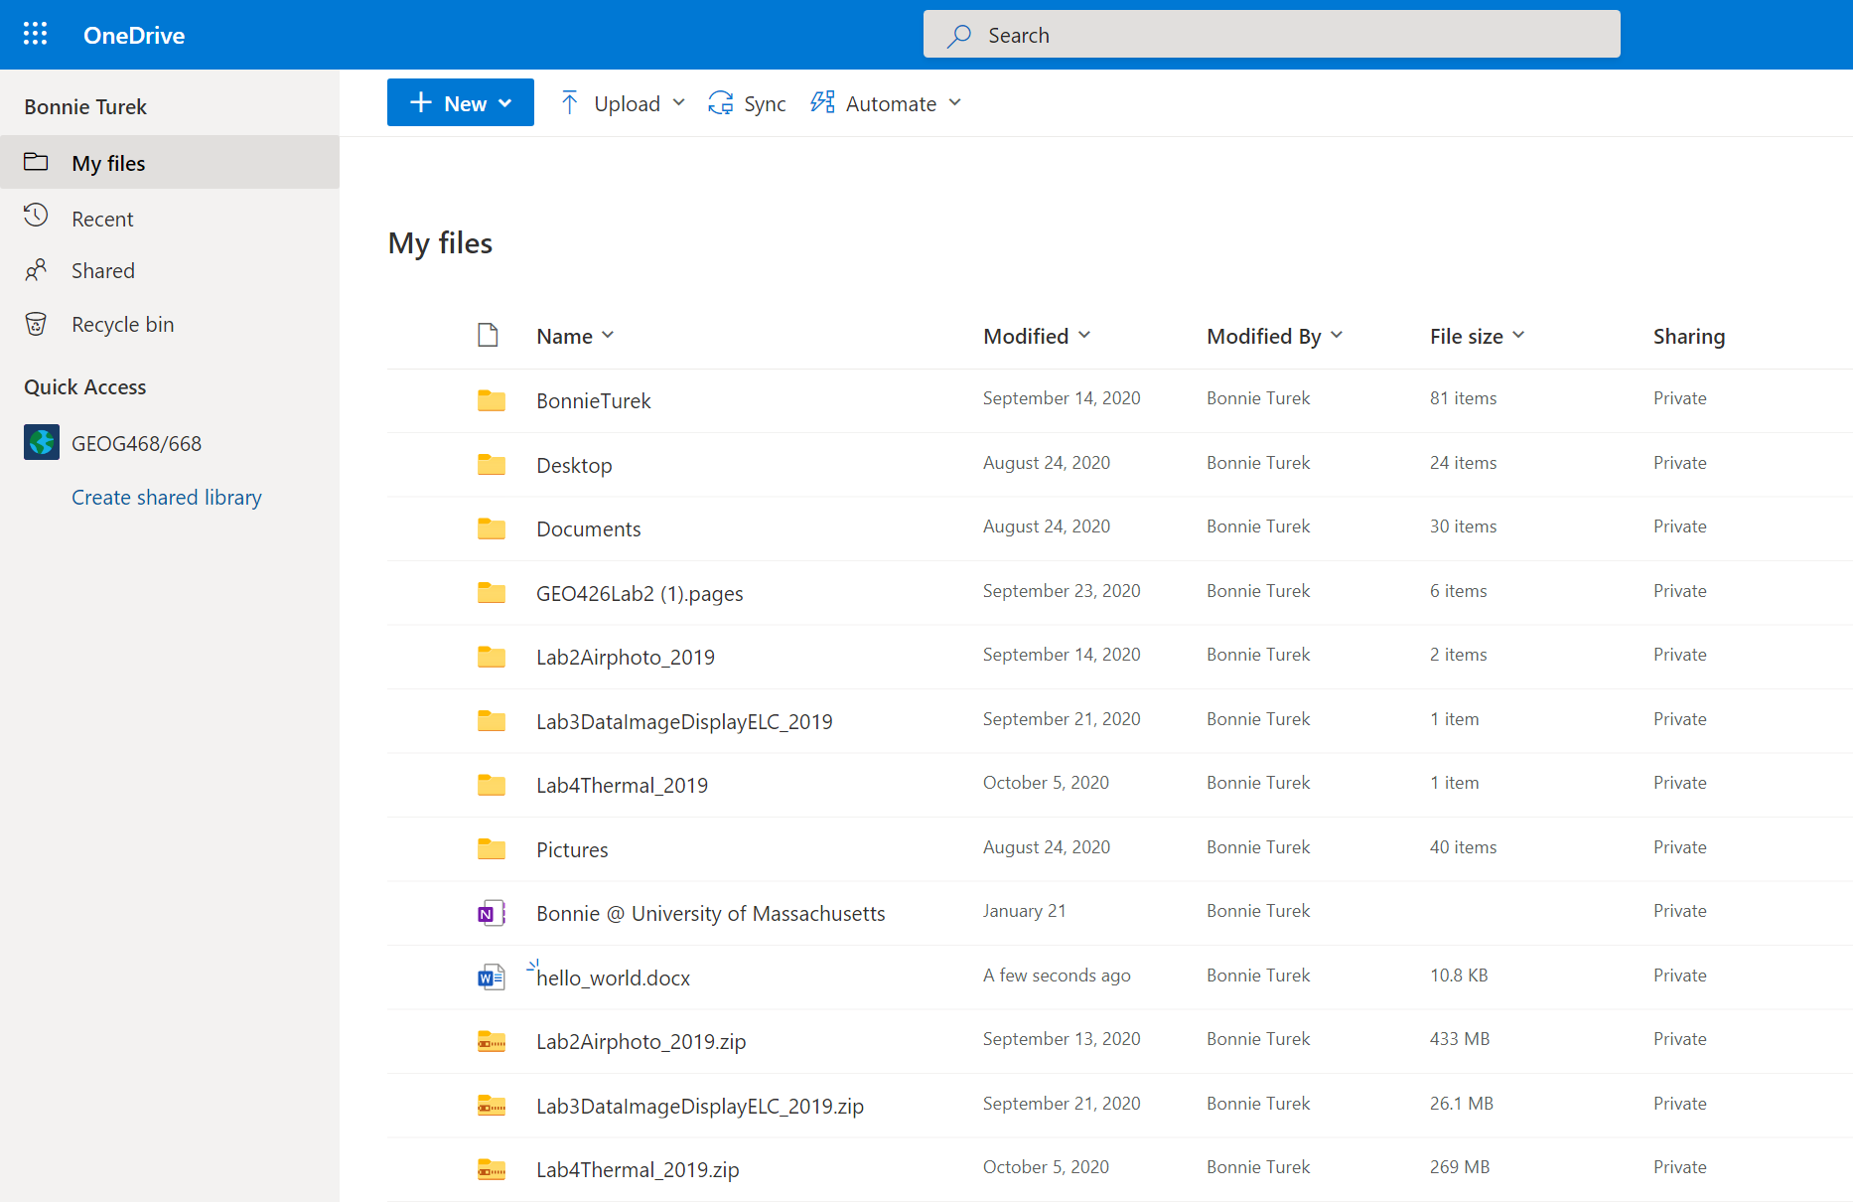

Folder Structure with Subdirectories

Project Options in RStudio

