DENNIS DARIUS MUKOYA

Nationality: KENYAN
Date of Birth: 08/05/2002
Email: dennisdarius43@gmail.com
Mobile: +254 793932805
Availability: January
Desired Position: Intern
P.O Box 724-00206 Kiserian

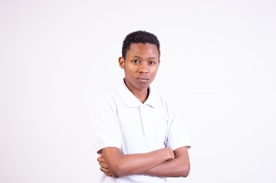

Career Objective
- Secure a responsible career opportunity to fully utilize my training and skills as a Software Engineer, while making a significant contribution to the success of the company.

Education
February 2023 – November 2023: Moringa School
Certificate in Software Engineering

2022: Photomagic School of Photography and Videography
Photography Certificate

2021: Segero Adventist National School
Kenya Certificate of Secondary Education

2016: Wanja & Kim Comprehensive School
Kenya Certificate of Primary Education

Work Experience

Jan 2022 – Present: Photomagic Studios
Photographer
Duties and responsibilities:
          - Analyze and plan the composition of photographs.
          - Use various photographic techniques and lighting equipment.
          - Capture subjects in professional-quality photographs.
          - Enhance the subject's appearance with natural or artificial light.

Languages
English - Fluent
Swahili - Fluent

Acquired skills

- Time Management
- Adaptability
- Problem solving
- Leadership skills

Referees

- Steven Nderitu
Photographer
Photomagic Studios, Nairobi
studio@photomagic.co.ke
+254-720-266-012

