Constrained Optimization
Consider the problem maximizing a function f that is constrained by a boundary; or more mathematically.
max 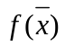 subject to 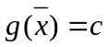,
where is the constraint function that limits f, ie the boundary
The point x* that maximizes subject to is different from the point x* obtained from just maximizing with no constraint. This is because the constrained points x* could occur along the curve of intersection between and rather than just in the range of f.

Consider: The problem of maximizing 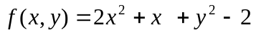, constrained by 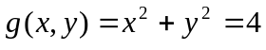.
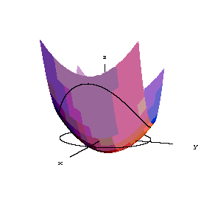
Source: www.math.ou.edu

The constrained extremum can be found by restricting our search to the curve of intersection.
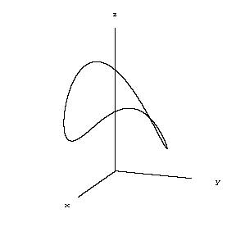
Source: www.math.ou.edu
Clearly this picture shows that there is 2 maximums and 2 minimums on the curve of intersection.
How are the extremum point to be determined ? Consider the various level curves for a two variable function f(x,y) and the level curves corresponding to a constraint g(x,y) = c
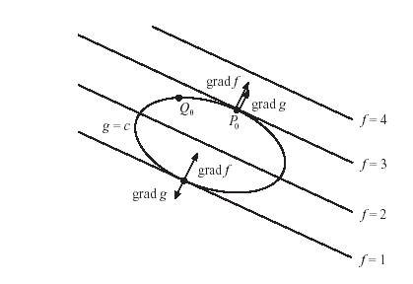

Clearly f is a maximum at the point Po on the constraint curve. At point Po f and g are tangent to another and thus the normal (or gradient) of f is parallel to normal (gradient) of g. Since 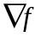is parallel to 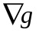then they must be proportional to each other. ie
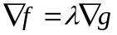

This equation leads to a method of that converts the constrained problem into an unconstrained problem that is solvable.
Method of Langrange Multipliers
Define another function called the Lagrangian of n + 1 variables 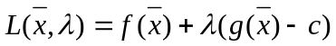. λ is called the Lagrangian multiplier
Setting the gradient of the Lagrangian to zero, yields:
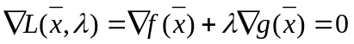
Thus maximizing the Lagrangian will be equivalent to
max subject to ,
Maximizing the Lagrangian will involve solving the following the system of n + 1 equations 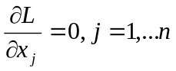 and 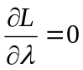 = 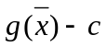

Eg. Max 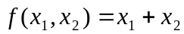, subject to 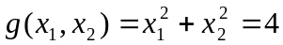
Form the Lagrangian
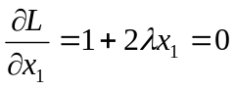, 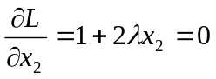, solving gives x₁ = x_{2,}
using this to solve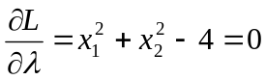gives 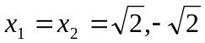

The maximum of is 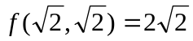

Generalizing to Multiple Constraints

Max subject to m constraints 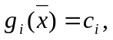i = 1,….m. Form the Langrangian function using m Langrangian multipliers λ_{i} .

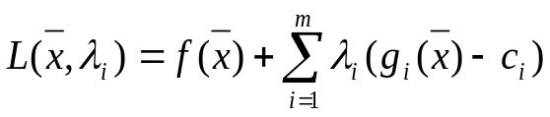
Then solve the following n + m equations
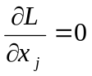j =1,….n 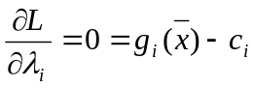, i = 1,….m

Numerous numerical methods, such as the Newton-Rhapson method can be used to solve this system of n + m non-linear equations.

Handling Inequality Constraints

Solving equality constraint problems with Lagrange Multiplier method is straight forward but what about solving inequality constraint problems; such as.
max subject to 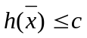,
Lagrange Multiplier method can still be used but a slack variable ‘s’ needs to be introduced to make an equality constraint. So the problem becomes:
max subject to 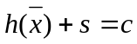,
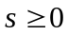
Then form the Lagrangian function and solve as before.
Potential Problems

Langrange Multiplier method is a simple procedure. However there are some potential problems that need to be considered and lead to some necessary conditions before Lagrange method can be used.

Potential Problems
1. Solving j =1,….n , i = 1,….m

means solving a system of n + m NON-LINEAR equations. Even with the best numerical methods such as the Newton-Rhapson method solving non-linear systems can be extremely difficult, especially when n and m become large. Numerical methods can also lead to rounding errors, which can add up over time.

2. Consider the following example.
Minimize 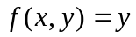, subject to 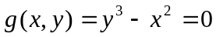
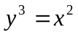 has a cusp at the origin, and clearly has a minimum value 0 at that point.

Notice that the minimum of y occurs at a point on the curve where the curve has no tangent line.

Try solving this using Lagrange multipliers.

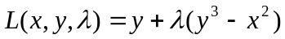
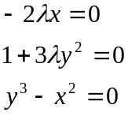
These equations have no solution for x, y, 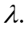

This example failed because 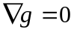 at the solution point of (0,0,0)
In general failure occurs when at the extrema points

3. The method of Lagrange multipliers similarly breaks down if 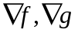
does not exist at the solution point. As in 2, no solution will be found for solving the system of non-linear equations.
- Extrema points could also occur at an endpoint of the constraint set. Method of Lagrange Multipliers will also fail if this is the case.

Necessary Conditions for Lagrange Multiplier Method

Max 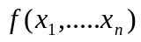 subject to 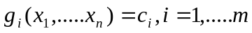
Let 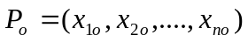be the point that max f subject to each g_{i}
- Let f and each g_{i} have continous first partial derivatives near P_{o}
- 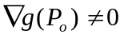
- P_{o} is not an endpoint of the constraint set (curve of intersection)

Then there exists a 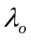such that 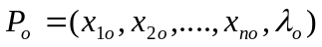is a critical point of the Lagrangian function.

Interpretation of λ

The value of is approximately the increase in the optimum value of f if the constraint is increased by 1 unit. Or more concisely, is the rate of change of the optimum value of f as c increases where 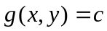; ie

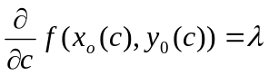

Eg. In economics when f is a profit function and g_{i} are constraints on the resource amounts. 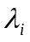would be the amount by which the profit f would rise if one more unit of resource i is available. This rate is called the shadow price of I, which is interpreted as the amount it would be worth to increase that constraint upwards. (use R&D, bribery)

