Steepest Decent or Gradient Method
1. Application: To minimize f(x) of N variables where x = (x₁,x₂,x₃,...,x_{N})
2. Requirement: 1. f(x) must be differentiable
2. Initial guess should be somewhat within the range of the roots.
3. Background:
3.1 Gradient
The gradient f(x) is a vector function defined as
grad(f(x)) = f(x) = (δf(x)/δx₁,δf(x)/δx₂,...,δf(x)/δx_{N}) (1)
4. Derivation
When a fuction f is differentiable, the direction that produces the maximum value for the directional derivative occurs when v is choosen to be parallel to f(x). As a geometric property of the gradient vector we know at an arbitrary pointx0, f(x) decreases most rapidly in the direction of -f(x0).
The steepest decent is basically a gradient method, where it starts off an arbitrary point x0 and then slide down the gradient until f(x) is minimized. The following is the iterative procedure for steepest decent
x_{k+1} = x_{k} – α_{k} f(x_{k}) (2)
x_{k+1} = x_{k} – α_{k} g(x_{k}) (3)
where g(x_{k}) is the gradient at one given point.
5. Step size determination
There many ways to determine the value of the step size α_{k} and one of the way is to find the exact solution of α_{k} by differentiate f(x_{k}+1) with respect to α_{k}.
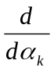f(x_{k}+1) = f(x_{k+1})^{T} · (x_{k}+1) (4)
f(x_{k}+1) = f(x_{k+1})^{T} · [x_{k} – α_{k} g(x_{k})] (5)
f(x_{k}+1) = f(x_{k+1})^{T} · – g(x_{k}) (6)
By letting d/dα_{k} f(x_{k}+1) = 0, we can solve for α_{k} and determine the step size.
6. Example
6.1 A visual example of step size.
x₁
x₂
6.2 path of steepest decent.
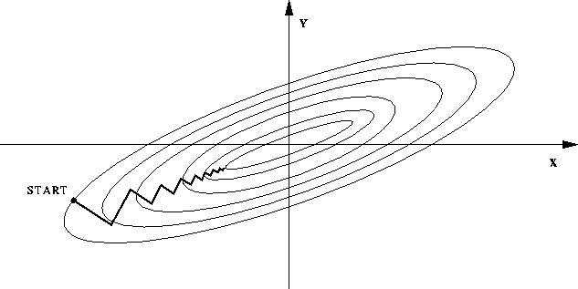

7. Problems associated with steepest decent methods
7.1 The gradient method does not guarantee a global minimum. The point obtained is the closest minimum in the path of the starting point.
7.2 The function f(x) must be differentiable.
7.3 Slow to converge due to the zip-zag path.

