Newton’s Method

1. Application: Use to solve a (system of) nonlinear equation(s) f(x)=0.
Only requires one iteration for a quadratic function to converge.

2. Requirement: f(x) must be twice differentiable

3. Derivation:

Newton’s method uses the first few terms of the Taylor series of a function f(x) in the vicinity of a suspected root to zero in on the root. The second order Taylor series of f(x) about the x = x_{o} + Δx point is given by

f(x_{o} + Δx) = f(x_{o}) + 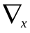f(x_{o}) Δx +  Δx ^{T}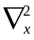f(x_{o}) Δx. (1)

By minimizing the quadratic approximation (1), a good approximation to x is obtained.
This is done by setting, df/dΔx_{j} = 0

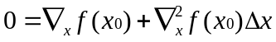 (2)

and to find the step size, we solve for Δx

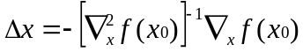 (3)

finally x₁ becomes,

x₁ = x_{o} + αΔx (4)

Below is the procedure of the Newton’s method.

1. Start from an initial point
2. Evaluate the gradient of the function at the initial point.
3. Evaluate the Hessian of the function at the initial point.
4. Use equation (4) to solve for the step size.
5 Add step size to the initial point to determine the next solution.

4. Example

Determine the value of x₁ and x₂ such that f is minimized.

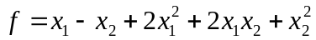
Step 1. Start with an initial guess.
Let x₁ = x₂ = 0
Step2. Evaluate the gradient of the function at (0,0)
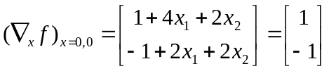
Step3. Evaluate the Hessian of the function at (0,0)
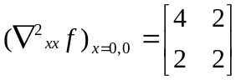

Step 4. Solve for Δx by using equation(4).

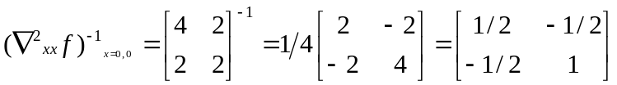
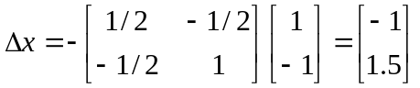
Step 5. Determine the new point
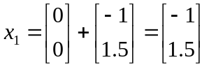
5. Problems associated with Newton’s method
5.1 Only exact for quadratic function
5.2 Can be computation demanding because the Hessian as well as the inverse of the Hessian are needed to perform the approximation.

