- Introduction

Annealing is a process where a solid-state material is melted to the liquid form with high temperature then the temperature is decreased slowly until it reaches the steady state equilibrium point. This procedure yields a physical system with low total energy. An example of this process can be found in silicon crystal manufacture, where annealing converts molten silicon to cylindrical crystals. The annealing process is time dependent so if the material is cooled too rapidly, the end result typically contains many defects among partially-ordered domains.

Simulated annealing is analogous to the process of annealing, in which a material is melted and cooled down so that it will crystallize into highly ordered state. The energy within the material corresponds to the partitioning score.

2. Steps for simulated annealing

- Select logic cells for a trial interchange usually at random.
- Evaluate the objective function E for the new placement.
- If ΔE is negative or zero, then exchange the logic cells. If ΔE is positive, then exchange the logic cells with a probability of 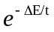.
- Repeat step 1 for a fixed number of time until the equilibrium is reached, and then lower the temperature T according to the a cooling schedule:
t_{n+1} = αt

3. Flowchart for the Algorithm
START
t=to;
cur_part = ini_part
cur_score = SCORE(cur_part)

if ΔE<0
if t< freezing point
ΔE = trial_score – cur_score
t = αt
cur_score = trial_score
if (r<e^{ΔE/t})
NO
NO
YES
S
YES
S
STOP
YES
S
NO
4. Algorithm

Algorithm SA
begin
t=to;
cur_part = ini_part;
cur_score = SCORE(cur_part)
repeat
repeat
comp1 = SELECT(part1);
comp2 = SELECT(part2);
trial_part = EXCHANGE(comp1,comp2,cur_part);
ΔE = trial_score – cur_score;
if (ΔE <0) then
cur_score = trial_score;
cur_part = MOVE(comp1,comp2);
else
r = RANDOM(0,1);
if(r<) then
cur_score = trial_score;
cur_part = MOVE(comp1,comp2);
until(equilibrium at is reached)
t = αt (where t is between 0 and 1)
until (freezing point is reched)
end

5. Comparison between greed’s method and simulated annealing.

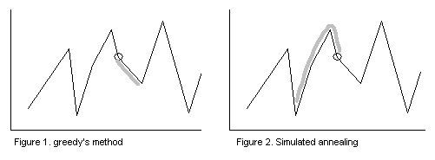

6. Pro’s and Con’s of simulated annealing algorithm

Advantages:
- Global optimization.
- Yields good results when proper cooling schedule is chosen.

Disadvantages:
- Computational expensive
- A long cooling schedule is required to yield good results
- Difficult to determine the optimal cooling schedule.

