**Intern Details**

**Name : Njoku Okechukwu Va**

**Username : bonsoirval**

**ID Number: U08B2R3B8BB**

**SuperStore Analysis**

**Introduction:**

The analysis has been conducted using historical dataset of a superstore beloning to a store based in America and which has outlets in 49 states and 531 cities. The dataset was downloaded from kaggle on the 31st of January 2025.

The dataset was downloaded for the purpose of review of the stores sales operations. This is to draw insights on patterns, trends and to detect anomalies in the data, hence the superstore and its sales operations.

**Observations:**

During the exploratory data analysis, first, we noticed that the data was clean or cleaned already before it was downloaded. This is shown in the image below:



From the image, we also notice that the datatypes are appropriate. And that the data was made of categorical and numerical datatypes.

During the course of the analysis, the following were discovered insights:

1. California has the highest sales, followed by New York and Texas, Pennsylvania, Washinton, Illinois, Ohio, Florida, Michiga and North Carolina. One this is striking, California sales alone is almost as big as New York and Texas put together. Huge!

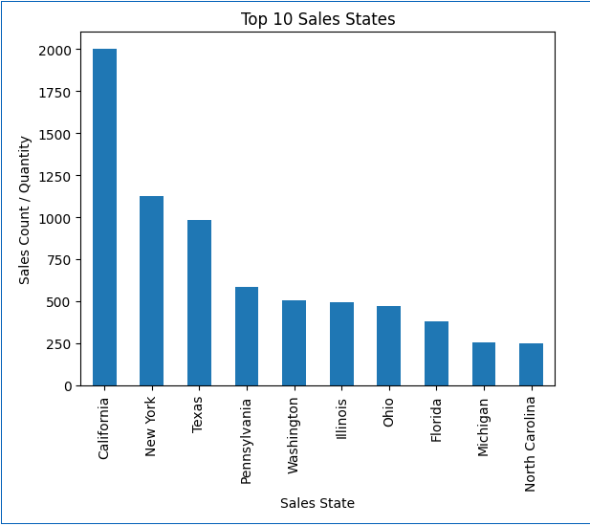

1. The store’s revenue come mainly from Office Supplies, followed by Furniture and Technology. Just like in the States sales, the highest selling category is is almost as big as the following two categories put together, office supplies selling as much as furniture and technology put together.

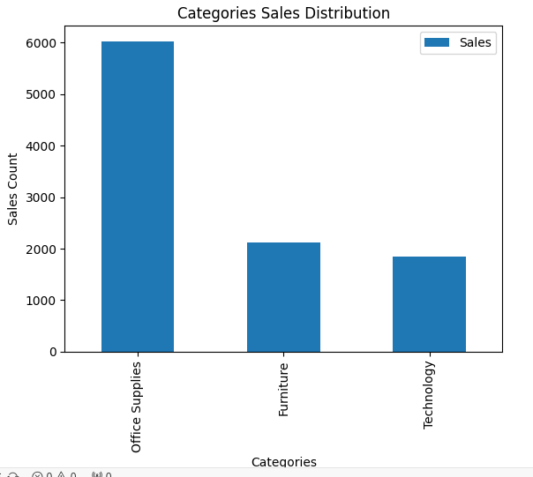

1. Even though California has the highest sales rate, Lafayette in Louisiana has the highest sales rate.

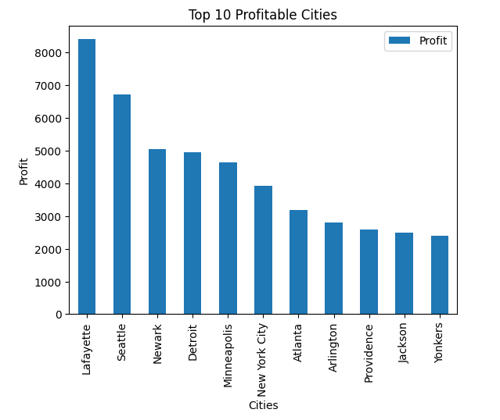

1. While the store has Consumer, Corporate and Home office customers, the store generates most revenue from Consumer customers.

**Conclusion:**

While the store has operation in many states and cities, it is advisable to for the business to add to its strength. Hence establishing more operations in Califormia. While doing this, Louisiana should also not be left behind having the most profitable city.

Consumer – Office supplies, being it major source of revenue has to be watched diligently. All these, so that the store maintains its market share in the areras it currently operates. Playing the 80/20 rule game.