DXC-990/CMA-D3
Serial Interface Specifications

Version 7.0 (April/01/2001)

SONY CORPORATION
IMAGE SENSING DEPT.
IMAGE ACQUISITION BUSINESS DIVISION

Table of contents

1. Hardware Specifications ------------- 3
1-1 Summary -------------3
1-2 Connector and Pin Assignments -------------3
1-3 Power Supply (7-pin Terminal) -------------3
1-4 [DXC-990] CCU Control (8-pin Terminal) -------------3

2. Communication Protocol Specifications -------------4
2-1 Summary -------------4
2-2 Selecting Baud Rate -------------4
2-3 Communication Data Structure -------------4
2-4 Command Protocol -------------5
2-4-1 CMA-D3 (DXC-990) Supplying Power -------------5
2-4-2 Transmitting RM-C950 Search Command -------------5
2-4-3 Confirming Version (First Command) -------------5
2-4-4 Camera Initial Settings -------------6
2-4-5 Camera Setting Changes -------------6
2-4-6 Quitting External Control Mode -------------6
2-5 The Relationship Between Camera and Host Computer -------------6

3. Command Specifications -------------7
3-1 Summary -------------7
3-2 Command Specifications and Examples -------------7
3-2-1 Commands to Establish Communication Protocol
with Host Computer -------------7
3-2-2 Feature Control Commands -------------8

4. Note -------------19

5. Modification History -------------19

Command Index

1. Hardware Specifications

1-1 Summary
The DXC-990/CMA-D3 serial interface has an asynchronous interface which conforms to the RS-232C standard.

1-2 Connector and Pin Assignments
Mini-DIN 8-pin connectors (female) are located on the rear panel of the DXC-990 and on the front panel of the CMA-D3. They are labeled "REMOTE".

The pin assignments are as follows:
- INTERNAL CONNECTION
2. INTERNAL CONNECTION
3. DATA OUT
4. GND
5. DATA IN
6. NC
7. POWER SUPPLY (+12V)
8. DXC-990: CCU CONTROL
CMA-D3: NC
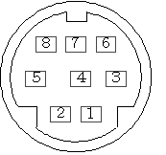
If a Macintosh computer is used as a host computer, its printer cable can be directly connected.

1-3 Power Supply (7-pin Terminal)
This terminal connection is used to supply power to the RM-C950 dedicated remote controller. Its design prohibits its use for other purposes. The power supply from this terminal is usually in an OFF condition. Power can only be supplied after the sending and receiving of a special command set between the RM-C950 and the power supply.

1-4 [DXC-990] CCU Control (8-pin Terminal)
This terminal is used for the CCMC-3M2 camera cable between the DXC-990 and the CMA-D3. This allows communication between the devices. Its design prohibits its use for other purposes. When power is supplied to the DXC-990, this terminal sends a command to search for the CMA-D3 for 1 second. When the DXC-990 is externally controlled, this terminal has to be OPEN (non-connection) or the command has to be ignored.

2. Communication Protocol Specifications

2-1 Summary
This is an asynchronous interface which conforms to the RS-232C standard.
The baud rates are as follows:
DXC-990: 19200, 9600, 4800, 2400, 1200 bps switchable
CMA-D3: 9600, 4800, 2400, 1200 bps switchable
The data format is fixed as follows:
Data bits: 8 bits
Stop bits: 1 bit
Parity: none
Flow Control (handshake): XOFF (ignored process method)
Each byte communicates from the LSB (least significant bit).

2-2 Selecting Baud Rate
DXC-990: Select the MENU bar > SYSTEM > BAUD RATE. The default baud rate is 9600 bps.
CMA-D3: The PR-260 mounted circuit board in the CMA-D3 has a dip switch set (S2).
The default baud rate is 9600 bps. Switches 5 and 6 correspond to baud rate selection.
These must be set before supplying power. The default settings are OFF.

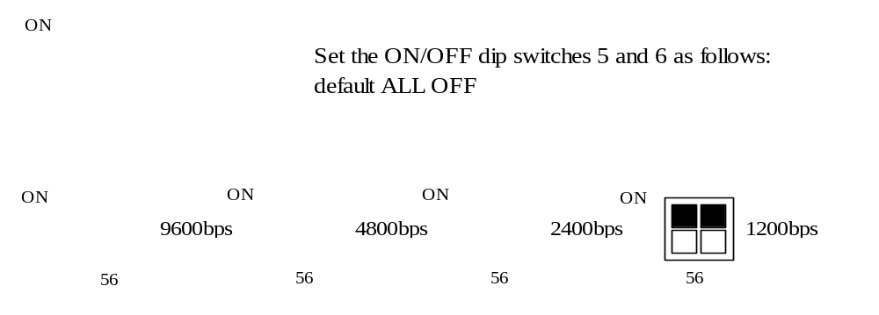

2-3 Communication Data Structure
Usable characters for communication are from 30h to 39h and from 41h to 5Ah in the ASCII code,
i.e. Arabic numerals 0 to 9
Alphabetical capital letters A to Z
and also <carriage return> (0Dh).
The camera control commands consist of the above characters and each command ends with a <carriage return> (0Dh). After transmitting 1 byte, there is 2ms pause set before the next transmission in order to avoid missing communication data based on the ignored process method.

2-4 Command Protocol
This section describes supplying power to CMA-D3 (DXC-990), establishing communication and the process necessary to enter each command. Details of the commands are explained in a separate section. The commands explained here are displayed by character only and the <carriage return> is assumed.
For example, when "OKAY" is displayed, actual data transmission looks like this 4Fh, 4Bh, 41h, 59h, 0Dh.

2-4-1 CMA-D3 (DXC-990) Supplying Power
After power is supplied to the DXC-990, a boot process begins with the data provided by the E2PROM built into the DXC-990. When the boot process completes, a command to search for the CMA-D3 is transmitted from the REMOTE 8-pin terminal for 1 second. If the CMA-D3 cannot respond to the command, it must be directly connected to the REMOTE terminal on the DXC-390 in order to accomplish serial communication control. NOTE: Serial communication control from the CMA-D3 cannot be accomplished if the CCMC-3MZ camera cable is not connected to the REMOTE terminal connector on the CMA-D3 before power is supplied. If the CMA-D3 has successfully negotiated with the DXC-990, then it waits until external communication can commence.

2-4-2 Transmitting RM-C950 Search Command
The DXC-990/CMA-D3 will keep on transmitting "OKAY" once per second to confirm that the RM-C950 is connected to the REMOTE terminal.
The host computer sends a "VERS" command (described below) to the DXC-990/CMA-D3 after receiving the "OKAY" at least once.
The host computer is set to ignore any further "OKAY" transmissions once the first command has been sent.

2-4-3 Confirming Version (First Command)
The host computer first transmits a "VERS" command. When the DXC-990/CMA-D3 receives this command, it enters "external control mode" and replies with ROM versions of "V7.*" [DXC-990] and "V6*" [CMA-D3] back to the host computer. These ROM versions are ID numbers.
The newest versions are "V7.0" [DXC-990], "V6.0" [CMA-D3]. <1>
Example: DXC-930 V1.0 ~
DXC-950 V2.0 ~
DXC-9000 V3.0 ~
DXC-H10 V4.0 ~
DXC-390 V5.0 ~

When in "external control mode" the "OKAY" command transmission for confirming the RM-C950 connection is canceled.

2-4-4 Camera Initial Settings
At this moment, the DXC-990 settings are default as built into E2PROM. Send each parameter and mode setting command from the host computer, then re-set up the DXC-990.

One command is basically 5 bytes including the <carriage return>. Command details are described later.

When the DXC-990/CMA-D3 receives a command, the same code of the received command is sent back to the host computer to verify the command is correct. Then the host computer requests the DXC-990 to execute the command. When the DXC-990 /CMA-D3 receives an "unknown" command, it sends a "CERR" back to the host computer and ignores the command. When the DXC-990 operation is set to a mode that cannot execute a command even if the command is "known", a "MERR" is sent back. When numerical data exceeds the permissible limit, a "DERR" is sent back (exceptional conditions may occur).

The host computer will not send a command until the DXC-990/CMA-D3 replies.
Exception: When a reply cannot be received during system operation, the command transmission interval is 17ns or more, with a maximum of 9 consecutive commands defined as a packet, though the operation is not guaranteed, it can be accomplished if the packet transmission interval is 1 sec or more.

2-4-5 Camera Setting Changes
To change the initial camera settings, just send the appropriate command.

2-4-6 Quitting External Control Mode
To terminate control by the host computer, send the command "STOP" to the DXC-990/CMA-D3. When the DXC-990/CMA-D3 receives the command, it will return to "normal mode" after "OKAY" is sent back to the host computer. (The "OKAY" command again begins to be transmitted once per second.) After quitting the external control mode, all other settings done through the host computer are still in effect while power is being supplied.

2-5 The Relationship Between Camera and Host Computer
When you change settings while the DXC-990 is being used as a stand-alone, the E2PROM data is rewritten. However, when settings are changed by the host computer, the changes are effective at that time only and is not written to the E2PROM except under special conditions.
Accordingly, when the host computer is connected, the parameter administration should be done by the host computer. To hold data, send an "EBF" before sending the "STOP" command. (refer to command details). Even if a command conflicts with the current status, only operations already set on the camera are executable.

3. Command Specifications

3-1 Summary
DXC-990/CMA-D3 control commands mainly consist of the following 3 types:
- Protocol establishment commands with the host computer
- Feature control commands: Communication control commands that allow you to use the available features of the DXC-990 for stand-alone operation.
(3) Private commands >>>unpublished <<< : These are special commands to set the DXC-990 system, to evaluate the firmware, and also the command architecture for the RM-C950.

Use of these command sets, allows for most DXC-990/CMA-D3 features to be controlled via the RS-232C link. The following sections explain the commands with exception of the "Private" command set from item (3).

3-2 Command Specifications and Examples

3-2-1 Commands to Establish Communication Protocol with Host Computer OKAY (DXC-990/CMA-D3 = >Host PC)
This command is sent approximately once per second in normal mode, in order to detect a connection between the RM-C950 and the REMOTE terminal.

"OKAY" is sent continuously every second until recognizing the RM-C950 connection, or until verifying the existence of the host computer by the receipt of a "VERS" command described below (establishment of external control mode).

Therefore the host computer has to send the "VERS" command after at least one receipt of the "OKAY" command.

After entering "external control mode", the DXC-990/CMA-D3 stops sending the "OKAY". When in "external control mode", the DXC-990/CMA-D3 receives a command from the host computer, if it is an executable command, an acknowledgment is sent back to the host computer once and the command is executed by the DXC-990.

VERS (Host PC = DXC-990/CMA-D3)
The host computer sends this command to confirm the firmware version of the devices to be controlled. When the DXC-990/CMA-D3 receives the command, it will enter "external control mode" as soon as responding "V7.*"/"V6.*" (*=0) to the host computer.

V7.* (*=0,1) (DXC-990 = >Host PC) <(1)>
This is an ID number of the DXC-990 which also serves to notify that the DXC-990 is in "external control mode".

V6.*(*=0) (CMA-D3 = >Host PC)
This is an ID number of the CMA-D3 which also serves to notify that the
CMA-D3 is in "external control mode".

STOP (Host PC = >DXC-990/CMA-D3)
This command allows the DXC-990/CMA-D3, which is in "external control mode", to return to "normal mode". As it simply returns to the "normal mode" without re-initializing the DXC-990, the host computer settings for the DXC-990 are retained while the power remains on. As soon as the DXC-990/CMA-D3 receives the STOP command, it starts sending "OKAY", "OKAY".

CERR (DXC-990/CMA-D3 = >Host PC)
This command is sent to the host computer when the DXC-990/CMA-D3 receives an unknown command.
The DXC-990/CMA-D3 then ignores the command and it is assumed it never received it.

MERR (DXC-990/CMA-D3 = >Host PC)
This command is sent to the host computer when the DXC-990/CMA-D3 is in a mode that does not allow the host computer's command to be executed. The DXC-990/CMA-D3 then ignores the command and it is assumed it never received it.

DERR (DXC-990/CMA-D3 = >Host PC)
This command is sent to the host computer when numerical data exceeds the permissible limit. The DXC-390/CMA-D3 then ignores the command and it is assumed it never received it.

3-2-2 Feature Control Commands
C800
The AWB execution commands. These are sent after setting the AWB mode. It takes several seconds to execute the AWB. In addition, the following series of status commands are sent back. Do not send any further commands until they have been received.
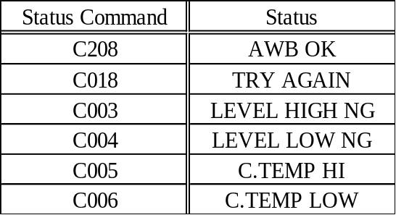

C400
The ABB execution commands. Like the AWB, it takes several seconds to execute the ABB, and the following series of status commands are sent back.
Do not send any further commands until they have been received.
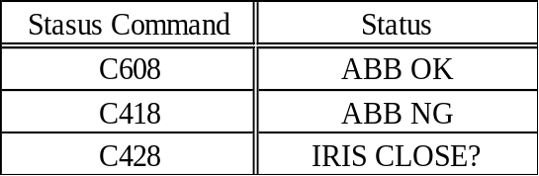

AE**, 84**, 85**
The lens control commands. Data (from H'00 to FF) which is contained in 3rd and 4th byte is used as 0 to 255. As the settings executed by these commands cannot be saved in the DXC-990, the host computer is to manage these.
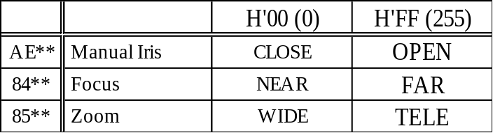

89**, 8A**, 8B**, 8C**, 8D**
The detection window of the luminance level control commands. Pay close attention to use these commands, since they have no region limitations. Setting modes
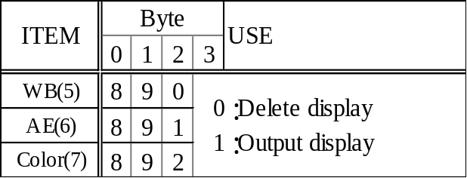

Setting coordinates
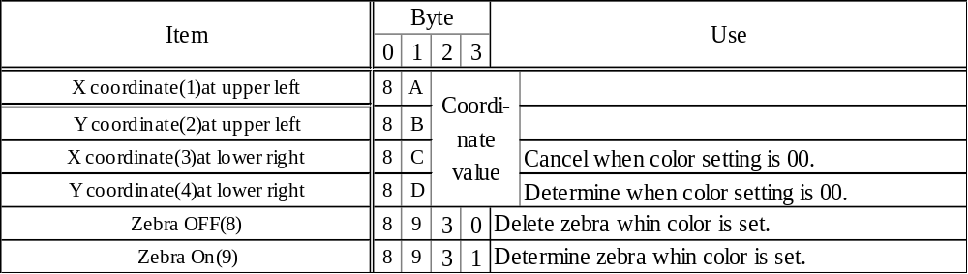
(1) and (2) are always used as a pair.
(3) and (4) are always used as a pair when in WB and AE modes.

<AE, WB>
To set an AE or WB window, select (5) or (6) to set the mode you want. Set selection the “3” byte to choose whether to display the windows or not.
When you select "Output display", the currently set window is displayed until you send (4) which is to specify and determine the coordinate. Then, set the coordinates at the upper left using (1) and (2), and set the coordinates at the lower right using (3) and (4). When (4) is sent to the DXC-990, the coordinates become effective. Once (5) or (6) is sent, you can change the window by sending (1) to (4) later, as long as you do not proceed to do other operations. Make sure that you always specify (3) and (4) values at the lower right than (1) and (2).
Note: When the host computer is connected with the REMOTE on the CMA-D3, the detection window of the luminance level should be set from WHITE BALANCE MODE to ATW NORMAL or ATW WIDE.(MERR is sent back except for ATW)
After the setting, the detection window of the luminance level is valid when you change the mode to AWB.
<Color>
To set a position for selecting a target color, send (7). As the position setting cursor should be displayed to select a color, the 3rd byte has to be 1. Specify the coordinates by using (1) and (2)
Send (9) to output zebra.
Send (8) to delete zebra.
Send 8931 (4) to determine the color.
Send 8930 (3) to stop the color setting.
When (3) or (4) is sent, the color setting mode is canceled. So, you need to send (7) to set a color and/or output zebra. After sending (3) or (4) the zebra display is also deleted. In "color mode" after sending (7), do not start other mode operation until sending (3) or (4).

Important: Set (5), (6) and (7) for certain, otherwise the window setting data may crash. Mode setting should be completely and done correctly.
Coordinate limit value
NTSC Upper left (8.10) Lower right (109.174)
PAL Upper left (13.13) Lower right (133.173)
Minimum window size AE: X axis direction 10 Y axis direction 10
WB: X axis direction 24 Y axis direction 14
(Decimal notation. Actual transmission is done by hexadecimal notation.)
The camera can accept values out of the above range, but normal operation is not guaranteed.

EBF*
Saving commands. All settings except the lens control can be saved in the E2PROM in the DXC-990. In case of other commands, when you select a different file using the FILE SELECT commands, you can save the settings in the E2PROM in the DXC-990. (Refer to the "EF0*" section.)
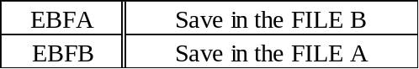

EAC*
Output setting commands for D-SUB 9-pin on the DXC-990 rear panel. When the host computer is connected with the REMOTE on the CMA-D3, the rear panel switches have a higher priority. So, "CERR" is sent and the setting commands are not executed.
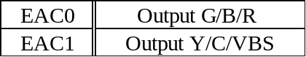

E2**
GAIN setting commands.
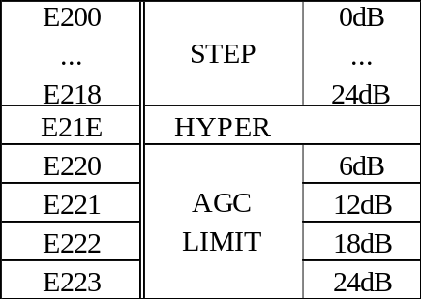

E3**, E4**
Shutter speed setting commands. Two commands (E3**, then E4**) have to be sent. After receiving E3** and E4**, the DXC-990 executes these commands.
When the 3rd and 4th data values of E3** and E4** commands are set to E3X1,
E3X2, E4X3 and E4X4, the values are on the next page:
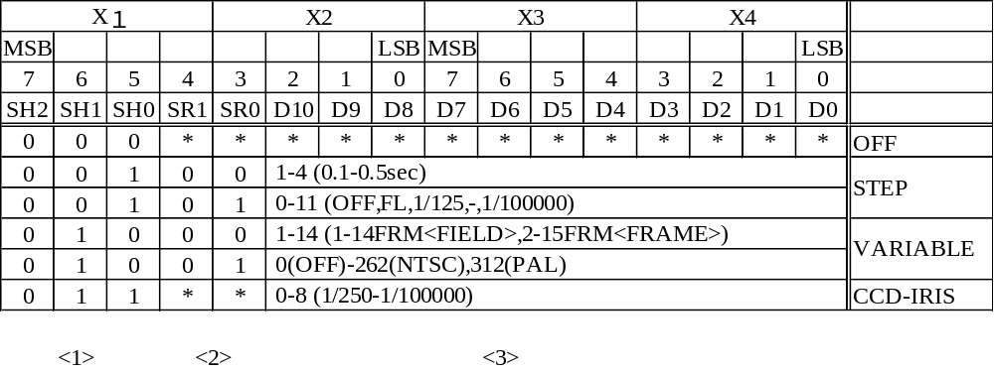
Each asterisk (*) shown in the above chart means "Non-applicable". The DXC-990 applies an order of sequence of <1> <2> <3> (see table).
The area of<1> is the mode and <2> is the sub mode and <3>, which is from D10 to D0, is 11bit data. (Decimal notation. Actual transmission is done by hexadecimal notation.)
The camera can accept values out of 0.5sec as STEP or 15frames(FIELD)/16frames(FRAME) as VARIABLE, but normal operation is not guaranteed.
Remarks: VARIABLE: In "Clear Scan mode", the reply command has a bug and limitation.
The CMA-D3 recognizes NTSC and even 312 PAL as normal data.

SW3A, SW3M
IRIS MODE setting commands.

A2**
AE level setting commands.
The 3rd and 4th byte of data (from H' 01 to FF) is used as +/-127 (0=H' 80, -127=H' 01, +127=H' FF).
EA0*
AE area setting commands.
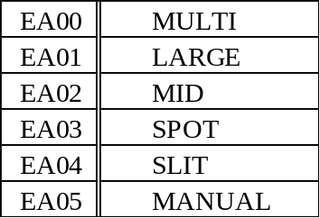

EB0*
AE SPEED & detection method of the luminance level setting commands. Bit operation.
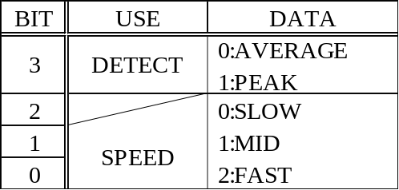

EA4*
EFFECT mode setting commands.
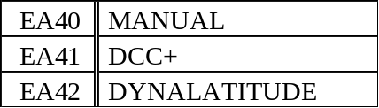

EA1*
KNEE POINT setting commands.
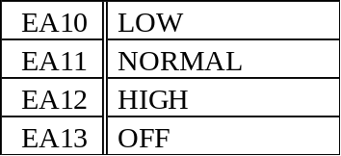

E1**
BLACK STRETCH setting commands.
The 3rd and 4th byte of data (from H' 76 to 8A) is used as +/-10 (0=H' 80,-10=H' 76, +10=H' 8A).
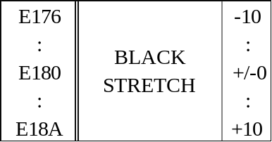

E5**
DYNALATITUDE LEVEL setting commands.
The 3rd and 4th byte of data (from H' 76 to 8A) is used as +/-10 (0=H' 80,-10=H' 76, +10=H' 8A).
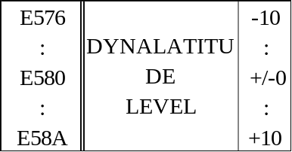

E8**
GAMMA setting commands.
The 3rd and 4th byte of data (H' 00, from H' 76 to 8A) is used as follows:
OFF: H' 00, +/-10: 0=H' 80, -10=H' 76, +10=H' 8A.
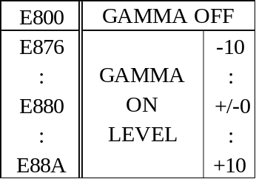

AD**
MASTER PEDESTAL setting commands.
The 3rd and 4th byte of data (from H' 01 to FF) is used as +/-127 (0=H' 80, -127=H' 01, +127=H' FF).

A8**
R PEDESTAL setting commands.
The 3rd and 4th byte of data (from H' 01 to FF) is used as +/-127 (0=H' 80, -127=H' 01, +127=H' FF).

A9**
B PEDESTAL setting commands.
The 3rd and 4th byte of data (from H' 01 to FF) is used as +/-127 (0=H' 80, -127=H' 01, +127=H' FF).

EA3*
WHITE BALANCE mode setting commands.
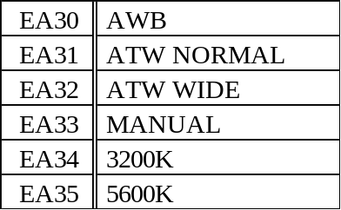

A0**, A1**
R PAINT (GAIN), B PAINT (GAIN) setting commands. Selecting the 3rd and 4th byte of data depends on "the white balance mode."
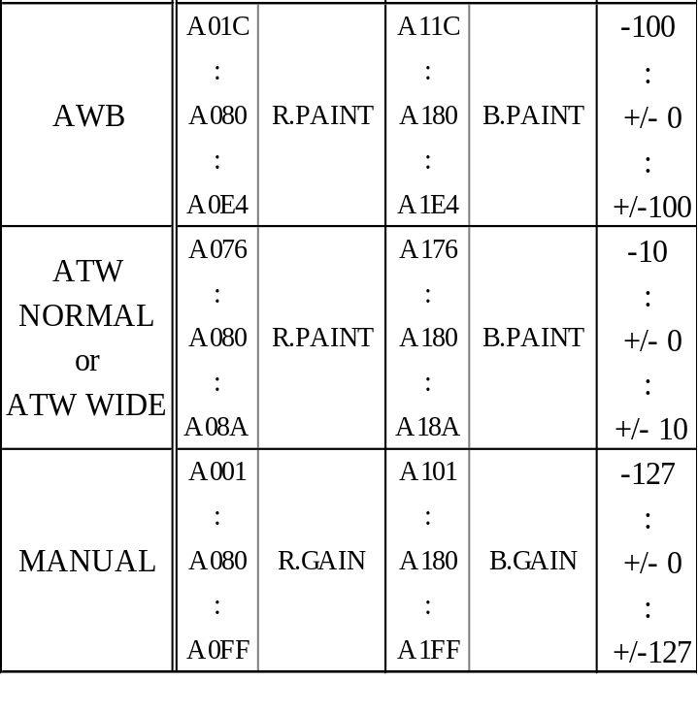
EB3*
AREA and SPEED setting commands in "white balance ATW or AWB mode." Bit operation.
During AWB, a bit of SPEED is invalid.
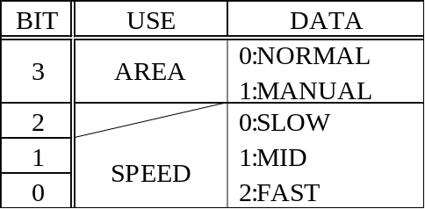
Note: When the host computer is connected with the REMOTE on the CMA-D3, the AREA for WB should be once set from WHITE BALANCE MODE to ATW NORMAL or ATW WIDE.(MERR is sent back except for ATW)
After the setting, it is effective when the mode is changed to AWB.

A5**, EC6*
DETAIL setting commands.
A5**: All/OFF, LEVEL setting
The 3rd and 4th byte of data (H' 00, from H' 01to H' FF ) is used as follows: OFF: H' 00
+/-127: 0=H' 80, -127=H' 01, +127=H' FF
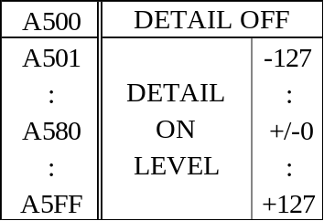
EC6*: DETAIL TARGET SETTING
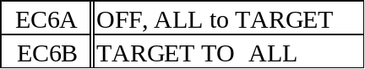
Switching to ALL/TARGET/OFF is used both EA5* and EC6*.
Use A500 for switching from TARGET to OFF.
Note: A5** is not allowed to switch from TARGET to ALL. Use the A501 to A5FF for DETAIL LEVEL when TARGET is ON.

EA6*
FREQUENCY MODE setting commands when DETAIL ALL and TAEGER is ON.
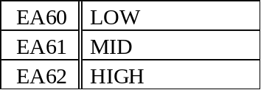

EA5*, EC6*
LINEAR MATRIX setting commands. Bit operation.
EA5*: ALL/OFF, MODE setting, bit operation
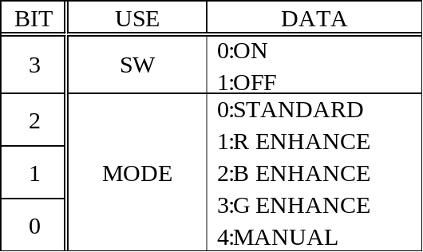

EC6*: DETAIL TARGET SETTING
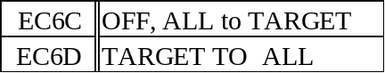
Switching to ALL/TARGET/OFF is used both EA5* and EC6*.
Use A500 for switching from TARGET to OFF.
Note: A5** is not allowed to switch from TARGET to ALL. Set the 3rd bit of EA5* 0 for mode switching.

AA**, AB**, AC**
R PAINT, G PAINT and B PAINT setting commands in "linear matrix manual mode." The 3rd and 4th byte of data (from H' 62 to 9E) is used as +/-30(0=H' 80, -30=H' 62, +30=H' 9E).
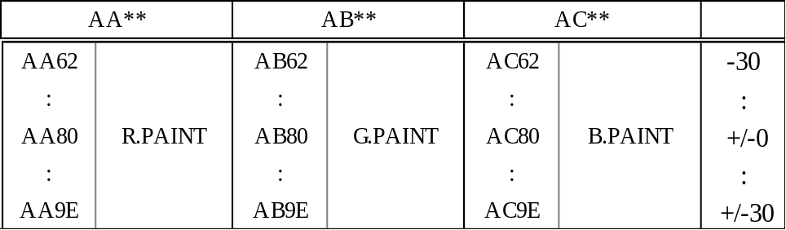

EB9*
TARGET COLOR MODE setting commands.
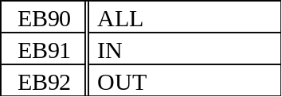
Note: When the host computer is connected with the REMOTE on the CMA-D3, the command is recognized when both DETAIL and LINIAR MATRIX are set ALL. However, the command is not effective.

E9**
RANGE setting commands in "target color mode" IN/OUT. The 3rd and 4th byte of data (from H' 76 to 8A) is used as +/-10 (0=H' 80, -10=H' 76, +10=H' 8A).
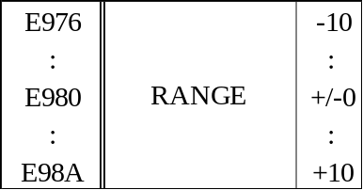

E7**
STORAGE mode setting commands.
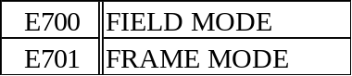

A3**
SHADING COMP. setting command.
The 3rd and 4th byte of data (H' 00, from H' 01 to H' FF) is used as follows: OFF: H' 00
+/-127: 0=H' 80, -127=H' 01, +127=H' FF
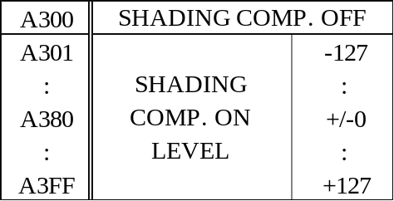

EA9*
TRIGGER MODE setting commands.
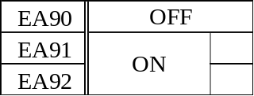

EAB*
NEGATIVE/POSITIVE CONVERSION setting commands.
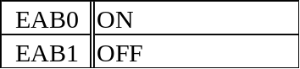

EAA*
FLICKER CHANCELLOR setting commands.
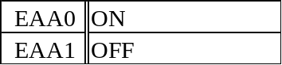

EA2*
D-SUB OUT setting commands. When the RGB switch on the rear panel is ON, this command is effective. When the VBS/Y/C switch is ON, EA2* command is sent back but it is invalid.
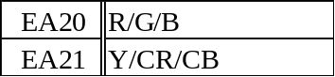

EA8*
D-SUB VIDEO setting commands. MERR is sent and these commands are not executed when connected with the REMOTE terminal on the CMA-D3.
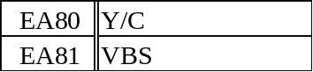

EB8*, EC6*
D-SUB SYNC setting commands. C SYNC setting cannot be made when connected with the REMOTE terminal on the CMA-D3. So, MERR is sent and these commands are not executed.
Regarding the WEN2 and WEN3, these cannot be set when TRIGER is OFF. So MERR is sent and these commands are not executed.
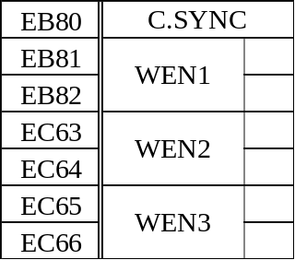

E6**
RGB SYNC setting commands.
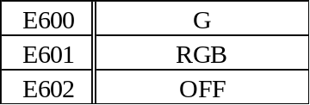

EAD*
12-pin CONNECTOR setting commands. The rear panel switch has a higher priority, when connected with the REMOTE terminal on the CMA-D3. So, MERR is sent and these commands are not executed.
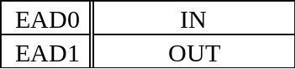
EA7*
Output signal setting commands when using a 12-pin connector OUT.
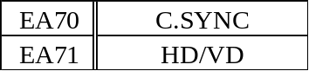

A4**
H PHASE setting commands.
The 3rd and 4th byte of data (from H' 6C to FF) is used as-20=H' 6C, 0=H'80, and +127=H' FF.

E0**
COLOR BAR and SC PHASE ROUGH setting commands. Bit operation. When selecting E0X1 and E0X2, X1 and X2 handle the following:
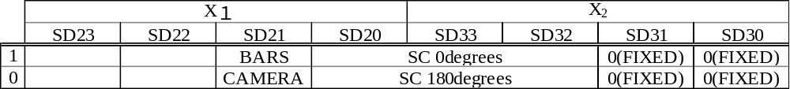

A7**
SC PHASE FINE setting commands.
The 3rd and 4th byte of data (from H' 01 to FF) is used as +/-127 (0=H' 80,-127=H' 01, +127=H' FF).

EF0*
FILE SELECT setting commands.
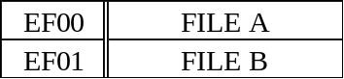

EF1*
FILE LOAD setting commands.
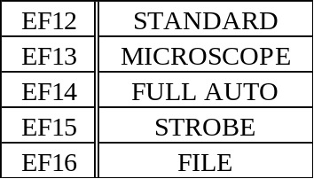

4. Note
The switches for GBR/Y-C-VBS and HD DV/SYNC IN/OUT are on the CMA-D3 rear panel. These switches are ineffective when the DXC-990 continuously receives communication data from the REMOTE terminal connected with the host computer. Therefore, the recommendation is that switching is to be selected before communication starts. If you have already connected the host computer, confirm the switch settings before sending data.
When the host computer is connected with the REMOTE on the CMA-D3 and “EC6*” is sent under the DXC-990 not receiving that commands, “ECEE” is sent to the host PC. (Usual command is MERR)
Please refer to the operation manual for more details on this unit's features and operations.
Due to further modifications, this unit's features and specifications are subject to change without notice.

5. Modification History
2001/04/01 Version 7.0 issue

Command Index

8
84** 9
85** 9
89** 9
8A** 9
8B** 9
8C** 9
8D** 9
A
A0** 14
A1** 14
A2** 11
A3** 16
A4** 18
A5** 14
A7** 18
A8** 13
A9** 13
AA** 15
AB** 15
AC** 15
AD** 13
AE** 9
C
C003 8
C004 8
C005 8
C006 8
C018 8
C208 8
C400 8
C418 9
C428 9
C608 9
C800 8
CERR 6, 8, 10
D
DERR 8
E
E0** 17
E1** 12
E2** 11
E3** 11
E4** 11
E5** 13
E6** 17
E7** 16
E8** 13
E9** 15
EA0* 12
EA1* 12
EA3* 13
EA4* 12
EA5* 15
EA6* 15
EA7* 18
EA8* 17
EA9* 16
EAA* 17
EAB* 16
EAC* 10
EAD* 17
EB0* 12
EB3* 14
EB8* 17
EB9* 16
EBF* 6, 10
EC6*……………………………………………….15, 17
EF0* 10, 18
EF1* 18
M
MERR 6, 8
O
OKAY 5, 6, 7, 8
S
STOP 6, 8
SW3A 11
SW3M 11
V
V5.* 5, 7
V6.* 5, 7, 8
VERS 5, 7

