2017年汉语水平考试通知
Hanyu Shuiping Kaoshi (HSK) Notice

留学生们：
For all international students:

2017年6月11日的汉语水平考试即将开始，我们需要在报名截止日期前统计大家参加汉语水平考试（HSK）的等级（如HSK 3级、4级或5级）以及考试的方式（笔考或机考）。请将你的决定回复在最下方“写留言”处。
Our Chinese Proficiency Test (HSK) is scheduled on 11th June, 2017. We need to collect everyone’s information about the HSK level and the test way (paper-based or computer-based) you will take. Please write down your decision in the message board below.

下面是新汉语水平考试的时间表，我们统一参加6月11日的考试。如果你参加笔考，我们学校会有专场考试；如果你参加机考，则需要去上海考试。
The following is the schedule table of Chinese Proficiency Test (HSK) in 2017. You can take the paper-based test in our school, while you have to go to Shanghai city for the computer-based test.
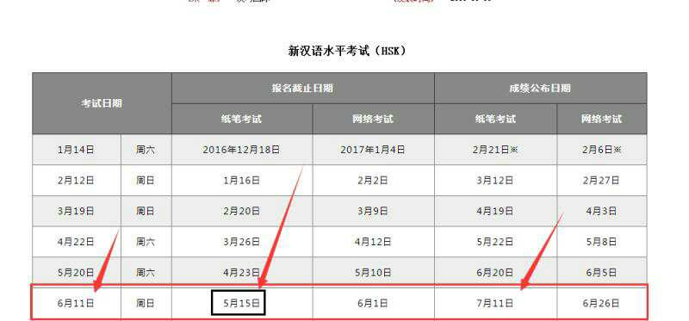

报名资料：
1. 护照复印件
2. 两张2寸彩色照片
3. 相应级别的报名费

The material you need to prepare for the test:
1. Copy of your passport
2. Two pieces of 2 inch color photos
3. Registration fee of the corresponding level of HSK

新汉语水平考试（HSK）费用（人民币）
Registration fee of the corresponding level of HSK (RMB)
等级 | 费用/元
一级 | 150
二级 | 250
三级 | 350
四级 | 450
五级 | 550
六级 | 650

Level | Fee/Yuan
HSK 1 | 150
HSK 2 | 250
HSK 3 | 350
HSK 4 | 450
HSK 5 | 550
HSK 6 | 650

考后30天可以查询成绩，考后45天领取成绩单和发票。
30 days after the test, students can inquire the score. And 45 days after the test, students can receive transcripts and invoices.

我们需要在报名截止日期前提前将大家的信息统计好，帮大家统一报名，所以请务必在2017年4月18日前在下方留言区回复你的中文姓名+参加HSK的等级+考试方式，如“小红+HSK4+笔考”。
We need to collect your information and complete the application procedures before the deadline. Please write down your Chinese name, the HSK grade you will take, and the test way (paper-based or computer-based) in the message board before 18th April, 2017. For example, you may write “小红+HSK4+paper-based test”.

不要错过我们的截止日期哦！
Pay attention to the deadline! Don’t forget!

咨询电话：0517-83591070
If you have any questions, please call: 0517-83591070

希望大家抓紧时间复习，顺利通过考试！
Hope you can pass the test!

