**A Comparative Analysis of Machine Learning Algorithms with the Latest Trends in AI: Blending tradition and innovation**

***Mrs.K.Shunmugapriya , D.Bhuvaneshwar , B.Pavithra , B.Srimadhi ,***

***Assistant Professor, Student, Student, Student,***

***Department of Computer Science and Applications,***

***Jeppiaar College Of Arts And Science ,Padur ,Chennai,India.***

**Abstract:** Machine learning (ML) has seen tremendous growth in recent years, with conventional algorithms facing competition from newer trends like deep learning, reinforcement learning, and quantum machine learning. This paper is a comparative analysis of traditional ML algorithms and popular AI-based techniques, evaluating their performance, scalability, and practicality. This work efficiently compares the recent and best algorithms for further works. In contrast to previous research, we present a new evaluation methodology that combines explainability, energy efficiency, and real-time adaptability as important performance indicators. Our results draw attention to the changing nature of AI and what this means for future research and industrial use cases.

**Keywords**: Machine Learning, Deep Learning, Traditional ML algorithm, Real-Time Adaptability, AI-Based Techniques.

**1. Introduction**

Machine learning algorithms have been a key driver of artificial intelligence, unravelling sophisticated problems in numerous fields such as healthcare, finance, robotics, and natural language processing. With AI-based technologies progressing further, researchers and professionals are looking more and more for fresh methodologies that enhance efficiency, precision, and flexibility.

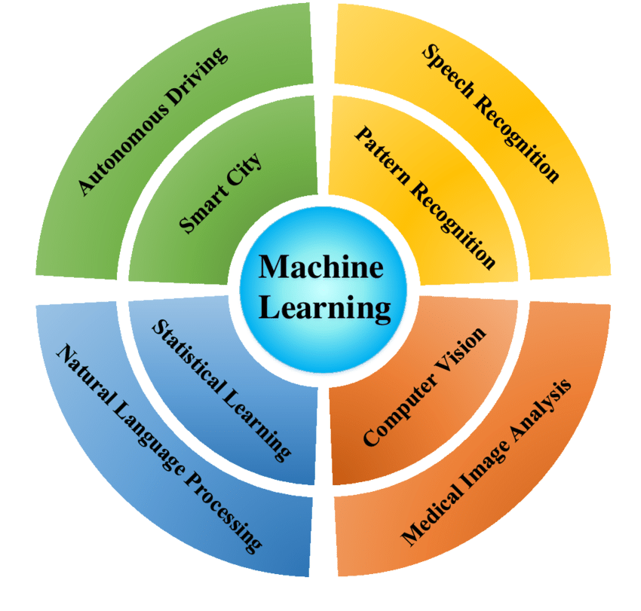

**Fig 1.1 Uses of Machine Learning**

Emergent paradigms like Federated Learning enable model training without violating user data privacy, a major drawback of centralized ML models. Further, Quantum Machine Learning is opening up the frontiers of computational efficiency and resolving complicated problems beyond what classical algorithms can handle.

**2. Background and Related Work**

Current comparative research targets mainly accuracy and computational complexity. They tend, however, to overlook new metrics like energy efficiency, ethics, and real-time adaptability. This paper pushes the boundaries of previous work with the introduction of an evaluation model that includes all these aspects and provides a multifaceted vision of ML algorithm performance. Newly developed AI elements like self-supervised learning and generative models have further shifted the boundaries for machine learning purposes. While deep learning approaches bring impressive performance gains, they tend to demand significant computational resources and large datasets for training.

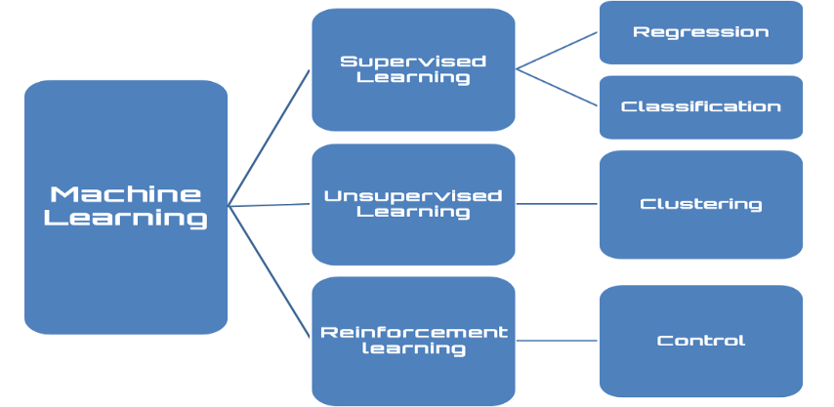

**Fig 2.1 Classifications of Machine Learning**

Although classical models are extensively researched, their shortcomings are apparent when dealing with big, unstructured data. In contrast, popular methods such as Transformers and Federated Learning offer scalability, privacy, and robustness solutions in decentralized settings. Even with these developments, it is still challenging to balance computational efficiency and model complexity.Our research will explore whether classic approaches remain valuable in certain applications where these limitations prevail.

**3. Comparative Methodology**

**3.1 Classic ML Algorithms**

* Decision Trees: They are tree-structured algorithms with feature-based decision-making. Decision trees are easy to implement but lack interpretability and are prone to overfitting.
* Support Vector Machines (SVM): SVM is ideal for high-dimensional data classification through hyperplanes but is computationally intensive for big data.
* Random Forest: Ensemble learning algorithm where multiple decision trees are used for enhanced accuracy and avoiding overfitting.
* k-Nearest Neighbors (k-NN): A basic, instance-based learning algorithm that labels data points based on how close they are to labelled known points.
* Naive Bayes: A probabilistic classifier founded on Bayes' theorem and best suited for text classification and spam filtering.
* Gradient Boosting Machines (GBM): An ensemble method that enhances accuracy by combining weak learners into a powerful predictive model.
* Logistic Regression: A core classification algorithm widely applied to binary classification problems.

**3.2 Trending AI Techniques**

Transformer-based models have revolutionized natural language processing through self-attention mechanisms, enabling context-sensitive learning at scale. Federated learning, a decentralized approach, allows models to train on edge devices without transferring raw data to central servers, enhancing privacy. Diffusion models, widely used in generative AI, iteratively refine data representations to generate high-quality synthetic samples. In computing, neuromorphic processors, inspired by the human brain, enable efficient real-time AI processing in low-power environments.

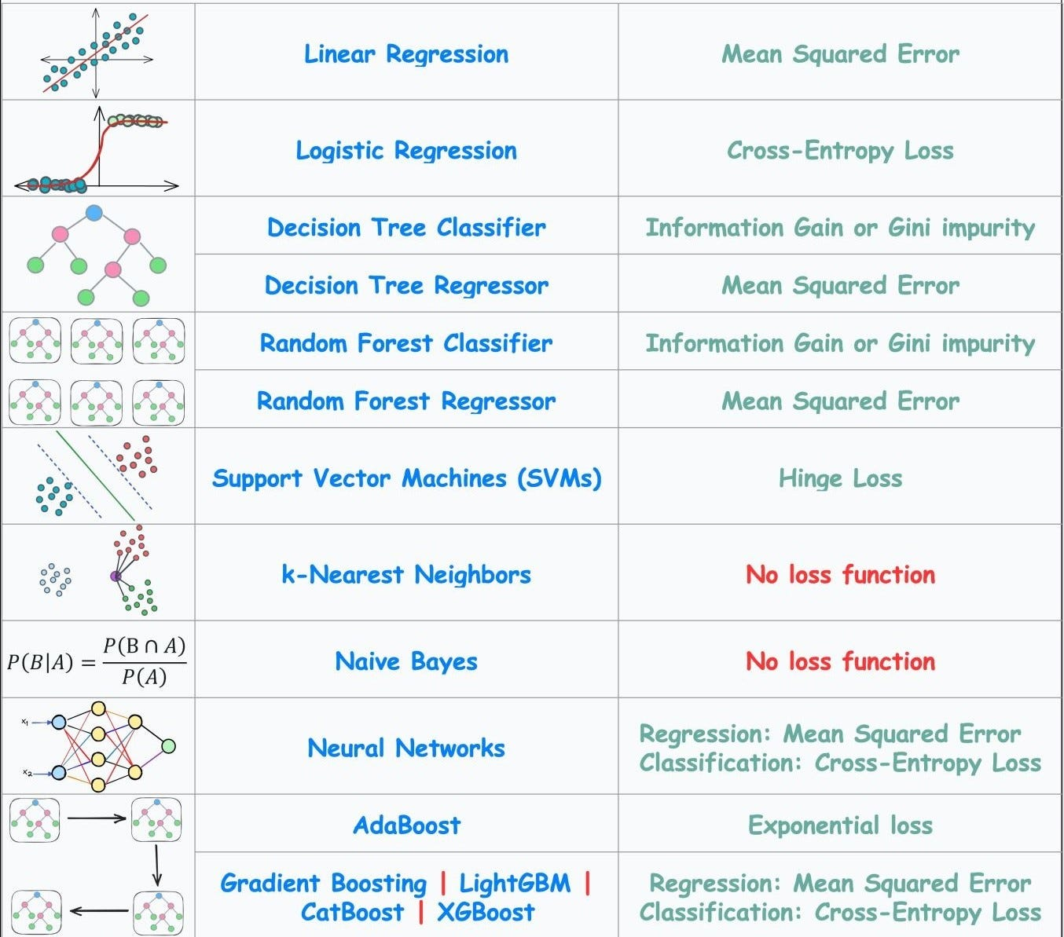

**Fig 3.2.1 Keys of Machine Learning Algorithms**

Explainability is how comprehensible the decision-making process of the model is, while energy efficiency measures the computational expense and sustainability of each method.

**4. Experimental Analysis**

**4.1 Dataset Selection**:

The assessment is conducted using publicly accessible datasets from various domains, including healthcare, where medical imaging and disease prediction datasets are utilized. In finance, datasets focus on stock market prediction and fraud detection. For autonomous systems, object detection and reinforcement learning environments support robotics research. Additionally, in natural language processing, datasets are used for sentiment analysis and evaluating chatbot performance.

**4.2 Performance Metrics and Evaluation**

The following table captures the comparative study of traditional and popular ML algorithms on major performance metrics:

|  |  |  |  |  |  |
| --- | --- | --- | --- | --- | --- |
| Algorithm | Accuracy | Computational Efficiency | Scalability | Explainability | Privacy & Security |
| Decision Trees | Moderate | High | Low | High | Low |
| Support Vector Machines | High | Moderate | Low | Moderate | Moderate |
| Random Forest | High | Moderate | Moderate | Moderate | Moderate |
| k-Nearest Neighbors | Moderate | Low | Low | High | Low |
| Transformer-Based Models | Very High | Low | High | Low | Moderate |
| Federated Learning | High | Moderate | High | Moderate | High |
| Diffusion Models | High | Low | Moderate | Low | Moderate |
| Neuromorphic Computing | Moderate | Very High | High | Moderate | High |
| Quantum ML | Very High | Very Low | Very High | Low | Moderate |
| Graph Neural Networks | High | Moderate | High | Low | Moderate |

**4.3 Results and Observations:**

Comparison of performance reveals that conventional ML algorithms such as Decision Trees and SVM are high in explainability and energy efficiency but are non-scalable and non-adaptive. On the contrary, Transformer models and Quantum Machine Learning are more accurate and adaptable but consume a lot more computation. Federated Learning is fair in terms of privacy and performance but adds communication overhead. Although deep learning models perform exceptionally well in sophisticated pattern recognition, they are extremely vulnerable to adversarial perturbations.

**5. Future Enhancement**

Future research should focus on optimizing hybrid AI models that combine the interpretability of traditional ML with the efficiency of deep learning and AI-driven techniques. Improving the security and efficiency of Federated Learning, advancing quantum computing frameworks for large-scale AI applications, and integrating ethical considerations into AI decision-making remain key challenges. Additionally, real-time flexibility and efficient AI models will be essential in the future of AI systems, especially for edge computing and IoT.

**6. Conclusion**

This paper offers a systematic comparison of classical ML and emerging AI techniques, with emphasis on their strengths, weaknesses, and possibilities for the future. While traditional ML methods are still pertinent due to their explainability and effectiveness, advanced AI techniques offer greater scalability and precision. The results emphasize ongoing innovation in hybrid designs to overcome current trade-offs, making AI's responsible and efficient integration into various sectors feasible.

***References***

1. *Goodfellow, I., et al. (2016). "Deep learning." MIT Press.*
2. *Bishop, C. M. (2006). "Pattern recognition and machine learning." Springer.*
3. *Hastie, T., et al. (2009). "The elements of statistical learning." Springer.*
4. *LeCun, Y., et al. (2015). "Deep learning." Nature.*
5. *Jordan, M. I., & Mitchell, T. M. (2015). "Machine learning: Trends, perspectives, and prospects." Science.*
6. *Vaswani, A., et al. (2017). "Attention is all you need." NeurIPS.*
7. *Schmidhuber, J. (2015). "Deep learning in neural networks: An overview." Neural Networks.*
8. *Konečný, J., et al. (2016). "Federated learning: Strategies for improving communication efficiency." arXiv.*
9. *Geiger, B. C., & Lenz, D. (2020). "Neuromorphic computing for AI applications." IEEE Transactions on Neural Networks.*
10. *Arute, F., et al. (2019). "Quantum supremacy using a programmable superconducting processor." Nature.*
11. *Kipf, T. N., & Welling, M. (2017). "Semi-supervised classification with graph convolutional networks." ICLR.*