**LEAF CURL DISEASE DETECTION**

**1. M.Manish( Presenter)**

**Mobile No:** **7550002575**

**Email.Id:** **manishmalmarugan07@gmail.com**

**2. D.Bhuvaneshwar**

**3. A.Muhilarasan**

**4.R.Vigneshlingam**

**Students, Department of Computer Science & Applications,**

**Jeppiaar college of arts & science, Chennai.**

**ABSTRACT**

Botany is one of the world's oldest natural sciences. Botany, also called plant science or phytology, is the branch of natural science and biology studying plants, especially their anatomy, taxonomy, and ecology. In Botany, Leaves play a vital role in by its uses. The main function of a leaf is to produce the food for the plants by using the mechanism called photosynthesis. Leaf Curl Disease is one of the common disease in Botany. In this work, we are going to detect the disease which is caused to leaf by using YOLOv8 method, a type of neural network which are very good at detecting patterns (and by extension objects and the like) in images. The YOLOv8 model, known for its high accuracy and speed, is employed to identify and classify images of leaves exhibiting symptoms of curl disease. This approach not only facilitates early detection but also contributes to precision agriculture by reducing the need for manual inspection and ensuring timely intervention.

**Keywords:** Leaf Curl Disease, YOLOv8 method, Neural network Photosynthesis.

**INTRODUCTION**

Leaf curl disease is one of the most widespread and damaging plant diseases, particularly affecting crops like tomatoes, peppers, and other fruit-bearing plants. It is caused by various pathogens, including viruses and fungi, which induce visible symptoms such as curling, yellowing, and deformation of leaves. These symptoms, if left undetected, can significantly reduce crop yields, degrade fruit quality, and result in substantial economic losses for farmers. Early detection of leaf curl disease is essential for timely intervention, preventing further spread, and reducing the need for extensive pesticide use.

Traditionally, the detection of plant diseases, including leaf curl, has relied on manual inspection by trained experts, which is time-consuming, labor-intensive, and often prone to errors, particularly in large-scale farming operations. To address this challenge, researchers have increasingly turned to machine learning and computer vision techniques for automating plant disease detection. Among these methods, deep learning algorithms have shown significant promise due to their ability to process large volumes of image data and accurately classify plant health status.

In this study, we propose the use of YOLOv8 (You Only Look Once version 8), a state-of-the-art object detection model, to automatically detect leaf curl disease in plants. YOLOv8, known for its efficiency and real-time detection capabilities, offers a significant advancement over traditional image classification methods. By training YOLOv8 on a curated dataset of healthy and diseased leaf images, we aim to leverage its ability to identify and localize symptoms of leaf curl with high precision. This approach not only enhances disease detection speed but also supports precision agriculture by enabling early intervention, minimizing crop damage, and optimizing resource usage.

The goal of this research is to demonstrate the potential of YOLOv8 for automated, real-time disease monitoring in agriculture, offering a practical solution for farmers to detect leaf curl disease more effectively and efficiently. Through this study, we aim to contribute to the growing field of AI-driven agricultural technology and provide a scalable tool for disease management in crop cultivation.

**MATERIALS AND METHODS**

YOLOv8 (You Only Look Once version 8) is a state-of-the-art object detection model developed by Ultralytics. Building upon its predecessors, YOLOv8 offers enhanced speed, accuracy, and versatility for tasks like object detection, segmentation, and image classification. It introduces new features like a modular PyTorch-based architecture, easy customization, and support for multi-task learning. YOLOv8 emphasizes user-friendliness with streamlined workflows, training on custom datasets, and real-time inference capabilities. Its lightweight design and efficiency make it suitable for edge devices and large-scale deployments. YOLOv8 is widely used in applications like autonomous driving, healthcare , and surveillance.

This picture clearly shows about the working principle of YOLOv8 method

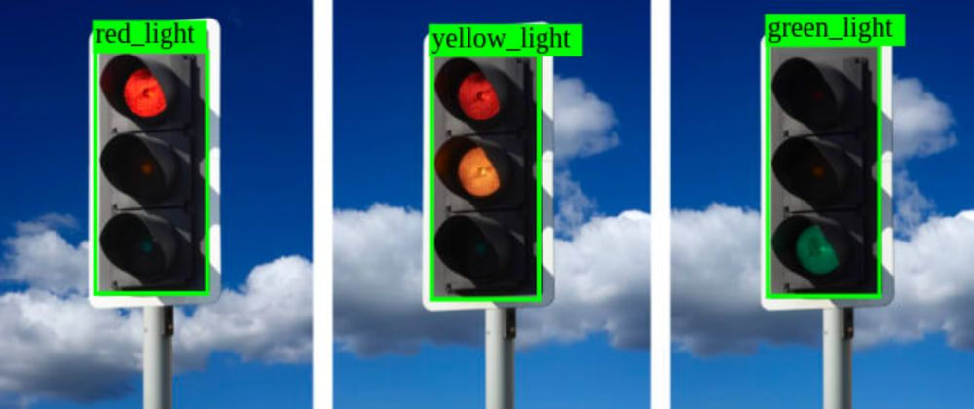

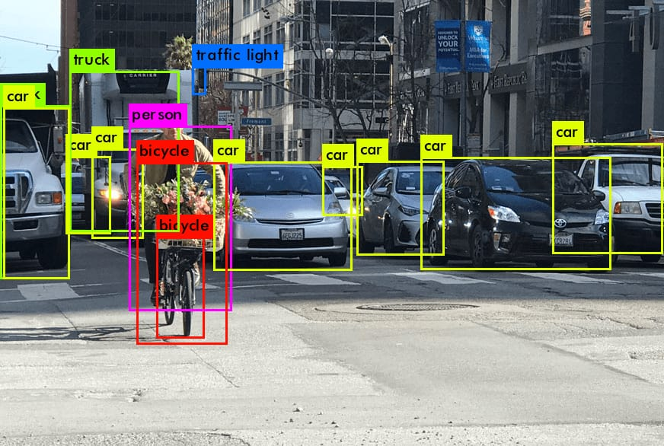

**PROPOSED WORK**

This paper investigates the detection of leaf curling using YOLOv8, an advanced object detection framework. The study begins with the preparation of a comprehensive dataset containing images of normal and curled leaves. A new, healthy leaf is scanned to generate 16-dimensional photos, which serve as a baseline for structural comparison. Similarly, a curled leaf undergoes inch-by-inch scanning to create another set of 16-dimensional images. These high-dimensional photos capture intricate details of the leaf's surface and structure.Using YOLOv8, the captured data is analyzed to identify and highlight differences between the healthy and curled leaves. The algorithm’s ability to process high-dimensional data ensures the precise detection of subtle changes in leaf shape and texture, automating the traditionally manual and error-prone inspection process. This method offers a robust and efficient solution for identifying leaf curling, contributing significantly to plant health monitoring and agricultural diagnostics.

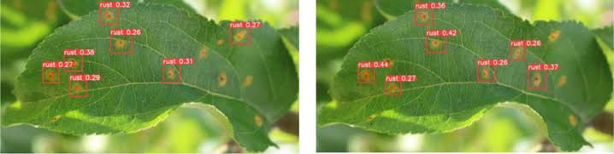

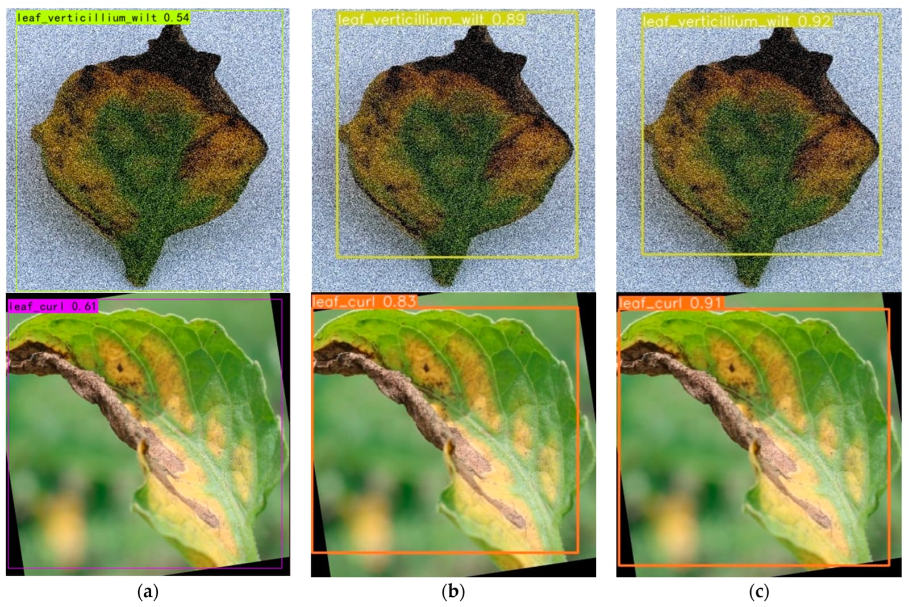

To ensure reproducibility, the study emphasizes detailed documentation of methodologies, including data acquisition, preprocessing steps, and the inch-by-inch scanning technique. Specifications of the YOLOv8 model, software tools, and hardware used are provided. This approach guarantees that the findings can be independently verified and replicated, fostering transparency and reliability in agricultural research.

**EVALUATION METRICS**

To assess the performance of the YOLOv8 model, several standard metrics were used:

Precision: The percentage of true positive predictions out of all positive predictions made by the model.

Recall: The percentage of true positive predictions out of all actual positive instances in the dataset.

**RESULT AND DISCUSION**

The YOLOv8 model demonstrated effective and efficient detection of leaf curl disease in plant leaves. However, the study's limitations, such as dataset size and image variability, were acknowledged. Future work will include expanding the dataset, fine-tuning the model with additional augmentations, and exploring the deployment of the model in real-time field scenarios for early detection and management of plant diseases.

**FUTURE ENHANCEMENT**

YOLOv8 is the latest and most advanced YOLO model, offering higher accuracy, faster inference, and support for multi-task learning (detection, segmentation, and classification). Unlike earlier YOLO versions, it features a modular PyTorch-based architecture, making customization and deployment easier. YOLOv8 emphasizes real-time performance on edge devices and scales well for large datasets. Previous YOLO versions focused mainly on detection, with incremental improvements in accuracy and speed. YOLOv8 combines these advancements into a unified, versatile framework.

**REFERENCES**

[1] Butter NS, Rataul HS. Nature and extent of losses in tomatoes due to tomato leaf curl virus(TLCV) transmitted by whitefly, Bemisia tabaci Gen. (Hemiptera, Aleyrodidae). IndianJournal of Ecology. 1981;8:299-300

[2] Kalloo G. Leaf curl virus of tomato and chilli in India. In: Proceeding of the phase I finalworkshop of the South Asian Vegetable Research Network. Kathmandu; January 23–28,(1996): pp 229-234

[3] Sastry KSM, Singh SJ. Assessment of losses in tomato by tomato leaf curl virus. IndianJournal of Mycology and Plant Pathology. 1973;3:50-54

[4] Fauquet CM, Briddon RW, Brown JK, Moriones E, Stanley J, Zerbini M, Zhou X. Geminivirusstrain demarcation and nomenclature. Archives of Virology. 2008;153(4):783-821

[5] Stanley J, Gay MR. Nucleotide sequence of cassava latent virus DNA. Nature. 1983;301:260-262