Input_Suzanne.txt
Area Ratio | Resolution | Time Elapsed (s) | Calculation of primitives
1x | 256x256 | 75.6088 | 126,945,188
4x | 512x512 | 249.8918 | 507,944,360
16x | 1024x1024 | 575.5547 | 1,143,343,644
64x | 2048x2048 | 1049.0348 | 2,031,670,544
256x | 4096x4096 | 1498.7429 | 3,174,854,828
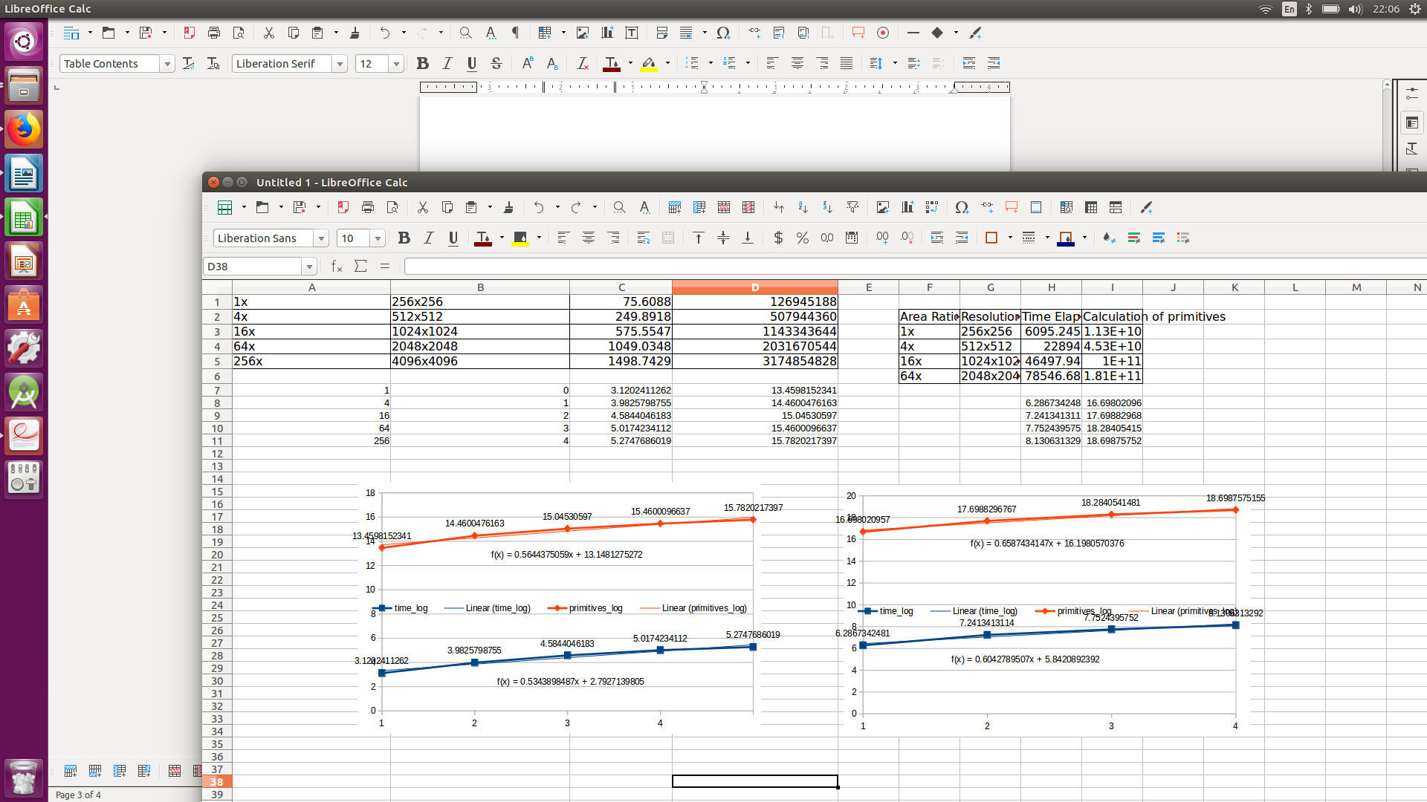
Output_Suzanne.ppm 1024x1024
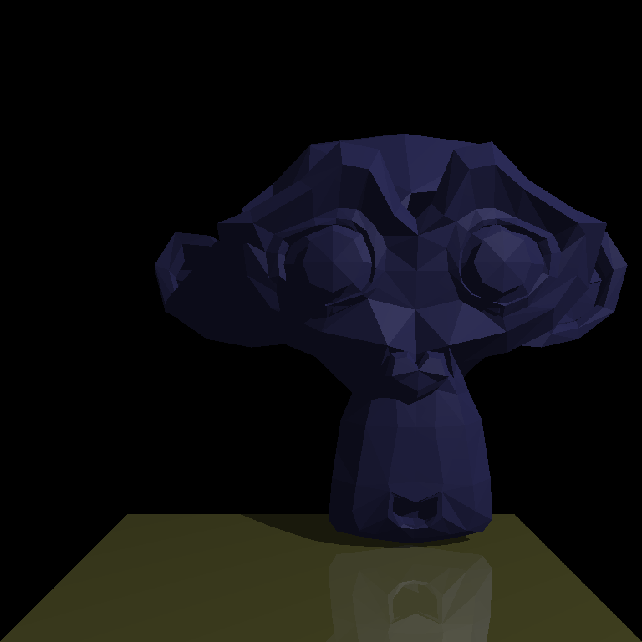

Input_Bunny.txt
Area Ratio | Resolution | Time Elapsed (s) | Calculation of primitives
1x | 256x256 | 6,095.245 | 11,303,432,692
4x | 512x512 | 22,894.011 | 45,264,449,370
16x | 1024x1024 | 46,497.939 | 101,882,004,692
64x | 2048x2048 | 78,546.679 | 181,039,685,978

Output_Bunny.ppm 1024x1024

