УО «Белорусский государственный университет информатики и радиоэлектроники»

Кафедра ПОИТ

Отчет по лабораторной работе №2

по предмету «Теория информации»

Выполнил:

Гридюшко Б.О

гр. 251003

Проверил:

Болтак С.В.

Минск 2024

Задача 2.

1. Шифрование

Текстовая фраза: I haVe SweTs

Ключ: 7641422672389234853

|  |  |  |  |  |  |  |  |  |  |  |
| --- | --- | --- | --- | --- | --- | --- | --- | --- | --- | --- |
| Data | Key | Crypt Data |  | Data | Key | Crypt Data |  | Data | Key | Crypt Data |
| 0 | 1 | 1 |  | 0 | 1 | 1 |  | 1 | 1 | 0 |
| 1 | 1 | 0 |  | 1 | 1 | 0 |  | 1 | 0 | 1 |
| 0 | 1 | 1 |  | 0 | 1 | 1 |  | 1 | 0 | 1 |
| 0 | 1 | 1 |  | 1 | 0 | 1 |  | 0 | 1 | 1 |
| 1 | 1 | 0 |  | 0 | 0 | 0 |  | 1 | 0 | 1 |
| 0 | 1 | 1 |  | 1 | 1 | 0 |  | 1 | 0 | 1 |
| 0 | 1 | 1 |  | 1 | 0 | 1 |  | 1 | 1 | 0 |
| 1 | 0 | 1 |  | 0 | 1 | 1 |  | 0 | 0 | 0 |
| 0 | 1 | 1 |  | 0 | 0 | 0 |  | 1 | 0 | 1 |
| 0 | 1 | 1 |  | 1 | 1 | 0 |  | 1 | 0 | 1 |
| 1 | 0 | 1 |  | 1 | 1 | 0 |  | 0 | 0 | 0 |
| 0 | 0 | 0 |  | 0 | 1 | 1 |  | 0 | 1 | 1 |
| 0 | 0 | 0 |  | 0 | 1 | 1 |  | 1 | 1 | 0 |
| 0 | 1 | 1 |  | 1 | 1 | 0 |  | 0 | 1 | 1 |
| 0 | 0 | 0 |  | 0 | 0 | 0 |  | 1 | 0 | 1 |
| 0 | 0 | 0 |  | 1 | 0 | 1 |  | 0 | 0 | 0 |
| 0 | 0 | 0 |  | 0 | 0 | 0 |  | 1 | 0 | 1 |
| 1 | 1 | 0 |  | 0 | 1 | 1 |  | 0 | 0 | 0 |
| 1 | 1 | 0 |  | 1 | 1 | 0 |  | 1 | 1 | 0 |
| 0 | 1 | 1 |  | 0 | 0 | 0 |  | 0 | 1 | 1 |
| 1 | 0 | 1 |  | 0 | 1 | 1 |  | 1 | 1 | 0 |
| 0 | 0 | 0 |  | 0 | 1 | 1 |  | 0 | 0 | 0 |
| 0 | 1 | 1 |  | 0 | 1 | 1 |  | 0 | 0 | 0 |
| 0 | 1 | 1 |  | 0 | 0 | 0 |  | 0 | 0 | 0 |
| 0 | 0 | 0 |  | 0 | 0 | 0 |  | 1 | 1 | 0 |
| 1 | 1 | 0 |  | 1 | 1 | 0 |  | 1 | 0 | 1 |
| 1 | 0 | 1 |  | 0 | 0 | 0 |  | 1 | 0 | 1 |
| 0 | 0 | 0 |  | 1 | 1 | 0 |  | 0 | 0 | 0 |
| 0 | 1 | 1 |  | 0 | 0 | 0 |  | 0 | 1 | 1 |
| 0 | 0 | 0 |  | 0 | 1 | 1 |  | 1 | 1 | 0 |
| 0 | 1 | 1 |  | 1 | 0 | 1 |  | 1 | 1 | 0 |
| 1 | 0 | 1 |  | 1 | 1 | 0 |  |  |  |  |
|  |  |  |  | 0 | 0 | 0 |  |  |  |  |

Зашифрованная фраза:



Ключ: 7641422672389234853

2. Дешифрация:

|  |  |  |  |  |  |  |  |  |  |  |
| --- | --- | --- | --- | --- | --- | --- | --- | --- | --- | --- |
| Data | Key | Crypt Data |  |  |  |  |  |  |  |  |
| 1 | 1 | 0 |  | 1 | 1 | 0 |  | 0 | 1 | 1 |
| 0 | 1 | 1 |  | 0 | 1 | 1 |  | 1 | 0 | 1 |
| 1 | 1 | 0 |  | 1 | 1 | 0 |  | 1 | 0 | 1 |
| 1 | 1 | 0 |  | 1 | 0 | 1 |  | 1 | 1 | 0 |
| 0 | 1 | 1 |  | 0 | 0 | 0 |  | 1 | 0 | 1 |
| 1 | 1 | 0 |  | 0 | 1 | 1 |  | 1 | 0 | 1 |
| 1 | 1 | 0 |  | 1 | 0 | 1 |  | 0 | 1 | 1 |
| 1 | 0 | 1 |  | 1 | 1 | 0 |  | 0 | 0 | 0 |
| 1 | 1 | 0 |  | 0 | 0 | 0 |  | 1 | 0 | 1 |
| 1 | 1 | 0 |  | 0 | 1 | 1 |  | 1 | 0 | 1 |
| 1 | 0 | 1 |  | 0 | 1 | 1 |  | 0 | 0 | 0 |
| 0 | 0 | 0 |  | 1 | 1 | 0 |  | 1 | 1 | 0 |
| 0 | 0 | 0 |  | 1 | 1 | 0 |  | 0 | 1 | 1 |
| 1 | 1 | 0 |  | 0 | 1 | 1 |  | 1 | 1 | 0 |
| 0 | 0 | 0 |  | 0 | 0 | 0 |  | 1 | 0 | 1 |
| 0 | 0 | 0 |  | 1 | 0 | 1 |  | 0 | 0 | 0 |
| 0 | 0 | 0 |  | 0 | 0 | 0 |  | 1 | 0 | 1 |
| 0 | 1 | 1 |  | 1 | 1 | 0 |  | 0 | 0 | 0 |
| 0 | 1 | 1 |  | 0 | 1 | 1 |  | 0 | 1 | 1 |
| 1 | 1 | 0 |  | 0 | 0 | 0 |  | 1 | 1 | 0 |
| 1 | 0 | 1 |  | 1 | 1 | 0 |  | 0 | 1 | 1 |
| 0 | 0 | 0 |  | 1 | 1 | 0 |  | 0 | 0 | 0 |
| 1 | 1 | 0 |  | 1 | 1 | 0 |  | 0 | 0 | 0 |
| 1 | 1 | 0 |  | 0 | 0 | 0 |  | 0 | 0 | 0 |
| 0 | 0 | 0 |  | 0 | 0 | 0 |  | 0 | 1 | 1 |
| 0 | 1 | 1 |  | 0 | 1 | 1 |  | 1 | 0 | 1 |
| 1 | 0 | 1 |  | 0 | 0 | 0 |  | 1 | 0 | 1 |
| 0 | 0 | 0 |  | 0 | 1 | 1 |  | 0 | 0 | 0 |
| 1 | 1 | 0 |  | 0 | 0 | 0 |  | 1 | 1 | 0 |
| 0 | 0 | 0 |  | 1 | 1 | 0 |  | 0 | 1 | 1 |
| 1 | 1 | 0 |  | 1 | 0 | 1 |  | 0 | 1 | 1 |
| 1 | 0 | 1 |  | 0 | 1 | 1 |  |  |  |  |
|  |  |  |  | 0 | 0 | 0 |  |  |  |  |

Результат: I haVe SweTs

1. Шифрование

Текстовая фраза: I haVe SweTs

Ключ: 7641422672389234853

|  |  |  |  |  |  |  |  |  |  |  |
| --- | --- | --- | --- | --- | --- | --- | --- | --- | --- | --- |
| Data | Key | Crypt Data |  |  |  |  |  |  |  |  |
| 0 | 1 | 1 |  | 1 | 0 | 1 |  | 1 | 0 | 1 |
| 1 | 1 | 0 |  | 0 | 0 | 0 |  | 0 | 0 | 0 |
| 0 | 1 | 1 |  | 0 | 0 | 0 |  | 0 | 1 | 1 |
| 0 | 1 | 1 |  | 0 | 1 | 1 |  | 0 | 1 | 1 |
| 1 | 1 | 0 |  | 0 | 0 | 0 |  | 0 | 0 | 0 |
| 0 | 1 | 1 |  | 0 | 0 | 0 |  | 1 | 1 | 0 |
| 0 | 1 | 1 |  | 0 | 0 | 0 |  | 1 | 0 | 1 |
| 1 | 0 | 1 |  | 1 | 1 | 0 |  | 0 | 0 | 0 |
| 0 | 1 | 1 |  | 1 | 1 | 0 |  | 0 | 1 | 1 |
| 0 | 1 | 1 |  | 0 | 1 | 1 |  | 0 | 0 | 0 |

Зашифрованная фраза:



Ключ: 34783274390234

2. Дешифрация:

|  |  |  |  |  |  |  |  |  |  |  |
| --- | --- | --- | --- | --- | --- | --- | --- | --- | --- | --- |
| Data | Key | CryptData |  |  |  |  |  |  |  |  |
| 1 | 1 | 0 |  | 1 | 0 | 1 |  | 1 | 0 | 1 |
| 0 | 1 | 1 |  | 0 | 1 | 1 |  | 0 | 0 | 0 |
| 1 | 0 | 1 |  | 0 | 1 | 1 |  | 1 | 0 | 1 |
| 1 | 1 | 0 |  | 1 | 1 | 0 |  | 1 | 1 | 0 |
| 0 | 0 | 0 |  | 0 | 0 | 0 |  | 0 | 1 | 1 |
| 1 | 0 | 1 |  | 0 | 1 | 1 |  | 0 | 1 | 1 |
| 1 | 0 | 1 |  | 0 | 0 | 0 |  | 1 | 1 | 0 |
| 1 | 1 | 0 |  | 0 | 1 | 1 |  | 0 | 1 | 1 |
| 1 | 0 | 1 |  | 0 | 1 | 1 |  | 1 | 0 | 1 |
| 1 | 0 | 1 |  | 1 | 1 | 0 |  | 0 | 1 | 1 |

Результат:



1. Шифрование

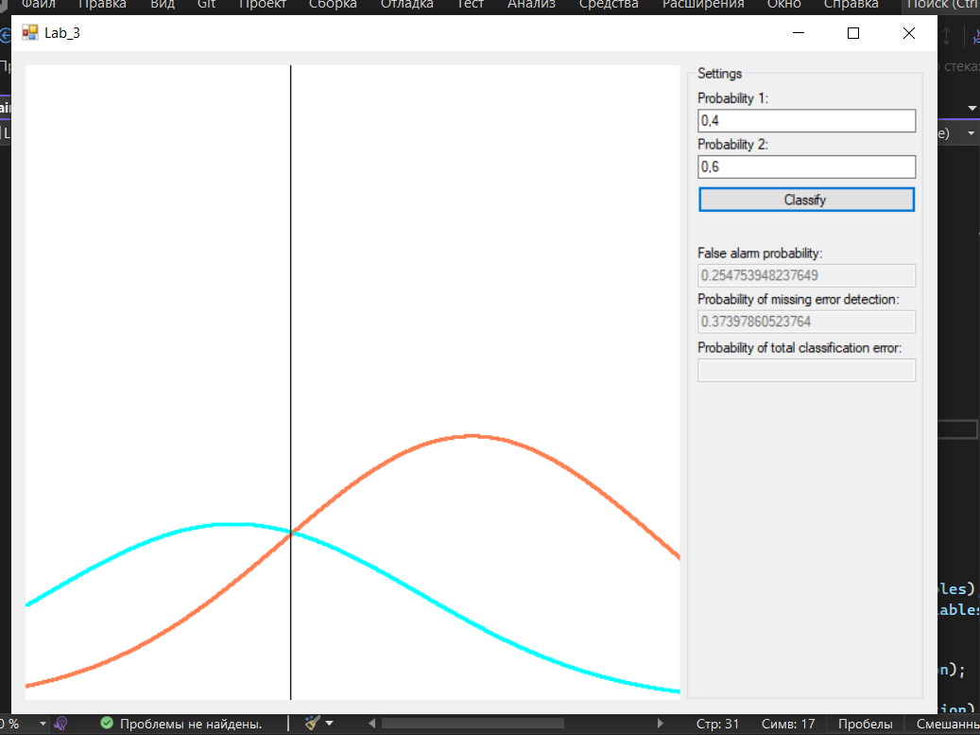Данные:

Ключ: 7641422672389234853

|  |  |  |  |  |  |  |  |  |  |  |
| --- | --- | --- | --- | --- | --- | --- | --- | --- | --- | --- |
| Data | Key | CryptData |  |  |  |  |  |  |  |  |
| 1 | 1 | 0 |  | 0 | 0 | 0 |  | 1 | 0 | 1 |
| 0 | 1 | 1 |  | 1 | 1 | 0 |  | 1 | 0 | 1 |
| 0 | 0 | 0 |  | 0 | 1 | 1 |  | 1 | 0 | 1 |
| 0 | 1 | 1 |  | 0 | 1 | 1 |  | 0 | 1 | 1 |
| 1 | 0 | 1 |  | 0 | 0 | 0 |  | 0 | 1 | 1 |
| 0 | 0 | 0 |  | 0 | 1 | 1 |  | 1 | 1 | 0 |
| 0 | 0 | 0 |  | 0 | 0 | 0 |  | 0 | 1 | 1 |
| 1 | 1 | 0 |  | 1 | 1 | 0 |  | 0 | 1 | 1 |
| 0 | 0 | 0 |  | 0 | 1 | 1 |  | 0 | 0 | 0 |
| 1 | 0 | 1 |  | 0 | 1 | 1 |  | 1 | 1 | 0 |

Результат:

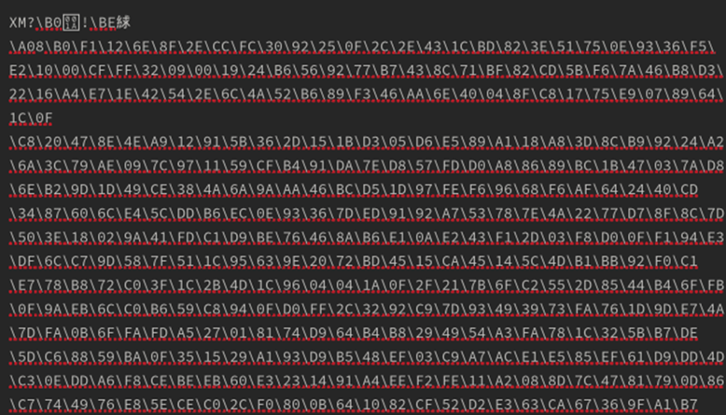

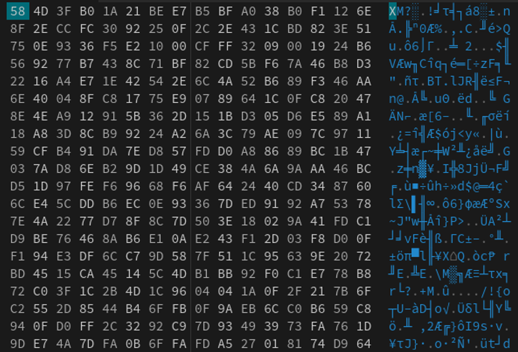

2. Дешифрация:

|  |  |  |  |  |  |  |  |  |  |  |
| --- | --- | --- | --- | --- | --- | --- | --- | --- | --- | --- |
| Data | Key | CryptData |  |  |  |  |  |  |  |  |
| 0 | 1 | 1 |  | 0 | 0 | 0 |  | 1 | 0 | 1 |
| 1 | 1 | 0 |  | 0 | 1 | 1 |  | 1 | 0 | 1 |
| 0 | 0 | 0 |  | 1 | 1 | 0 |  | 1 | 0 | 1 |
| 1 | 1 | 0 |  | 1 | 1 | 0 |  | 1 | 1 | 0 |
| 1 | 0 | 1 |  | 0 | 0 | 0 |  | 1 | 1 | 0 |
| 0 | 0 | 0 |  | 1 | 1 | 0 |  | 0 | 1 | 1 |
| 0 | 0 | 0 |  | 0 | 0 | 0 |  | 1 | 1 | 0 |
| 0 | 1 | 1 |  | 0 | 1 | 1 |  | 1 | 1 | 0 |
| 0 | 0 | 0 |  | 1 | 1 | 0 |  | 0 | 0 | 0 |
| 1 | 0 | 1 |  | 1 | 1 | 0 |  | 0 | 1 | 1 |

