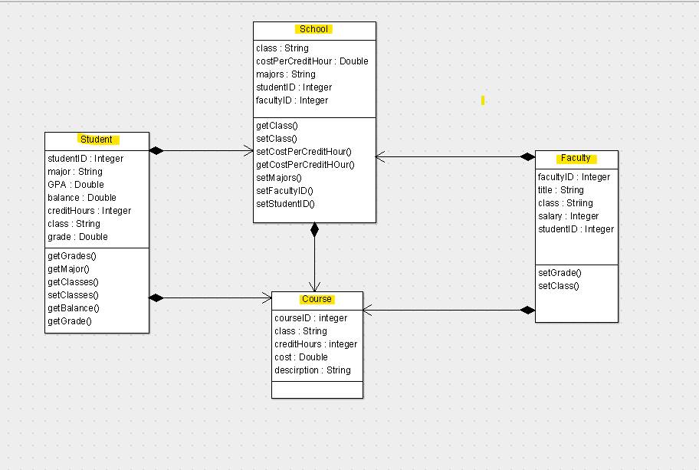From what I’m reading on the project criteria, this would be the minimum info we would need:

student:

- name

- id

- registered courses (doesn’t specify how to identify this, so I guess you could do string i.e. CS2305 etc)

course:

- name

- exam score(s) for each student

- Gpa for each student (prob just based off the exams)

The instruction doesn’t say to structure it this way, so I think we can structure the data however we want.