TOKTICKIT / LAB 4

Final Report
Actions Taken • Ticket Workflow • Dashboards • Regression
Evidence snapshot: 31 October 2026 · main commit 6e66c2c
Status: PR #62 was reviewed and merged to lab4-staging; PR #63 promoted it to main at 6e66c2cf187c0a83e6ea36c4a6c6711f886c0866. Local post-merge suites, builds, Prisma validation, and health check passed. Issues #51–#56 are closed. GitHub returned no status checks, and the project-board columns were not verified. T-20 remains Planned, so keep this report as a draft until that evidence and board state are resolved.
Pull requests: #62 final regression and #63 promotion to main. Tested revision: 6e66c2cf187c0a83e6ea36c4a6c6711f886c0866.
Source branch: main · merge commit 6e66c2cf187c0a83e6ea36c4a6c6711f886c0866
Prepared from the reviewed Lab 4 contract, closed feature Issues, verified peer reviews, local post-merge runs, and real Playwright screenshots.

Answer Part 1
Git use with engineering workflow. PRs #57–#62 were reviewed and merged to lab4-staging; PR #63 promoted the release to main at 6e66c2cf187c0a83e6ea36c4a6c6711f886c0866. Issues #51–#56 are closed. Punge089 commented on and approved PRs #62 and #63, and book6349 replied. Local verification passed on main. GitHub returned no status checks. The project board was not inspected, and T-20 remains Planned.
PR | Scope | State at report date
#57 | Contract, tests, and documentation | Merged
#58–#61 | Actions Taken, UI, workflow, dashboards | Merged
#62–#63 | Final regression, responsive evidence, and promotion to main | Reviewed and merged; main commit 6e66c2c

PR chain: #57–#62 to lab4-staging; #63 to main
Review record: docs/lab-04/reviewer.md
Repository evidence. The increment is organized under docs/lab-04, server/tests/lab-04, client/tests/lab-04, e2e/lab-04, and artifacts/lab-04/screenshots. README setup and root .gitignore are part of the promoted release. Main-branch run logs are retained under output/evidence. The project board was not inspected.

Rendered repository and peer-review record
This renders the repository structure and the completed GitHub review record. Setup guidance: README.md; ignore rules: .gitignore; full review record: docs/lab-04/reviewer.md.

Repository layout and setup
Repository path | What the structure and setup document
docs/lab-04/ | Specification, API/UI contracts, test map, AI-use, review, and screenshot index.
server/tests/lab-04/ | API, role, PostgreSQL, migration, dashboard, and workflow checks.
client/tests/lab-04/ | React component and interaction checks for Lab 4.
e2e/lab-04/ | Real browser journeys and responsive screenshot assertions.
artifacts/lab-04/screenshots/ | 24 real captures: eight screen states at desktop, tablet, and mobile sizes.
README.md / .gitignore | Stack, database setup and test commands; environment, dependencies, builds, and generated test output exclusions.
The README names Node.js 18+, Docker Desktop for PostgreSQL 18, and npm. It directs setup to a new uniquely named empty database and warns against running db push --accept-data-loss against a database containing data. The .gitignore excludes dependencies, environment files, builds, private storage, and generated Playwright output.

Actual peer-review record: PRs #57–#63
Each row links to a public GitHub PR. Punge089 is the reviewer; book6349 is the PR author. GitHub dates are UTC.
PR / date | Reviewer comment | Author reply | Reviewer approval
PR #57 · 30 Oct | Punge089: “Please confirm every acceptance criterion maps to a named test and the AI-use entries are actual prompts.” Comment | Added the acceptance-criterion map and actual prompt excerpts, with commit links. Author reply | Punge089: “The contract and test mapping are consistent, and my comments have been addressed. Approved.” Approval
PR #58 · 30 Oct | Punge089: “Please check actor attribution, access control, idempotency, lifecycle rules and migration recovery.” Comment | Checked those paths; reported 227 server tests (37 PostgreSQL checks), build and Prisma validation, and linked both commits. Author reply | Punge089: “Ok comments resolved, Approved.” Approval
PR #59 · 30 Oct | Punge089: “Can Requesters view Actions Taken without editing it, and does the form retain input after a failed save?” Comment | Confirmed Requesters are read-only and failed saves retain values; linked component and browser tests. Author reply | Punge089: “Requester access stays read-only, and failed saves preserve input. Looks good to merge.” Approval
PR #60 · 30 Oct | Punge089: “Try invalid status changes and blocked resolutions; neither should alter the ticket.” Comment | Confirmed rejected transitions and blocked resolution leave state unchanged; linked transition, gate, and conflict coverage. Author reply | Punge089: “Invalid transitions and blocked resolutions leave ticket state intact. I approve.” Approval
PR #61 · 31 Oct | Punge089: “Compare dashboard totals with their ticket lists, including the date-range boundaries.” Comment | Reported matching query filters, inclusive UTC windows, dashboard E2E and test/build results; Lab 1–3 and remaining Lab 4 browser checks were still pending at that time. Author reply | Punge089: “Totals match the underlying tickets across the tested date windows. Approved to merge.” Approval
PR #62 · 31 Oct | Punge089: “Please check the full-regression results and confirm the responsive captures match the tested build.” | book6349: linked the 21-test run, 24 captures, report, and commit 4f4a847. | Punge089: “The results and captures match this revision. Approved to merge.”
PR #63 · 31 Oct | Punge089: “Please confirm the staged scope and note how the pending CI and main-branch checks will be verified.” | book6349: recorded that CI and main verification were pending at the time and fixes would stay on that PR. | Punge089: “Reviewed the scope and verification notes. Approved.”
PRs #62 and #63 each received a reviewer comment, an author reply, and Punge089’s approval before merge. PR #62 merged into lab4-staging; PR #63 merged lab4-staging into main. The board state is unverified, and GitHub returned no status checks.

Answer Part 2
Spec DD. The Lab 4 engineering contract was reviewed in PR #57 before the feature implementation PRs. It defines numbered requirements and business rules, the Actions Taken data model, Ticket transition and resolution rules, dashboard calculations, migration and seed behavior, authorization, conflicts, safe errors, acceptance criteria, and a Product Definition of Done.
Engineering specification: specification.md
API contract: api-spec.md
UI contract: ui-spec.md
Contract PR: #57 — Contract, test DD and documentation
The acceptance criteria are traced to named tests in tests.md; the migration preserves earlier records and refuses unsafe reuse of an existing E2E database.

Rendered specification excerpts
The contract was committed in fd390c3 on 28 October 2026. PR #57 recorded Punge089’s review and approval on 30 October, before implementation PRs #58–#61 were completed. Source: specification.md.

Roles and authorization
Role | Actions Taken | Dashboards | Ticket status
Requester | Read-only; owned Tickets only | Requester dashboard; owned data only | Cannot change formal status or resolution
IT Staff | Read, create, assign, edit and transition actions on accessible Tickets | Staff dashboard and operational drill-downs | May use the documented matrix
Administrator | Same action permissions as IT Staff; may be an action assignee | Staff dashboard; no account counts | Read-only for formal status in this increment

ActionTaken record fields
Field | Contract
id | Primary key
ticketId | Required foreign key to exactly one Ticket
actionDateTime | Required effective work/plan timestamp with ISO 8601 offset; stored and compared in UTC
description | Required, trimmed, 1–2,000 characters
result | Required, trimmed, 1–2,000 characters
performedById | Required User foreign key; set from the session on create and never accepted from the client
assigneeId | Required User foreign key; active IT Staff or Administrator; distinct from Ticket Owner and performer
status | PLANNED, IN_PROGRESS, COMPLETED or CANCELLED
followUpRequired | Required boolean
followUpNote | Required, trimmed, 1–1,000 characters when followUpRequired is true; otherwise null
attachmentNotes | Optional plain text, up to 1,000 characters; describes a file to look for, not an upload
version | Integer starting at 1; incremented for each accepted edit or lifecycle change
createdAt, updatedAt | Server-managed timestamps

Ticket transition matrix
From | Allowed destinations | Confirmation required
NEW | OPEN, CANCELLED | CANCELLED
OPEN | IN_PROGRESS, WAITING_FOR_REQUESTER, RESOLVED, CANCELLED | RESOLVED, CANCELLED
IN_PROGRESS | WAITING_FOR_REQUESTER, RESOLVED, CANCELLED | RESOLVED, CANCELLED
WAITING_FOR_REQUESTER | IN_PROGRESS, RESOLVED, CANCELLED | RESOLVED, CANCELLED
RESOLVED | CLOSED, REOPENED | CLOSED
CLOSED | REOPENED | —
REOPENED | IN_PROGRESS, WAITING_FOR_REQUESTER, RESOLVED, CANCELLED | RESOLVED, CANCELLED
CANCELLED | REOPENED | —
Resolution requires confirmation, a non-empty summary, at least one COMPLETED action, and no PLANNED or IN_PROGRESS action. CANCELLED actions do not block resolution. Closing retains the summary; reopening requires a reason. The server checks the current state and workflow version in the write transaction.

All numbered functional requirements and acceptance criteria
ID | Type | Rendered contract text | Trace
FR-01 | Functional requirement | Persist one or more zero-to-many ActionTaken records per Ticket; a Ticket may have no actions. | Contract
FR-02 | Functional requirement | Validate the required fields and active Staff/Admin assignee; derive immutable performedById from the authenticated session. | Contract
FR-03 | Functional requirement | Permit Requesters to list actions only for their own Tickets; deny their action writes and cross-owner access server-side. | Contract
FR-04 | Functional requirement | Permit authorized Staff/Admin to create, edit and transition actions; append an event for each accepted write; never hard-delete actions. | Contract
FR-05 | Functional requirement | Apply the action and Ticket status matrices, resolution gate, confirmation and version check atomically. | Contract
FR-06 | Functional requirement | Return safe, consistent validation, authorization, not-found and stale-version errors without leaking another Requester’s Ticket. | Contract
FR-07 | Functional requirement | Provide Requester and Staff dashboards with server-calculated metrics, explicit UTC boundaries, empty states and drill-downs; Admin uses the Staff dashboard. | Contract
FR-08 | Functional requirement | Migrate additively, preserve prior rows/relationships, avoid fabricated history, recover from failed rollout and seed idempotently. | Contract
FR-09 | Functional requirement | Meet keyboard, focus, contrast, semantic-label, responsive and accessible error-state requirements in the UI contract. | Contract
FR-10 | Functional requirement | Preserve Lab 1–3 behavior and verify server, client, browser and migration regression paths listed in the test plan. | Contract
AC-01 | Acceptance criterion | Authorized Staff/Admin create an action and the server stores the authenticated performer, validated assignee, timestamp, required description/result, follow-up choice and initial version/event. | test map
AC-02 | Acceptance criterion | Requesters see an ordered action history only on owned Tickets and cannot mutate it; unauthorized/cross-owner requests fail safely. | test map
AC-03 | Acceptance criterion | Action edits and transitions follow the documented lifecycle, increment version and append one event; stale or duplicate requests do not partially apply. | test map
AC-04 | Acceptance criterion | Every Ticket transition matches the matrix; invalid transitions and unauthorized role attempts are rejected. | test map
AC-05 | Acceptance criterion | Resolution and closure enforce confirmation and the resolution gate, store server attribution/time, and preserve the resolution data in history. | test map
AC-06 | Acceptance criterion | Dashboard counts use all matching rows, not a page subset; definitions, UTC boundaries, zero/empty behavior and drill-down filters match this specification. | test map
AC-07 | Acceptance criterion | Migration preserves every pre-existing record and relation, creates no fabricated actions/dates, and passes rollback/recovery and twice-run seed checks. | test map
AC-08 | Acceptance criterion | UI behavior is usable by keyboard and assistive technology, fits supported narrow viewports, and presents validation, authorization, conflict and loading states accessibly. | test map
AC-09 | Acceptance criterion | Lab 1–3 regression suites pass with the new workflow and migration in place. | test map
AC-10 | Acceptance criterion | Evidence, actual AI-use prompts, reviewer outcome, and implementation test results are recorded before the final Lab 4 release. | test map
Definition of Done requires passing named tests, resolved reviewer feedback, migration and seed recovery, role checks, dashboard/date-boundary evidence, accessible/responsive checks, and Lab 1–3 regression. The specification describes the target contract; it does not by itself prove each item is complete.

Answer Part 3
Test DD and traceability. All post-merge results below are local runs on main commit 6e66c2cf187c0a83e6ea36c4a6c6711f886c0866, recorded on 31 October 2026 (Bangkok time). The browser run used a fresh disposable PostgreSQL database.
Check | Command / path | Observed result
Server regression | In server/: npm test -- --reporter=dot; LAB4_DB_TEST=1 | 23 files, 306 tests passed, including 37 PostgreSQL checks; main SHA 6e66c2c
Client regression | In client/: npm test -- --reporter=dot | 18 files, 58 tests passed; main SHA 6e66c2c
Browser regression | Repository root: npm run test:e2e; disposable DB toktickit_lab3_e2e_main_20261031222922 | 21 Playwright tests passed across Labs 2–4; main SHA 6e66c2c
Build and schema | Server/client npm run build; server npx prisma validate | Both builds and Prisma validation passed; exit code 0
Fresh setup and health | Fresh E2E database, migrations, repeated seed, compiled server, GET /api/health | Setup assertions passed; HTTP 200 and status=ok; see full logs

Test plan and AC map: docs/lab-04/tests.md
Server test log: output/evidence/lab4-main-server-tests.log
Browser log: output/evidence/lab4-main-e2e-final.log
Environment and limits. The full browser run used fresh disposable PostgreSQL database toktickit_lab3_e2e_main_20261031222922 with one Playwright worker. The server and client tests, both builds, Prisma validation, and compiled-server health check were rerun on main. The GitHub combined-status response had no checks. The project board was not inspected.
T-20 remains Planned for dedicated Lab 4 keyboard, ARIA, reduced-motion, and 320px evidence. T-25 passed after the dated run record, reviewer outcomes, actual AI-use prompts, and limits were checked. The current report is not submission-ready until T-20 and the project-board state are resolved.

Rendered acceptance-criterion test matrix
The full T-01–T-26 plan is rendered below. T-20 remains Planned; T-25 and the post-merge regression are Passed.
Test | AC | Planned test and named evidence file | Status
T-01 | AC-01 | Server creates action; session actor immutable; active assignee validation; required fields; version 1; one creation event. Files: actions-taken.api.test.ts | Passed
T-02 | AC-01, AC-03 | Action field validation, trimming/length boundaries, offset timestamp normalization, follow-up conditional note and attachment note limits. Files: actions-taken.api.test.ts | Passed
T-03 | AC-02 | Requester sees ordered actions for owned Ticket; empty list; cross-owner and nonexistent Ticket both safe 404; Requester cannot POST/PATCH/transition. Files: actions-taken.api.test.ts | Passed
T-04 | AC-03 | PLANNED/IN_PROGRESS lifecycle matrix, terminal COMPLETED/CANCELLED, no hard delete, exactly one event and version increment per accepted write. Files: actions-taken.api.test.ts | Passed
T-05 | AC-03 | Concurrent stale edit/transition yields 409 and no partial event/data update; same idempotency key/payload returns original; different payload conflicts. Files: actions-taken.api.test.ts | Passed
T-06 | AC-04 | Every allowed and disallowed Ticket transition; only IT Staff can write status; administrator/requester forbidden; version conflict returns 409. Files: ticket-workflow.api.test.ts | Passed
T-07 | AC-05 | RESOLVED requires confirm, summary, completed action and no planned/in-progress actions; cancelled actions do not block. Files: ticket-workflow.api.test.ts | Passed
T-08 | AC-05 | CLOSED gate, reopen reason, server-side resolvedAt/resolvedById, retained workflow history and confirmation requirements. Files: ticket-workflow.api.test.ts | Passed
T-09 | AC-06 | Requester counts and drill-downs are owner scoped; active status definition; zero/empty values; not limited by list pagination. Files: requester-dashboard.api.test.ts | Passed
T-10 | AC-06 | Requester 7-day and 30-day exact lower/upper boundaries, future exclusion, null resolvedAt exclusion, reopened Ticket exclusion, stable top-five order. Files: requester-dashboard.api.test.ts | Passed
T-11 | AC-06 | Staff/Admin unassigned, assigned-to-me, per-status/priority and own-action metrics; zero values; full-count query and filter drill-down. Files: staff-dashboard.api.test.ts | Passed
T-12 | AC-06 | Staff recent active 7-day boundaries, future exclusion and stable top-five order; Administrator receives Staff data without user-account counts. Files: staff-dashboard.api.test.ts | Passed
T-13 | AC-07 | Apply additive migration to representative Lab 3 database; preserve all prior ids, relations and statuses; create no fabricated actions/resolution dates; recover from failed migration. Files: actions-taken.api.test.ts | Passed
T-14 | AC-07 | Seed twice with stable keys; no duplicate Users, Tickets, actions or events. Files: actions-taken.api.test.ts | Passed
T-15 | AC-08 | Requester read-only state, no mutation controls, ordered action history and empty state. Files: ActionsTaken.test.tsx | Passed
T-16 | AC-01, AC-03, AC-08 | Action form conditional fields, server validation, retained input, pending/double-submit, safe failure and conflict review state. Files: ActionsTaken.test.tsx | Passed
T-17 | AC-05, AC-08 | Resolution gate summary/blocker links, confirmation, advisory feedback and reopen reason UX. Files: TicketWorkflow.test.tsx | Passed
T-18 | AC-06, AC-08 | Requester dashboard labels/definitions, zero and empty states, accessible drill-down links and UTC/as-of context. Files: RequesterDashboard.test.tsx | Passed
T-19 | AC-06, AC-08 | Staff/Admin metric cards, active status/priority breakdown, own actions, empty states and drill-downs. Files: StaffDashboard.test.tsx | Passed
T-20 | AC-08 | Shared style and keyboard checks in Labs 2–3 plus the Lab 4 viewport/no-overflow capture assertion; dedicated Lab 4 keyboard, ARIA, reduced-motion, and 320px viewport evidence remains outstanding. Files: ui-style.test.tsx, ui-style.test.tsx, z-accessibility-evidence.spec.ts, evidence.ts | Planned
T-21 | AC-01, AC-02, AC-03, AC-08 | Staff records multiple actions; Requester sees the same history read-only; responsive widths are checked and desktop/tablet/mobile evidence is captured. Files: actions-taken-flow.spec.ts | Passed
T-22 | AC-04, AC-05, AC-08 | Complete Ticket resolution, close and reopen journey; blocked resolution, retained public history, and Requester write denial. Files: ticket-resolution.spec.ts | Passed
T-23 | AC-06, AC-08 | Requester and Staff dashboard metrics render, and active/unassigned drill-downs include the expected Tickets. Files: dashboards.spec.ts | Passed
T-24 | AC-09 | Post-merge Lab 1–4 server/client/browser regression, builds, Prisma validation, and compiled-server health on main 6e66c2c. Full logs: output/evidence/lab4-main-*.log. | Passed
T-25 | AC-10 | Dated main evidence, PR #57–#63 reviewer disposition, actual AI-use record, and limits checked in reviewer.md, ai-use.md, and output/evidence. | Passed
T-26 | AC-09 | Built server npm start; GET /api/health returned HTTP 200 and {"status":"ok","service":"TokTickIT API"}. Full response: lab4-main-health.log. | Passed

Run identity, commands, and observed results
Check | Exact command, environment, and result
Revision / date | Main merge commit 6e66c2cf187c0a83e6ea36c4a6c6711f886c0866; 31 October 2026 (+07:00); PR #63 promoted lab4-staging to main.
Server regression | In server/: npm test -- --reporter=dot; LAB4_DB_TEST=1. 23 files, 306 tests, including 37 PostgreSQL checks. Full log: output/evidence/lab4-main-server-tests.log.
Client regression | In client/: npm test -- --reporter=dot. 18 files, 58 tests. Full log: output/evidence/lab4-main-client-tests.log.
Production builds | In server/: npm run build; in client/: npm run build. Both passed. Logs: lab4-main-server-build.log and lab4-main-client-build.log.
Prisma validation | In server/: npx prisma validate. Schema valid; exit code 0. Log: lab4-main-prisma-validate.log.
Browser regression | Repository root: npm run test:e2e; fresh database toktickit_lab3_e2e_main_20261031222922; one worker. 21 tests passed, exit code 0. Full log: lab4-main-e2e-final.log.
Fresh setup / health | E2E setup applied migrations, preserved baseline data, and seeded twice. Built server GET /api/health returned HTTP 200 and status=ok. Log: lab4-main-health.log.
Release boundary | Local post-merge results on main only. GitHub combined status returned no checks; no CI result is claimed. Project-board columns were not inspected. T-20 remains Planned.

Complete post-merge verification logs on main
Complete source logs are committed under output/evidence/lab4-main-*.log and reproduced below.

Server API and PostgreSQL test output
Command: cd server; npm test -- --reporter=dot; LAB4_DB_TEST=1. Start: 22:31:48 +07:00. Exit code: 0.

> toktickit-server@1.0.0 test
> vitest run --reporter=dot

RUN v2.1.9 C:/Users/Jitvoottikrai/OneDrive/เดสก์ท็อป/SoftwareEn/LAB1/Lab1_Starter_Scaffold/toktickit/LAB4/toktickit-main-verify-6e66c2c/server

✓ tests/lab-03/migration-regression.test.ts (2 tests) 8ms
✓ tests/lab-02/validation.unit.test.ts (3 tests) 8ms
✓ tests/lab-03/auth.unit.test.ts (4 tests) 430ms
✓ tests/lab-03/e2e-fixtures.unit.test.ts (11 tests) 656ms
✓ Lab 3 disposable E2E preparation safeguards > uses actual email-based IDs, preserves accounts, and populates stable realistic Queue fixtures 388ms
✓ tests/lab-04/requester-dashboard.api.test.ts (4 tests) 93ms
✓ tests/lab-04/staff-dashboard.api.test.ts (3 tests) 96ms
✓ tests/lab-02/ticket-detail.api.test.ts (2 tests) 58ms
✓ tests/lab-02/requester-context.api.test.ts (2 tests) 79ms
✓ tests/lab-02/my-tickets.api.test.ts (2 tests) 81ms
✓ tests/lab-03/authorization.api.test.ts (3 tests) 155ms
✓ tests/lab-02/attachments.api.test.ts (3 tests) 101ms
✓ tests/lab-02/create-ticket.api.test.ts (2 tests) 126ms
✓ tests/lab-03/comments-notes.api.test.ts (8 tests) 355ms
✓ tests/lab-03/staff-queue.api.test.ts (38 tests) 397ms
✓ tests/lab-02/ticket-number.unit.test.ts (1 test) 9ms
✓ tests/lab-02/reference-data.api.test.ts (2 tests) 60ms
✓ tests/lab-04/ticket-workflow.api.test.ts (72 tests) 867ms
✓ tests/lab-01/categories.test.ts (1 test) 40ms
✓ tests/lab-03/staff-ticket-detail.api.test.ts (89 tests) 1041ms
✓ tests/lab-01/health.test.ts (1 test) 38ms
✓ tests/lab-03/auth.api.test.ts (7 tests) 1226ms
✓ Lab 3 authentication contract > requires CSRF and returns safe user data on login 484ms
✓ Lab 3 authentication contract > gates normal routes until password change and revokes the old session 401ms
✓ tests/lab-03/users-admin.api.test.ts (9 tests) 2947ms
✓ Lab 3 Administrator User Management API > lists safe users with case-insensitive search and one role filter 445ms
✓ Lab 3 Administrator User Management API > rejects non-Administrators and invalid role filters 557ms
✓ Lab 3 Administrator User Management API > rejects duplicate email and invalid create input safely 419ms
✓ Lab 3 Administrator User Management API > edits permitted account fields and resets the initial password 327ms
✓ Lab 3 Administrator User Management API > blocks self-deactivation and removal of the last active Administrator 360ms
stdout | tests/lab-04/actions-taken.api.test.ts > Lab 4 Actions Taken with disposable PostgreSQL
Disposable database: toktickit_lab4_prep_1793460710597

✓ tests/lab-04/actions-taken.api.test.ts (37 tests) 11867ms
✓ Lab 4 Actions Taken with disposable PostgreSQL > rolls back action, event and Ticket version when persistence fails 526ms

Test Files 23 passed (23)
Tests 306 passed (306)
Start at 22:31:48
Duration 14.02s (transform 1.73s, setup 0ms, collect 23.87s, tests 20.74s, environment 7ms, prepare 8.14s)

Client test output
Command: cd client; npm test -- --reporter=dot. Start: 22:32:12 +07:00. Exit code: 0.

> toktickit-client@1.0.0 test
> vitest run --reporter=dot

RUN v2.1.9 C:/Users/Jitvoottikrai/OneDrive/เดสก์ท็อป/SoftwareEn/LAB1/Lab1_Starter_Scaffold/toktickit/LAB4/toktickit-main-verify-6e66c2c/client

✓ tests/lab-01/App.test.tsx (3 tests) 174ms
✓ tests/lab-02/RequesterContext.test.tsx (1 test) 191ms
✓ tests/lab-03/ui-style.test.tsx (2 tests) 255ms
✓ tests/lab-04/StaffDashboard.test.tsx (2 tests) 438ms
✓ Lab 4 Staff dashboard UI > shows all status and IT-priority values and drills down through the dashboard filter API 338ms
✓ tests/lab-03/Login.test.tsx (3 tests) 413ms
✓ tests/lab-03/ChangePassword.test.tsx (2 tests) 433ms
✓ Lab 3 mandatory Change Password > blocks the normal shell until a valid replacement password is saved 360ms
✓ tests/lab-04/RequesterDashboard.test.tsx (2 tests) 493ms
✓ Lab 4 Requester dashboard UI > shows UTC context, full counts, accessible definitions and matching owned-Ticket drill-downs 329ms
✓ tests/lab-03/StaffTicketQueue.test.tsx (2 tests) 560ms
✓ Lab 3 IT Staff Ticket Queue > loads the authenticated Staff Queue and sends the documented filters 421ms
✓ tests/lab-02/ui-style.test.tsx (2 tests) 588ms
✓ Lab 2 Zen Green UI conventions > exposes the required theme tokens and visible button hierarchy 411ms
✓ tests/lab-02/AttachmentSection.test.tsx (1 test) 702ms
✓ Lab 2 AttachmentSection > allows upload and removal for active files while hiding actions for removed files 700ms
✓ tests/lab-02/MyTickets.test.tsx (2 tests) 697ms
✓ Lab 2 My Tickets > sends the selected filters and sort controls to the requester-scoped API 413ms
✓ tests/lab-03/UserManagement.test.tsx (3 tests) 732ms
✓ tests/lab-02/RequesterTicketDetail.test.tsx (2 tests) 781ms
✓ Lab 2 owned Ticket Detail > renders an owned detail as read-only and navigates back to My Tickets 613ms
✓ tests/lab-03/RequesterWorkflow.test.tsx (3 tests) 898ms
✓ Lab 3 Requester ticket regression > adds a public comment to the owned ticket and never renders Internal Notes 596ms
✓ tests/lab-02/CreateTicket.test.tsx (4 tests) 946ms
✓ Lab 2 Create Ticket > shows field-level validation without calling the API 371ms
✓ tests/lab-04/ActionsTaken.test.tsx (11 tests) 1090ms
✓ tests/lab-03/StaffTicketDetail.test.tsx (6 tests) 1081ms
✓ Lab 3 Staff Ticket Detail > shows a Requester resolution indication without changing formal status for 'IT_STAFF' 406ms
✓ Lab 3 Staff Ticket Detail > keeps public comments and Internal Notes separate and supports staff operations 342ms
✓ tests/lab-04/TicketWorkflow.test.tsx (7 tests) 1208ms

Test Files 18 passed (18)
Tests 58 passed (58)
Start at 22:32:12
Duration 6.60s (transform 3.03s, setup 8.91s, collect 14.75s, tests 11.68s, environment 56.62s, prepare 7.27s)

Server production build output
Command: cd server; npm run build. Exit code: 0.

> toktickit-server@1.0.0 build
> tsc

Prisma validation output
Command: cd server; npx prisma validate. Exit code: 0.
Prisma schema loaded from prisma\schema.prisma
The schema at prisma\schema.prisma is valid 🚀

Client production build output
Command: cd client; npm run build. Exit code: 0.

> toktickit-client@1.0.0 build
> tsc && vite build

vite v6.4.3 building for production...
transforming...
✓ 33 modules transformed.
rendering chunks...
computing gzip size...
dist/index.html 0.41 kB │ gzip: 0.28 kB
dist/assets/index-BqV5ZKM1.css 246.73 kB │ gzip: 34.38 kB
dist/assets/index-DK9F3_Hw.js 238.44 kB │ gzip: 66.41 kB
✓ built in 754ms

Production health output
Command: cd server; npm start; GET /api/health. HTTP 200. Exit code: 0.
GET /api/health
HTTP 200
{"status":"ok","service":"TokTickIT API"}
Exit code: 0

Browser regression output
Command: npm run test:e2e. Fresh disposable database: toktickit_lab3_e2e_main_20261031222922. Start: 22:29:22 +07:00. One worker. Exit code: 0.

> toktickit-lab3-integration@1.0.0 test:e2e
> npm run test:e2e:prepare && playwright test

> toktickit-lab3-integration@1.0.0 test:e2e:prepare
> npm --prefix server run test:e2e:prepare

> toktickit-server@1.0.0 test:e2e:prepare
> tsx prisma/prepare-lab3-e2e.ts

New disposable database: toktickit_lab3_e2e_main_20261031222922
server: npx --no-install prisma db execute --schema prisma/schema.prisma --stdin
Script executed successfully.
Synthetic pre-Lab-3 snapshot: {"requesters":[{"id":1,"name":"Ariya Somchai","email":"ariya.somchai@example.com","isActive":true,"createdAt":"2026-10-31T15:29:28.486Z"}],"tickets":[{"id":1,"ticketNumber":"TT-DOCKER-PRELAB3-001","requesterId":1,"categoryId":1,"relatedSystemId":1,"requestedPriority":"HIGH","status":"NEW","summary":"Pre-Lab 3 preservation fixture","description":"Synthetic migration fixture for local verification."}],"attachments":[{"id":1,"ticketId":1,"originalFilename":"baseline.txt","storageKey":"toktickit_lab3_e2e_main_20261031222922-baseline.txt","mimeType":"text/plain","sizeBytes":17,"removedAt":null}],"categories":[{"id":1,"name":"Hardware","isActive":true,"createdAt":"2026-10-31T15:29:28.486Z"}],"systems":[{"id":1,"name":"Corporate Laptop","isActive":true,"createdAt":"2026-10-31T15:29:28.486Z"}]}
server: npx --no-install prisma migrate resolve --applied 20260824000000_lab2_foundation
Prisma schema loaded from prisma\schema.prisma
Datasource "db": PostgreSQL database "toktickit_lab3_e2e_main_20261031222922", schema "public" at "localhost:5432"

Migration 20260824000000_lab2_foundation marked as applied.

server: npx --no-install prisma migrate deploy
Prisma schema loaded from prisma\schema.prisma
Datasource "db": PostgreSQL database "toktickit_lab3_e2e_main_20261031222922", schema "public" at "localhost:5432"

4 migrations found in prisma/migrations

Applying migration `20260919000000_lab3_auth_requester`
Applying migration `20261030000000_lab4_actions_foundation`
Applying migration `20261030100000_lab4_ticket_workflow`

The following migration(s) have been applied:

migrations/
└─ 20260919000000_lab3_auth_requester/
└─ migration.sql
└─ 20261030000000_lab4_actions_foundation/
└─ migration.sql
└─ 20261030100000_lab4_ticket_workflow/
└─ migration.sql

All migrations have been successfully applied.
┌─────────────────────────────────────────────────────────┐
│ Update available 5.22.0 -> 8.0.0-rc.29 │
│ │
│ This is a major update - please follow the guide at │
│ https://pris.ly/d/major-version-upgrade │
│ │
│ Run the following to update │
│ npm i -g prisma@latest │
│ npm i @prisma/client@latest │
└─────────────────────────────────────────────────────────┘
server: npx --no-install prisma migrate status
Prisma schema loaded from prisma\schema.prisma
Datasource "db": PostgreSQL database "toktickit_lab3_e2e_main_20261031222922", schema "public" at "localhost:5432"

4 migrations found in prisma/migrations

Database schema is up to date!
┌─────────────────────────────────────────────────────────┐
│ Update available 5.22.0 -> 8.0.0-rc.29 │
│ │
│ This is a major update - please follow the guide at │
│ https://pris.ly/d/major-version-upgrade │
│ │
│ Run the following to update │
│ npm i -g prisma@latest │
│ npm i @prisma/client@latest │
└─────────────────────────────────────────────────────────┘
Post-migration snapshot: {"requesters":[{"id":1,"name":"Ariya Somchai","email":"ariya.somchai@example.com","isActive":true,"createdAt":"2026-10-31T15:29:28.486Z"}],"tickets":[{"id":1,"ticketNumber":"TT-DOCKER-PRELAB3-001","requesterId":1,"categoryId":1,"relatedSystemId":1,"requestedPriority":"HIGH","status":"NEW","summary":"Pre-Lab 3 preservation fixture","description":"Synthetic migration fixture for local verification."}],"attachments":[{"id":1,"ticketId":1,"originalFilename":"baseline.txt","storageKey":"toktickit_lab3_e2e_main_20261031222922-baseline.txt","mimeType":"text/plain","sizeBytes":17,"removedAt":null}],"categories":[{"id":1,"name":"Hardware","isActive":true,"createdAt":"2026-10-31T15:29:28.486Z"}],"systems":[{"id":1,"name":"Corporate Laptop","isActive":true,"createdAt":"2026-10-31T15:29:28.486Z"}]}
server: npm run prisma:seed (run 1)

> toktickit-server@1.0.0 prisma:seed
> tsx prisma/seed.ts

Seeding completed successfully: 10 users and 3 tickets.
Seed 1 assertions: {"users":10,"tickets":4,"attachments":1,"comments":3,"notes":3,"activeRequesters":4,"inactiveRequesters":1,"activeStaff":3,"inactiveStaff":1,"activeAdmins":1,"seededRequesterOwnership":3,"seededStaffOwnership":2,"commentAuthors":3,"noteAuthors":3,"baselineAttachment":1}
server: npm run prisma:seed (run 2)

> toktickit-server@1.0.0 prisma:seed
> tsx prisma/seed.ts

Seeding completed successfully: 10 users and 3 tickets.
Seed 2 assertions: {"users":10,"tickets":4,"attachments":1,"comments":3,"notes":3,"activeRequesters":4,"inactiveRequesters":1,"activeStaff":3,"inactiveStaff":1,"activeAdmins":1,"seededRequesterOwnership":3,"seededStaffOwnership":2,"commentAuthors":3,"noteAuthors":3,"baselineAttachment":1}
Baseline attachment SHA256: cc7098632c30d31ed81ff5936a75a027f3136024cb96efd35e8fe3f9b4d3cfaf
Prepared E2E fixture IDs/count: {"databaseName":"toktickit_lab3_e2e_main_20261031222922","baselineTicketId":1,"reassignmentOwnerId":8,"queueTotal":20}
[WebServer] (node:18840) Warning: The 'NO_COLOR' env is ignored due to the 'FORCE_COLOR' env being set.
[WebServer] (Use `node --trace-warnings ...` to show where the warning was created)
[WebServer] (node:9860) Warning: The 'NO_COLOR' env is ignored due to the 'FORCE_COLOR' env being set.
[WebServer] (Use `node --trace-warnings ...` to show where the warning was created)
[WebServer] (node:17100) Warning: The 'NO_COLOR' env is ignored due to the 'FORCE_COLOR' env being set.
[WebServer] (Use `node --trace-warnings ...` to show where the warning was created)

Running 21 tests using 1 worker

(node:30308) Warning: The 'NO_COLOR' env is ignored due to the 'FORCE_COLOR' env being set.
(Use `node --trace-warnings ...` to show where the warning was created)
ok 1 [lab-03] › e2e\lab-03\authentication.spec.ts:15:3 › Lab 3 authentication and Requester regression › valid login, first-login change, role shell, logout, and direct blocking (1.2s)
ok 2 [lab-03] › e2e\lab-03\authentication.spec.ts:33:3 › Lab 3 authentication and Requester regression › invalid and inactive accounts receive safe sign-in failure (637ms)
ok 3 [lab-03] › e2e\lab-03\authentication.spec.ts:50:3 › Lab 3 authentication and Requester regression › Requester can create, open, comment, and indicate resolution (996ms)
ok 4 [lab-03] › e2e\lab-03\authentication.spec.ts:73:3 › Lab 3 authentication and Requester regression › Requester shell is captured at required responsive sizes (840ms)
ok 5 [lab-03] › e2e\lab-03\staff-ticket-flow.spec.ts:5:3 › Lab 3 IT Staff Queue and Ticket Detail › IT Staff can search Queue, open Detail, and see separate comments and notes (1.1s)
ok 6 [lab-03] › e2e\lab-03\staff-ticket-flow.spec.ts:23:3 › Lab 3 IT Staff Queue and Ticket Detail › IT Staff Queue and Detail are captured at required responsive sizes (1.6s)
ok 7 [lab-03] › e2e\lab-03\staff-ticket-flow.spec.ts:30:3 › Lab 3 IT Staff Queue and Ticket Detail › IT Staff can advance to a populated second Queue page (778ms)
ok 8 [lab-03] › e2e\lab-03\staff-ticket-flow.spec.ts:46:3 › Lab 3 IT Staff Queue and Ticket Detail › preserves migrated Attachment and verifies reassignment, priority, and status operations (1.2s)
ok 9 [lab-03] › e2e\lab-03\staff-ticket-flow.spec.ts:75:3 › Lab 3 IT Staff Queue and Ticket Detail › Staff sees the Requester resolution indication without a formal status change (1.2s)
ok 10 [lab-03] › e2e\lab-03\user-administration.spec.ts:5:3 › Lab 3 Administrator User Management › Administrator can list, search, create, edit, reset, and require the new initial password at next login (2.8s)
ok 11 [lab-03] › e2e\lab-03\user-administration.spec.ts:60:3 › Lab 3 Administrator User Management › Administrator navigation excludes Queue and direct Ticket Detail remains explicit (674ms)
ok 12 [lab-03] › e2e\lab-03\user-administration.spec.ts:70:3 › Lab 3 Administrator User Management › Administrator User Management is captured at required responsive sizes (1.1s)
ok 13 [lab-03] › e2e\lab-03\z-accessibility-evidence.spec.ts:24:3 › Lab 3 accessibility and transient-state evidence › captures the visible sign-in busy state and successful destination (2.0s)
ok 14 [lab-03] › e2e\lab-03\z-accessibility-evidence.spec.ts:40:3 › Lab 3 accessibility and transient-state evidence › completes a keyboard-only sign-in and reaches requester navigation (793ms)
ok 15 [lab-03] › e2e\lab-03\z-accessibility-evidence.spec.ts:57:3 › Lab 3 accessibility and transient-state evidence › traverses the IT Staff Queue and opens Ticket Detail with the keyboard (1.1s)
ok 16 [lab-03] › e2e\lab-03\z-accessibility-evidence.spec.ts:69:3 › Lab 3 accessibility and transient-state evidence › traverses Administrator User Management and opens Create User with the keyboard (851ms)
(node:12628) Warning: The 'NO_COLOR' env is ignored due to the 'FORCE_COLOR' env being set.
(Use `node --trace-warnings ...` to show where the warning was created)
ok 17 [lab-02] › e2e\lab-02\requester-ticket-flow.spec.ts:24:3 › Lab 2 requester ticket flow › creates, lists, inspects, and manages an owned ticket (2.8s)
ok 18 [lab-02] › e2e\lab-02\requester-ticket-flow.spec.ts:79:3 › Lab 2 requester ticket flow › supports keyboard traversal across authenticated requester controls (1.3s)
(node:18188) Warning: The 'NO_COLOR' env is ignored due to the 'FORCE_COLOR' env being set.
(Use `node --trace-warnings ...` to show where the warning was created)
ok 19 [lab-04] › e2e\lab-04\actions-taken-flow.spec.ts:27:3 › Lab 4 Actions Taken Ticket Detail › Staff records two actions on one Ticket and its Requester sees both read-only (3.3s)
ok 20 [lab-04] › e2e\lab-04\dashboards.spec.ts:6:3 › Lab 4 role dashboards › shows Requester and Staff metrics and opens the matching paginated Ticket lists (2.5s)
ok 21 [lab-04] › e2e\lab-04\ticket-resolution.spec.ts:6:3 › Lab 4 Ticket resolution workflow › resolves, closes, and reopens a Ticket with a Requester-readable history (3.5s)

21 passed (40.6s)

Answer Part 4
AI use with reflection. The committed AI-use record names the model and includes actual prompt excerpts used for the Lab 4 specification and implementation. It is the source for the selected prompts and records what was checked against code and test results.
AI-use record: docs/lab-04/ai-use.md
My Reflection. The specification agent helped turn the stakeholder request into numbered rules and acceptance criteria before implementation. The coding agent was most useful when work stayed tied to an Issue, a branch, and named tests. I learned to verify suggestions against the running application and database: a build alone did not catch integration problems such as stale selectors or role-flow timing. Keeping test output and screenshots tied to a commit made review more concrete. I still had to judge what was safe to claim, especially when the final staging PR and release review were not complete.

Actual prompt excerpts rendered from the AI-use record
Model: GPT-6 in Codex; the exact served deployment identifier is not exposed. Source: docs/lab-04/ai-use.md.
1. read handover file and plans thing out for SELAB4 tasks
2. did u planout pr/issues?
3. For Lab 4, we can create all the approved Issues in one session, as separate Issues, and add each to the project board in Backlog. Then work through them one at a time: only the Issue you’re actively implementing goes to Started, and only one PR should be active at a time. We still need to agree on the Lab 4 issue list before creating them.
4. while we wating for my friend to come, preprare content for the next PRs
5. For each PR, my friend reviews and leaves comments. I reply to every comment and keep any fixes on the same branch and PR. My friend—not the PR author—approves and merges. Please prepare short, copy-ready comment, reply, and approval text, but don’t post or approve on my friend’s behalf.
6. can u also prepare content for the next pr planned? my friebd is out side and will be back in a few hour, when hes back we can go faster after closing this pr, also these comment/reply/approve only for pr not issue
Reflection from the source record: AI assistance helped organize the approved handout into explicit requirements and connect acceptance criteria to planned tests. This PR contains documentation work only; no application code was changed and no planned tests were run for it. Later coding preparation was made separately for the next Issue. Peer review and merge remain human decisions.

Answer Part 5
Working IT Staff Dashboard. The Staff/Admin dashboard reports unassigned work, Tickets owned by the current staff member, status and priority counts, recent active Tickets, and the current user’s Actions Taken. Metrics are calculated on the server from authoritative Ticket data and link to filtered lists. The API tests compare each count to fixture records and verify the matching drill-down filters; the browser flow opens the corresponding paginated lists.
Server metric tests: staff-dashboard.api.test.ts
UI tests: StaffDashboard.test.tsx
Browser flow: dashboards.spec.ts
The responsive dashboard screenshots are included in the evidence pages at the end of this report. Zero/empty states and role-specific access are covered by the client and API checks.

Dashboard metric-to-query trace
Surface | Database / named test evidence | What it establishes
Requester counts / recent lists | server/src/dashboards.ts scopes by authenticated requesterId; Prisma count supplies all matches and findMany limits recent rows to five with inclusive UTC bounds. query · API test · UI test | Asserts owner scope, full counts, 7/30-day windows, matching drill-downs, zero metrics, and the empty-list return path.
Staff / Admin metrics | Server counts active, unassigned, current-user, assigned-action and recent scopes; status and priority totals use Prisma groupBy. query · API test · UI test | Covers zero groups, Administrator access, Requester denial, drill-down predicates, and separate performer/assignee labels.
Database drill-down | The detail route applies the same active-status, owner, priority, and date predicates to count and paginated rows. query · API test · browser journey | Confirms counts do not come from the current page and that role dashboards open matching Ticket lists.
Loading / failed UI requests | Not demonstrated by screenshots. Lab 4 dashboard component tests have no dedicated loading or failed-request case; server errors are safe, but the recorded run has no dashboard failure-injection test. | Keep these states on the final checklist; do not call them independently verified.

Answer Part 6
Working Actions Taken. Each Ticket can hold multiple chronological Actions Taken entries with action time, description, result, server-attributed performer, follow-up flag and conditional note, and attachment notes. The primary Ticket Owner remains distinct from the staff member who performs an action. IT Staff and Administrators can write on accessible Tickets; Requesters can read their own Ticket history but cannot edit it.
Actions Taken API and PostgreSQL tests: actions-taken.api.test.ts
Actions Taken UI tests: ActionsTaken.test.tsx
Actions Taken browser flow: actions-taken-flow.spec.ts
Verification. The 37 PostgreSQL-backed checks cover persistence, actor and assignee validation, lifecycle rules, optimistic conflicts, idempotency, and migration recovery. The browser test records two actions on one Ticket and verifies the Requester sees both as read-only. The desktop, tablet, and mobile form/history captures follow.

Behavior evidence not visible in the static captures
The screenshots show the entry form, saved multi-action history, and Requester read-only history. They do not show the interactions below; each claim links to a named component/API test.
Behavior | Screenshot coverage | Named test evidence
Edit an in-progress action | Not shown. | UI edit/version · API stale/cross-Ticket guard
Complete / cancel | Not shown. | UI terminal confirmation · API lifecycle matrix · terminal immutability
Validation / retained input | Not shown. | UI validation and focus · API input validation
Inactive-assignee rejection | Not shown. | API active eligible assignee
Requester role / multi-action Ticket | Read-only history and saved entries are shown; server role checks also apply. | Requester API scope · component history · same-Ticket browser journey
Safe failure / duplicate / concurrency | Not shown. | UI safe failure · concurrent update · duplicate create · rollback
The browser Actions Taken journey verifies Staff records two Actions on one Ticket and the Requester sees them read-only. It does not automate the edit, terminal-action, validation-error, or inactive-assignee UI states; those rely on the linked component/API tests.

Answer Part 7
Working Ticket Workflow. The server enforces the documented transition matrix and resolution gate. A Requester’s “problem appears resolved” response is advisory. Formal resolution requires the contract’s confirmation and action-completion rules; invalid transitions, unresolved blockers, stale versions, and forbidden roles are rejected without partial updates. Reopen events retain history.
Workflow API tests: ticket-workflow.api.test.ts
Workflow UI tests: TicketWorkflow.test.tsx
Resolution browser flow: ticket-resolution.spec.ts
The 72 workflow API tests and final browser journey passed. Evidence pages show a blocked resolution, a reopened Ticket, and the Requester-visible resolution history.

Ticket workflow transition and history evidence
Required behavior | Direct source links
Allowed / rejected transitions | API transition matrix (72 cases) · UI legal choices
Resolution gate and cancellation rule | API completed-action gate · UI blocker link
Confirmation, close, retained summary | API confirmation/history
Reopen reason and history | API reopen test · browser resolution journey
Stale version and atomic update | Ticket workflow API conflict · Action stale update
Role visibility and owner scope | Requester/Admin read-only status · owned history · cross-owner safe 404

Answer Part 8
Working Requester Dashboard and Final Regression UI. Requester dashboard data is restricted to the authenticated owner and summarizes open, attention-required, recently changed, and recently resolved work with links to matching Ticket lists. The main regression exercised login and first-password change, Requester Ticket creation/comments, Staff Queue and Ticket Detail, attachment preservation and reassignment, Administrator user management, and keyboard navigation. All 21 browser cases passed: 16 Lab 3, 2 Lab 2, and 3 Lab 4 journeys. The 306 server and 58 client tests also passed on main.
Requester metric tests: requester-dashboard.api.test.ts
Requester dashboard UI tests: RequesterDashboard.test.tsx
Regression configuration: playwright.config.ts
Scope note. This report includes local post-merge verification on main commit 6e66c2cf187c0a83e6ea36c4a6c6711f886c0866. The results are not GitHub CI results. T-20 accessibility and 320px evidence remains Planned, and the project-board columns were not checked.

Regression coverage verified on main
Regression layer | Observed coverage in the committed run logs
Lab 1 | Health and category suites passed in the server/client regression logs.
Lab 2 | Requester create/list/detail, filters, keyboard traversal, attachments, and shared UI conventions appear in named client/browser output.
Lab 3 | Authentication and roles, Staff Queue/Detail, Requester public comments vs Internal Notes, Admin User Management, migration-fixture preservation, and keyboard journeys appear in the run logs.
Lab 4 | Actions Taken multi-entry/read-only flow, both dashboards with matching drill-downs, and Ticket resolve/close/reopen browser flow passed.
The main-branch E2E log records 21 passing tests: 16 Lab 3, 2 Lab 2, and 3 Lab 4. The report does not claim GitHub CI passed.

Answer Part 9
Zen Green UI, Responsive Behavior, Accessibility, and Final Polish. Twenty-four real browser captures document eight Lab 4 states at desktop (1280×900), tablet (900×900), and mobile (390×844). The capture helper asserted no page-level horizontal overflow at those widths. The captures were made on code candidate a988031; client, server, and E2E sources have no differences through main. The screenshots remain representative of the merged application. Dedicated 320px evidence remains Planned.
Screenshot index: docs/lab-04/screenshots.md
Review item | Evidence | Status
Responsive layouts | 24 screenshots from 1280, 900, and 390px; helper verified no horizontal page overflow at those widths. | Passed at captured sizes; 320px remains T-20 Planned.
Keyboard and visible focus | Shared Lab 2–3 style and keyboard checks; no dedicated Lab 4 keyboard/ARIA run. | Partial; T-20 Planned
Labels, live regions, reduced motion, non-color status cues | No dedicated Lab 4 reduced-motion or ARIA audit was recorded. | Partial; T-20 Planned
Standalone automated accessibility scan | No separate axe or equivalent audit was run | Not run
GitHub CI and main-branch verification | Main commit 6e66c2c passed local verification; GitHub status response had no checks. | Local main Passed; CI unavailable

Remaining verification. PR #62 was approved and merged into lab4-staging; PR #63 was approved and merged into main. Local post-merge regression passed on 6e66c2cf187c0a83e6ea36c4a6c6711f886c0866. GitHub returned no status checks, the project-board Done state was not verified, and T-20 remains Planned. Do not treat this report as final submission evidence until the dedicated Lab 4 accessibility/320px check and board confirmation are complete. No separate axe or equivalent automated accessibility audit or performance benchmark was run.

Rendered UI contract checklist and evidence limits
Source: docs/lab-04/ui-spec.md. Each item preserves the contract wording and links supporting evidence. Screenshots show state, not every interaction or accessibility criterion.
Rendered UI acceptance item | Supporting evidence / limit
1. Requester sees their own action history and no mutation controls. | Requester history / no mutation controls Read-only capture, component test, and server role check.
2. Staff/Admin can complete the action flows and understand performer versus assignee. | Staff/Admin action flow and actor/assignee labels Component tests, multi-action browser journey, and API assignee rules.
3. Illegal transitions are unavailable in the UI and rejected by the backend. | Illegal action and Ticket transitions Action lifecycle matrix, Ticket transition API matrix, and UI legal choices.
4. Resolution blockers are explained and linked to their source actions. | Resolution blockers link to source actions UI blocker test, API gate, and blocked-resolution screenshot.
5. Dashboard counts and drill-down filters agree with server results and show boundary-consistent records. | Dashboard counts / matching drill-downs Server predicate assertions, dashboard UI suites, and browser journey.
6. Loading, empty, validation, authorization, network and concurrency states are understandable and keyboard accessible. | Loading, empty, validation, permissions, failure, conflict, keyboard Action tests cover loading/empty/retry/validation/failure/conflict. T-20 remains Planned for dedicated Lab 4 keyboard/ARIA/reduced-motion and 320px evidence.
7. Narrow layout has no page-level horizontal overflow. | Narrow layout without page overflow Capture helper checks 1280px, 900px, and 390px. The 320px contract floor remains Planned in T-20.
Responsive evidence: 24 real Playwright screenshots at 1280×900, 900×900, and 390×844. The helper checks page overflow at those sizes; the 320px contract floor remains Planned in T-20. Shared Lab 2–3 keyboard/style checks passed, but this report does not claim a dedicated Lab 4 keyboard, ARIA, reduced-motion, or automated accessibility scan. T-25 passed. GitHub CI has no status checks, and the user-maintained project board was not inspected.

Requester dashboard metrics and recent Tickets
Source captures from the final PR6 Playwright run. Open the full screenshot index

Requester dashboard metrics and recent Tickets — Desktop 1280×900
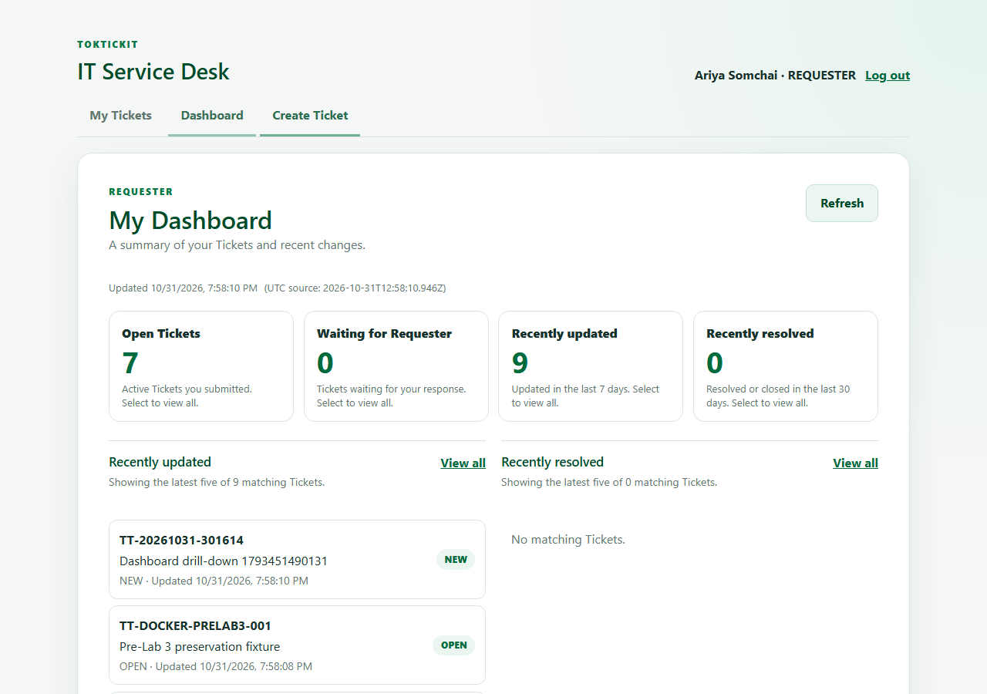
View full image
Automated test: e2e/lab-04/dashboards.spec.ts:6

Requester dashboard metrics and recent Tickets — Tablet 900×900
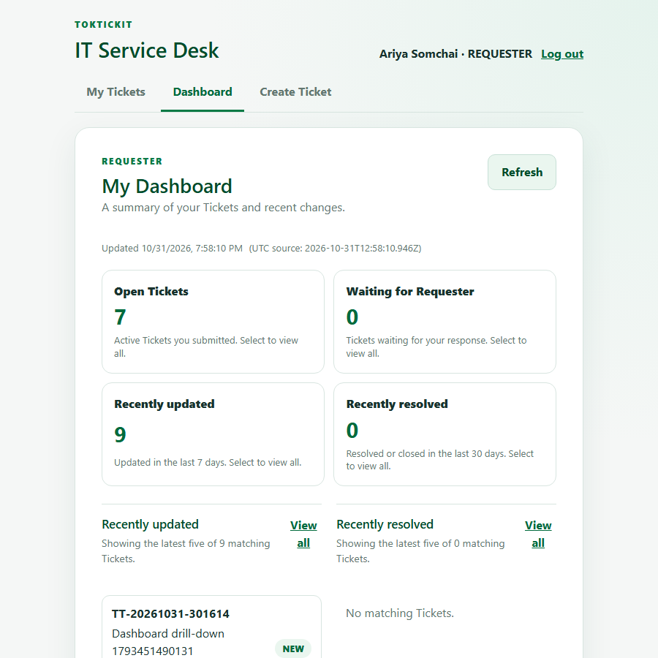
View full image
Automated test: e2e/lab-04/dashboards.spec.ts:6

Requester dashboard metrics and recent Tickets — Mobile 390×844
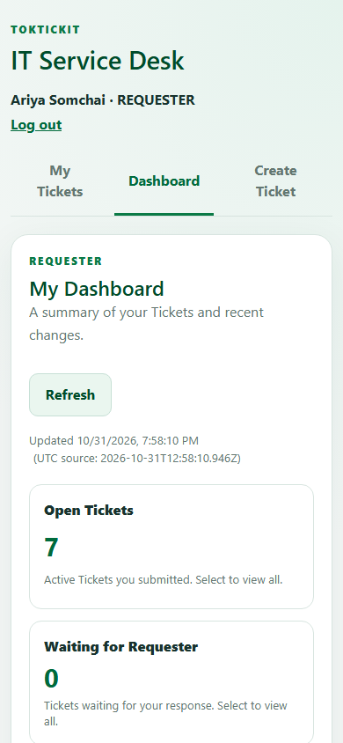
View full image
Automated test: e2e/lab-04/dashboards.spec.ts:6

Staff dashboard metrics and active Ticket counts
Source captures from the final PR6 Playwright run. Open the full screenshot index

Staff dashboard metrics and active Ticket counts — Desktop 1280×900
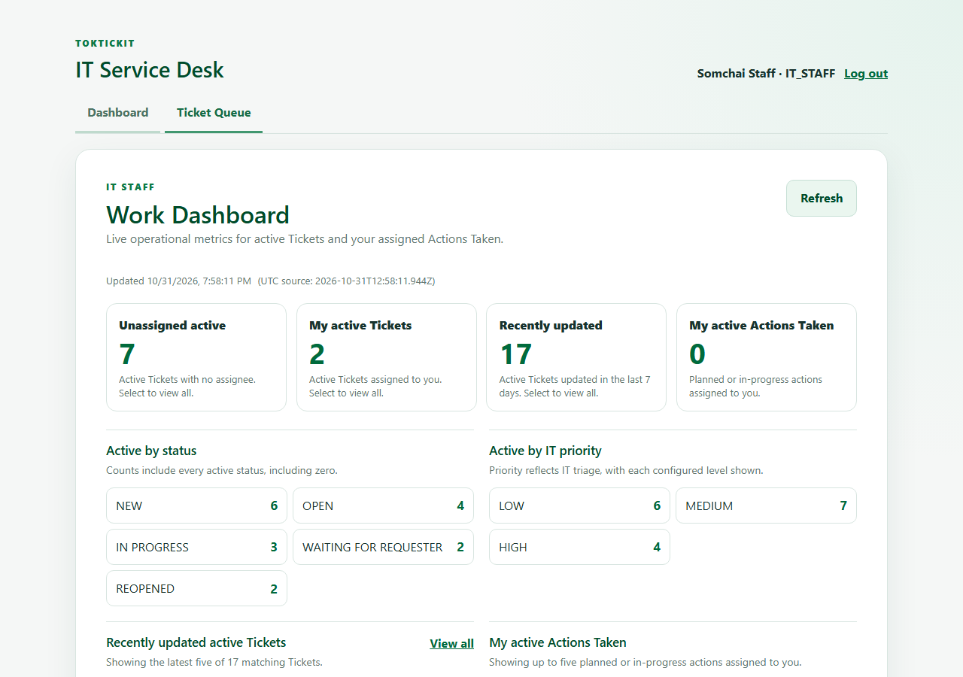
View full image
Automated test: e2e/lab-04/dashboards.spec.ts:6

Staff dashboard metrics and active Ticket counts — Tablet 900×900
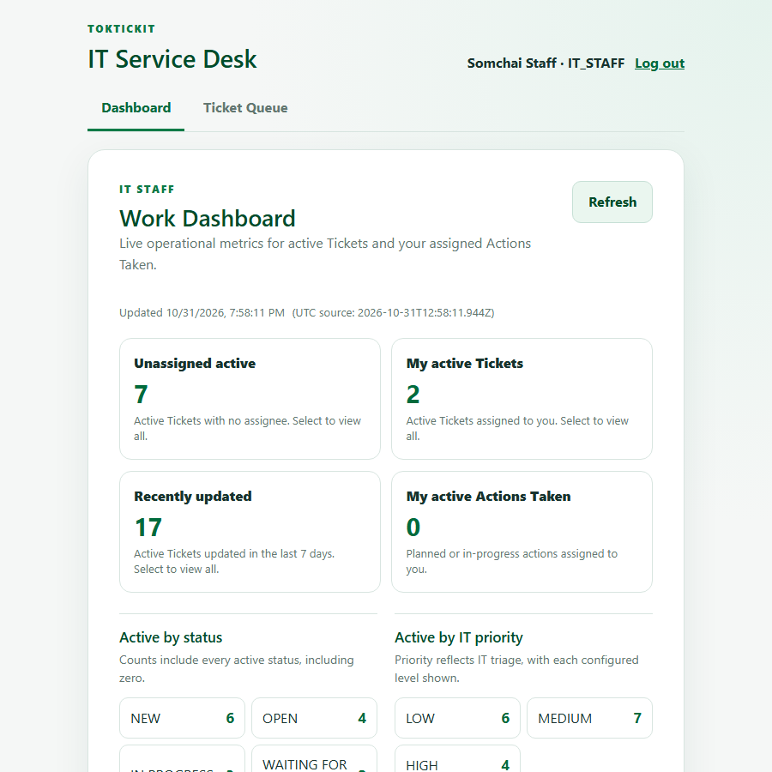
View full image
Automated test: e2e/lab-04/dashboards.spec.ts:6

Staff dashboard metrics and active Ticket counts — Mobile 390×844
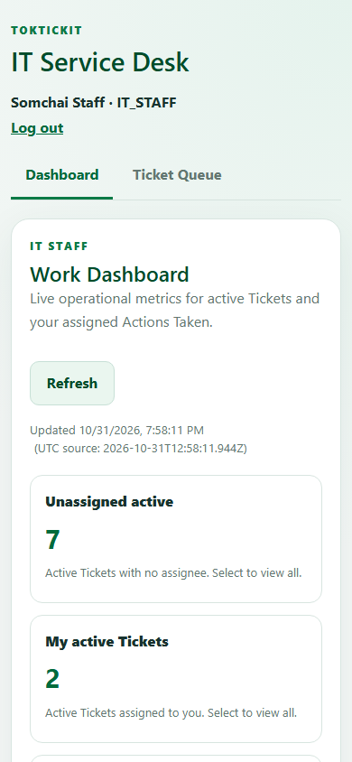
View full image
Automated test: e2e/lab-04/dashboards.spec.ts:6

Staff action entry form
Source captures from the final PR6 Playwright run. Open the full screenshot index

Staff action entry form — Desktop 1280×900
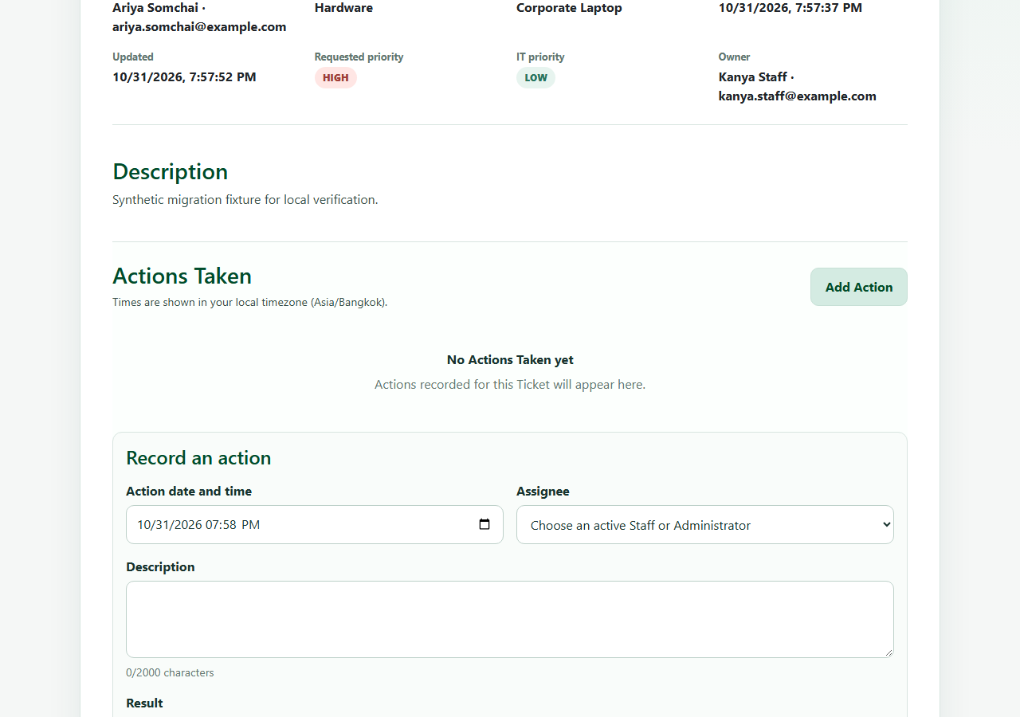
View full image
Automated test: client/tests/lab-04/ActionsTaken.test.tsx:105

Staff action entry form — Tablet 900×900
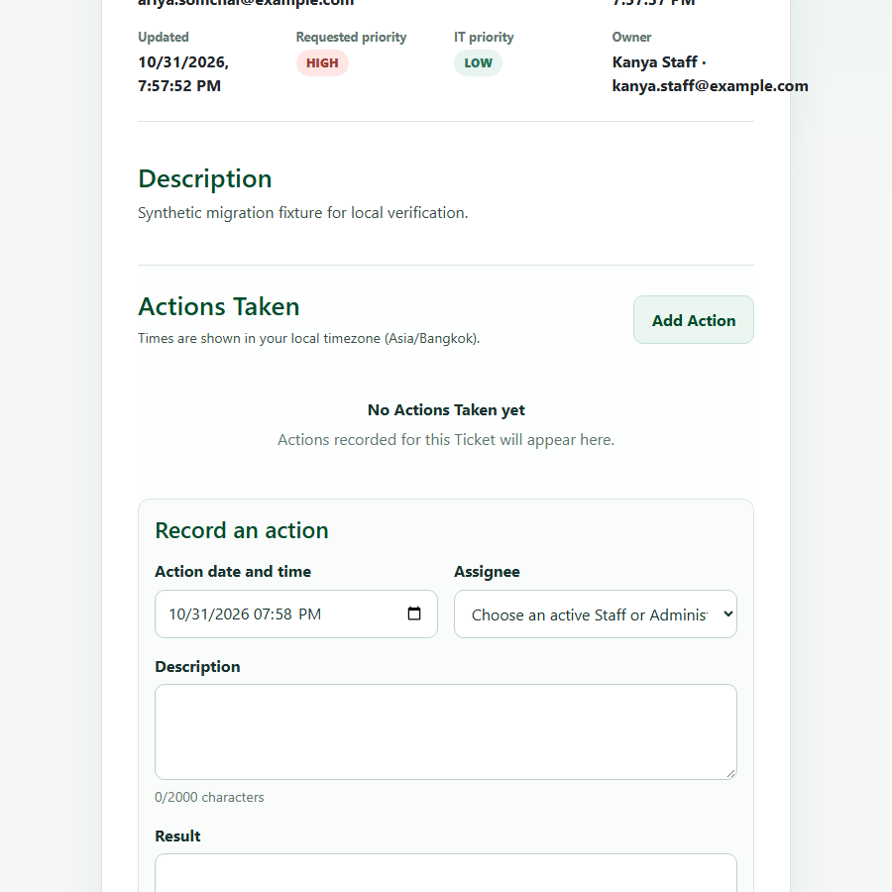
View full image
Automated test: client/tests/lab-04/ActionsTaken.test.tsx:105

Staff action entry form — Mobile 390×844
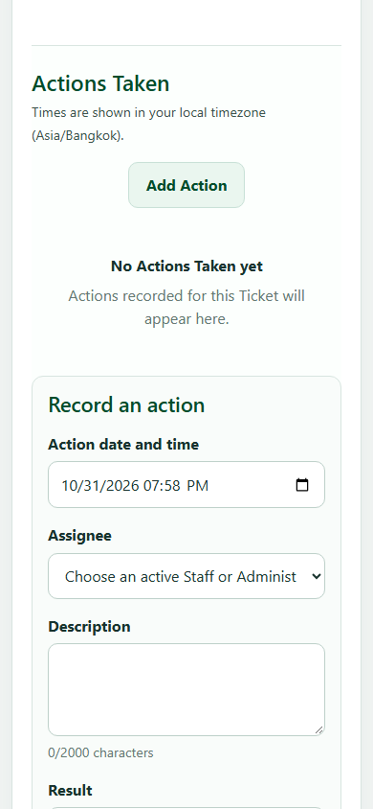
View full image
Automated test: client/tests/lab-04/ActionsTaken.test.tsx:105

Staff history with multiple recorded actions
Source captures from the final PR6 Playwright run. Open the full screenshot index

Staff history with multiple recorded actions — Desktop 1280×900
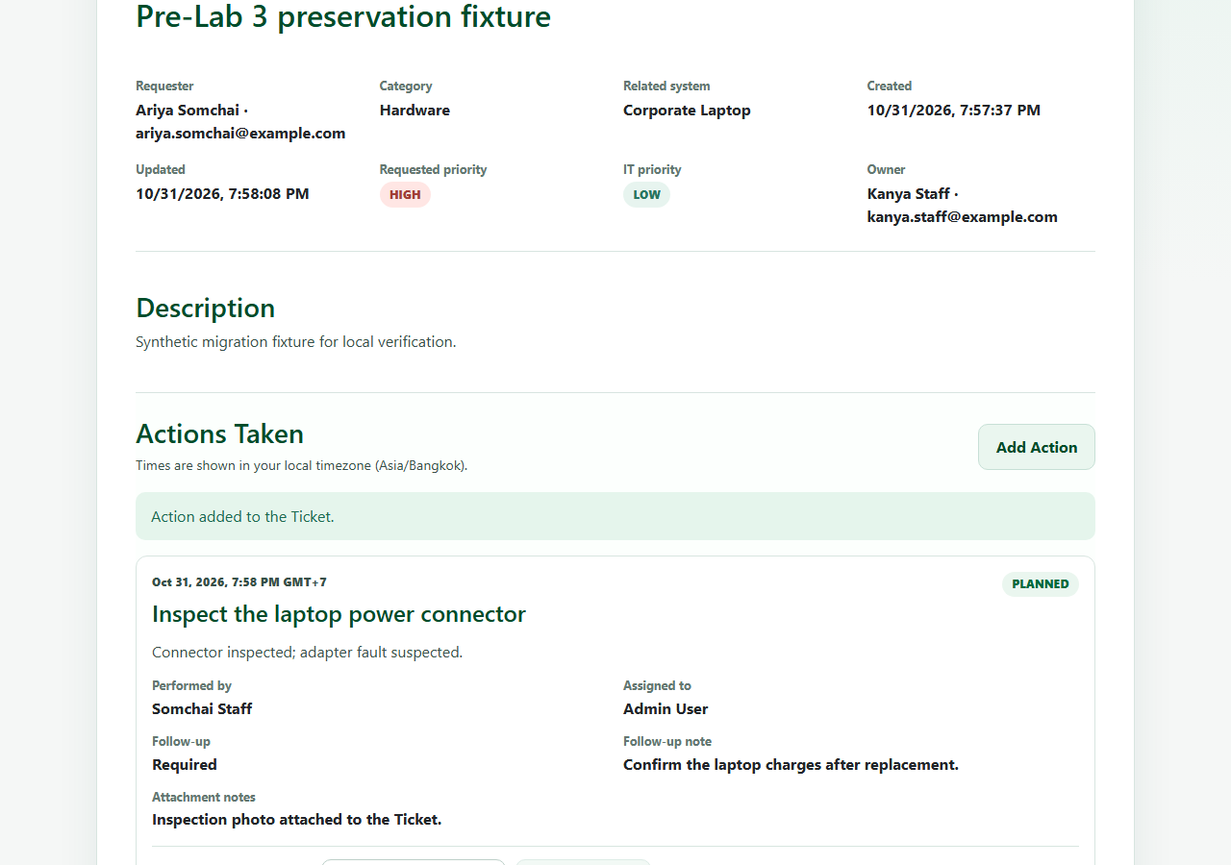
View full image
Automated test: e2e/lab-04/actions-taken-flow.spec.ts:27

Staff history with multiple recorded actions — Tablet 900×900
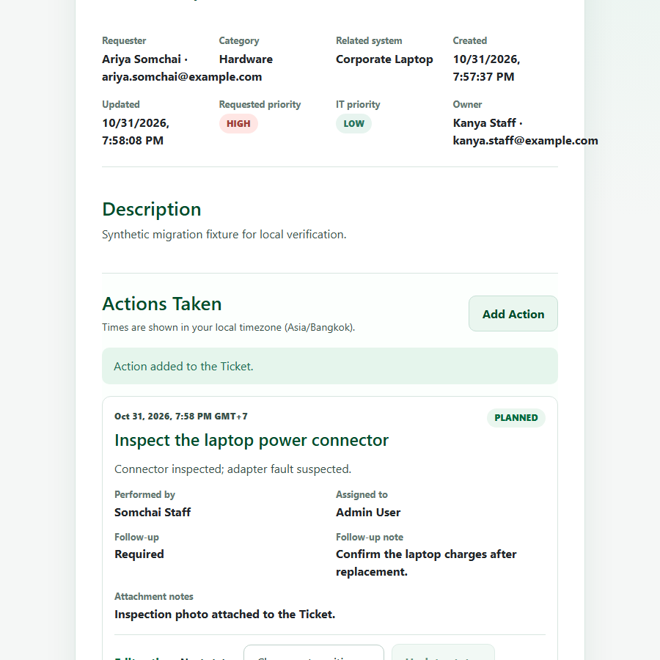
View full image
Automated test: e2e/lab-04/actions-taken-flow.spec.ts:27

Staff history with multiple recorded actions — Mobile 390×844
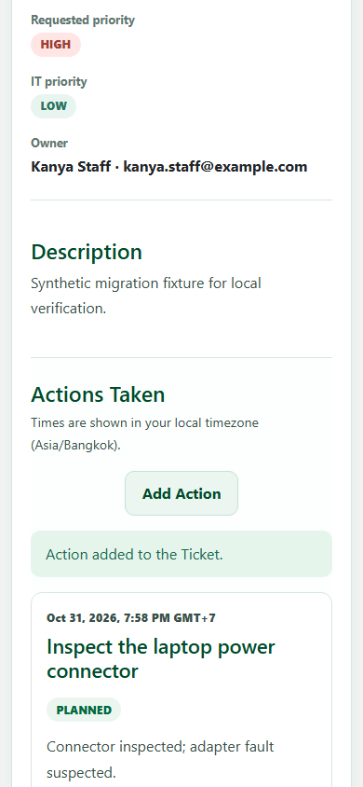
View full image
Automated test: e2e/lab-04/actions-taken-flow.spec.ts:27

Requester read-only Actions Taken history
Source captures from the final PR6 Playwright run. Open the full screenshot index

Requester read-only Actions Taken history — Desktop 1280×900
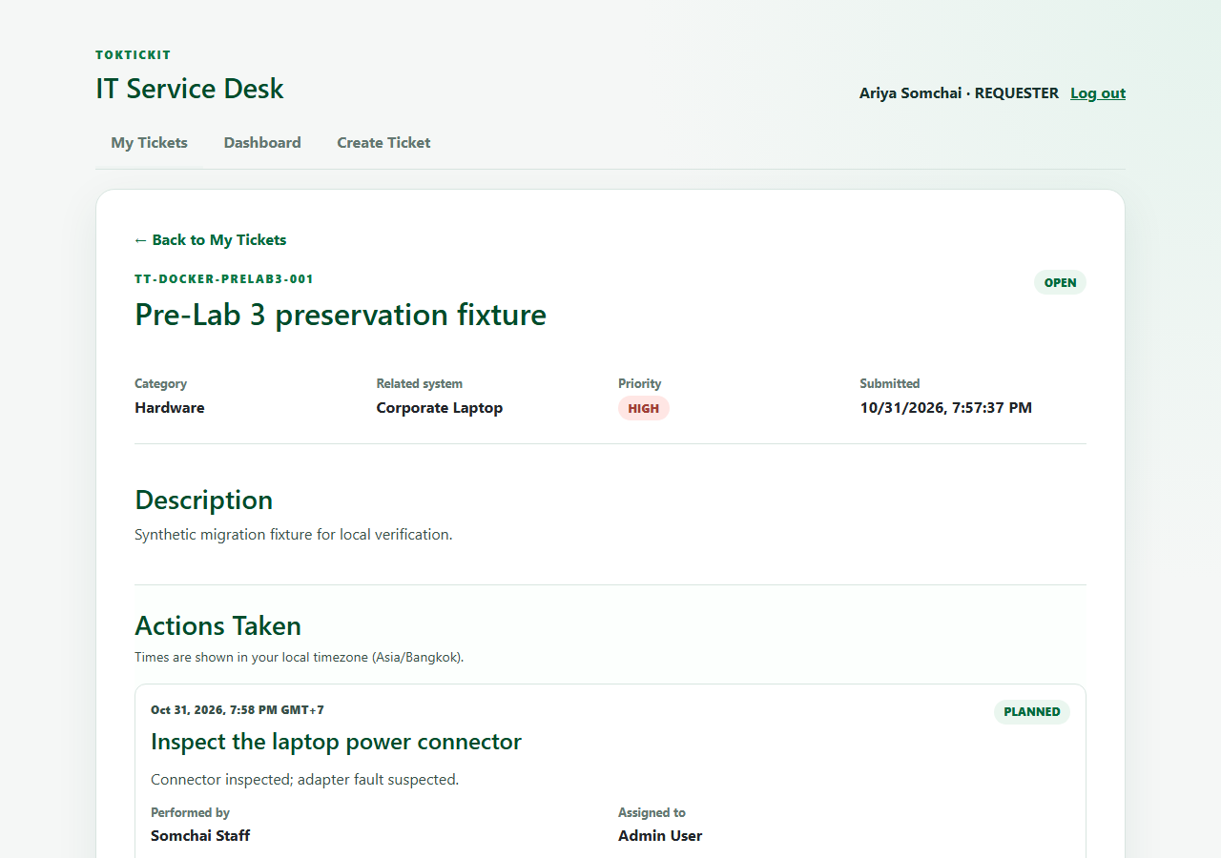
View full image
Automated test: client/tests/lab-04/ActionsTaken.test.tsx:43

Requester read-only Actions Taken history — Tablet 900×900
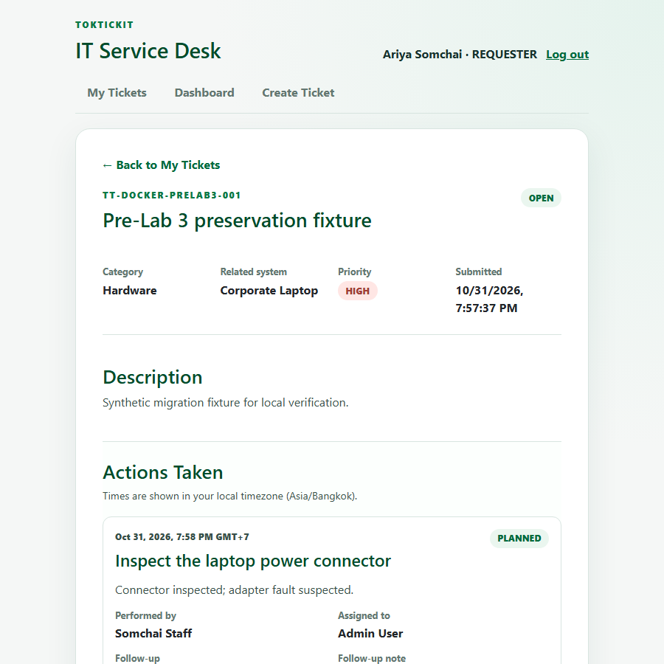
View full image
Automated test: client/tests/lab-04/ActionsTaken.test.tsx:43

Requester read-only Actions Taken history — Mobile 390×844
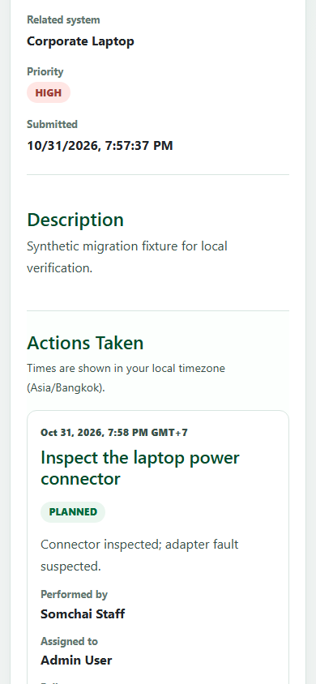
View full image
Automated test: client/tests/lab-04/ActionsTaken.test.tsx:43

Resolution blocked before completed work
Source captures from the final PR6 Playwright run. Open the full screenshot index

Resolution blocked before a completed action — Desktop 1280×900
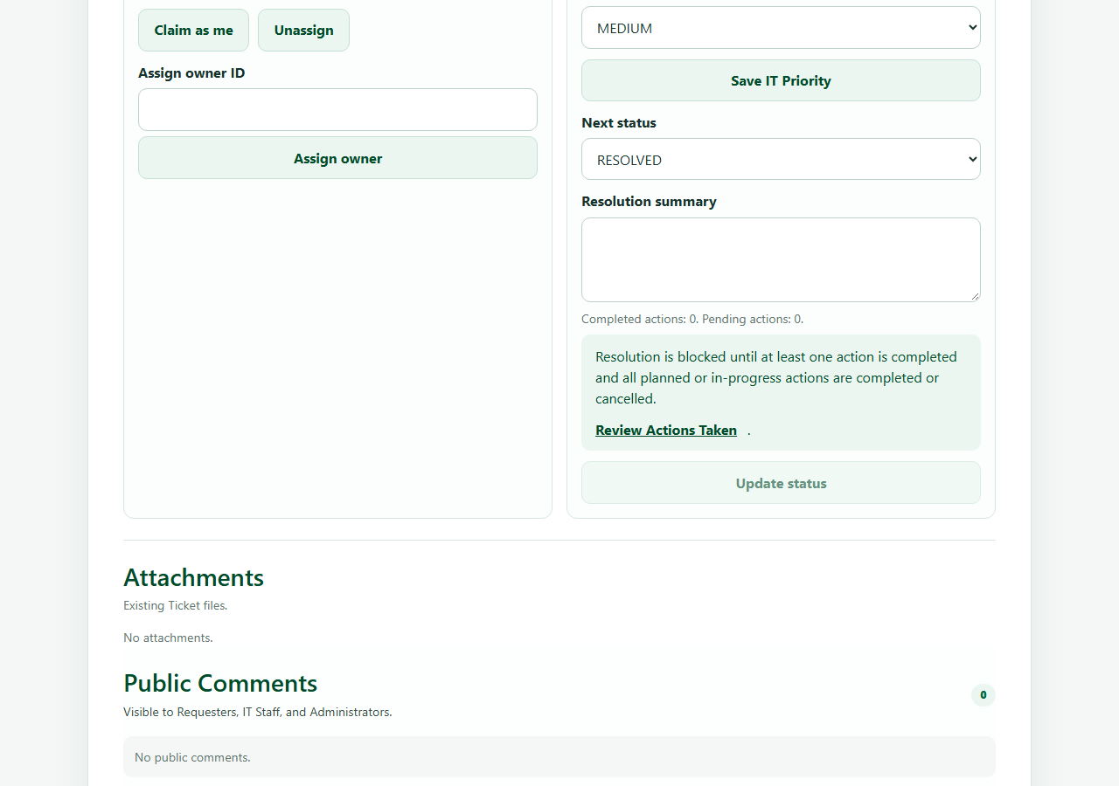
View full image
Automated test: client/tests/lab-04/TicketWorkflow.test.tsx:55

Resolution blocked before a completed action — Tablet 900×900
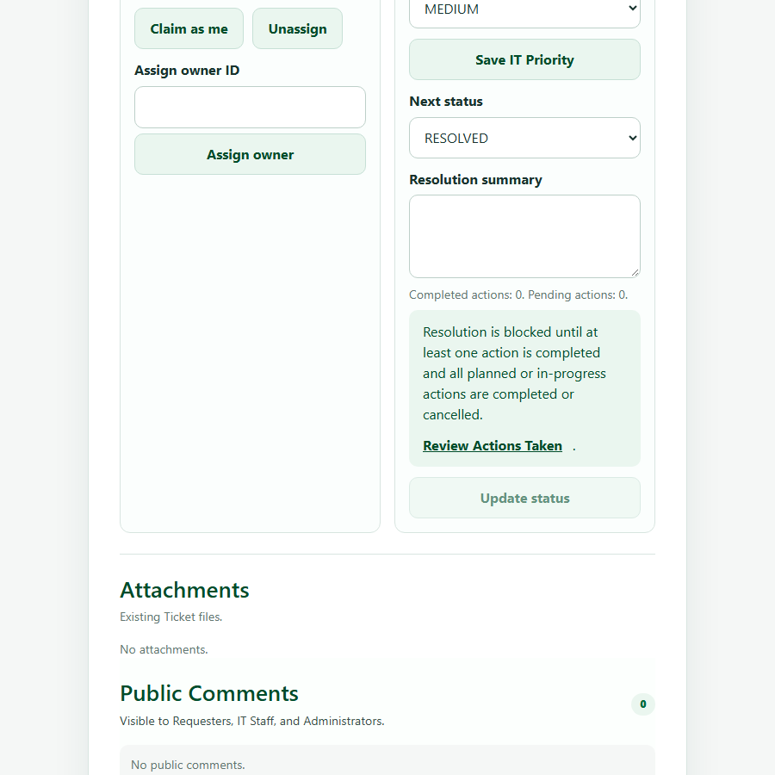
View full image
Automated test: client/tests/lab-04/TicketWorkflow.test.tsx:55

Resolution blocked before a completed action — Mobile 390×844
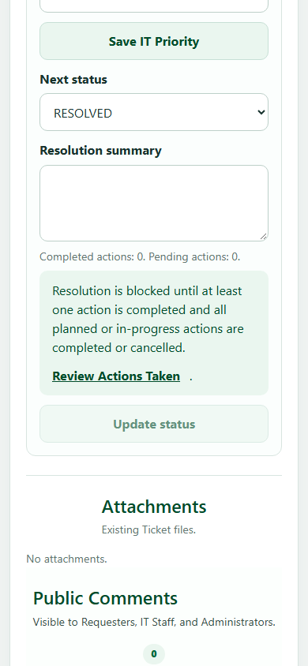
View full image
Automated test: client/tests/lab-04/TicketWorkflow.test.tsx:55

Staff view after reopening a Ticket
Source captures from the final PR6 Playwright run. Open the full screenshot index

Staff view after reopening a Ticket — Desktop 1280×900
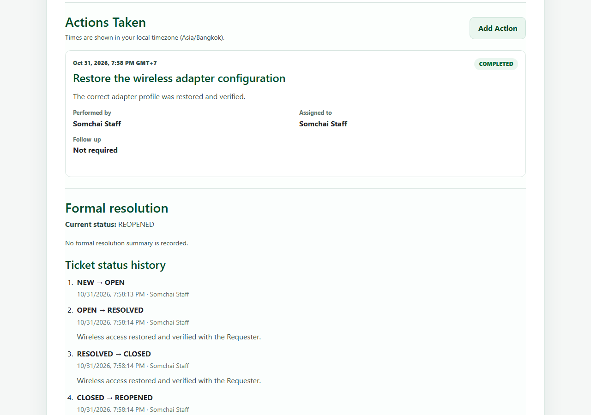
View full image
Automated test: e2e/lab-04/ticket-resolution.spec.ts:6

Staff view after reopening a Ticket — Tablet 900×900
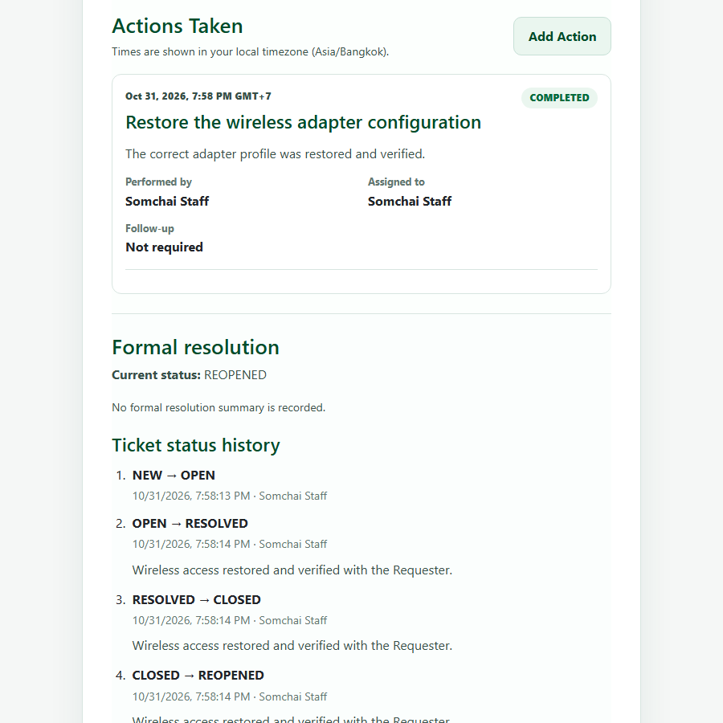
View full image
Automated test: e2e/lab-04/ticket-resolution.spec.ts:6

Staff view after reopening a Ticket — Mobile 390×844
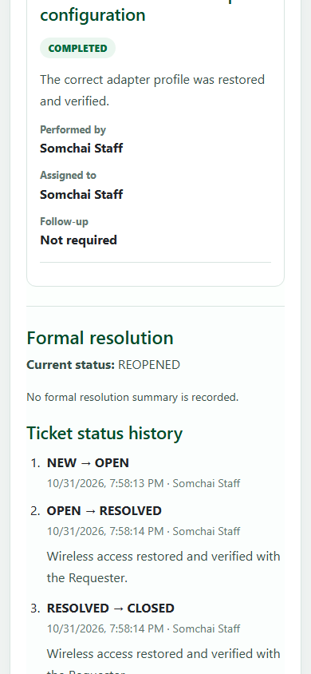
View full image
Automated test: e2e/lab-04/ticket-resolution.spec.ts:6

Requester resolution and Ticket history
Source captures from the final PR6 Playwright run. Open the full screenshot index

Requester resolution and Ticket history — Desktop 1280×900
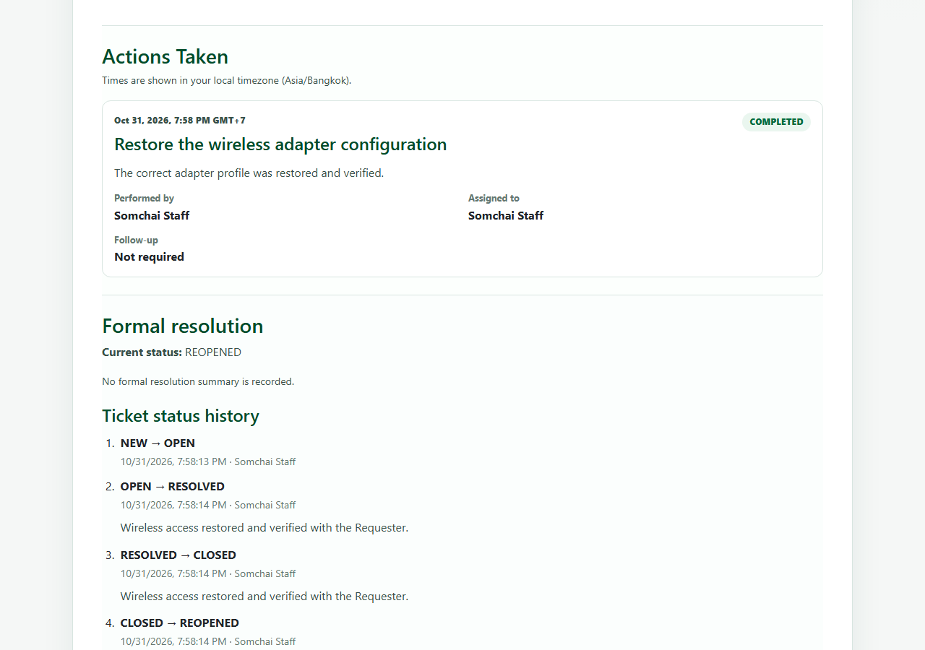
View full image
Automated test: e2e/lab-04/ticket-resolution.spec.ts:6

Requester resolution and Ticket history — Tablet 900×900
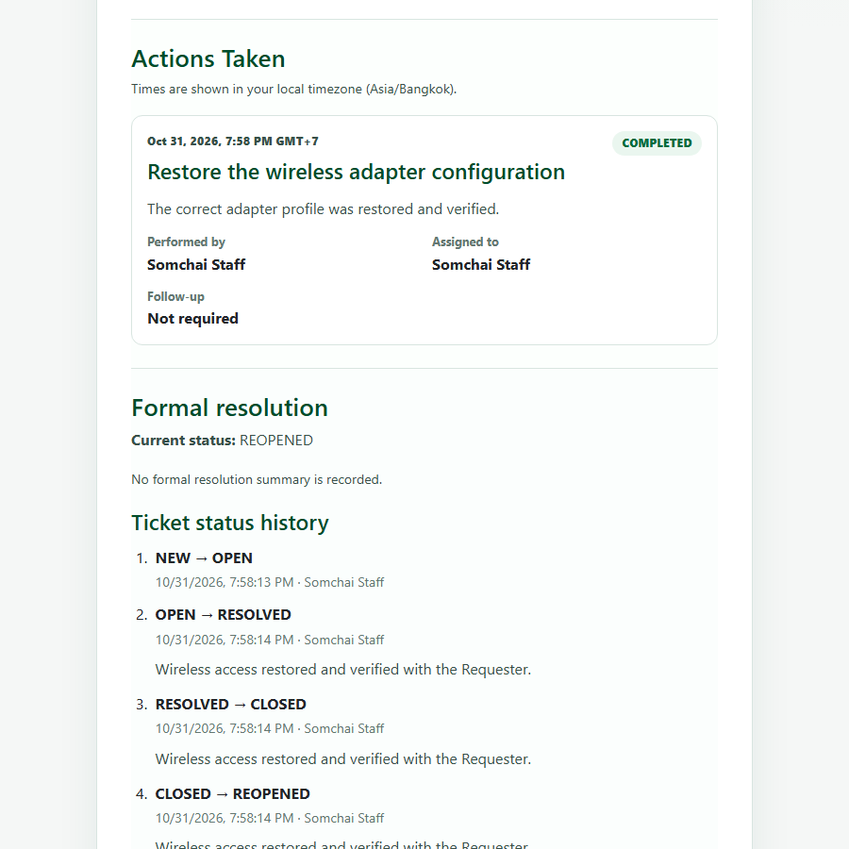
View full image
Automated test: e2e/lab-04/ticket-resolution.spec.ts:6

Requester resolution and Ticket history — Mobile 390×844
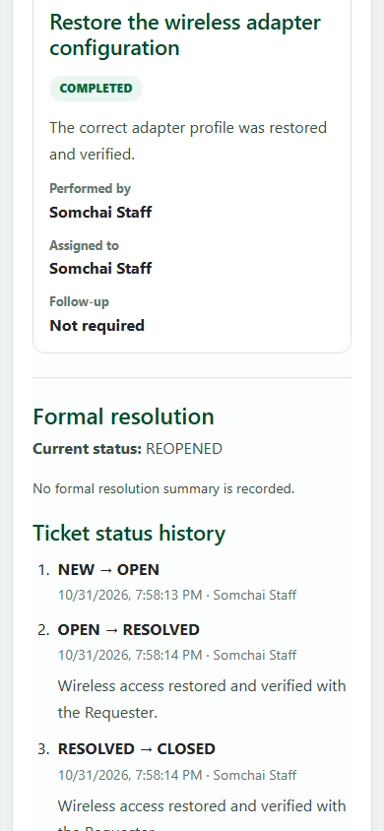
View full image
Automated test: e2e/lab-04/ticket-resolution.spec.ts:6

