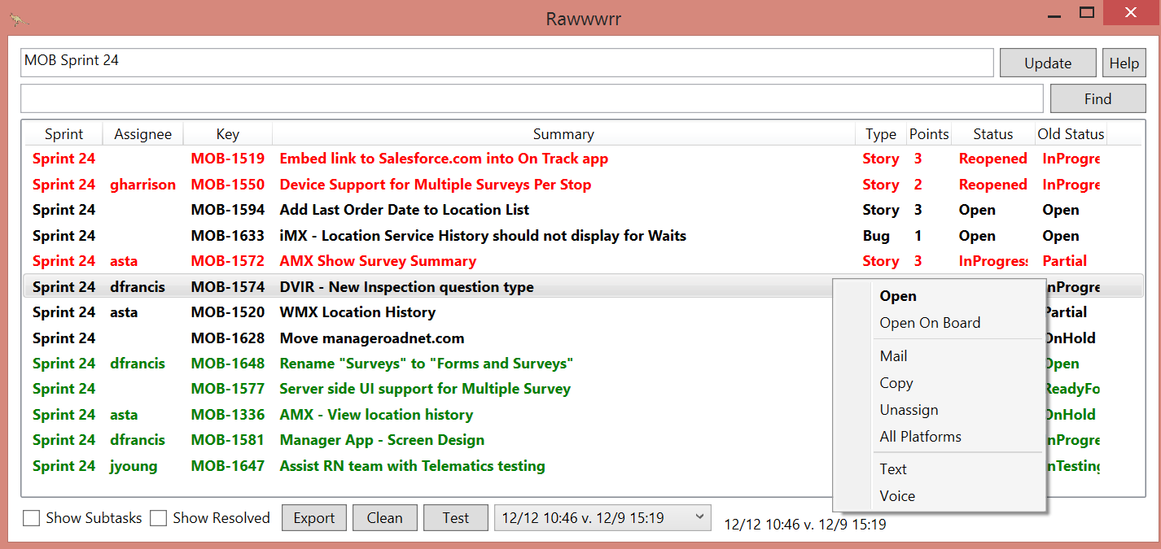

* Update edit box (top)
  + Enter the name of the project and sprint, not case-sensitive, trimmed
  + Project name is in config
  + Sticky
  + Supports comma-delimited- “MOB Sprint 22, MOB Sprint 23, RP Sprint 17”
  + Supports range- “MOB Sprint 19-25” (longer ranges can take a while)
  + Will show items from a sprint even if it was moved from the sprint.
* Update button
  + Auto updates when opened if “last” is older than 5 minutes, otherwise just shows last
* Help button
  + This doc
* Find edit box
  + Filters as you type of listed items
  + Case insensitive search of key(“MOB-127”), summary, real status(not calculated) and Assignee
  + Shows all subtasks with tasks that meet criteria
* Find Button
  + Enter a key on find box and click find to do search on Jira server
* Grid
  + Can sort by any column
  + Status
    - For a Task, “calculated status” is based on the statuses of the subtasks
      * In Progress means at least one of the subtasks is In Progress.
      * Partial means at least one of the subtasks is Resolved.
      * The best way to understand Calced Status is to show subtasks
  + Old Status
    - The calculated status from the “Compare To” date, only shown for single sprint
  + Coloring
    - Green means status progressed, red means regressed, black stayed the same
  + Double-click on item does Open(see below)
* Context menu
  + Open and Open On Board
    - Open in Jira with web browser
  + Mail
    - mailto: of current item
    - Also does “Copy”
  + Copy
    - Copy to clipboard with link
  + Unassign
    - Assign task or subtask to “Unassigned” resource
  + All Platforms
    - Add subtasks for AMX, WMX, and iMX
    - could be easily modified to do any type of tasks or subtasks
  + Text and Voice
    - Send link to selected item as text or voice to a phone, just for testing
* Show Subtasks
  + Expand subtasks
  + Can’t sort in this mode
* Show Resolved
  + If off, hides if both the Status and Old Status are Resolved or Done
* Export
  + Save current view as a CSV file and opens it
* Clean
  + Clears out old stored files but saves first and last from each day for each sprint
* Test
  + Homer
* Comp To
  + Date to compare data to for “Old Status”. Defaults to yesterday (or most recent run before today).
* Status
  + Bottom right general status, usually shows the timestamp of the current and old data

## Requests

UI ability to set project

Change data storage folder