To run application on Tomcat

Install db schema by running Sql>source razor.sql. Unzip and copy razor_for_tomcat to tomcat’s webapps and goto http://localhost:8080/razor

FOR API

Unzip Booking_source, import to Eclipse. Start with

C:\BOOKINGS\Booking\src\net\cbtltd\rest\flipkey\FlipkeyRest.java

Package C:\BOOKINGS\Booking\src\net\cbtltd\rest\flipkey has junit tests Also C:\BOOKINGS\Booking\build.xml has FlipKey launcher task

GWT Run Project in devmode

* Change name to Razor in .project
* Copy razor.launch to the directory where .project is at
* Copy Hosts.properties to src\net\cbtltd\client\resource

GWT project has a launch file in project’s working directory, used to store project specific launch configurations. Normally, when you right click on a resource and select "Run As..." eclipse will store the settings you enter in a location that is specific to your machine. We need not to configure it manually

To run razor project in dev mode

1. Right click on Razor.launch file. Click on Run Configurations.

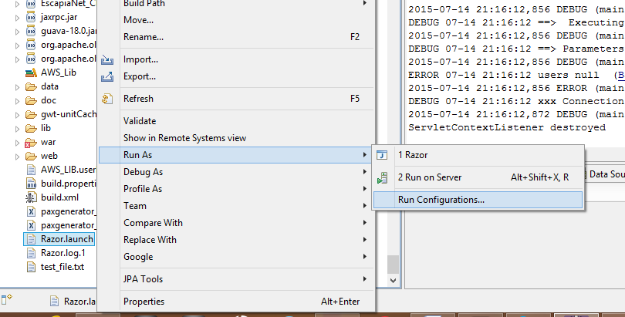

1. It will open Run Configuration window. Click on Razor under Java Application. Click on arguments tab. Set VM arguments **-Xmx256M**

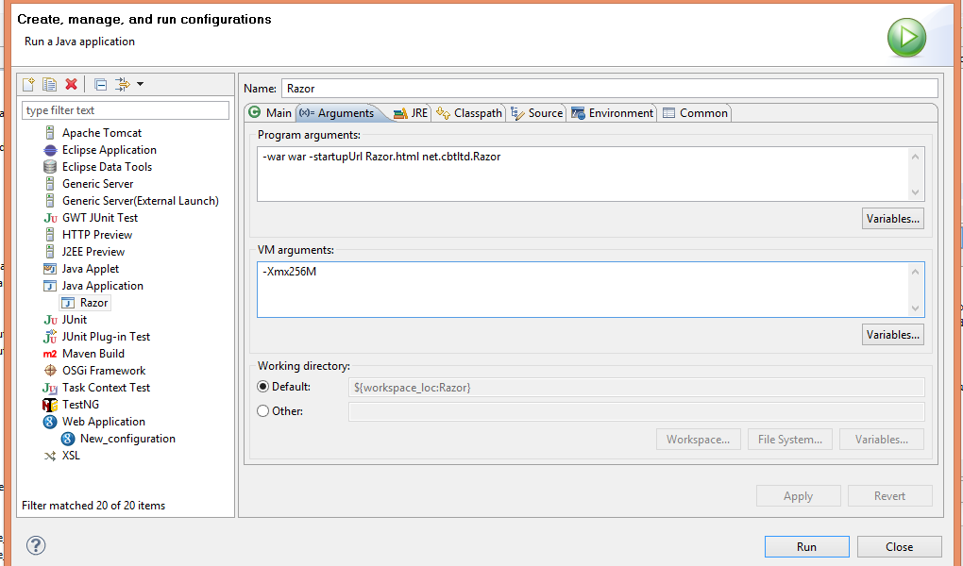

1. Click on Run button. It will open gwt development mode. Click on Copy to Clipboard. And copy the url http://127.0.0.1:8888/Razor.html?gwt.codesvr=127.0.0.1:9997 and paste it in browser and press enter. If you want to test in default browser, you can directly click on ‘Launch Default Browser’

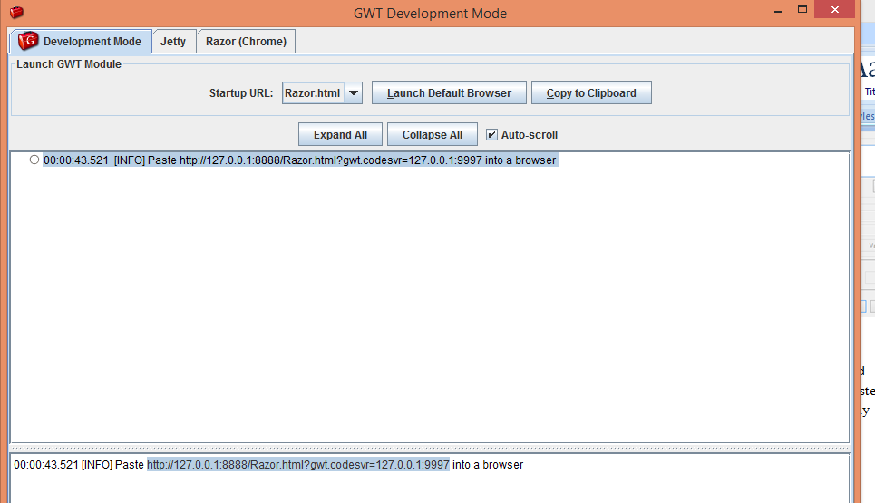

1. If you are using first time browser for running GWT project in devmode then it will first ask you to download GWT developer plugin.

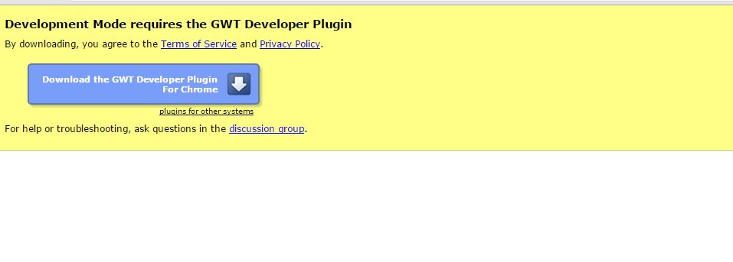

1. Once plugin downloaded refresh the GWT application in browser.

Note that only once you have to set properties from Run configuration. Next time you can launch application directly on Right click Run as->Razor