**Prerequisites**

* Visual Studio 2019 (.Net Core 3.1)
* NODE JS

**Running CakesApi**

1. Open the solution file in visual studio
2. Make sure 'CakesApi' application is running on ‘https://localhost:44355/’
3. Change the connection string property as per your requirements

"ConnectionStrings": {

"DefaultConnection": "Server=DESKTOP- 7R4VH3B;Database=CakesDb;Trusted_Connection=True;MultipleActiveResultSets=true"

}

1. Open package manage console and run the command ‘Update-Database’. This will create the Database on your machine. Now Run the API project and you will see Swagger Page loaded

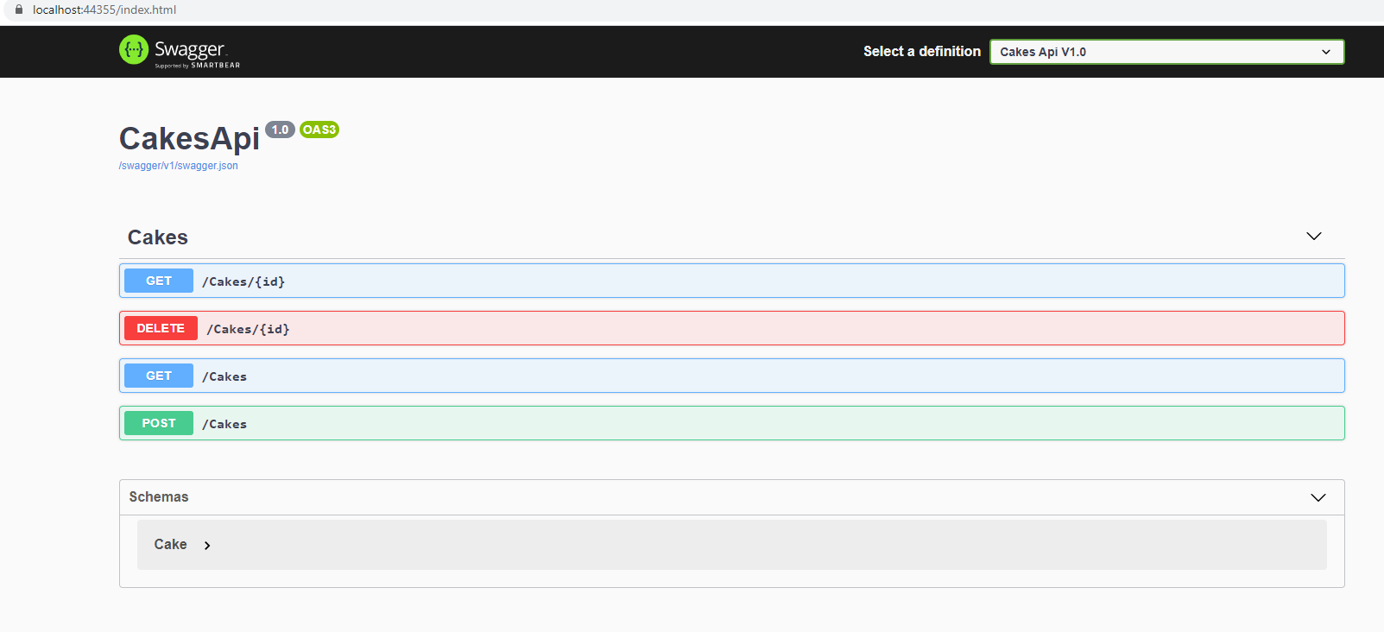

**Running CakesApp (UI)**

1. Open Command Line and browse to the root directory of the project where “package.json” file is located.
2. Execute this command ‘npm install’
3. Once package installation is complete then run the command ‘ng serve’
4. Open the url ‘http://localhost:4200/’ in the browser. Change port 4200 to whichever port your application is running on.