

|  |
| --- |
| PENNSTATE University  Software ENGINEERING  Functional Specification Document  <book it> |

**DOCUMENT VERSION <1.1>**

**<12/09/2019>**

**AUTHORS**

|  |  |  |
| --- | --- | --- |
| **Name** | **Role** | **Department** |
| Ahmeeya | Graduate Student | Software Engineering |
| Brandon | Graduate Student | Software Engineering |
| Eric | Graduate Student | Software Engineering |
| Standley | Graduate Student | Software Engineering |
| Sukanti Madala | Graduate Student | Software Engineering |

**DOCUMENT HISTORY**

|  |  |  |  |
| --- | --- | --- | --- |
| **Date** | **Version** | **Document Revision Description** | **Document Author** |
| 10/07/2019 | 1.0 | Initial Draft with Initial Scope | Sukanti Madala |
| 12/07/2019 | 1.1 | Final Draft with Revised scope | Sukanti Madala |
|  |  |  |  |
|  |  |  |  |
|  |  |  |  |

**Table of Contents**

1. Introduction 5

1.1 Purpose of the document 5

1.2 Project Scope 5

1.3 Scope of the document 5

1.4 Business Context 5

1.5 User Characteristics 5

1.6 General constraints 6

2. Functional Specifications 6

2.1 Modules, Descriptions, Benefits, Outputs and Assumptions 6

2.1.1 Client SignUp Manual 6

2.1.2 New Account Verification 6

2.1.3 User Login 6

2.1.4 User Account Updates 7

2.1.5 Select Service Provider 7

2.1.6 Create An Appointment 7

2.1.7 Client Update Appointment 7

2.1.8 Client Cancel Appointment 8

2.1.9 Client Special Request for Appointment 8

2.1.10 Client Update Appointment History Review 8

2.1.11 Client Update Appointment Status 9

2.1.12 Service Provider Signup 9

3. Interface Specifications 10

3.1 User Interfaces 10

3.1.1 Login Screen 10

3.1.2 User Preferences Screen 11

3.1.3 Create Appointment and Signup Screen 12

3.1.4 Account Dashboard 14

3.1.5 View More Appointments 15

3.1.6 View Appointment details 16

3.1.7 Edit Appointments 17

3.1.8 Profile 18

3.2.0 Hardware Interfaces 18

3.3.0 Communication Interfaces 18

3.4.0 Softwatre Interfaces 18

4. Performance Requirements 18

4.0.0 System 18

4.1.0 Response Time 19

4.2.0 WorkLoad 19

4.3.0 Scalability 19

5. Non-Functional Requirements 19

5.0.0 Security 19

5.1.0 Maintainability 19

5.2.0 Portability 19

5.3.0 Extensibility 19

5.4.0 Reusability 19

5.5.0 Compatibility 19

# Introduction

Book IT is an all-in-one mobile friendly online booking solution with features that make managing a Salon easier, including: online booking, schedule management, marketing, payments, and financial reporting.

## Purpose of the document

The Functional Specification Document is a document that provides detailed information on *how* the system solution will function and the requested behavior. This document is created based on the high-level requirements identified in the Business Requirements Document and provides traceability on the functional specifications back to the business requirements.

## Project Scope

The project scope that addresses the business need or problem of the BOOKIT application is intended to provide its users with a way to book and track their Salon appointments using their mobile devices. The application will maintain a list of appointments which can be viewed with all service provider’s and consumer’s details. The user can create, update and delete profiles; setup, modify and cancel appointments based on the user needs. Additionally, the app can notify the users with appropriate email notifications based on different scenario.

## Scope of the document

Book IT requirement effort intends to define the requirements for the BOOKIT mobile application. The Team will spend the period between Aug12, 2019 to Dec09, 2019 identifying and documenting functional, interface, performance and other requirements for the BOOKIT software system.

## 1.4 Business Context

The development of this Software system is sponsored by Software Engineering program in the department of Software Engineering at Penn State, Great Valley University. The Software Engineering major is intended to produce designers and developers for robust complex software systems. The program introduces students to the concepts and techniques required to build large Software systems, and provide opportunities to obtain Practical experience applying those techniques on an actual development effort.

## 1.5 User Characteristics

The BOOKIT mobile application is intended to be used by users having some experience of using mobile operating systems. A basis knowledge of the IOS and Android operating system on a Mobile device as well as the ability to authenticate corresponding web services will be sufficient to use the application effectively.

## 1.6 General Constraints

The application must run on the mobile operating system. A User’s Mobile device must provide network connectivity (both hardware and Software) in order for the application for fully function. The system must use data and authentication system which are already in place.

# Functional Specifications

## 2.1 Modules, Descriptions, Benefits, Outputs and Assumptions

### 2.1.1 Client Sign Up – Manual

• Description: How a user will sign up manually

• Actors: Client and System

• Benefits: Allows businesses to begin allowing customers to book with them on our system.

• Frequency: Anytime a new user launches the mobile application

• Triggers: Users selects sign up button

• Assumptions: The user has not already created an account with the system and would like to create an account for the first time.

### 2.1.2 New Account Verification

• Description: Verifies a user's identity before allowing them to use the system by sending a code to their email.

• Actors: Client and System

• Benefits: Allows Book It to verify that the account created belongs to the user email used

• Frequency: Anytime a new user submits their information to create an account

• Triggers: Users selects submit account button

• Assumptions: The user account is not already verified

### 2.1.3 User Login

• Description: How a user will log in manually

• Actors: Client and System

• Benefits: Allows businesses to begin allowing customers to book with them on our system.

• Frequency: Anytime a user selects login

• Triggers: User selects the login button

• Assumptions: The user is not already signed in and has an account created

### 2.1.4 User Account updates

• Description: How a user can update their account information

• Actors: Client and System

• Benefits: Allow the business to easily keep track of user updates

• Frequency: Anytime a user decided to update their information

• Triggers: User selects account settings

• Assumptions: The user is signed in to their account

### 2.1.5 Select Service Provider

• Description: Allows user to connect with different service providers

• Actors: Client and System

• Benefits: Allows Book It to begin connecting service providers and clients

• Frequency: Anytime a user decides to book an appointment

• Triggers: User selects book appointment

• Assumptions: The user is signed into their account

### 2.1.6 Create an Appointment

• Description: Allows client to create an appointment

• Actors: Client, Service Provider, and Book It

• Benefits: Allows Clients to book appointments with Service Provider

• Frequency: Anytime a user selects a service provider to book with

• Triggers: User selects service provider

• Assumptions: The user has selected a service provider to do their services

### 2.1.7 Client Update Appointment

• Description: Allows the client to change appointment details including time, date, and stylist at a shop.

• Actors: Client, Service Provider, and Book It

• Benefits: Allows our system to easily keep track of appointment changes and to free up space in the shops calendar.

• Frequency: Anytime a client needs to make changes to an already existing appointment

• Triggers: User selects edit appointment

• Assumptions: The client has an already existing appointment in the system that is in the future.

### 2.1.8 Client Cancel Appointment

• Description: Allows the client to cancel an already existing appointment

• Actors: Client, Service Provider, and Book It

• Benefits: Allows our system to easily keep track of appointment changes and to free up space in the shops calendar.

• Frequency: Anytime a client needs to cancel an appointment before it has already started.

• Triggers: User selects cancel appointment

• Assumptions: The client has an already existing appointment in the system that has not started yet.

### 2.1.9 Client Special Request for Appointment

• Description: Allows the client to add additional details for their appointment

• Actors: Client, Service Provider, and Book It

• Benefits: Allows the clients and service provider to communicate about appointment details.

• Frequency: Anytime a client books a new appointment.

• Triggers: User select books appointment

• Assumptions: The client has filled out their required appointment information and wants to add additional details about the appointment.

### 2.1.10 Client Appointment History Review

• Description: Allows the client to view old appointment details

• Actors: Client and Book It

• Benefits: Allows the clients to view previous appointments and to easily reschedule the same appointment

• Frequency: Anytime a client selects view history

• Triggers: User selects view history

• Assumptions: The client has previously made appointments using Book It

### 2.1.11 Client Update Appointment Status

• Description: Allows the client to notify the stylist if they are running late or on time the day of the appointment

• Actors: Client, Service Provider, Book It

• Benefits: Allows the client and service provider to update each other on the day of the appointment

• Frequency: Anytime it's the day of the clients scheduled appointment

• Triggers: The client has a scheduled appointment on the present day

• Assumptions: The client has previously made appointments using Book It

### 2.1.12 Service Provider Sign Up

• Description: Allows the Service provider to create an account in order to allow customers to book appointment

• Actors: Service Provider, Book It

• Benefits: Allows the client and service provider to update each other on the day of the appointment

• Frequency: Anytime the Service provider clicks on Sign-up

• Triggers: Manual account creation with Input field Validation for email formats, phone numbers, Business name, EIN, email, address, logo image

• Assumptions: The Address should be a valid US address with zip code

# Interface Specifications

## 3.1 User Interfaces

### 3.1.1 Login Screen

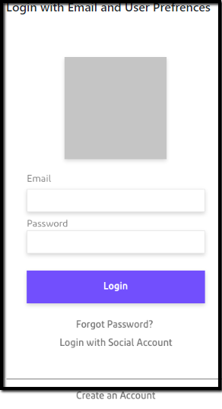

### User Preferences Screen

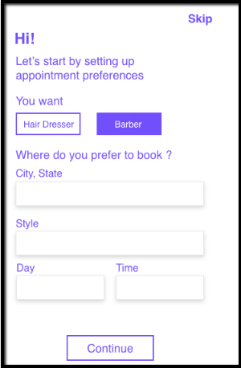

### Create Appointment & Signup Screen

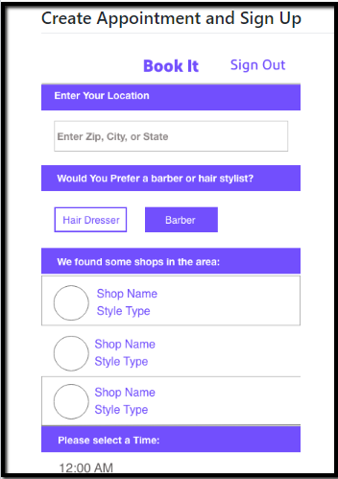

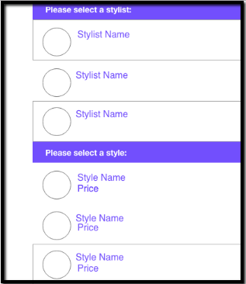

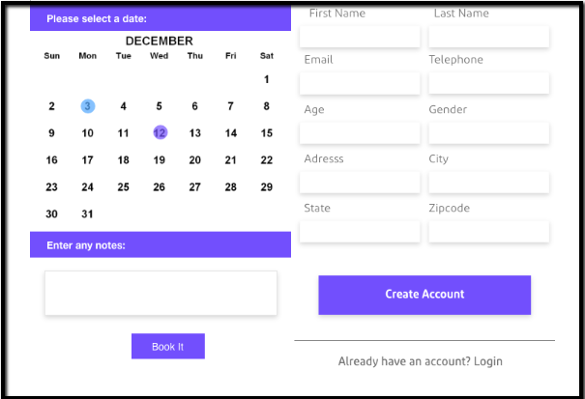

### Account Dashboard

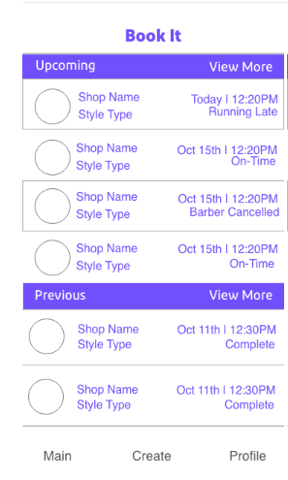

### View more Appointments

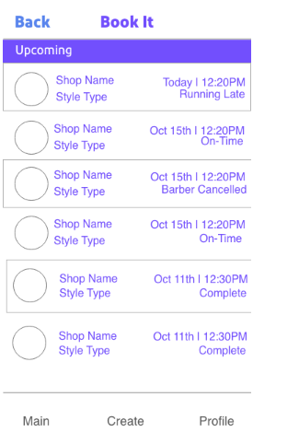

### View Appointments Details

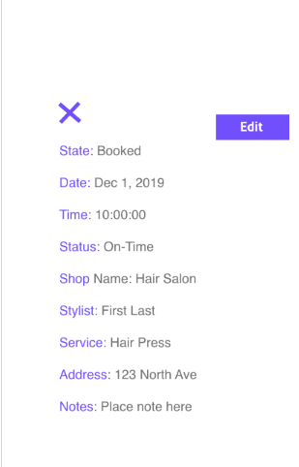

### Edit Appointments

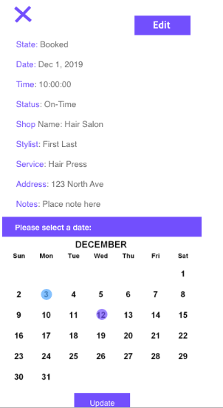

### Profile

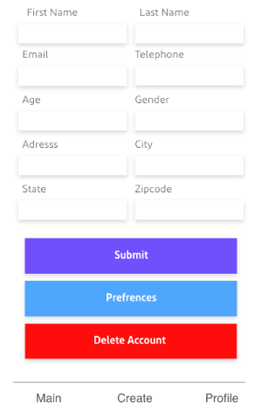

### Hardware Interfaces

The App is designed for the Mobile phone and Market.

### Communication Interfaces

The App will utilize the Networking hardware of the user’s device through network communications services provided by the Mobile operating system. Network communication capability will be used to connect to remote databases or web services for authentication and importing the user’s information.

### Software Interfaces

None Additional

# Performance Requirements

### System

The Application will run on all Mobile devices running ----or later. It will be around – MB in size. The application will respond to the size of the screen or window the application is running in.

### Response Time

The application should take less than …. Seconds while running on a Mobile phone and less than --- seconds when on an appetizer emulator. The application will run fine until the user process sequentially.

### Work Load

The application, must support approximately ----users at the time of launch.

### Scalability

The application will be able to scale to the required size as it increases.

# Non-Functional Requirements

### Security

Users must be able to authenticate by logging in using their username and Password

### Maintainability

The team will follow best practices for clean code and software modularity in order to make the application as maintainable as possible.

### Portability

Users will be able to access this application anytime on their mobile device with an internet connection

### Extensibility

The application will be highly extensible in terms of adding features.

### Reusability

The Application components will be able to be integrated into larger Mobile application developed and maintained in future.

### Compatibility

The application shall be compatible with Mobile --- or any later version.