***PROJECT MANAGEMENT DOCUMENTATION BOOKIT***

Book It is a mobile application that allows its users to schedule appointments with their local barbers by simply selecting location, date and time to ensure their barber’s availability in order to schedule an appointment in advance.

The purpose of this application is to help our users avoid long and unnecessary wait times. It also allows for barbershops to have a more balanced workflow by having immediate access to all scheduled appointments they may have throughout a given workday.

The BOOKIT Mobile Application development has been accomplished with Agile project management approach in an iterative and incremental method to deliver intended requirements. It allowed the Team to break the requirement into smaller pieces and then prioritize in terms of importance. It promoted collaborative working culture among the team members.

***SPRINT-PLANNING*** (<https://dev.azure.com/ayg5410/Book%20It/_dashboards/dashboard/8cedda81-a56d-4373-b5c5-3f56081a1fe8> )

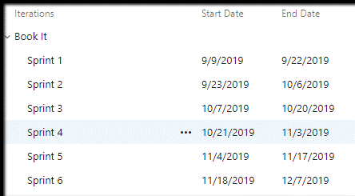

***SPRINT-1***

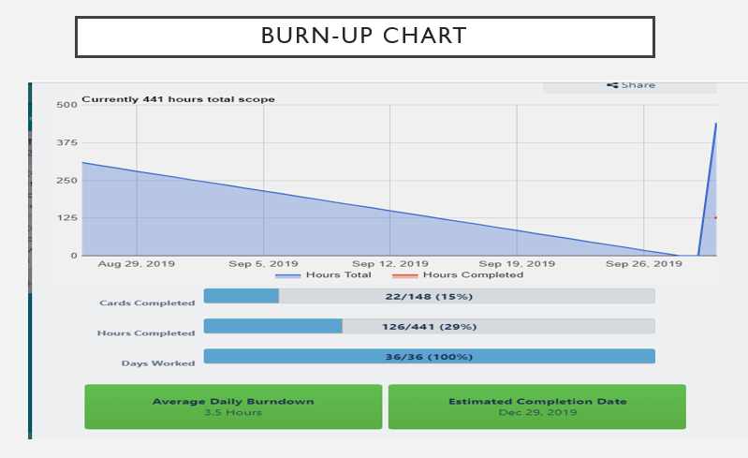

***SPRINT-2***

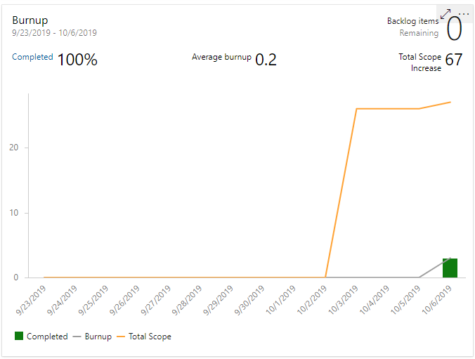

***SPRINT-3***

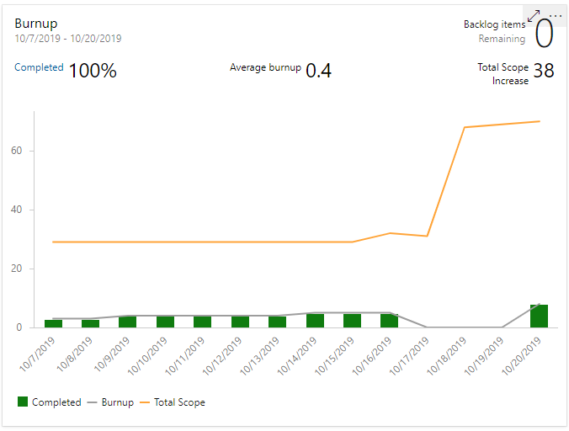

***SPRINT-4***

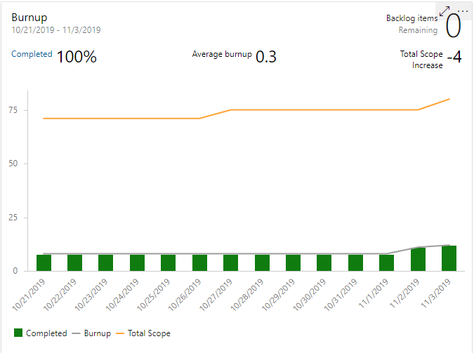

***SPRINT-5***

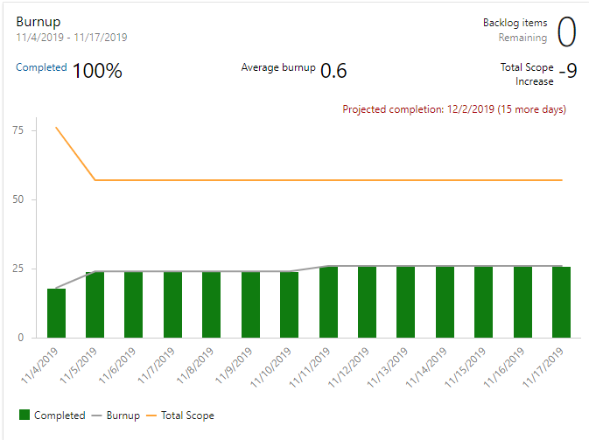

***SPRINT-6***

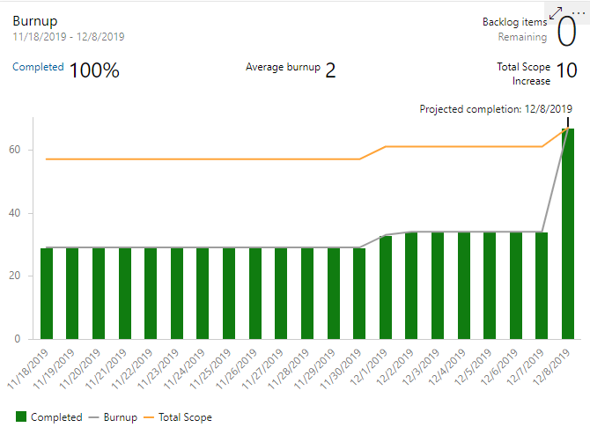

***TEAM RETROSPECTIVES : (***<https://trello.com/b/SBooMfQK/retro-capstone-experiences>)

An Agile Retrospective is a meeting that ́s held at the end of each iteration in Agile Development. At regular intervals, the team reflects on how to become more effective, then tunes and adjusts its behavior accordingly.

During the development of the BOOKIT product, our team performed following steps to have an effective Retrospectives:

* We amplified the good, instead of focusing on what didn’t work well
* Thinking about a problem deeply instead of trying to solve it right away
* Analyzing how to improves using 5 whys concept

