

BOOKMYTURF

Project Name: BookMyTurf
Online Turf Booking System

Documentation On

"BOOKMYTURF - ONLINE TURF BOOKING SYSTEM"

Guided By: SNEHAL SOMVANSHI

Submitted By:
Group No: 15

Akshata Umesh Shet 250843020092
Gayatri Wagh 250843020037

Table of Contents

1. Introduction | 4
1.1 Document Purpose | 4
1.2 Project Background | 4
1.3 Aim & Objectives | 5
2. Business Requirements Overview | 6
3. Functional Requirements | 7
3.1 Customer Module | 7
3.2 Turf Owner Module | 8
3.3 Admin Module | 8
4. Non-Functional Requirement | 9
5. Use Case Diagram | 10
5.1 Customer | 10
5.2 Turf Owner | 11
5.3 Admin | 11
6. Project Architecture Diagram | 12
7. Database Design | 13
8. ER-Diagram | 27
9. Snapshots | 28
10. Conclusion and Future Scope | 35

List of Figures

- Fig 1 - Customer Use Case Diagram
- Fig 2 - Turf Owner Use Case Diagram
- Fig 3 - Admin Use Case Diagram
- Fig 4 - Project Architecture Diagram
- Fig 5 - ER Diagram
- Fig 6 - Home Page Screenshot
- Fig 7 - Turf List Page Screenshot
- Fig 8 - Login Page Screenshot
- Fig 9 - Registration Page Screenshot

1. Introduction

1.1 Document Purpose
This document communicates the business requirements and scope for developing BookMyTurf - Online Turf Booking System. The scope of this document is to define the functional and non-functional requirements, business rules, and other constraint requirements for the system.

1.2 Project Background
Sports enthusiasts and turf owners face significant challenges in managing bookings efficiently. Currently, most turf booking processes are manual, leading to booking conflicts, missed opportunities, and poor customer experience. We gathered information and discovered that the majority of turf owners still handle their day-to-day operations manually.

Customer records are still entered manually, as are:
• Transactions with clients
• Tracking of slot availability
• Updates of booking status
• Payment processing and invoicing

The ongoing usage of manual procedures slows down the functioning of turf management and the response time to client queries.

1.3 Aim & Objectives
The main objective of this project is to build a website that improves user accessibility and time flexibility to help customers and authorized turf owners.

Key objectives:
• Customers will be able to browse turf information and view offers provided by turf owners
• Customers can book service slots after login and track booking status
• Customers may conduct bookings easily and comfortably from anywhere
• Turf owners can manage their facilities, slots, and pricing efficiently
• Automated notifications for booking confirmations and reminders
• Secure payment processing with multiple payment methods
• Admin can monitor and manage the entire platform

2. Business Requirements Overview
• BookMyTurf is a public web application.
• BookMyTurf is opened to all turf owners and customers in India.
• There are mainly three types of users: Customers (Players), Turf Owners, and Administrators.
• Customers can search for available turfs and available booking slots for specific time.
• Customers can see past booking records and payment history.
• Turf owners can get customer booking information and manage their facilities.
• The BookMyTurf System provides functions which connect customers and turf owners.
• BookMyTurf System is maintained by Administrator.
• The system generates reports for booking trends and revenue analytics.

3. Functional Requirements
BookMyTurf consists of three modules described as below:

3.1 Customer Module
• Customers can register.
• Customer can login to the system.
• Customer can add vehicle information for parking records.
• Customer can view service packages along with standard rates offered by turf owners.
• Customer can see available booking slots on a specific day, at a specific time before booking.
• Customers can book slots and make payments.
• Customers can check the progress of their bookings.
• Customer can view past booking records.
• Customer can request refunds for cancellations.
• Customer can give rating and feedback.

3.2 Turf Owner Module
• Turf owners can request for registration.
• Turf owners can login to the system.
• Turf owners can upload information about their facilities.
• Turf owners can upload multiple photos of the turf.
• Turf owners can upload information about different packages offered.
• Turf owners can manage amenities available.
• Turf owners can create and manage time slots.
• Turf owners can view booking requests.
• Turf owners can approve booking requests.
• Turf owners can process payments.
• Turf owners can raise invoices.
• Turf owners can process refunds.
• Turf owners can view ratings and feedback given by customers.

3.3 Admin Module
• Administrator will approve the registration request of turf owners.
• Manage all user accounts and turf listings.
• Monitor all bookings and transactions.
• Manage master data (cities, areas, amenities).
• Approve refund requests.
• View all feedback across platform.
• Generate reports about completed bookings and revenue.
• Handle disputes between customers and turf owners.

4. Non-Functional Requirement
• The website should use professional design, look and feel and color scheme.
• Users will have no limitations for accessing the application through the Internet.
• The portal being an internet application, it is designed to support sufficient users.
• Being a public website, the site must follow general usability guidelines for menus, navigation, colors, links and other actions provided on the screens.
• The system should be designed in such a manner that the user will be able to complete tasks in a minimum number of steps.
• System should maintain 99% uptime.
• Page response time should not exceed 3 seconds.
• All passwords must be encrypted using BCrypt algorithm.
• The system must be fully responsive and work on all devices.
• Database backup should be automated and done daily.

5. Use-Case Diagram

5.1 Customer:
Following diagram shows the use case for Customer module:
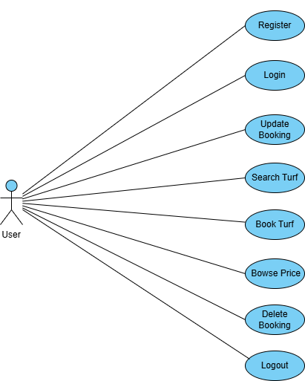

Fig. Use-Case Diagram for Customer

5.2 Turf Owner:
Following diagram shows the use case for Turf Owner module:

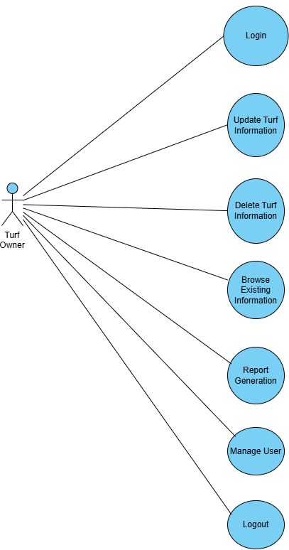
Fig. Use-Case Diagram for Turf Owner

5.3 Admin:
Following diagram shows the use case for Admin module:

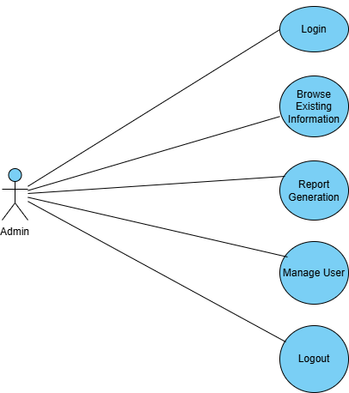
Fig. Use-Case Diagram for Admin

6. Project Architecture Diagram
BookMyTurf follows a three-tier architecture pattern with React Frontend, Spring Boot Backend, and MySQL Database.

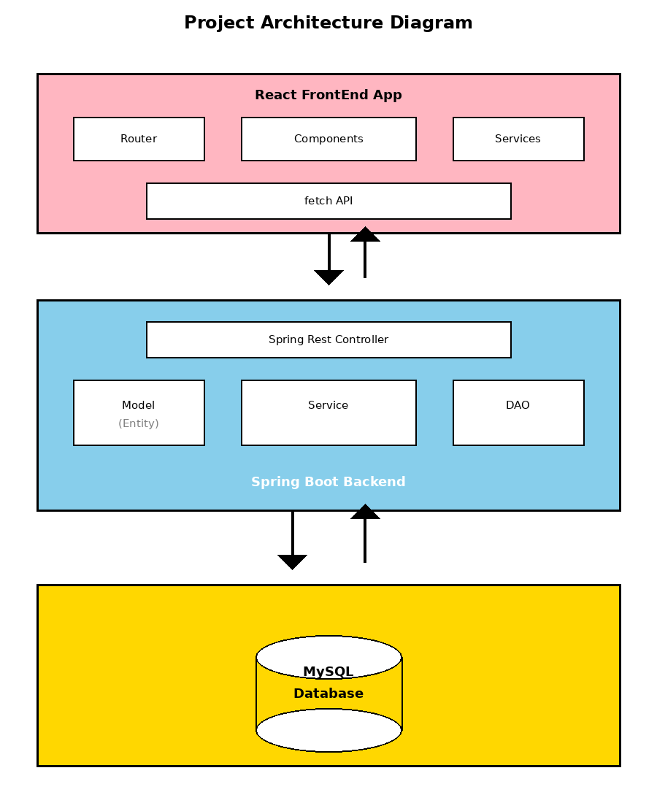

Fig. Project Architecture Diagram

The architecture consists of:
• React FrontEnd App: User interface layer with Router, Components, and Services
• Spring Rest Controller: REST API endpoints for handling HTTP requests
• Model, Service, DAO (Repository): Business logic and data access layers
• MySQL Database: Persistent data storage with 13 normalized tables

7. Database Design
The BookMyTurf database consists of 13 normalized tables designed to efficiently manage users, turfs, bookings, payments, and related data. Below is the detailed structure of each table with field names, data types, constraints, and descriptions.

1. user_type table
Field | Type | Key | Description
UserTypeID | Integer | Primary Key | Unique user type ID
TypeName | Varchar(20) | Null | Name of user type (Player/Turf Owner/Administrator)

2. user table
Field | Type | Key | Description
UserID | Integer | Primary Key | Unique user identifier
UserTypeID | Integer | Foreign key | References user_type table
FirstName | Varchar(50) | Null | First name of user
LastName | Varchar(50) | Null | Last name of user
EmailAddress | Varchar(100) | Null | Email address of user
Password | Varchar(255) | Null | Encrypted password (BCrypt)
PermanentAddress | Varchar(255) | Null | Permanent address of user
CityName | Varchar(50) | Null | City name
ContactPhoneNo | Varchar(15) | Null | Contact phone number
AccountStatus | Enum | Null | Active or Suspended
CreatedDate | Datetime | Null | Account creation date
UpdatedDate | Datetime | Null | Last updated date

3. admin table
Field | Type | Key | Description
AdminID | Integer | Primary key | Unique admin identifier
UserID | Integer | Foreign key | References user table

4. turf table
Field | Type | Key | Description
TurfID | Integer | Primary key | Unique turf identifier
UserID | Integer | Foreign key | Turf owner ID (references user)
TurfName | Varchar(100) | Null | Name of the turf
Location | Varchar(255) | Null | Turf location/address
City | Varchar(50) | Null | City where turf is located
Description | Text | Null | Turf description
TurfStatus | Enum | Null | Active or Inactive
ContactNumber | Varchar(15) | Null | Turf contact number
CreatedDate | Datetime | Null | Turf creation date

5. amenities table
Field | Type | Key | Description
AmenityID | Integer | Primary key | Unique amenity identifier
AmenityName | Varchar(50) | Null | Name of the amenity
Description | Varchar(255) | Null | Amenity description

6. turf_amenities table
Field | Type | Key | Description
TurfAmenityID | Integer | Primary key | Unique mapping identifier
TurfID | Integer | Foreign key | References turf table
AmenityID | Integer | Foreign key | References amenities table

7. turf_photos table
Field | Type | Key | Description
PhotoID | Integer | Primary key | Unique photo identifier
TurfID | Integer | Foreign key | References turf table
PhotoURL | Varchar(255) | Null | Cloud storage URL of photo
IsMainPhoto | Boolean | Null | Flag for main display photo
UploadedDate | Datetime | Null | Photo upload date

8. slot_master table
Field | Type | Key | Description
SlotID | Integer | Primary key | Unique slot identifier
TurfID | Integer | Foreign key | References turf table
SlotDate | Date | Null | Date of the slot
StartTime | Time | Null | Slot start time
EndTime | Time | Null | Slot end time
SlotPrice | Decimal(10,2) | Null | Price for the slot
IsAvailable | Boolean | Null | Slot availability flag
CreatedDate | Datetime | Null | Slot creation date

9. booking table
Field | Type | Key | Description
BookingID | Integer | Primary key | Unique booking identifier
UserID | Integer | Foreign key | Customer ID (references user)
SlotID | Integer | Foreign key | References slot_master table
BookingDate | Datetime | Null | Date of booking creation
TotalAmount | Decimal(10,2) | Null | Total booking amount
BookingStatus | Enum | Null | Confirmed/Cancelled/Completed
PaymentStatus | Enum | Null | Pending/Success/Refunded
CreatedDate | Datetime | Null | Booking creation timestamp

10. payment table
Field | Type | Key | Description
PaymentID | Integer | Primary key | Unique payment identifier
BookingID | Integer | Foreign key | References booking table
UserID | Integer | Foreign key | References user table
PaymentAmount | Decimal(10,2) | Null | Payment amount
PaymentMethod | Varchar(50) | Null | UPI/Credit/Debit/NetBanking
BankDetails | Varchar(200) | Null | Bank transaction details
PaymentStatus | Varchar(20) | Null | Success/Failed/Pending
TransactionID | Varchar(100) | Unique | Unique transaction ID
TransactionDate | Datetime | Null | Transaction timestamp
PaymentDate | Datetime | Null | Payment completion date

11. refund table
Field | Type | Key | Description
RefundID | Integer | Primary key | Unique refund identifier
BookingID | Integer | Foreign key | References booking table
UserID | Integer | Foreign key | Customer ID (references user)
TurfOwnerID | Integer | Foreign key | Turf owner ID
ApprovedBy | Integer | Foreign key | Admin who approved refund
RefundAmount | Decimal(10,2) | Null | Refund amount
RefundStatus | Varchar(20) | Null | Pending/Approved/Completed
RequestDate | Datetime | Null | Refund request date

12. notification table
Field | Type | Key | Description
NotificationID | Integer | Primary key | Unique notification ID
UserID | Integer | Foreign key | References user table
Type | Varchar(50) | Null | Notification type
Message | Text | Null | Notification message
ReadStatus | Varchar(10) | Null | Unread or Read
SentDate | Datetime | Null | Notification sent date

13. report table
Field | Type | Key | Description
ReportID | Integer | Primary key | Unique report identifier
AdminID | Integer | Foreign key | References admin table
ReportType | Varchar(50) | Null | Daily/Weekly/Monthly
ReportDate | Date | Null | Report generation date
TotalBookings | Integer | Null | Total bookings count
SuccessfulBookings | Integer | Null | Successful bookings
CancelledBookings | Integer | Null | Cancelled bookings
TotalRevenue | Decimal(10,2) | Null | Total revenue generated
TotalUsers | Integer | Null | Total active users
TotalTurfs | Integer | Null | Total active turfs
ReportContent | Text | Null | Detailed report content
GeneratedDate | Datetime | Null | Report generation timestamp

8. ER-Diagram
The Entity-Relationship diagram shows the database structure of BookMyTurf system with all entities, their attributes, and relationships between them.
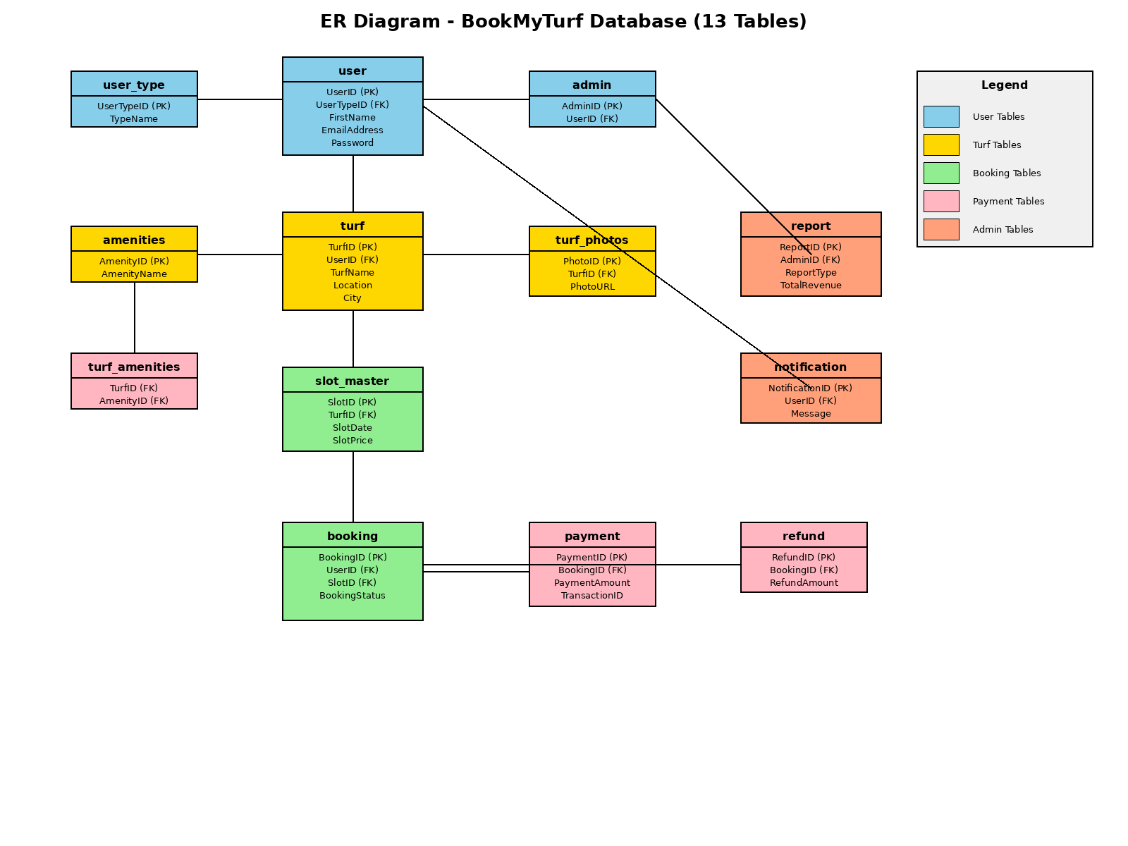

Fig. E-R diagram shows database of BookMyTurf System

9. Snapshots

9.1 Home Page:
Following snapshot shows the Home page for BookMyTurf System

This page contains following controls:
• Home
• Browse Turfs
• Contact Us
• Login
• Sign Up
• • Customer
• • Turf Owner

9.2 Turf List Page:
Following snapshot shows the Turf List page for BookMyTurf System

9.3 Login Page:
Following snapshot shows the Login page for BookMyTurf System

9.4 Sign Up Page:
Following snapshot shows the Sign Up page for BookMyTurf System

• Customer Registration Page:

• Turf Owner Registration Page:

9.5 Customer Dashboard:
Following snapshot shows the Customer Dashboard for BookMyTurf System

This page contains following controls:
• Profile
• • Update profile
• • Change password
• Browse Turfs
• View Available Slots
• Book Slot
• My Bookings
• View Notifications

9.6 Turf Owner Dashboard:
Following snapshot shows the Turf Owner Dashboard for BookMyTurf System

This page contains following controls:
• Profile
• • Update profile
• • Change password
• Manage Turf Information
• Upload Photos
• Manage Amenities
• Create/Manage Slots
• View Bookings
• Process Payments
• Generate Invoices
• Process Refunds
• View Ratings and Feedback

10. Conclusion and Future scope
BookMyTurf provides a better platform to get customers and turf owners connected. Our system provides a very user-friendly platform where customers can easily browse turfs, check availability, book slots, and make payments. Turf owners can efficiently manage their facilities, slots, and bookings from a single dashboard.

Our system is aimed to do efficient management of various tasks like user registration, turf listing, slot management, booking processing, payment handling, refund processing, and generating comprehensive reports. It digitally manages the entire booking workflow on a single platform.

Key Achievements:
• Successful implementation of real-time slot availability system
• Secure payment processing with multiple payment methods
• Automated notification system for booking updates
• Comprehensive admin dashboard for platform management
• Responsive design working across all devices
• Complete API integration between frontend and backend
• Efficient database design with proper normalization

Future Scope:
Few things which we have kept aside for right now as our platform is new in the market but in future we desire to add are:

• Establish this platform across pan India with support for multiple cities
• Mobile application for iOS and Android platforms
• Integration with Google Maps for location-based search
• Dynamic pricing based on demand and peak hours
• Advanced search filters (sport type, amenities, price range)
• Real-time chat between customers and turf owners
• Loyalty programs and membership plans
• Social media integration for sharing bookings
• Email notifications in addition to in-app notifications
• Analytics dashboard with AI-powered insights for turf owners
• Multi-language support for wider reach
• Integration with popular payment gateways (Razorpay, PayU)

--- END OF REPORT ---

