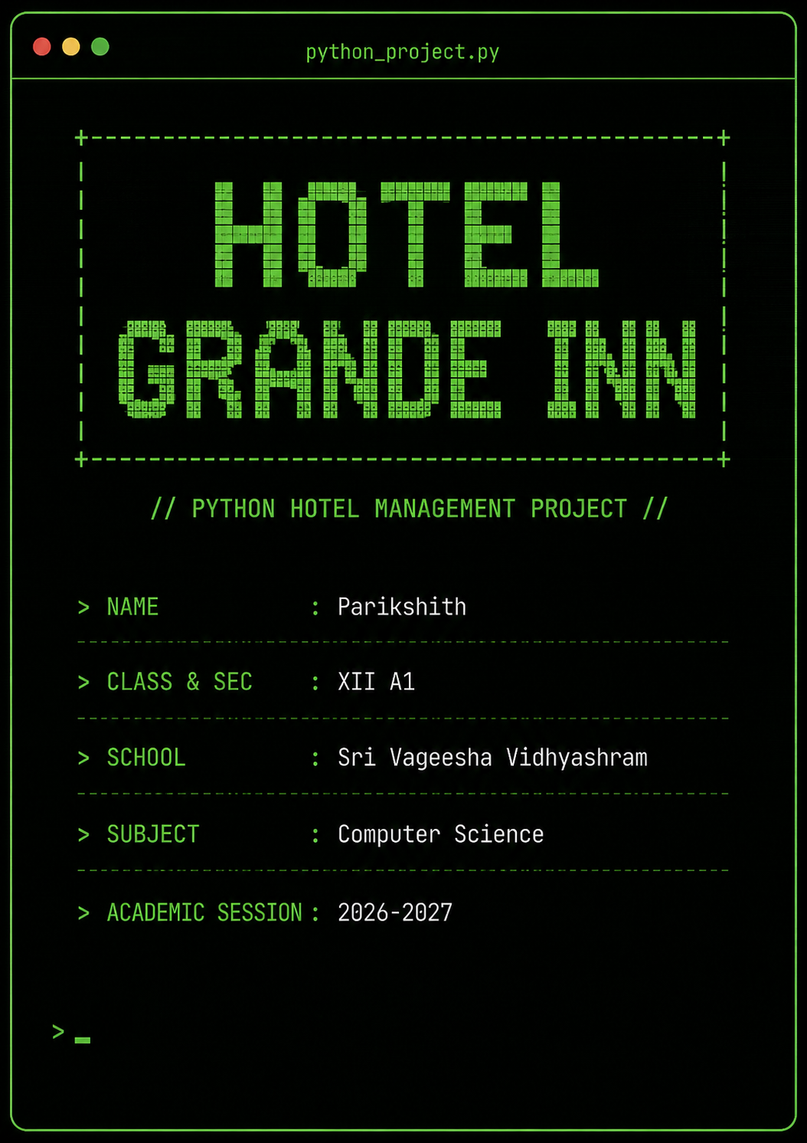

ACKNOWLEDGEMENT

I would like to express my sincere gratitude to my Computer Science teacher Mrs.Ramya for providing valuable guidance, encouragement, and support throughout the development of my Python project, “HOTEL GRANDE INN.” The suggestions and explanations provided during the planning, coding, and testing stages helped me understand the practical application of Python programming concepts.
I am also thankful to Sri Vageesha Vidhyashram for providing a supportive academic environment and the necessary facilities to complete this project successfully. Finally, I would like to thank everyone who contributed directly or indirectly to the completion of this project.

INTRODUCTION

HOTEL GRANDE INN
* HOTEL GRANDE INN is a Python-based hotel room management program designed to maintain and manage room-related records in a simple, menu-driven manner. The program allows the user to insert, display, search, update, delete, and calculate bills for hotel room records. It provides a practical application of Python programming concepts such as functions, lists, loops, conditional statements, file handling, and modules.
* The program stores each room record as a list containing the room provider’s name, room number, availability status, number of nights, floor number, and room type. The available room types are Normal, Pro, Deluxe, and Ultra, with different rates assigned to each type. The program repeatedly displays a main menu and asks the user to select an operation. The user can continue performing different operations until the Exit option is selected.
* The pickle module is used for storing and retrieving the room records in a binary file named data.dat. This enables the data entered by the user to remain available for later operations such as displaying, searching, updating, deleting, and billing. The os module is used in the deletion process to remove the old data file and rename a temporary file so that the updated records replace the previous file.The project is built around the following core functions, each handling a specific hotel management operation:

Functions Used in the Program
Function | Purpose
ins() | The ins() function is used to insert room records. It accepts details such as the room provider’s name, room number, availability, number of nights, floor, and room type. It writes the newly entered records to data.dat. Since the file is opened in write-binary mode, the previous records are replaced when this function is used. It also checks that a duplicate room number is not entered during the insertion process.
dis() | The dis() function displays the records stored in the data file. It shows the room provider’s name, room number, availability, number of nights, floor, and room type. It also calculates and displays the total number of rooms, the number of available rooms, and the number of unavailable rooms.
sea() | The sea() function enables the user to search for room records according to different choices. The user can search by room provider’s name, room number, availability, room type, or rooms that have no provider. The matching records are then displayed.
update() | The update() function provides two options: adding a new record to the existing records or modifying an existing record. A selected record can be changed using its room number. The user can update the provider’s name, number of nights, availability, floor, or room type. The modified data is then saved back to the file.
delete() | The delete() function removes a selected room record. The user enters the room number to be deleted and confirms the operation. The remaining records are temporarily stored in script.dat; the original data.dat file is removed using os.remove(), and the temporary file is renamed to data.dat using os.rename().
billc() | The billc() function calculates and displays the bill for all customers or for one selected room. The bill is calculated by multiplying the number of nights by the rate of the selected room type: Normal at 100 dollars per night, Pro at 200 dollars per night, Deluxe at 250 dollars per night, and Ultra at 500 dollars per night.

Overall, HOTEL GRANDE INN demonstrates how Python can be used to create a basic record-management system for a hotel. Its menu-based design makes it possible for the user to perform different operations easily, while file handling allows the room records to be stored and managed for future use.

SOURCE CODE
COMPLETE PYTHON SOURCE CODE OF HOTEL GRANDE INN
import pickle,os
##HOTEL MANAGEMENT PROJECT##

#HOTEL GRANDE INN

#PARIKSHITH.N XII A1

def ins():#working

f=open("data.dat","wb")
print("."*267)
l=[]
e=[]
while True:

nam=input("enter the room donater's name, if no enter 'null' ")
rno=int(input("enter room number"))
eroom=[i[1] for i in e]
if rno in eroom:
print("ROOM NUMBER ALDREADY EXISTS")
continue

ava=input("enter if the room AVAILABLE or NOT AVAILABLE ")
ni=int(input("enter how many nights you are going to stay in the room"))
flo=int(input("enter which floor"))

typ=input("""enter room type:
| NORMAL [100$] |
| PRO [200$] |
| DELUXE [250$] |
| ULTRA [500$] |
""")
ch=input("do you want to add more records, enter | y | or | n |")
l=[nam,rno,ava,ni,flo,typ]
e.append(l)
print("."*267)
if ch=='n':
break

pickle.dump(e,f)
print("RECORDS ADDED SUCCESFULLY")
print("."*267)
f.close()

def dis():#working
f=open("data.dat","rb")

try:
while True:

e=pickle.load(f)
x=sorted(e)
for i in x:
print('*'*45)
print('ROOM PROVIDER NAME===> ||',i[0],'||')
print('ROOM NO.=============> ||',i[1],'||')
print('ROOM AVAILABILITY=====> ||',i[2],'||')
print('NO.OF NIGHTS==========> ||',i[3],'||')
print('FLOOR===============> ||',i[4],'||')
print('ROOM TYPE===========> ||',i[5],'||')
print('*'*45)

except:
f.close()
tot=len(e)
av=0
nav=0
for i in e:
if i[2]=='available':
av=av+1
if i[2]=="not available":
nav=nav+1
print('.'*267)
print("TOTAL ROOMS------------------>",tot)
print("AVAILABLE ROOMS COUNT--------->",av)
print("NOT AVAILABLE ROOMS COUNT----->",nav)
print('.'*267)
def sea():

f=open("data.dat","rb")
try:

l=pickle.load(f)

gh=int(input("""enter what you want to search;
ROOM PROVIDER'S NAME....................................................1
ROOM NUMBER........................................................................2
BY AVAILABILITY..................................................................3
ROOM TYPE.............................................................................4
ROOMS WHICH HAS GOT NO PROVIDER(NULL)..............5
"""))
print("."*267)
print(" ")

if gh==1:
print("."*267)
sf=input("what name you want search")
print("."*267)

for i in l:
if i[0]==sf:
print("."*267)
print('ROOM PROVIDER NAME===> ||',i[0],'||')
print('ROOM NO.=============> ||',i[1],'||')
print('ROOM AVAILABILITY=====> ||',i[2],'||')
print('NO.OF NIGHTS==========> ||',i[3],'||')
print('FLOOR===============> ||',i[4],'||')
print('ROOM TYPE===========> ||',i[5],'||')
print(" ")
print("."*267)

if gh==2:
print("."*267)
sf=int(input("what room no. you want to search"))
print("."*267)
for i in l:

if i[1]==sf:
print("."*267)
print('ROOM PROVIDER NAME===> ||',i[0],'||')
print('ROOM NO.=============> ||',i[1],'||')
print('ROOM AVAILABILITY=====> ||',i[2],'||')
print('NO.OF NIGHTS==========> ||',i[3],'||')
print('FLOOR===============> ||',i[4],'||')
print('ROOM TYPE===========> ||',i[5],'||')
print(" ")
print("."*267)

if gh==3:

print("."*267)
print("AVILABLE ROOMS:")

for i in l:

if i[2]=="available":

print('ROOM PROVIDER NAME===> ||',i[0],'||')
print('ROOM NO.=============> ||',i[1],'||')
print('ROOM AVAILABILITY=====> ||',i[2],'||')
print('NO.OF NIGHTS==========> ||',i[3],'||')
print('FLOOR===============> ||',i[4],'||')
print('ROOM TYPE===========> ||',i[5],'||')
print(" ")

print("."*267)
print("NOT AVAILABLE ROOMS:")

for i in l:

if i[2]=="not available":

print('ROOM PROVIDER NAME===> ||',i[0],'||')
print('ROOM NO.=============> ||',i[1],'||')
print('ROOM AVAILABILITY=====> ||',i[2],'||')
print('NO.OF NIGHTS==========> ||',i[3],'||')
print('FLOOR===============> ||',i[4],'||')
print('ROOM TYPE===========> ||',i[5],'||')
print(" ")

print("."*267)
if gh==4:
matches=[]

print("."*267)
rtypes = int(input("""enter which room type you want to search
NORMAL...................1
PRO...........................2
DELUXE...................3
ULTRA.....................4
"""))
print("."*267)
if rtypes == 1:
want = 'normal'
elif rtypes == 2:
want = 'pro'
elif rtypes == 3:
want = 'deluxe'
elif rtypes == 4:
want = 'ultra'
else:
want = 'no'

if want == 'no':
print("Invalid choice.")
else:

for i in l:
if i[5].lower() == want:

matches.append(i)

if len(matches) > 0:

print(want.upper() + " ROOMS:")
for i in matches:
print('ROOM PROVIDER NAME===> ||', i[0], '||')
print('ROOM NO.=============> ||', i[1], '||')
print('ROOM AVAILABILITY=====> ||', i[2], '||')
print('NO.OF NIGHTS==========> ||', i[3], '||')
print('FLOOR===============> ||', i[4], '||')
print('ROOM TYPE===========> ||', i[5], '||')
print(" ")
print("."*267)
else:
print("NO ROOMS FOUND!")

if gh==5:

print("ROOMS WITH NO PROVIDER")
matches = []
for i in l:
name = i[0].lower()
if name =='null':
matches.append(i)
if len(matches)>0:

for i in matches:

print('ROOM PROVIDER NAME===> ||', i[0], '||')
print('ROOM NO.=============> ||', i[1], '||')
print('ROOM AVAILABILITY=====> ||', i[2], '||')
print('NO.OF NIGHTS==========> ||', i[3], '||')
print('FLOOR===============> ||', i[4], '||')
print('ROOM TYPE===========> ||', i[5], '||')
print(" ")

else:
print("NO ROOMS WITH NO PROVIDER FOUND")
except:
f.close()
def update():

uch=int(input("""
ADD A RECORD......1
UPDATE.....................2
"""))

if uch==1:

try:
f=open("data.dat","rb")
e=pickle.load(f)
f.close()
except:

return
print("."*267)
l=[]

while True:
nam=input("enter the room holder's name, if no enter 'NULL' ")
rno=int(input("enter room number"))
ava=input("enter if the room AVAILABLE or NOT AVAILABLE ")
ni=int(input("enter how nights you are going to stay in the room"))
flo=int(input("enter which floor"))
typ=input("""enter room type:
| NORMAL [100$] |
| PRO [200$] |
| DELUXE [250$] |
| ULTRA [500$] |
""")
ch=input("do you want to add more records, enter | y | or | n |")
l=[nam,rno,ava,ni,flo,typ]
e.append(l)
if ch=='n':
break

print("RECORD ADDED SUCCESFULLY")
print("."*267)
f=open('data.dat','wb')
pickle.dump(e,f)
f.close()
if uch==2:
try:
f=open("data.dat","rb")
e=pickle.load(f)
f.close()
except:

return
rono=int(input("enter the room no. to be changed"))
upda=int(input("""TO CHANGE:
ROOM PROVIDER NAME..................1
STAY NIGHTS....................................2
MAKE AVAILABILE..........................3
MAKE NOT AVAILABLE..................4
FLOOR..................................................5
ROOM TYPE........................................6
"""))
if upda==1:

y=input('enter new provider name')
for i in e:

if i[1]==rono:

i[0]=y
if upda==2:
y=int(input('enter new no. of nights'))
for i in e:

if i[1]==rono:
i[3]=y
if upda==3:
z=[]
for i in e:
z.append(i[1])
if rono in z:

for i in e:

if i[1]==rono:

i[2]="available"
print("RECORD MARKED AVAILABLE")
if upda==4:

z=[]
for i in e:
z.append(i[1])
if rono in z:

for i in e:
if i[1]==rono:
i[2]="not available"
print("RECORD MARKED NOT AVAILABLE")
if upda==5:

y=int(input("enter new floor no."))
for i in e:
if i[1]==rono:
i[4]=y
if upda==6:
y=input("enter new room type")
for i in e:
if i[1]==rono:
i[5]=y

f=open("data.dat","wb")
pickle.dump(e,f)
f.close()
print('RECORD UPDATED SUCCESFULLY')

def delete():
print("."*267)

try:

f=open("data.dat",'rb')
e=pickle.load(f)
f.close()
except :

return

rono=int(input("ENTER ROOM NO.TO BE DELETED"))
chy=int(input("are you sure you want to delete the record..............1"))
print("."*267)

if chy==1:
ne=[]
for i in e:
if i[1]!=rono:
ne.append(i)

fl=open("script.dat",'wb')
pickle.dump(ne,fl)
fl.close()
os.remove("data.dat")
os.rename("script.dat","data.dat")
print("THE RECORD HAS BEEN DELETED")
print("."*267)

def billc():
try:
f=open("data.dat","rb")
e=pickle.load(f)
f.close()
except:
return

bills=int(input("""SHOW:
ALL CUSTMER'S BILLS.........1
ONE CUSTUMER'S BILL.........2
"""))
if bills==1:
for i in e:

if i[5] in "normalNormalNORMAL":

q=i[3]*100
print(q,'$ is the bill amount for ',i[3],'nights for room number',i[1],'[',i[5],']')

if i[5] in "proProPRO":
q=i[3]*200
print(q,'$ is the bill amount for ',i[3],'nights for room number',i[1],'[',i[5],']')

if i[5] in "deluxeDeluxeDELUXE":
q=i[3]*250
print(q,'$ is the bill amount for ',i[3],'nights for room number',i[1],'[',i[5],']')

if i[5] in "ultraUltraULTRA":
q=i[3]*500
print(q,'$ is the bill amount for ',i[3],'nights for room number',i[1],'[',i[5],']')

if bills==2:
rono=int(input('enter the room no. you want to calculate the bill'))
for i in e:
if i[1]==rono:

if i[5] in "normalNormalNORMAL":

q=i[3]*100
print(q,'$ is the bill amount for ',i[3],'night for room number',i[1],'[',i[5],']')

if i[5] in "proProPRO":
q=i[3]*200
print(q,'$ is the bill amount for ',i[3],'nights for room number',i[1],'[',i[5],']')

if i[5] in "deluxeDeluxeDELUXE":
q=i[3]*250
print(q,'$ is the bill amount for ',i[3],'nights for room number',i[1],'[',i[5],']')

if i[5] in "ultraUltraULTRA":
q=i[3]*500
print(q,'$ is the bill amount for ',i[3],'nights for room number',i[1],'[',i[5],']')

print("~"*133)
print(" || WELCOME TO HOTEL GRANDE INN || ")
print("~"*133)
while True:
print("~"*133)
defch=int(input("""ENTER WHAT FUNCTION YOU WANT TO DO:
|1|-------------------> || INSERT ||

|2|-------------------> || DISPLAY ||

|3|-------------------> || SEARCH ||

|4|-------------------> || UPDATE ||

|5|-------------------> || DELETE ||

|6|-------------------> || BILL ||

|7|-------------------> || EXIT ||
"""))

print("~"*133)

if defch==1:
ins()
if defch==2:
dis()
if defch==3:
sea()
if defch==4:
update()
if defch==5:
delete()
if defch==6:
billc()
if defch==7:
break

print(" "*55," || THANK YOU ||", " "*59)
print("~"*133)

#PROJECT BYPARIKSHITH.N XII A1 CS

SAMPLE OUTPUT
SAMPLE OUTPUT SCREENSHOTS
These screen shots cover the main menu and every function: ins(), dis(), sea(), update(), delete(), billc()
showing sample inputs and their corresponding outputs.
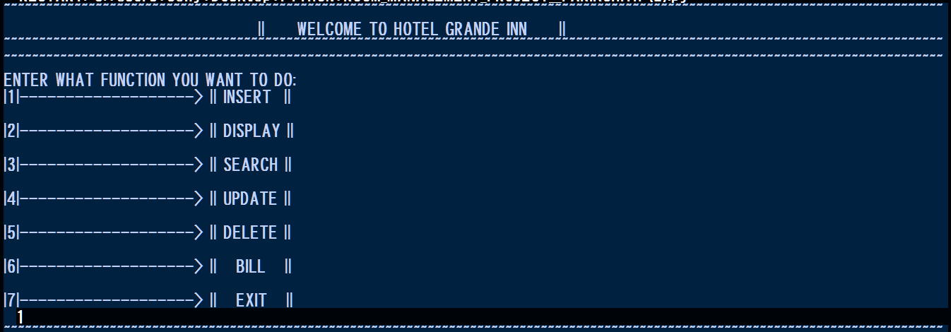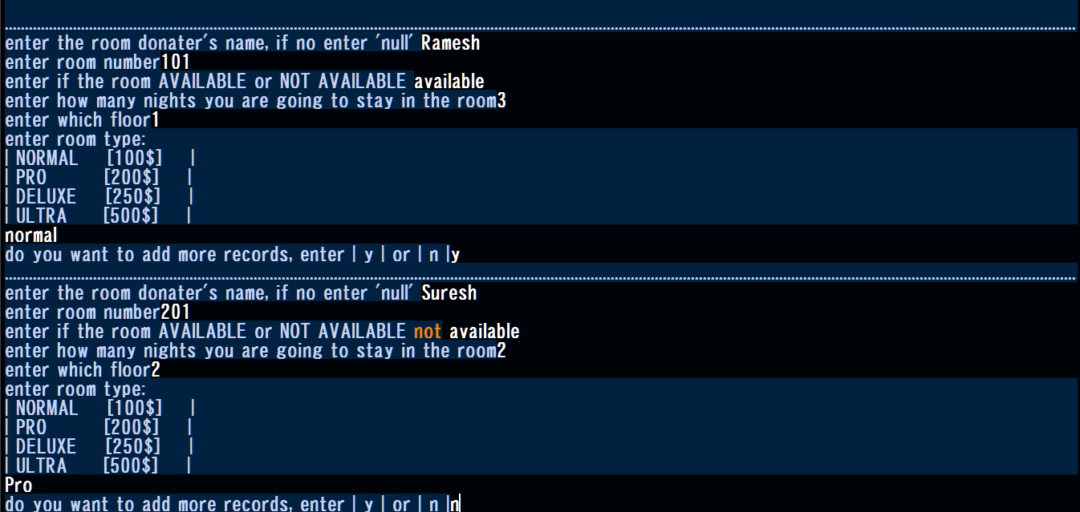
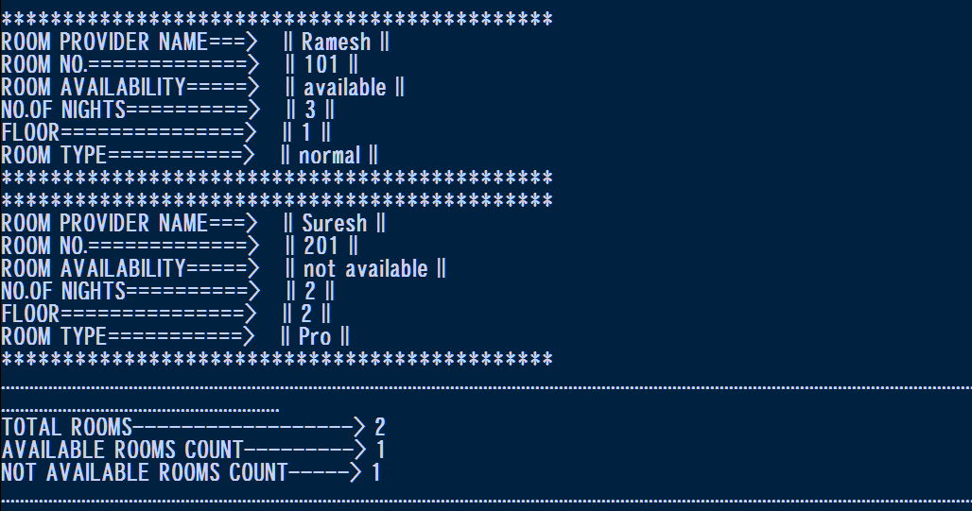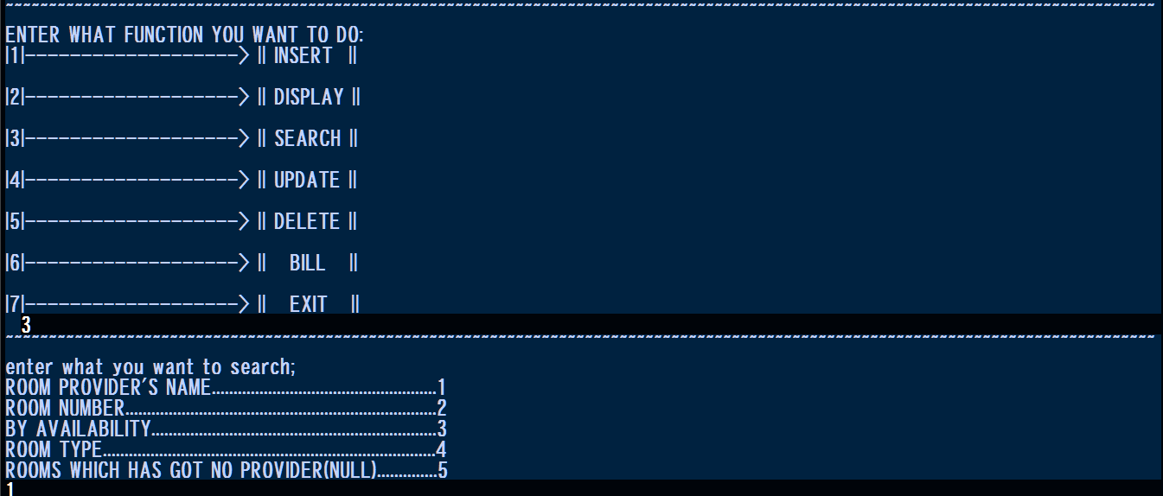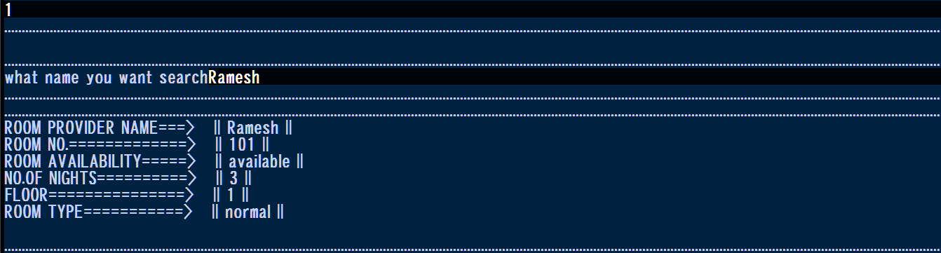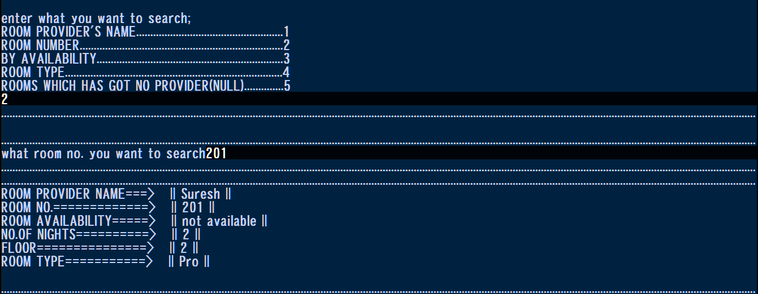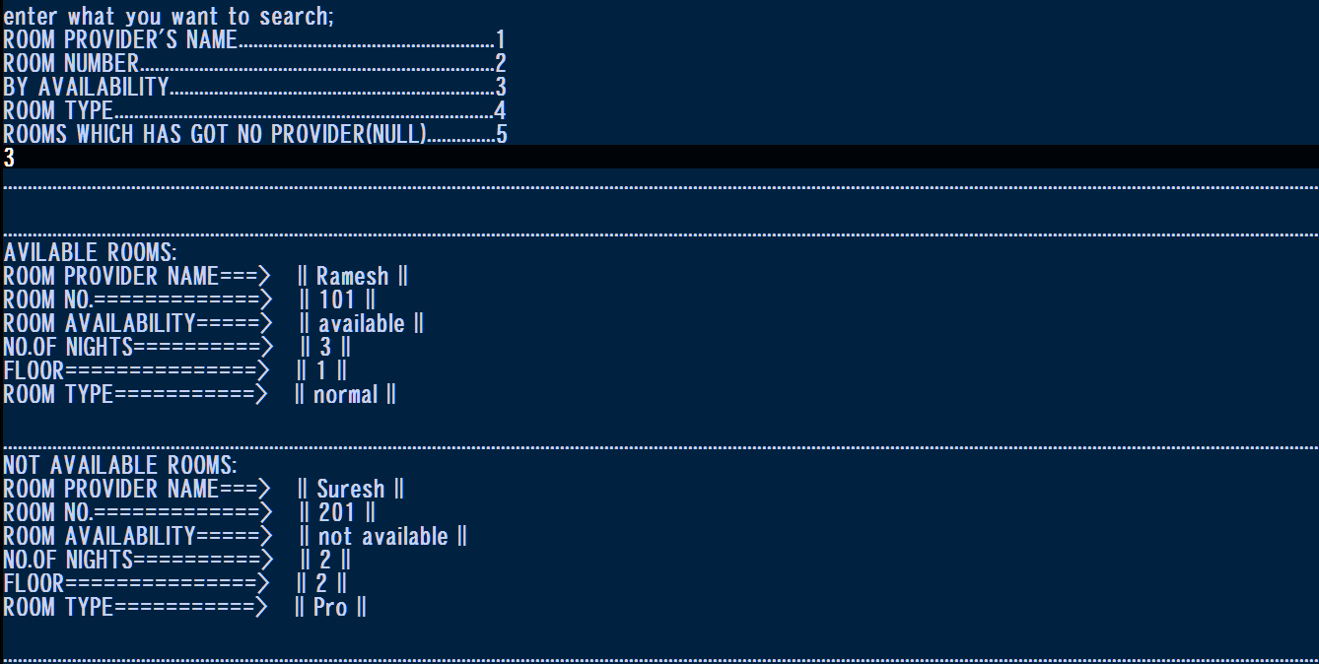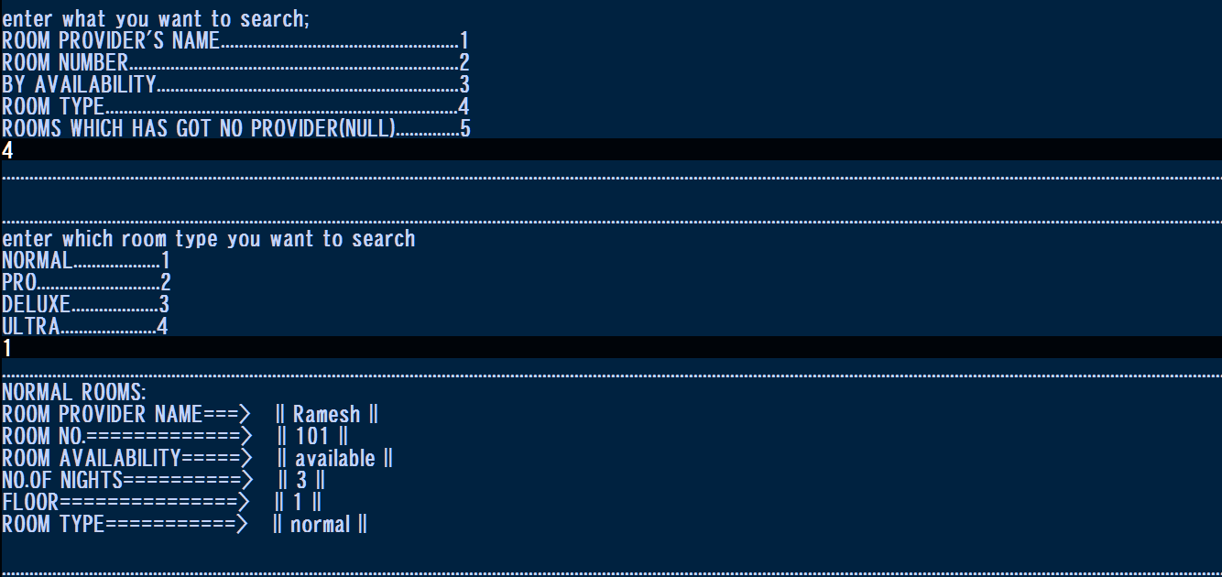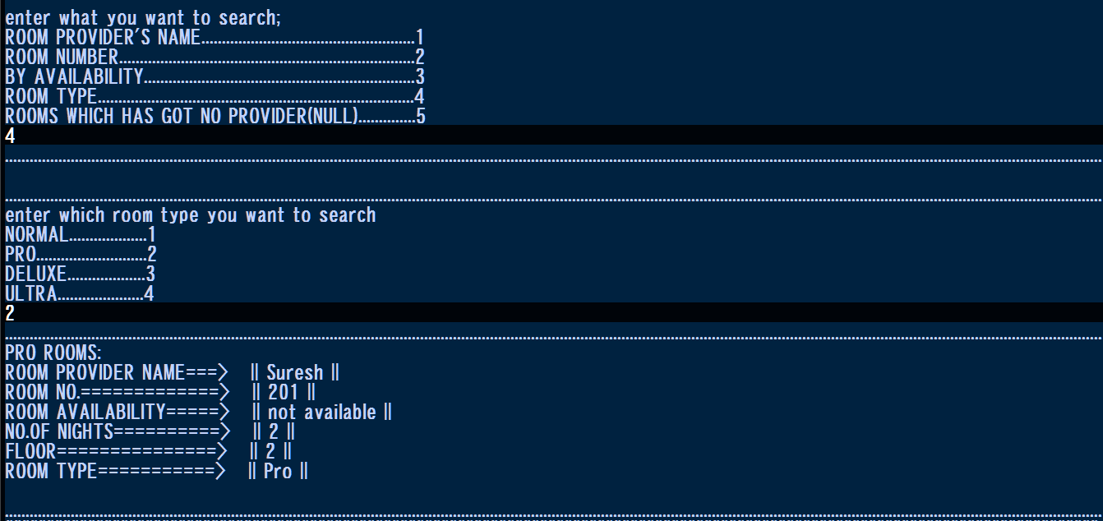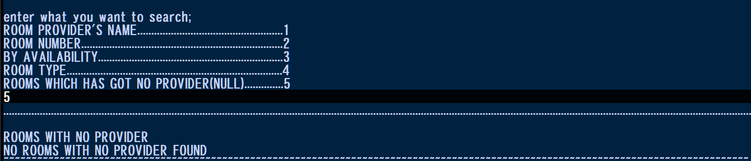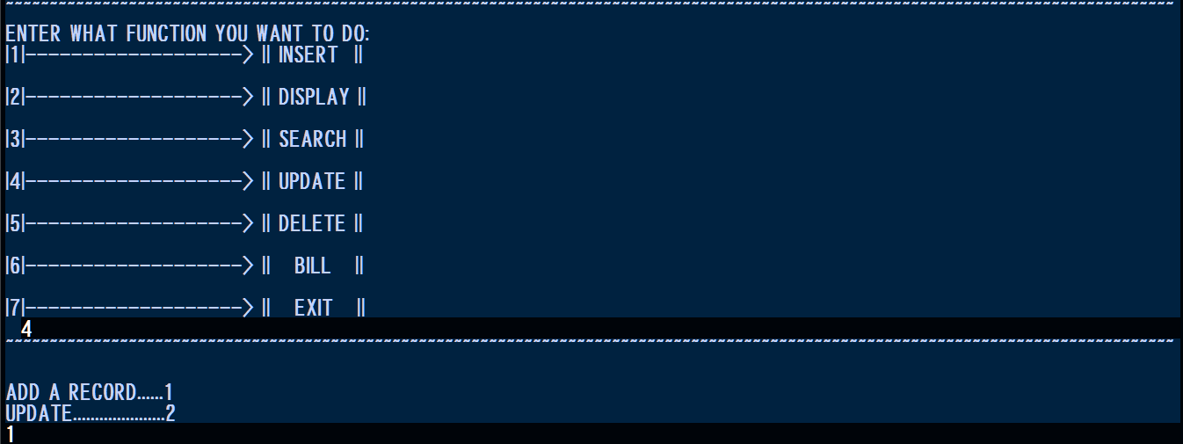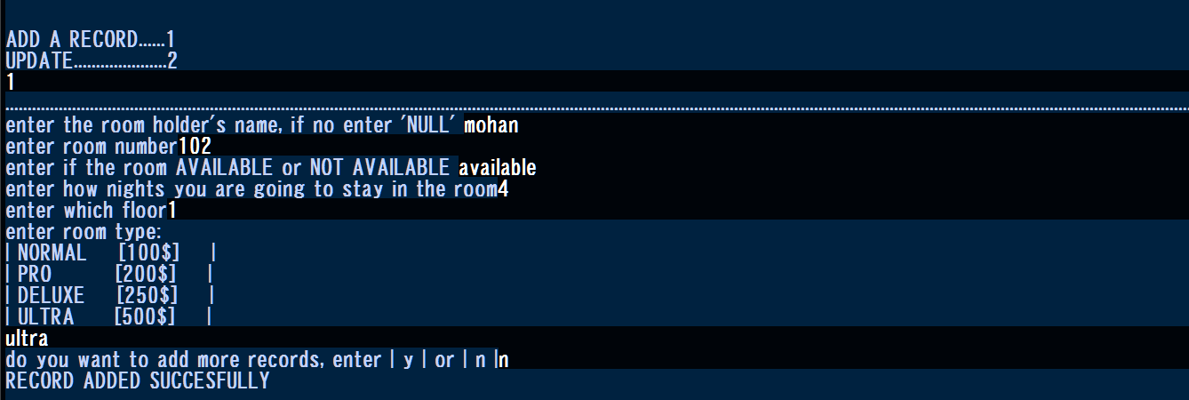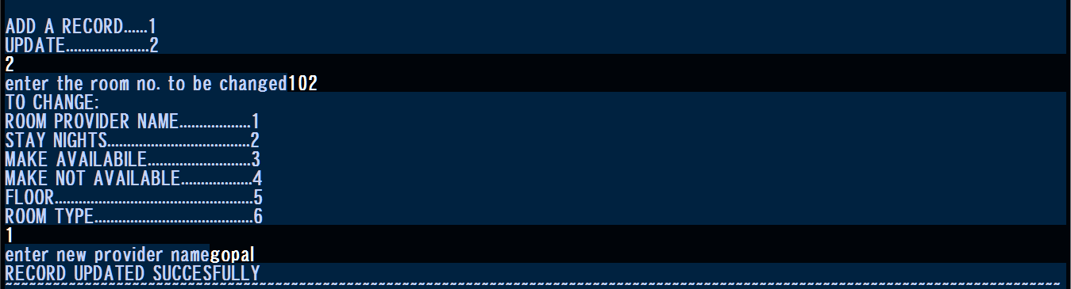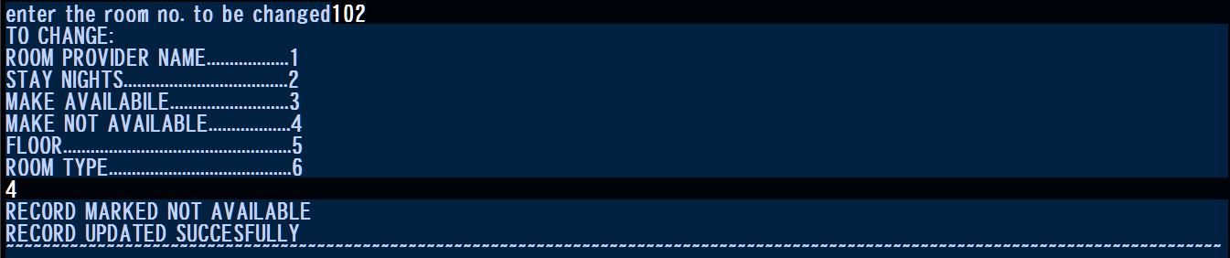
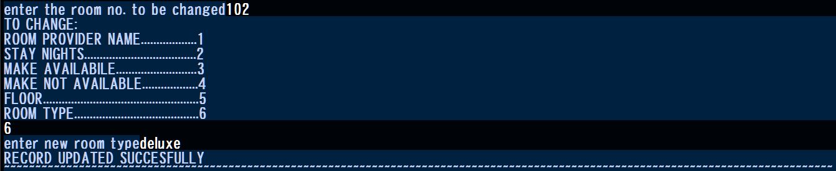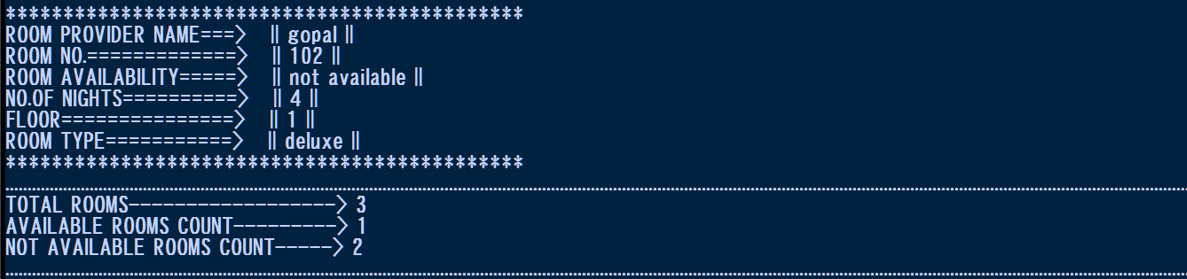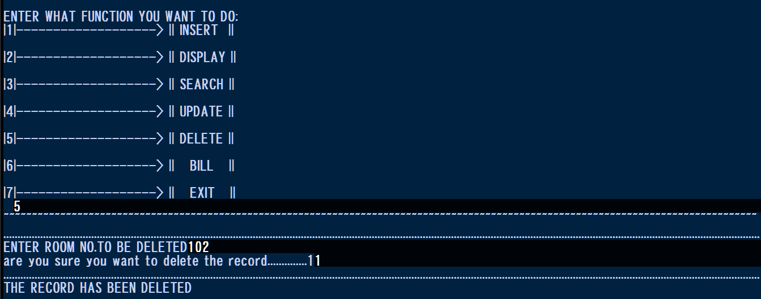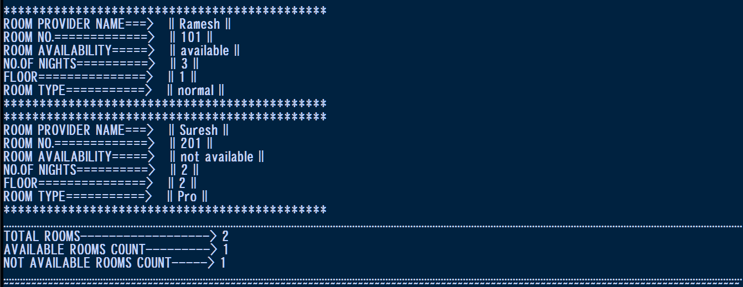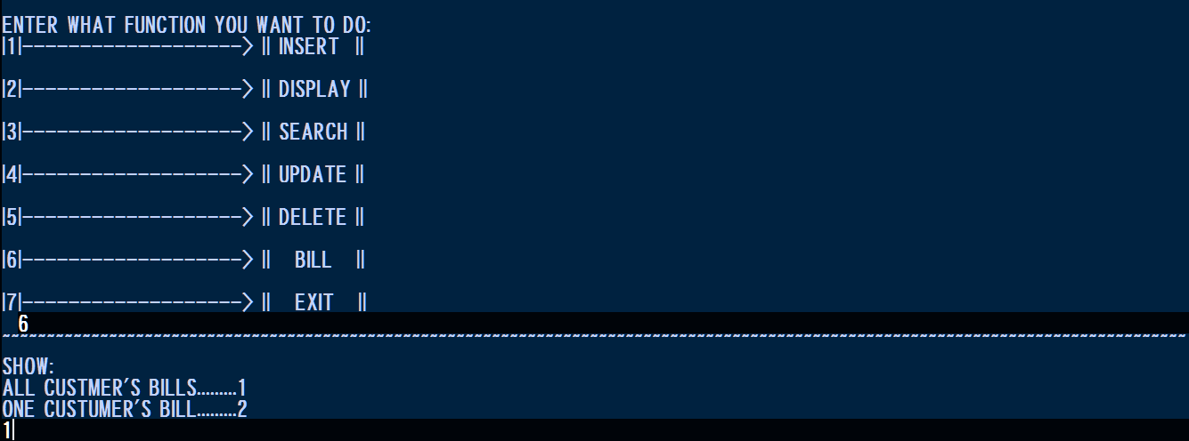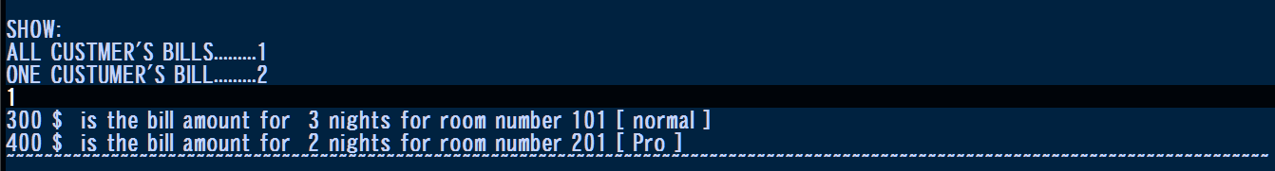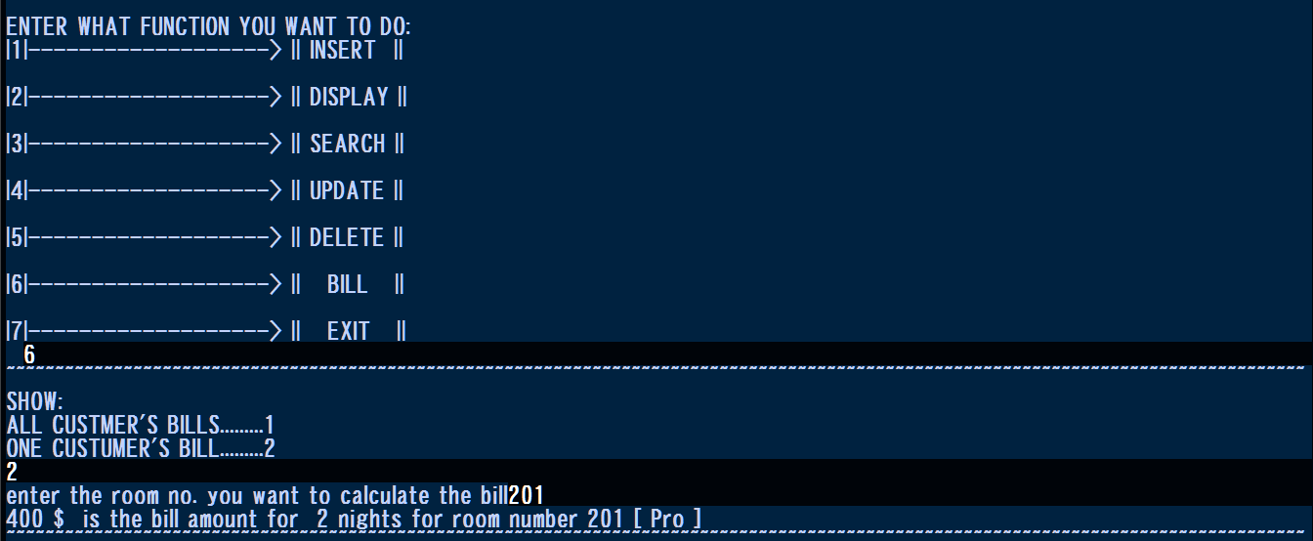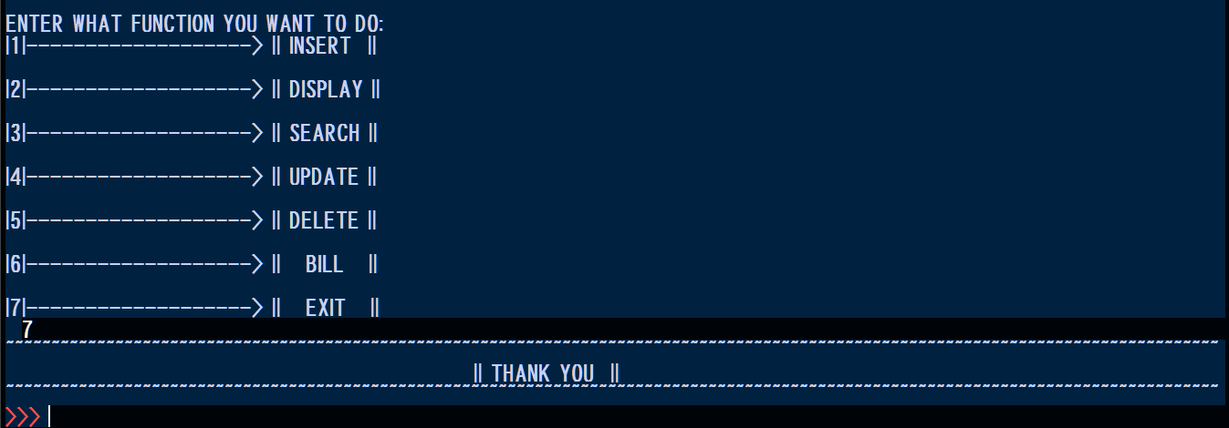

FUTURE ENHANCEMENTS
The current version of HOTEL GRANDE INN successfully performs the basic operations required for managing hotel room records. However, several improvements can make the program more convenient, secure, reliable, and user-friendly.Although “HOTEL GRANDE INN” successfully performs the basic operations of hotel record management, there is scope for further improvement. Some of the current limitations and possible future enhancements are listed below:
Limitations:
- The project currently uses a text-based, command-line interface, which may not be as user-friendly as a graphical interface.
- Data is stored using the pickle module in a local file, which is not as secure or scalable as a proper database system.
- The ins() function overwrites previous records instead of appending to them, which means only one set of records can be maintained at a time.
- There is no login or password protection, so anyone with access to the program can view or modify the data.
- The program does not support multiple users accessing the system simultaneously.
- There is limited validation of user input, which could lead to errors if incorrect data is entered.
Future Enhancements:
- A Graphical User Interface (GUI) can be developed using Tkinter to make the program more interactive and user-friendly.
- The project can be upgraded to use a proper database management system such as MySQL, to store data more securely and allow for larger volumes of records.
- The insertion function can be modified to append new records instead of deleting previous ones, allowing multiple guest records to accumulate over time.
- A login/authentication system can be added to restrict unauthorized access to sensitive hotel data.
- Input validation can be improved to handle incorrect or unexpected user entries more gracefully.
- The billing function can be enhanced to include taxes, discounts, and generate printable invoices/receipts.
These improvements would make HOTEL GRANDE INN more suitable for practical hotel administration while retaining its basic Python programming foundation.

BIBLIOGRAPHY
1. Arora, Sumita. Computer Science with Python, Class XI. Dhanpat Rai & Co.
2. Arora, Sumita. Computer Science with Python, Class XII. Dhanpat Rai & Co.
3.Mosh Hamedani. Python Programming Videos. YouTube
4.GeeksforGeeks www.geeksforgeeks.org

