RippleCarry4 code goes here, but it’s the same code

module Adder8(

input Cin,

input [7:0] A,

input [7:0] B,

output [7:0] S,

output Cout

);

wire cout3;

RippleCarry4

rc40(Cin, A[3:0], B[3:0], S[3:0], cout3),

rc41(cout3, A[7:4], B[7:4], S[7:4], Cout);

endmodule

Timing Diagram

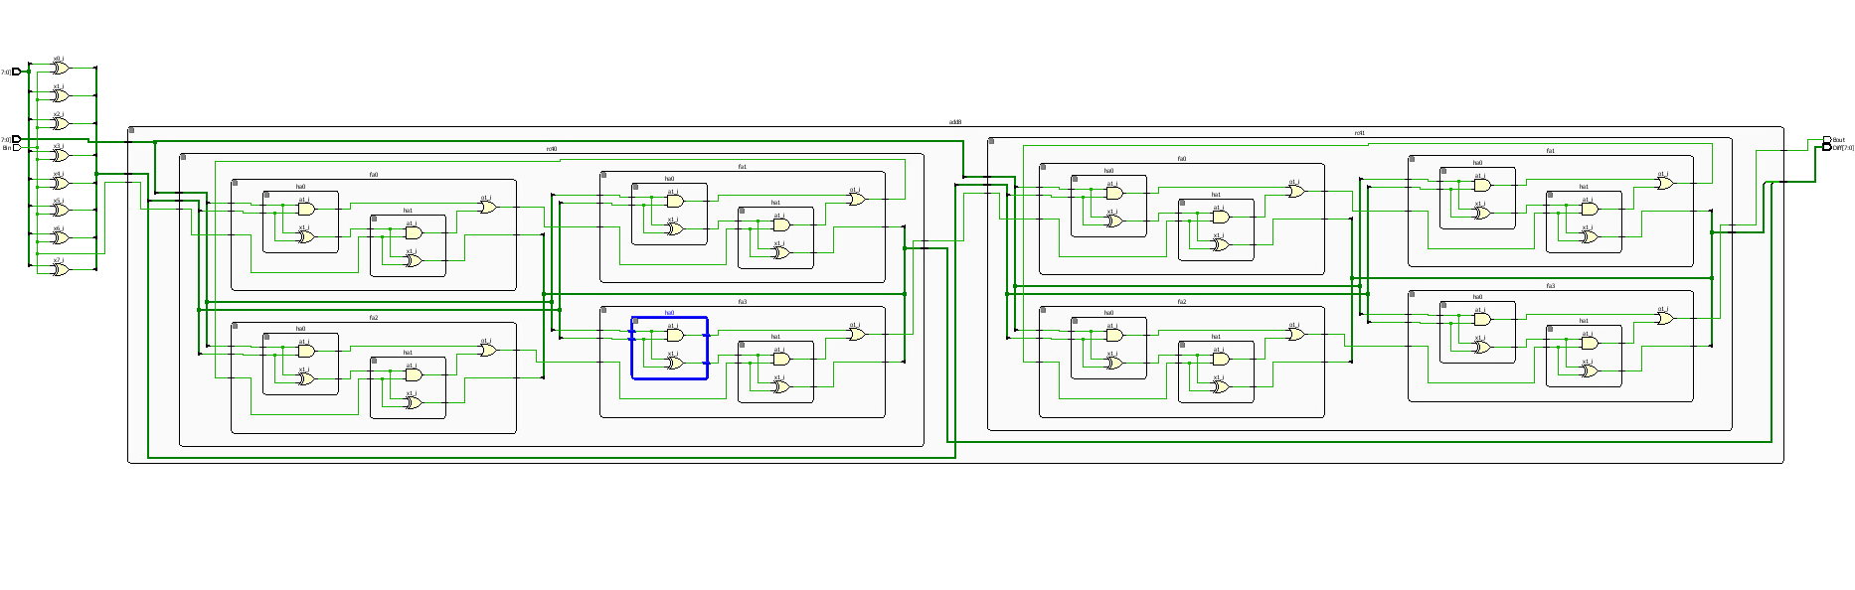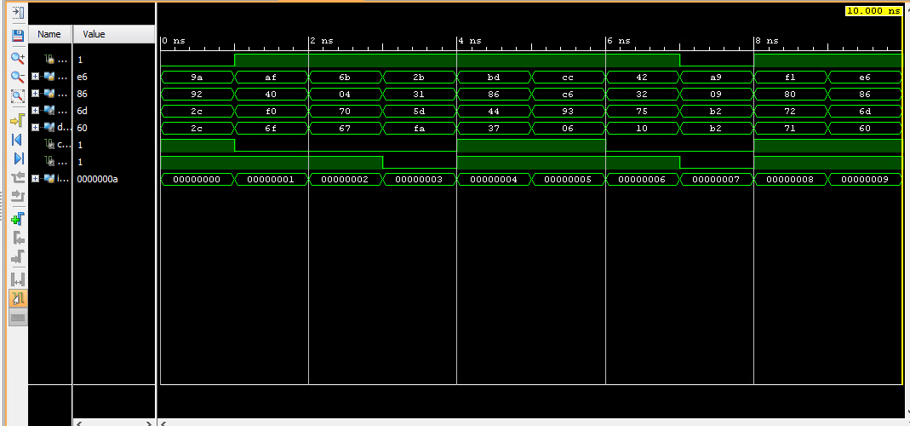

Schematic just in case

Youtube Link:

<https://youtu.be/VmebTCkcLN4>