Comparator

Design Code

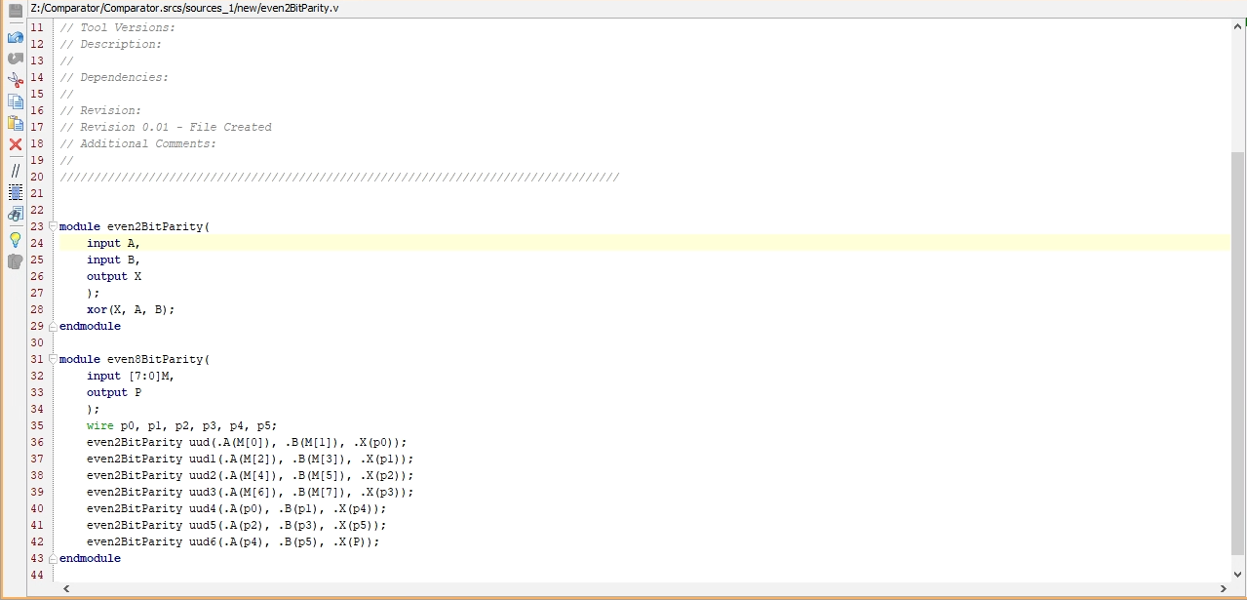

Test Bench

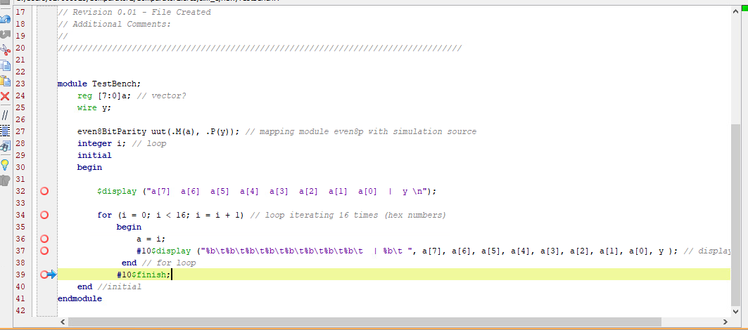

RTL Schematic

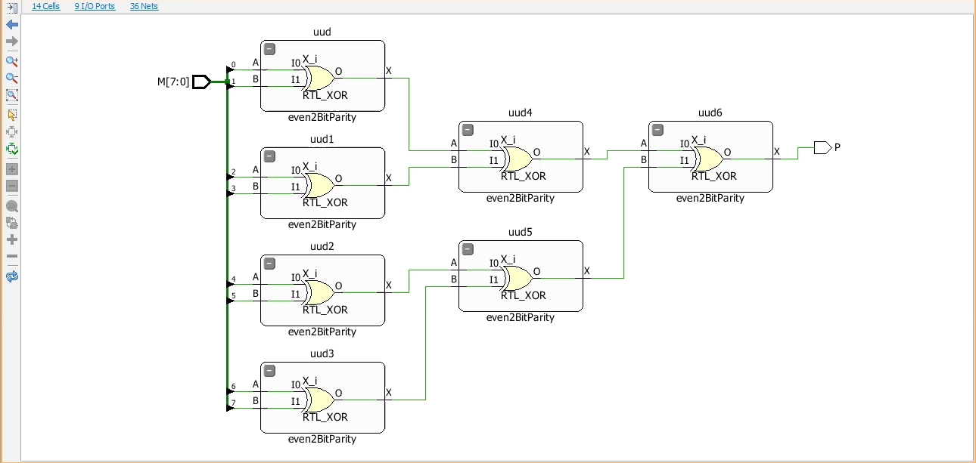

Timing Diagram

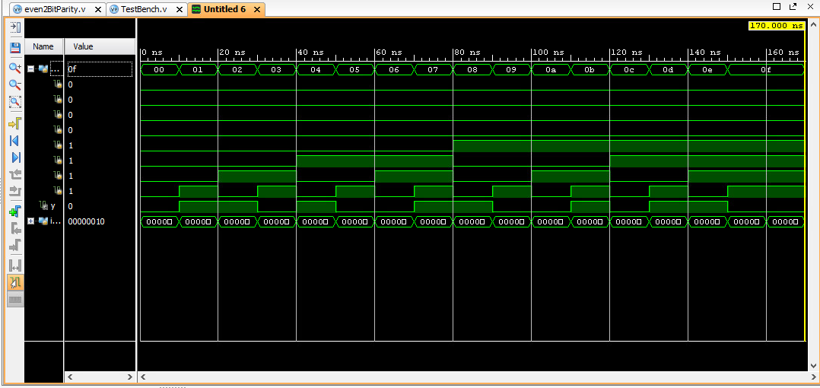

Youtube link:

<https://www.youtube.com/watch?v=js_w9cWSjX8>