Ripple Adder

RippleCarry4.v

`timescale 1ns / 1ps

module HalfAdder(

input a,

input b,

output c,

output s

);

xor x1(s, a, b);

and a1(c, a, b);

endmodule

module FullAdder(

input a,

input b,

input cin,

output s,

output cout

);

wire carryGenerate, carryPropagate, sum1;

HalfAdder ha0(.a(a), .b(b), .c(carryGenerate), .s(sum1));

HalfAdder ha1(.a(sum1), .b(cin), .c(carryPropagate), .s(s));

or o1(cout, carryGenerate, carryPropagate);

endmodule

module RippleCarry4(

input cin,

input [3:0] a,

input [3:0] b,

output [3:0] s,

output cout

);

wire cout0, cout1, cout2;

FullAdder fa0(a[0], b[0], cin, s[0], cout0);

FullAdder fa1(a[1], b[1], cout0, s[1], cout1);

FullAdder fa2(a[2], b[2], cout1, s[2], cout2);

FullAdder fa3(a[3], b[3], cout2, s[3], cout);

Endmodule

Schematic

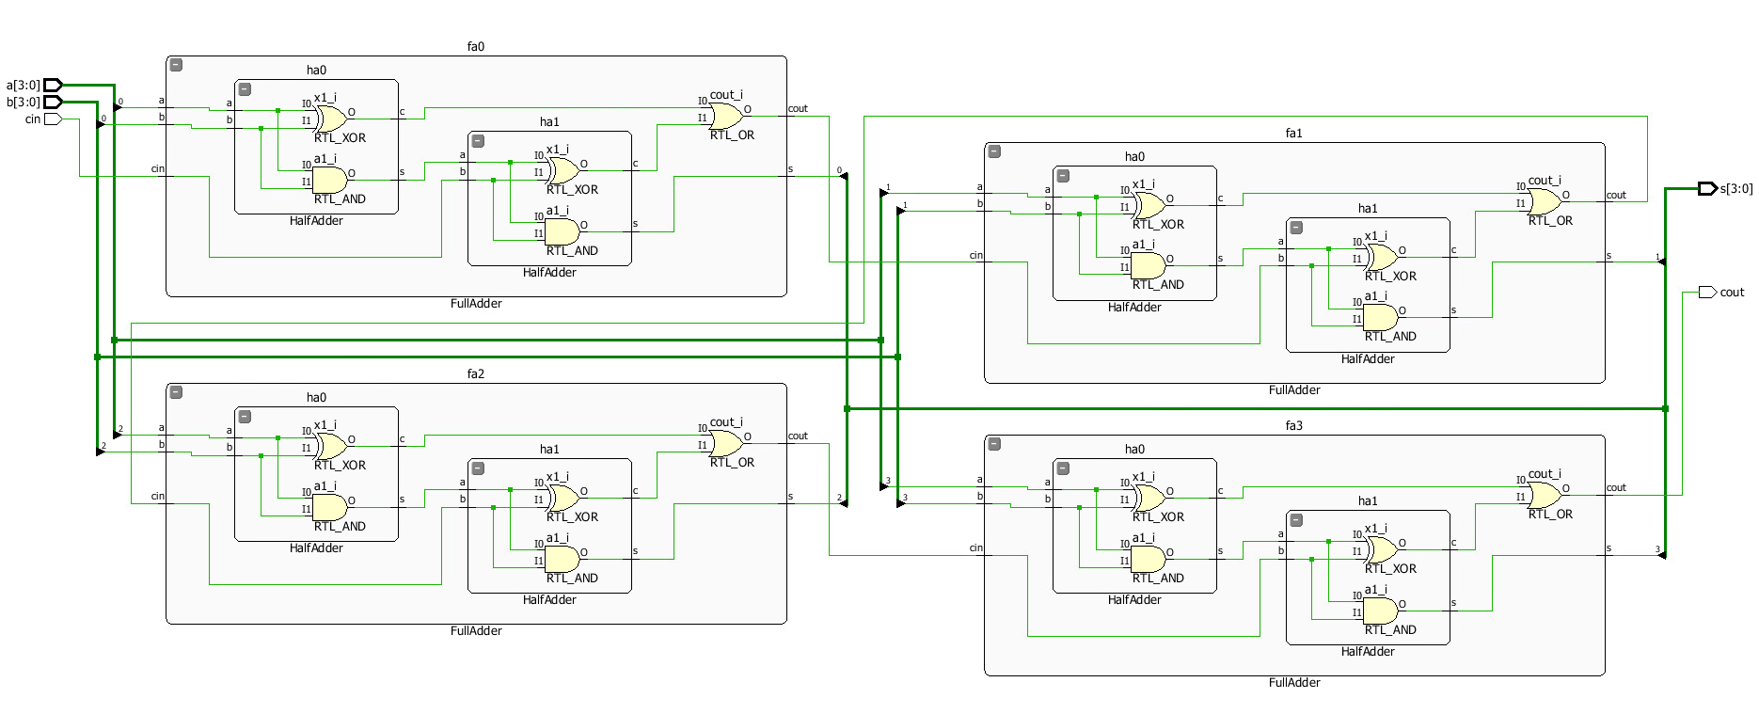

TestBench

`timescale 1ns / 1ps

module TestBench();

reg cin;

reg [3:0] a, b;

wire [3:0] s;

wire cout;

RippleCarry4 rut(cin, a, b, s, cout);

integer i;

initial

begin

$display ("4-bit Ripple Carry");

cin = 0;

for (i = 0; i < 8; i = i+1)

begin

#1 {a, b} = $random;

#5 $display ("a = %d, b = %d, s= %d, cout = %b", a, b, s, cout);

end

end

endmodule

Timing Diagram

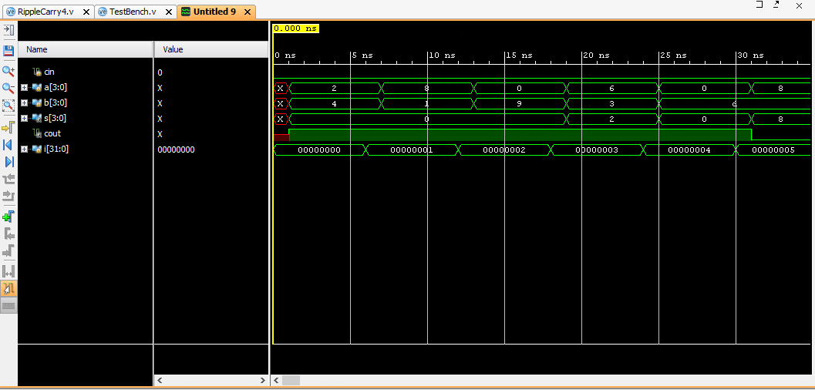

Youtube link:

<https://youtu.be/eHOL4aypPaw>