1. Write the boolean equation:
   1. assign X = (L & (T & P)) | (~L & (T & W)) | (~L & (~T & P)) | (~L & (~W & T));

|  |  |  |  |  |  |  |  |  |
| --- | --- | --- | --- | --- | --- | --- | --- | --- |
| L | T | P | W | L & (T&P) | ~L & (T&W) | ~L & (~T&P) | ~L & (~W&T) | X |
| 0 | 0 | 0 | 0 | 0 | 0 | 0 | 0 | 0 |
| 0 | 0 | 0 | 1 | 0 | 0 | 0 | 0 | 0 |
| 0 | 0 | 1 | 0 | 0 | 0 | 1 | 0 | 1 |
| 0 | 0 | 1 | 1 | 0 | 0 | 1 | 0 | 1 |
| 0 | 1 | 0 | 0 | 0 | 0 | 0 | 1 | 1 |
| 0 | 1 | 0 | 1 | 0 | 1 | 0 | 0 | 1 |
| 0 | 1 | 1 | 0 | 0 | 0 | 0 | 1 | 1 |
| 0 | 1 | 1 | 1 | 0 | 1 | 0 | 0 | 1 |
| 1 | 0 | 0 | 0 | 0 | 0 | 0 | 0 | 0 |
| 1 | 0 | 0 | 1 | 0 | 0 | 0 | 0 | 0 |
| 1 | 0 | 1 | 0 | 0 | 0 | 0 | 0 | 0 |
| 1 | 0 | 1 | 1 | 0 | 0 | 0 | 0 | 0 |
| 1 | 1 | 0 | 0 | 0 | 0 | 0 | 0 | 0 |
| 1 | 1 | 0 | 1 | 0 | 0 | 0 | 0 | 0 |
| 1 | 1 | 1 | 0 | 1 | 0 | 0 | 0 | 1 |
| 1 | 1 | 1 | 1 | 1 | 0 | 0 | 0 | 1 |

1. Write the truth table
2. Write the Boolean equation using the minterms

~L&(~T&P)&~W + ~L&(~T&P) &W+ ~L&(~W&T) + ~L&(T&W)&~P + ~L&(~W&T) + ~L&(T&W)&P + L&(T&P)&~W + L&(T&P)&W

1. Simplify

P&T + P&~L + T&~L

1. K-map



|  |  |  |  |  |
| --- | --- | --- | --- | --- |
|  | 00 | 01 | 11 | 10 |
| 00 | 0 | 1 | 0 | 0 |
| 01 | 0 | 1 | 0 | 0 |
| 11 | 1 | 1 | 1 | 0 |
| 10 | 1 | 1 | 1 | 0 |

~LT + ~L&P + P&T

1. Full expression for truth table

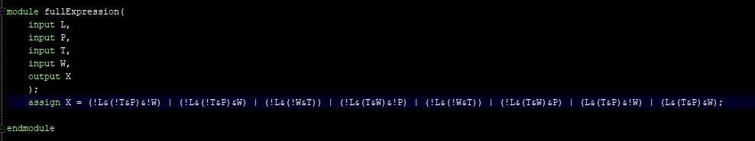

Simplified expression for truth table

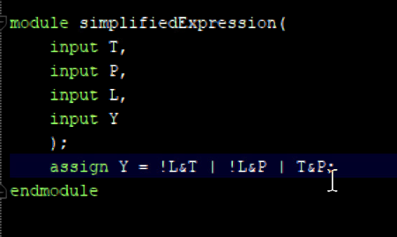

fullExpression timing Diagram

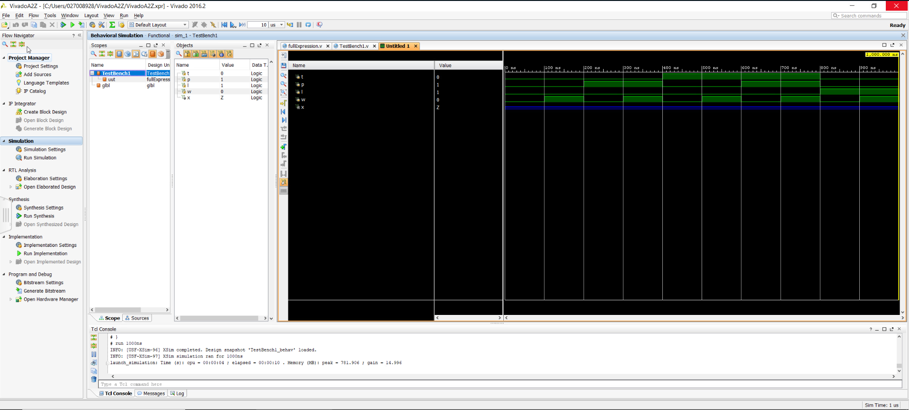

simplifiedExpression timing Diagram

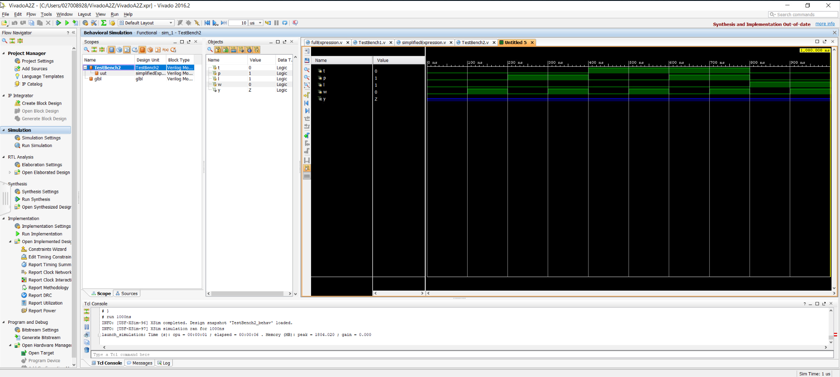

Schematic

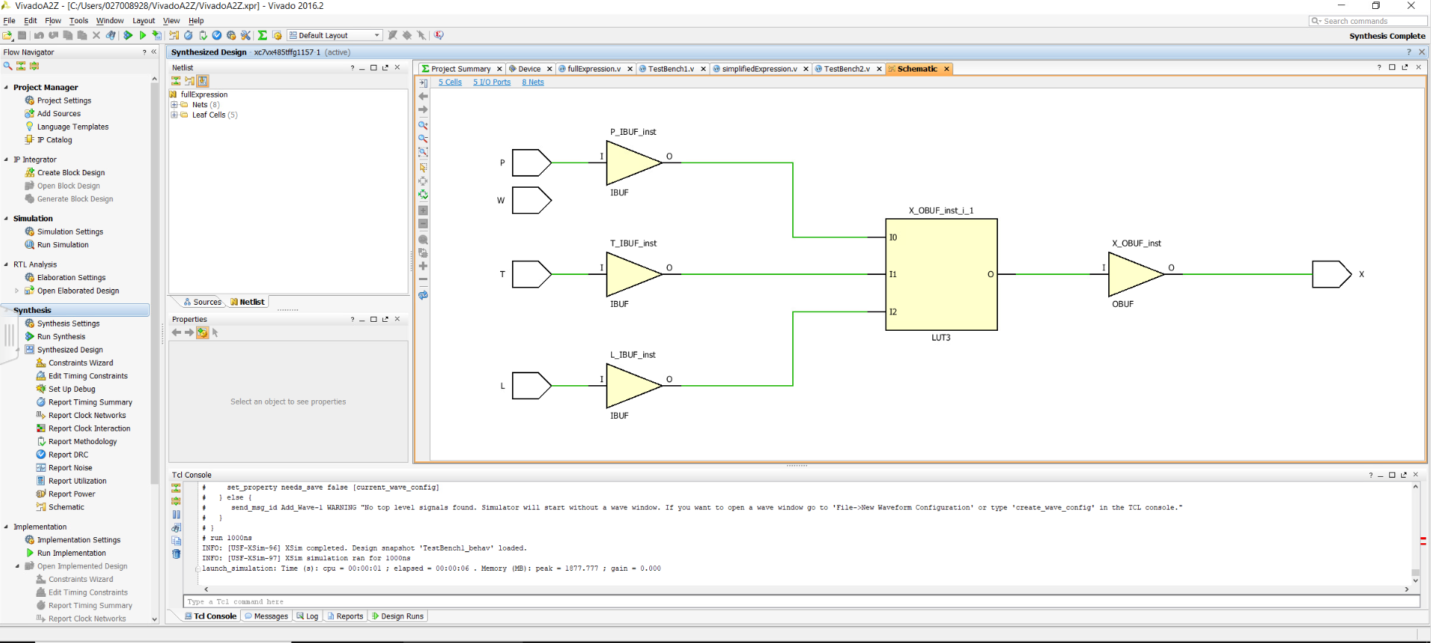

Youtube Video:

<https://youtu.be/MMeyKJ4j3CM>