OR Gate

1. Schematic 1

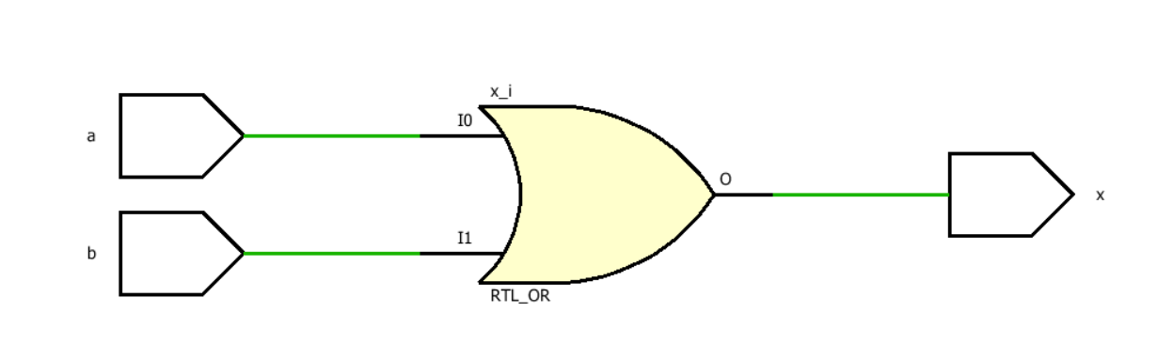

1. Schematic 2

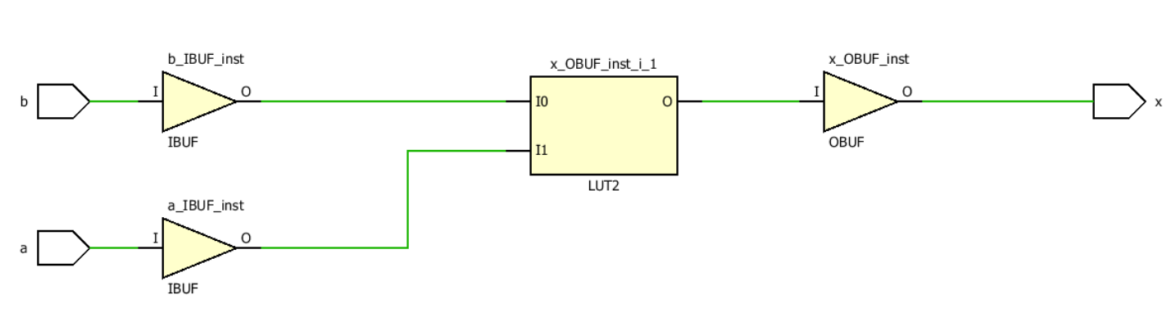

1. Timing diagram

