CSULB

Lab

Write the truth table for a 3-input xor gate. Derive the equation using sum of product.

Use logic.Ly, build the circuit using the your function, and make sure that your truth table is

correct.

Build the same 3-xor gate using two more methods (using a 3-input xor gate, using 2, 2-input

xor gates.

In every step just make sure that the truth table is correct.

Draw the timing diagram.

Submit the truth table, a screenshot of your drawings, and the timing diagram in one

document. Upload as a pdf.

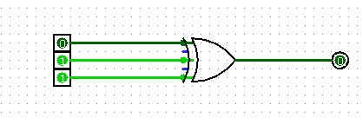3-input xor gate:

|  |  |  |  |
| --- | --- | --- | --- |
| A | B | C | Y = A **⊕**B**⊕C** |
| 0 | 0 | 0 | 0 |
| 0 | 0 | 1 | 1 |
| 0 | 1 | 0 | 1 |
| 0 | 1 | 1 | 0 |
| 1 | 0 | 0 | 1 |
| 1 | 0 | 1 | 0 |
| 1 | 1 | 0 | 0 |
| 1 | 1 | 1 | 1 |

2 2-input xor gates

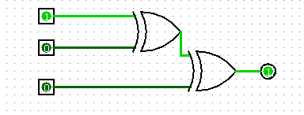 correct truth table

Timing Diagram for 2 2-input xor

