Name: Matthew Zaldana

CECS 225 – Computer Architecture

Assignment #03 Logic Gates Due: 17 SEP 2020 (8am)

Please download the software Logisim from [http://www.cburch.com/logisim /download.html](http://www.cburch.com/logisim%09/download.html) and install in your computer. Then open Logisim.

1. Click on HELP button in the ribbon at the top of the Logism desktop.
2. Click on the Tutorial to open it
3. Follow the instructions stated in the 5 steps of the Tutorial
4. The circuit you create should resemble this:

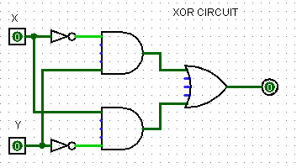

1. 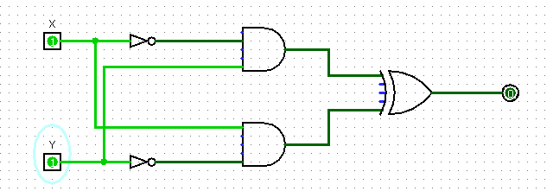Verify the truth table by using the four different inputs of X and Y and entering them in the table. You should get the outputs shown in red. What is its name?

|  |  |  |
| --- | --- | --- |
| Name: XOR Circuit | | |
| X | Y | Output |
| 0 | 0 | 0 (0) |
| 0 | 1 | 1 (1) |
| 1 | 0 | 1 (1) |
| 1 | 1 | 0 (0) |

All my outputs match

1. Modify the Logisim circuit of #4 by moving the inter-connect from terminal X to the lower AND gate to the other side of the inverter and do the same with the interconnect from Y to the upper AND gate. Complete the truth table for this new logic circuit: What is its name?

|  |  |  |
| --- | --- | --- |
| Name: NOR Circuit | | |
| X | Y | Output |
| 0 | 0 | 1 |
| 0 | 1 | 0 |
| 1 | 0 | 0 |
| 1 | 1 | 0 |

1. Modify the Logisim circuit of #4 by changing AND gates to OR gates and the OR gate to an AND gate. Complete the truth table for this new logic circuit. What is its name?

|  |  |  |
| --- | --- | --- |
| Name: XNOR Circuit | | |
| X | Y | Output |
| 0 | 0 | 1 |
| 0 | 1 | 0 |
| 1 | 0 | 0 |
| 1 | 1 | 1 |