Yes

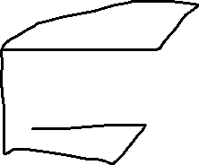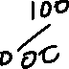

We can see that that each two vertices differ by exactly 1 bit.