CECS 327 – Assignment 1

Problems:

1. Efficiency, b/c packets can find their own paths to their destination without the need for a dedicated channel. That way there is no requirement to establish a channel and is available to all users throughout the network. Also, long messages are broken down into packets and sent individually, this eliminates packet loss.
2. Application – sends data over end systems via HTTP, SMTP, and FTP   
   transport – transfers content between two endpoints via TCP  
   network – moves packets between hosts via IP  
   data link – moves packets from one node to next node using P2P  
   physical – transfers individual bits from one node to next using physical materials, e.g. ethernet cable, coaxial, etc.
3. Transmission delay = L/S = 8 bits/byte * 1500 bytes / 2,000,000 bps = .006 s  
   Propagation delay = D / S = 2500 km / 2.5 * 10 ^5 km / s = .01 s  
   Total time delay = .006 + 0.01 s = 0.016 s  
   No, it does not depend on packet length nor transmission rate.
   1. RTT = 2 * Propagation delay = 2 * (D / S) = 2 * (385000 km / 3 * 10^5 m / s) = 2.56 s
   2. RTT * bandwidth = 2.56 s * 1 Gbps = 2560000000 bits or 320 MB
   3. This means how much data can be sent over the network at any given time.
   4. Min time is request RTT + transfer TT = 2.56 + (2.56 / 2 ) = 3.84 s
   5. Ping [www.google.com](http://www.google.com)  
      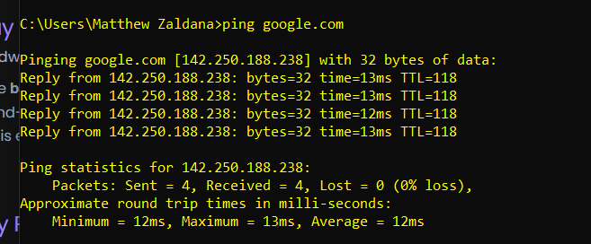  
      Minimum: 12ms, maximum: 13 ms, Average: 12 ms
   6. Ping -n 2 [www.google.com](http://www.google.com) vs ping -n 7 [www.google.com](http://www.google.com)  
      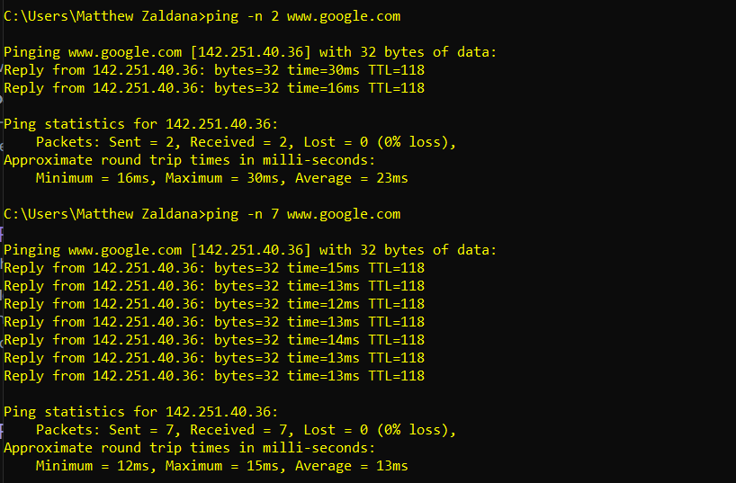  
      Difference is the count of ping requests sent out
   7. Ping 10.0.0.50  
      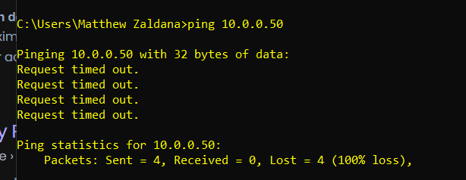  
      Request timed out 4 times, this probably happens due to the IP address being unreachable, firewall rules put in place that don’t allow me to contact the IP, or the requested IP address is not available.
   8. Ping [www.imperialequestriancenter.com](http://www.imperialequestriancenter.com)  
      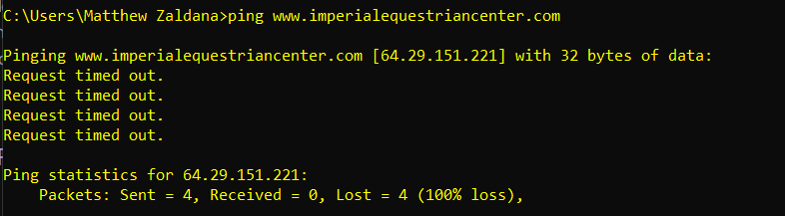  
      No I did not for the reasons described above. However, I did receive the IP address of the domain name
4. 1. Tracert [www.google.com](http://www.google.com)  
      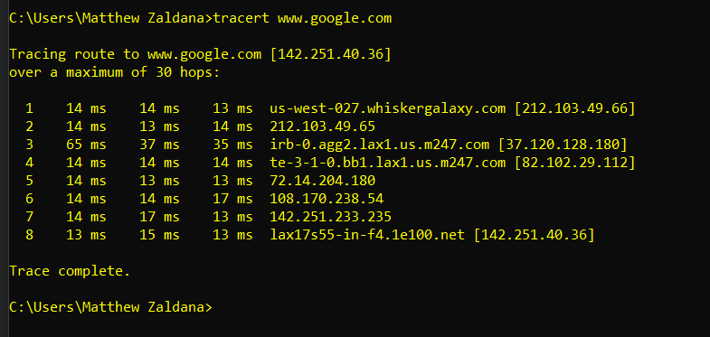  
      8 hops
   2. Tracert [www.ieee.org](http://www.ieee.org)  
      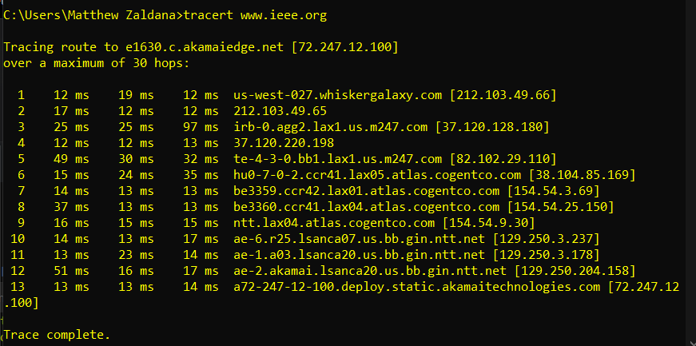  
      Same ones are the first, second, third hops
   3. Tracert [www.ubc.ca](http://www.ubc.ca)  
      Tracert -d [www.ubc.ca](http://www.ubc.ca)  
      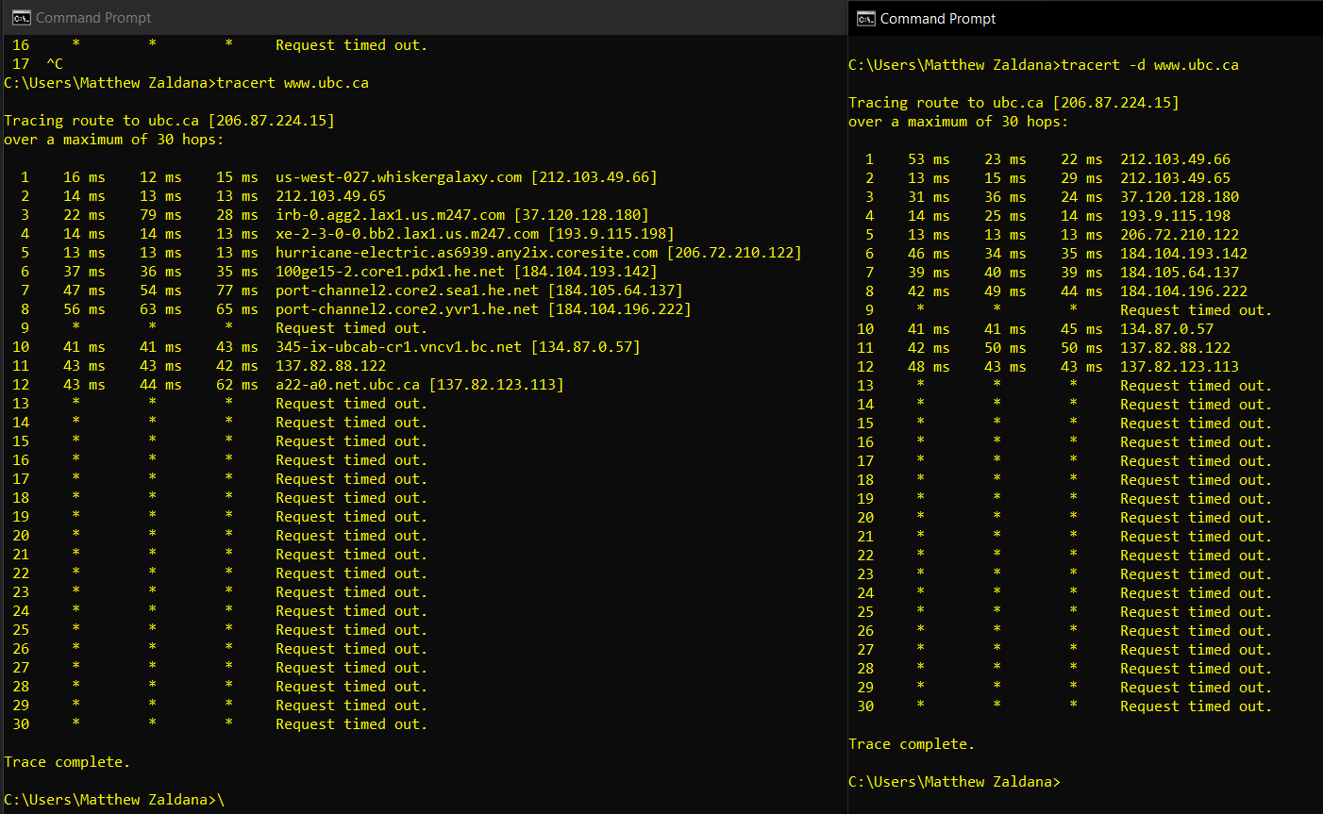  
      The difference is that it doesn’t display the domain name when using the -d flag option. It ialso went by a lot faster.
   4. Compare different hosts  
      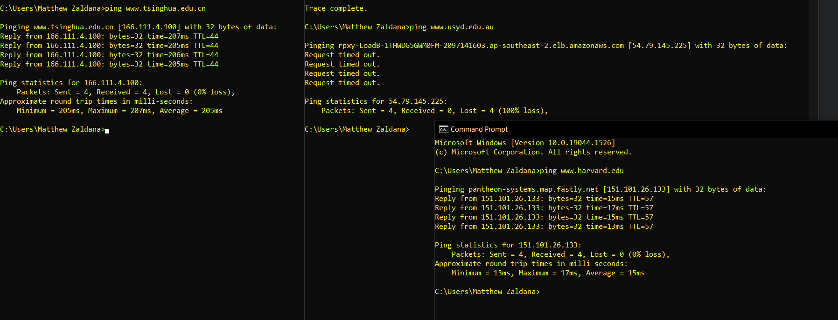  
      I notice that those that are closer to me are faster to respond and have a smaller average of round times than those that are farther. Also, those domains such as usyd.edu.au may be behind a firewall and don’t allow me to get a reply back b/c inbound communication port may be disabled.
   5. Use traceroute mapper  
      For Harvard.edu:  
      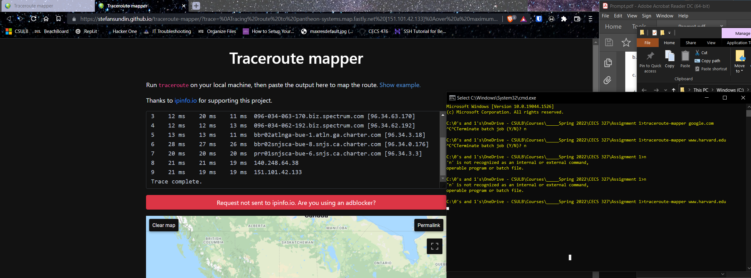  
      Sorry professor, the website does not work for me for any host trace route mapping, I followed the example to see how formatting should work, however, not even the example maps out the route of the trace.   
      However, I can conclude that the route for the first couple of hops is the same because the trace is navigating throughout my wifi-provider’s network. From there, the shorter the distance to the host, the shorter the trace route is as well.