1. **PC-1 and PC-2 and PC-3 are now in the same broadcast domain. In your own words, explain the concept of a broadcast domain** 
   1. A broadcast domain is a set of IP addresses that belong to one network device. This encapsulates all the devices connected to a network and allows each one to connect to each other.
2. **What was the result of the arp command on your PCs? Explain this result.** 
   1. Arp allows the computer to see all the available connections communicating on its port. Since there is only a switch in the configuration, the computers will look for all the connections on the switch and save the IP address and MAC address of each device
3. **What are the MAC addresses assigned to PC-1 and PC-2 and PC-3?** 
   1. MAC addresses:  
      PC-1: 00:50:79:66:68:00  
      PC-2: 00:50:79:66:68:01  
      PC-3: 00:50:79:66:68:02
4. **Are PC-1 and PC-2 and PC-3 in the same layer 3 network? Explain your answer.** 
   1. Yes, because they are all connected to the same switch.
5. **Are PC-1 and PC-2 and PC-3 in the same broadcast domain? Explain your answer.** 
   1. Yes because they are all connected to the same switch.
6. **Include the contents of the arp tables from all PCs in your lab report.** 
   1. PC-1  
      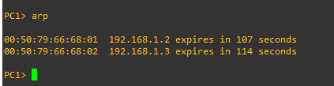  
      PC-2  
      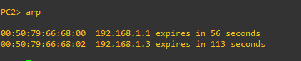  
      PC-3  
      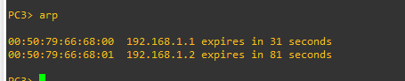
7. **Explain the purpose of ARP and how it works. Use appropriate terminology for things like OSI or TCP layer names or numbers, protocols, addresses, and datagram names (i.e. packet, segment, frame, etc.). Be specific and discuss how caching improves performance.** 
   1. ARP saves the IP address and MAC address of each device on the network. When the ping command is called from one computer to another, the request bounces back with a packet containing the information of the device which is saved in the computer’s arp table. When the arp table is saved, the computer knows which computer has what MAC address and can locate it quickly when a packet has to be forwarded. This is the concept of caching and improves the performance of the computer.
8. **Did the MAC address on the PCs change when you changed the IP address on PC2? Why?** 
   1. No, the MAC address stays the same as it is soldered onto the NIC.
9. **Is PC-2 in the same layer 3 network as it was when it had an IP address of 192.168.1.2? Explain.** 
   1. Yes, it still lives on the switch as an IP address on it.
10. **Is PC-2 in the same broadcast domain as it was when it had an IP address of 192.168.1.2? Explain.** 
    1. No, the broadcast is now different, because it belongs to a different subnet.
11. **Why does the ping from PC-1 to PC-2 (and PC-3 to PC-2)fail? Explain this in terms of layer 3 networks and broadcast domains** 
    1. The ping fails because PC-2 is now in a different broadcast domain, in a different pool of IP addresses.

This lab showed me how computers communicate with each other so quickly to the point that they are constantly monitoring any changes that are occurring throughout the network. The *save* and *arp* commands are very helpful when seeing these changes as it allows me to not think about whether some network device or folder that exists on my network is still there or whether its IP address has changed or not. I appreciate the fact that this is all being done in the background and that this data is being configured all the time. I am impressed as well with the speed with which they communicate. I can’t imagine where we could get in the next couple of years regarding newer and faster connections that are continuously being built. To prepare for this lab, I first opened all the documentation I could find on how to install GNS3 as well as pros and cons of each OS and which one benefits me the most. I think for the next lab I would consider doing the same thing, however, I would also open the slides and notes that I have written so I understand better what each component and rule is being solidified in the prompt provided. I think that something that could help with this lab is reviewing the information that has already been discussed in class as well as looking up some more information on YouTube or other documents online that explain each of the terminology and commands to more of a extent so that you know all the things that are being involved in each of the commands.