|  |  |  |  |  |
| --- | --- | --- | --- | --- |
|  | Router 1 | Success? (y/n) | Router 2 | Success? (y/n) |
| 1 | R1# ping 192.168.102.1 | N | R2# ping 192.168.101.1 | N |
| 2 | R1# ping 192.168.100.2 | Y | R2# ping 192.168.100.1 | Y |
| 3 | R1# ping 192.168.101.1 | Y | R2# ping 192.168.102.1 | Y |

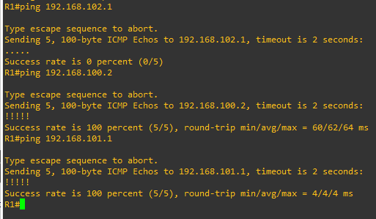

1. Some pings aren’t successful because they aren’t pingable address or those IP addresses weren’t configured on the network. For example, R1 cannot access the fast ethernet interface on R2 ending in 100.2 as it is in a different interface card 0/0 rather than 1/0. The same goes for R2 which cannot access IP address 101.1 on R1 as this IP assigned to the fast ethernet 0/0 is on a different interface that cannot be accessed.
2. 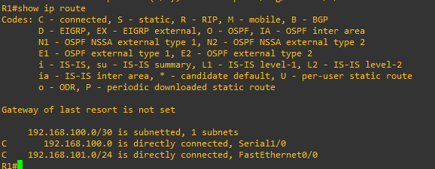  
   Text

   Description automatically generated  
   The show ip route command shows the connections of each ip address and the routes they must take on the interfaces they are in to be accessible to other devices on the network. Interestingly enough, the IP addresses in table that were not able to be pinged are shown that they are subnets which were not configured.
3. We can’t do this because IP addresses were not configured for the PC’s. DHCP isn’t automatic so we must assign IPs manually.   
   Text

   Description automatically generated  
   Text

   Description automatically generated  
   To get successful pings, we have to configure the device’s ip address with its subnet mask followed by the next router ip address on the same connected interface using ip route. The command goes like this: ip address mask gateway  
   Text

   Description automatically generated  
   A picture containing text

   Description automatically generated  
   Successfully pinged both PC’s