**CECS 378 – Spring 2021 – Uuh**

**Due:** Monday, February 1st by 11:59 PM

**The hands-on labs in this class will be run using virtual machines hosted within Oracle VirtualBox on your personal laptop. We will need to setup VirtualBox on your personal laptop along with several virtual machines, which we will document here.**

**Step 1 – Install Oracle VirtualBox**

The Oracle VirtualBox website can be found here: <https://www.virtualbox.org/>

Perform the following steps to install Oracle VirtualBox:

1. Access the VirtualBox website listed above.
2. Select the Download VirtualBox 6.1 link in the middle of the web page.
3. Select appropriate host (Windows hosts or OS X hosts) in the VirtualBox 6.1.16 platform packages section.

**Note:** VirtualBox 6.1.16 must be used to ensure compatible with SEEDLabs VM we will be using.

1. Select Save File and the file will be saved in your Downloads folder.
2. Right-click the VirtualBox-6.1.16-140961-Win.ext file in your Downloads folder and Select Run as Administrator. At the prompt, Select Yes. (This will start the setup wizard)
3. Select Next, at the Setup Wizard screen.
4. Select Next, at the Custom Setup screen. (Leave the default install directory)
5. Select Next, at the Custom Setup screen. (Leave all options selected)
6. Select YES, at the Network Warning screen and proceed with the installation.
7. Click Install, at the Ready to Install screen.
8. Select Install if you receive a Windows Security prompt. (Always trust software from “Oracle”)
9. Select Finish, at the installation complete screen.
10. Select OK if you receive a new version notification but DO NOT upgrade to future versions of VirtualBox.

The VirtualBox 6.1.16 application should now be installed.

**Step 2 – Install three SEEDLabs Virtual Machines**

Some of the labs we will be using come from the SEEDLabs website which can be accessed here:

<https://seedsecuritylabs.org/index.html>

The SEED labs come preconfigured and assume you are using their custom-built virtual machines. We will be using the 32-bit version of Ubuntu 16.04 (We will not be using the Beta versions).

Perform the following steps to install three SEED lab virtual machines:

1. Access the SEEDLabs website listed above.
2. Select the Lab Setup tab at the top of the page on the menu bar.
3. Scroll down to the Ubuntu 16.04 VM section, Select the DigitalOcean download location to download the SEEDUbuntu-16.04-32bit.zip file.
4. Select Save at the What do you want to do prompt. (Be patient as it is a large file - when the .part file disappears from the Download folder the download is complete)
5. Right-click the SEEDUbuntu-16.04-32bit zip file and select the Extract All option. Leave all the defaults at the next screen and Select Extract. The SEEDUbuntu-16.04-32bit.zip file folder will be created & you should see VM files in that folder when the extraction completes.
6. Select the “VM Manual” link in the Ubuntu 16.04 VM section on the SEEDLabs web site to run and configure the VM on VirtualBox by following Steps 1 thru 7 in the document.

**Note:** Please name the first virtual machine SEEDUbuntu1 when completing Step 2 in the SEED

Document.

1. Complete the steps in Appendix B and D on the SEEDUbuntu1 virtual machine.
2. Change the time zone on your SEEDUbuntu1 virtual machine to reflect Pacific time (Los Angeles) by clicking on the time in the upper right-hand corner of the screen.
3. Shutdown the SEEDUbuntu1 virtual machine.
4. Next, complete the steps in Appendix A to create the next two VM’s (name them SEEDUbuntu2 and SEEDUbuntu3)

The 3 SEEDLabs vm’s (SEEDUbuntu1, SEEDUbuntu2, & SEEDUbuntu3) should now be installed.

**Step 3 – Install a Windows Virtual Machine**

Some of the labs we will be doing will require a Windows virtual machine which you should be able to access from the CSULB software depot.

Perform the following steps to install the Windows 10 v1909 (or newer) virtual machine:

1. Access the CSULB Portal. Select Software Depot chiclet. Select Software | Microsoft | Win10.
2. Select Save at the What do you want to do prompt. (Be patient as it is a large file – status is shown in the lower left corner of the screen)
3. Once the iso file has been downloaded, open the VirtualBox Manager and Select New.
4. Enter Windows10 for the virtual machine Name, Select Microsoft Windows for the Type, Select Windows 10 (64-bit) for the Version and Select Next.
5. Leave the Memory size at 2048 MB and Select Next.
6. Select Create a virtual hard disk now (default) and Select Create.
7. Select VDI (default) and Select Next.
8. Select Dynamically allocated (default) and Select Next.
9. Adjust the File size to 50 GB and Select Create.
10. The virtual machine template is now created, you should see the Windows10 vm powered off.
11. Highlight the Windows10 vm and Select Settings.
12. Select the Advanced tab and Change Shared Clipboard and Drag’n’Drop to Bidirectional.
13. Select System | Processor & change number of Processor(s) to 2, Select Enable PAE/NX Option.
14. Select Storage, Select the Empty setting under Controller: SATA, Select the icon that looks like a CD-ROM at the far right (Optical Drive: setting), Select Choose/Create a Virtual Optical Disk File, Select Add, Select the en_windows_10_consumer_editions_version_1909_x64_dvd_be09950e ISO file you downloaded in step 2 (may be a different file name), Select Choose and Select OK.
15. Select Network and Change Attached To: to NAT Network, Select Advanced and Change Promiscuous Mode to Allow VM’s.
16. Start the Windows10 virtual machine in the VirtualBox Manager.
17. At the Windows Setup screen, Select the Language (English), Time (English), and Keyboard (US) settings, Select Next.
18. At the Windows Setup screen, Select Install Now.
19. At the Activate Windows screen, enter 2M6CM-FNH2D-F692C-MR34R-3DBMY for the product key, Select Next. **Note:** this is a valid product key for Win 10 consumer edition 1909 x64 and your product key may differ.
20. Accept the licensing terms, Select Next.
21. At the Which type of installation do you want?, Select Custom: Install Windows Only (Advanced)
22. At the Where do you want to install Windows?, Select Next. Be patient, this step takes a bit…the virtual machine will reboot twice, just let it install with no user input.
23. Ensure the United States is selected at the Region screen, Select Yes.
24. Ensure the US keyboard layout is selected, Select Yes.
25. At the enable second keyboard screen, Select Skip.
26. At the sign in with Microsoft screen, Select Domain join instead at bottom left corner of screen.
27. At the who is going to use this PC? Screen, enter a UserID (Do not forget this ID) and Select Next.
28. At the create a super memorable password Screen, enter a password (Do not forget this PW) and Select Next.
29. At the confirm the password Screen, re-enter the password and Select Next.
30. Create your three security questions for this PC. (Remember the 3 security question answers)
31. At the Do more with devices with activity history screen, Select No.
32. At the make Cortana your personal assistant? Screen, Select Decline.
33. At the choose privacy settings for your device screen, Select Accept. Be patient, this takes a bit.

The Windows 10 virtual machine should now be installed.

**Step 4 – Install a Kali Linux Virtual Machine**

Some of the labs we will be doing will require a Kali Linux virtual machine which can be accessed here: <https://www.kali.org/downloads/>

Perform the following steps to install the Kali Linux virtual machine:

1. Access the Kali Linux website listed above.
2. Select the Kali Linux 64-bit (installer).
3. Select Save at the What do you want to do prompt. (Be patient as it is a 4.1 Gb file and takes some time - when the .part file disappears from the Download folder the download is complete)
4. Once the iso file has been downloaded, open the VirtualBox Manager and Select New.
5. Enter KaliLinux for the virtual machine Name, Select Linux for the Type, Select Debian 64-bit for the Version and Select Next.
6. Adjust the Memory size to 2048 MB and Select Next.
7. Select Create a virtual hard disk now (default) and Select Create.
8. Select VDI (default) and Select Next.
9. Select Dynamically allocated (default) and Select Next.
10. Adjust the File size to 20 GB and Select Create.
11. The virtual machine template is now created, and you should see the KaliLinux vm powered off.
12. Highlight the KaliLinux vm and Select Settings.
13. Select the Advanced tab and Change Shared Clipboard and Drag’n’Drop to Bidirectional.
14. Select System | Processor & change number of Processor(s) to 2, Select Enable PAE/NX Option.
15. Select Storage, Select the Empty setting under Controller: IDE, Select the icon that looks like a CD-ROM at the far right (Optical Drive: setting), Select Choose/Create Virtual Optical Disk File, Select Add, Select the kali-linux-2020.3-installer-amd64 ISO file we downloaded in step 2, Select Choose and Select OK.
16. Select Network and Change Attached To: to NAT Network, Select Advanced and Change Promiscuous Mode to Allow VM’s.
17. Start the KaliLinux virtual machine in the VirtualBox Manager.
18. At the Boot Menu, Select Graphical Install and Enter.
19. At the Select a language page, Select English and Continue.
20. At the Select your location page, Select United States and Continue.
21. At the Configure the keyboard page, Select American English and Continue.
22. At the Configure the network page, Change the Host name: to KaliLinux and Select Continue.
23. At the Configure the network page, Leave the Domain name: blank and Select Continue.
24. At the Setup users and passwords page, enter the full name of the user and Select Continue.
25. At the Setup users and passwords page, enter the username for your account (Do not forget this ID) and Select Continue. **Note:** Must use lower case characters or numbers.
26. At the Setup users and passwords page, assign a password (i.e., KaliLinux) for your user account, re-enter the password for confirmation (Do not forget this PW) & Select Continue.
27. At the Configure the clock page, Select Pacific and Continue.
28. At the Partition disks page, Select Guided – use entire disk (default) and Select Continue.
29. At the Partition disks page, you should only have one item listed (default) and Select Continue.
30. At the Partition disks page, Select the All files in one partition (default) and Select Continue.
31. At the Partition disks page, Select Finish partitioning and write changes to disk (default) and Select Continue.
32. At the Partition disks page, At the Write the changes to disks?, Select Yes and Continue.
33. At the software selection page, leave the default selections and Select Continue.
34. At the Install the GRUB boot loader on a hard disk, Select Yes (default) and Continue.
35. At the Install the GRUB loader on a hard disk, Select the /dev/sda option and Select Continue.
36. At the Finish the Installation page, Select Continue.

The Kali Linux virtual machine should now be installed.

**Step 5 – Conclusion**

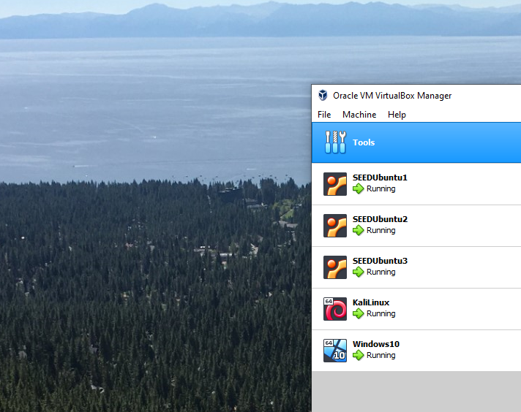

Submit a screen shot (like the one above) of your 5 ***running*** virtual machines along with something unique in the background using the snipping tool.

Post a file containing your screen shot in dropbox on BeachBoard to validate you performed Lab1.

This is the only document required to be submitted for Lab1.

**Note:** You should power off all your virtual machines when not in use!

Close the Oracle VirtualBox Manager application as well.

This will ensure your laptop is not negatively impacted by the lab environment.