Part 1

1. 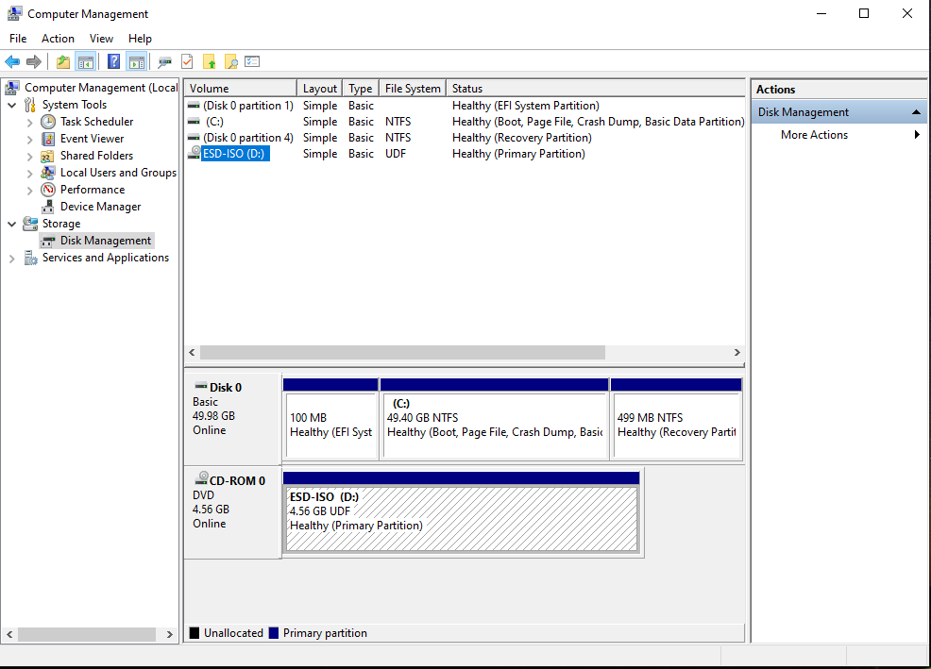



6. 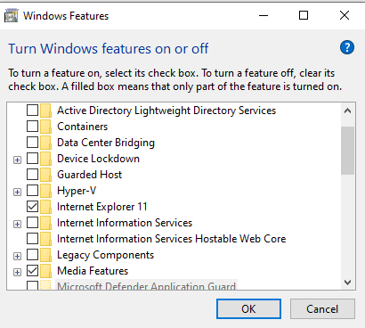
7. 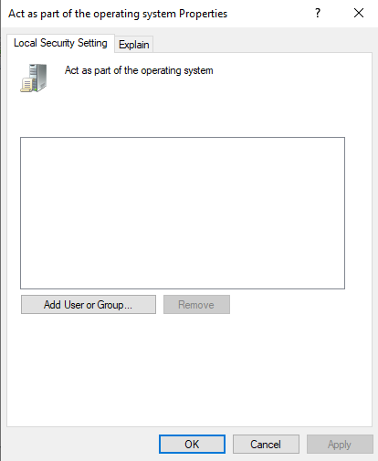
8. Implement whitelisting is one of the easiest things you can do so that admin/users can only access sites that are safe for the workplace they are in. Also, they can implement a strong group that limits access to a network connection or even better yet, uninstall web browsers.
9. 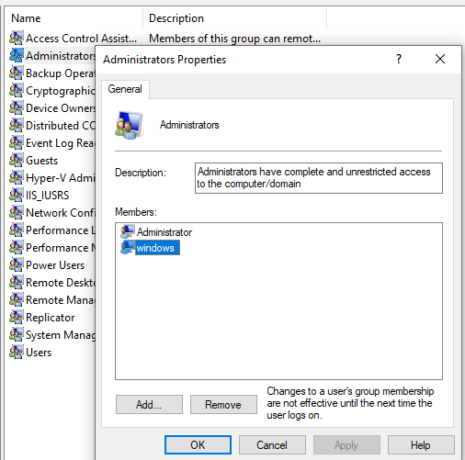
10. 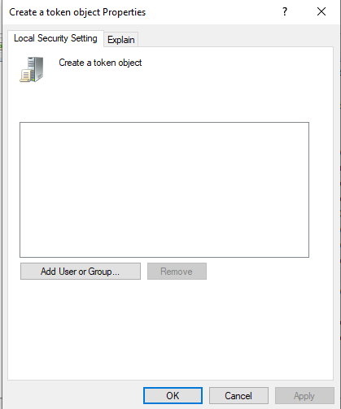
11. 

14. 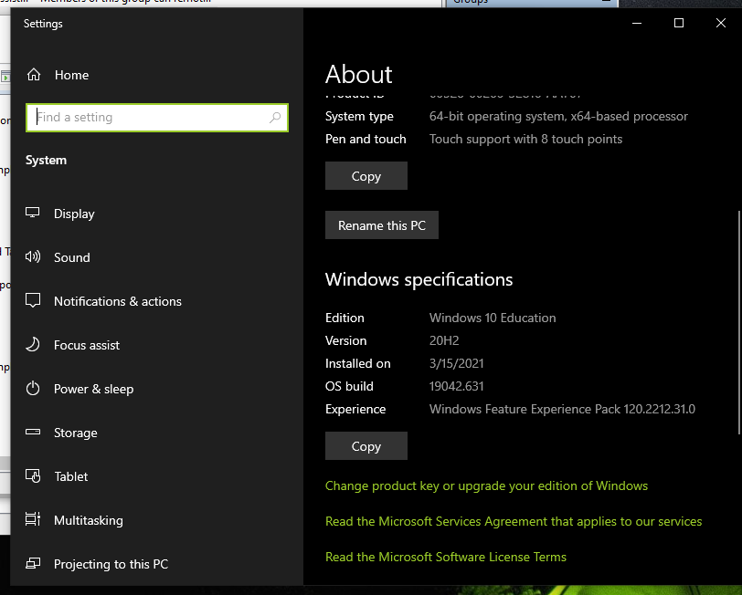
16.  It sets an entry option value in the boot configuration data store.

19. 05/02/23, it means no more updates for the version and security patches will be made for it

Part 2

1. Done
2. Done
3. Done
4. Done
5. Done
6. 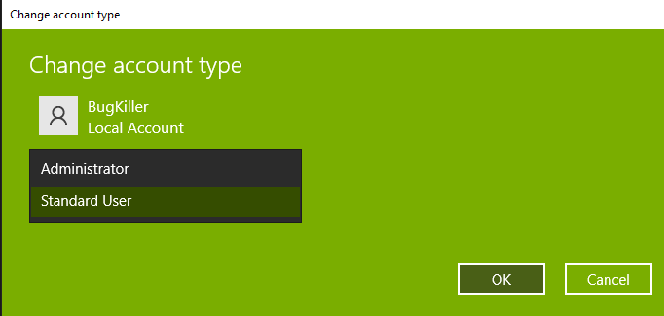
7. Done
8. Yes, I was able to shut it down via the command prompt as an admin hahaha, but technically, you can’t as it is a standard user with no privileges of shutting down due to the GPO enforced.