Part A

6. 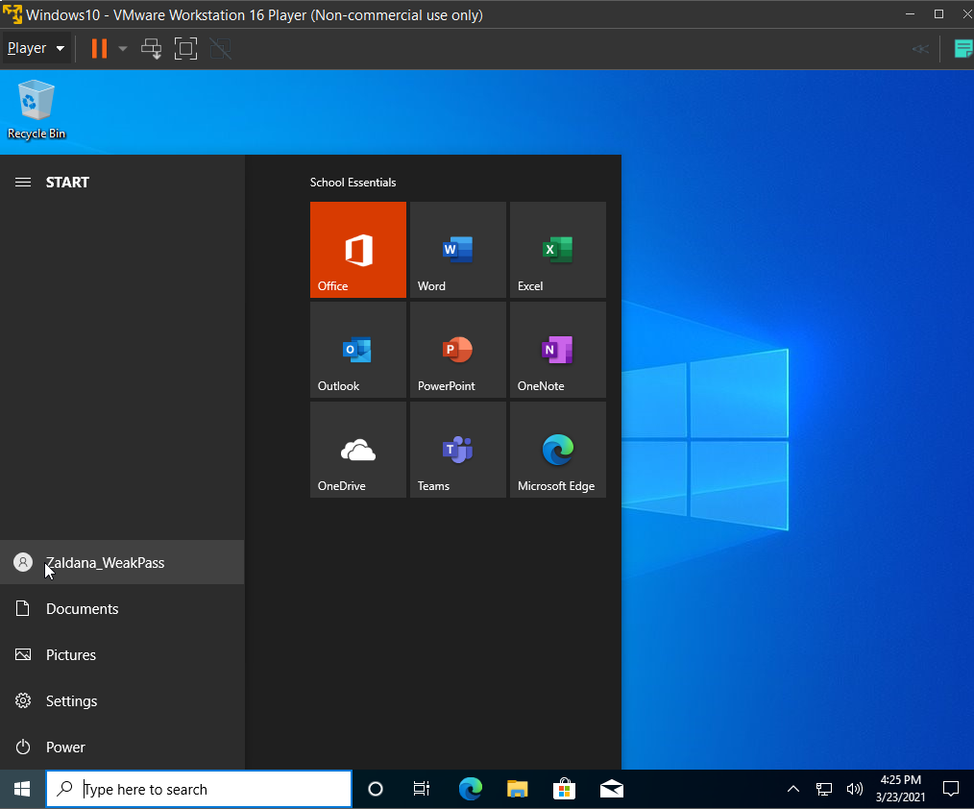

14. Switches to this function minidump within the program

18. b/c Im logged on as a regular user

24. b/c privileges to do this aren’t on

25. I had to run, Privileges::debug and token::elevate

28. Princess

30.

1. admin
   * 1. N/A
2. Zaldana_WeakPass
   * 1. password
3. Bright
   * 1. Rachel21
4. WHC
   * 1. 12345
5. Chan
   * 1. N/A
6. Cris
   * 1. 5692
7. josep
   * 1. N/A
8. Ear
   * 1. starcraft2
9. 5aga1
   * 1. N/A
10. Daniel
    * 1. N/A
11. Administrator
    * 1. N/A
12. Guardado
    * 1. 1904
13. Gulland
    * 1. N/A
14. riley
    * 1. N/A
15. cecs3
    * 1. Password N/A
16. xhika
    * 1. N/A
17. Mia
    * 1. N/A
18. miche
    * 1. N/A
19. MAPA
    * 1. N/A
20. Marlon Molina
    * 1. Password N/A
21. Moua
    * 1. 0335
22. TristanNguyen
    * 1. N/A
23. Francis
    * 1. N/A
24. Jason Panella
    * 1. N/A
25. Kevin
    * 1. N/A
26. austin patton
    * 1. N/A
27. Kevbot
    * 1. N/A
28. MayraSanchez
    * 1. N/a
29. Harry Tran
    * 1. 7500
30. alext
    * 1. N/A
31. Wei
    * 1. password
32. Work
    * 1. Password123

If any are N/A it’s because the file could not crack the password, maybe it’s too complex, or the VM’s hardware resources cap out.

Part B

8. sethc.exe runs the windows accessibility executable file for accessibility shortcuts and keystrokes

10. Causes COPY to replace existing files without providing a confirmation prompt.

17. use control panel, navigate to user acct, then change password

Use computer management and click on user to change password of

Call Microsoft ahahahha

**ONLY FOR PROS: USE RUFUS, you know what I mean hehehe**