第二次实验

实验一：weatherForecast
#include<iostream>
using namespace std;
bool updown = false;
int minTemp = 0;
void inputTemps(int temps[], int n) {
int temp = 0;
cout << "Please input the temprature: " << endl;
for (int i = 0; i < n; i++)
{
cin >> temp;
if (temp<0)
{
if (temp< minTemp)
{
minTemp = temp;
}
updown = true;
}
temps[i] = temp;
//cout << -minTemp << endl;
}
}
void displayTemps(int temps[], int n) {
for (int i = 0; i < n; i++)
{
cout << i + 1 << "\t";
if (updown)
{
int now = 0;
if (temps[i] > 0)
{
now = -minTemp;
for (int m = 0; m < now; m++)
{
cout << " ";
}
}
else
{
now = temps[i] - minTemp;
for (int m = 0; m < now; m++)
{
cout << " ";
}
for (int q = 0; q < -temps[i]; q++)
{
cout << "*";
}
}
cout << "|" ;
}
for (int j = 0; j < temps[i]; j++)
{
cout << "*";
}
cout << endl;
}
}
void displayPeaks(int temps[], int n) {
int hightTemps[15] = { 0 };
cout << "显示峰值如下: " << endl;
for (int i = 1; i < n-1; i++)
{

if (temps[i]>temps[i+1]&&temps[i]>temps[i-1]||temps[0]>temps[1])
{
hightTemps[i] = temps[i];
}
}
for (int i = 0; i < 15; i++) {
if (hightTemps[i]!=0)
{
cout << "Max at day " << i + 1 << " is " << hightTemps[i] << endl;
}
}

}
void displayFlat(int temps[], int n) {
int lenght = 1;
int MaxLenght = 0;
for (int i = 0; i < n; i++)
{
if (temps[i]==temps[i+1])
{
lenght++;
for (int j = i+1; j < n; j++)
{
if (MaxLenght < lenght)
{
MaxLenght = lenght;
}
if (temps[j] == temps[j + 1]) {
lenght++;
}
else
{
lenght = 0;
break;
}
}
}
}
cout << "显示崮的长度如下：" << endl;
cout << "The lenght of longest flat is " << MaxLenght << endl;
}
void displayMost(int temps[], int n) {
int most = 0;
int mostTemp = 0;
int lenght = 1;
for (int i = 0; i < n; i++)
{
for (int j = i+1; j < n; j++)
{
if (temps[i]==temps[j])
{
lenght++;
}
if (lenght > most)
{
most = lenght;
mostTemp = temps[i];
}
}
lenght = 1;
}
cout << "出现次数最多的温度是：" << mostTemp<< endl;
cout<<"出现次数：" << most << endl;
}
int main() {
int temps[15];
inputTemps(temps, 15);
displayTemps(temps, 15);
displayPeaks(temps, 15);
displayFlat(temps, 15);
displayMost(temps, 15);
system("pause");
return 0;
}
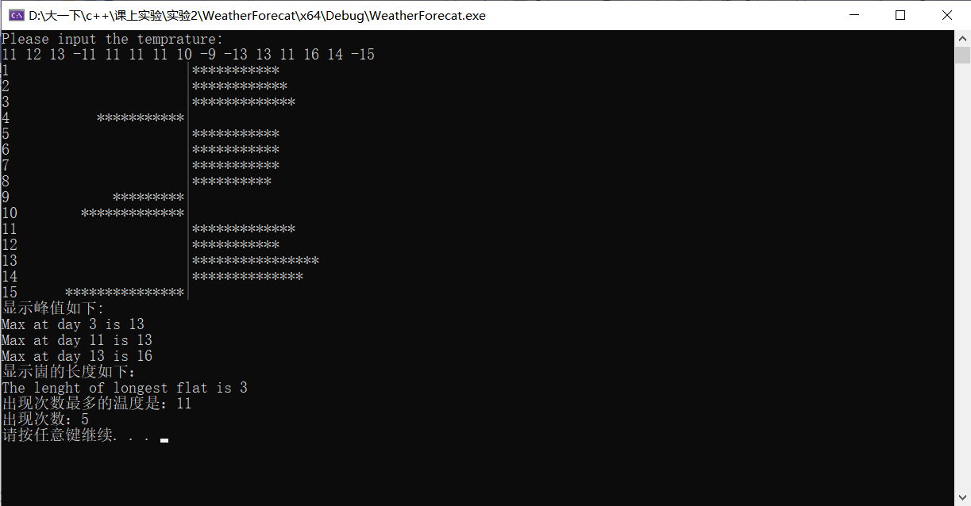

实验二：将牌
#include<iostream>
using namespace std;
#include<cstring>
#include<algorithm>
struct Data {
char data[7];
}charString[7];
bool cmp(const Data& elem1, const Data& elem2) {
if (strcmp(elem1.data, elem2.data) < 0) {
return true;
}
return false;
}
void printString(string trump) {
for (int i = 0; i < 7; i++)
{
cout << trump[i];
}
cout << endl;
}
void charArray(string trump,int num) {
/*for (int i = 0; i < 7; i++) {
for (int j = 0; j < 7; j++)
{
charString[i][j] = '0';
}
}*/
for (int i = 0; i < 7; i++)
{
charString[num].data[i] = trump[i];
}
}
void printChar() {
for (int i = 0; i < 7; i++) {
for (int j = 0; j < 7; j++)
{
if(charString[i].data[j]!='0')
cout << charString[i].data[j];
}
cout << endl;
}
}
void sortChar() {
sort(charString, charString + 6, cmp);
}
void FindString(string trump,int times) {
int space = 0;
int white = 0;
int black = 0;
int step = 0;
string FakeTrump = trump;
for (int i = 0; i < 7; i++)
{
for (int j = 0; j < 7; j++) {
charString[i].data[j]='0';

}
}
bool change = true;
cout << "结果_" << times << "：" << endl;
for (int i = 0; i < 7; i++)
{
if (trump[i]=='W')
{
white++;
}
else if (trump[i] == 'E')
{
space++;
step = i;
}
else if(trump[i] == 'B')
{
black++;
}
if (white == 3&&black==0)
{
cout << "目标格局" << endl;
change = false;
break;
}
}
if (change) {
char temp;
int num = -3;
int hang = 0;
for (int j = 0; j < 7; j++)
{
if (step + num < 7 && step + num >= 0&& num !=0) {
temp = FakeTrump[step + num];
FakeTrump[step + num] = FakeTrump[step];
FakeTrump[step] = temp;
charArray(FakeTrump,hang);
hang++;
FakeTrump = trump;
}
num++;
}
sortChar();
printChar();
}
}
int main() {
int step = 0;
string trumpCard;
int num = 0;
cin >> num;
for (int i = 0; i < num; i++)
{
cin >> trumpCard;
FindString(trumpCard,i+1);
}
system("pause");
return 0;

}
