实验五

Circle
#include<iostream>
using namespace std;
struct Point
{
int x;
int y;
};
void displayMenu() {
cout << "***************" << endl;
cout << "***1.Circle****" << endl;
cout << "***2.Rectangle*" << endl;
cout << "***0.exit******" << endl;
cout << "***************" << endl;
cout << "请选择图形：";
}
int getTwoPoints(struct Point *startP, struct Point * endP) {
cout << "请确保输入的坐标均为正数！" << endl;
cout << "请输入起始坐标的（x，y）坐标：" << endl;
cin >> (*startP).x;
cin >> startP->y;
cout<<"请输入最终坐标的（x，y）坐标：" << endl;
cin >> endP->x;
cin >> endP->y;
if (endP->y<=startP->y||endP->x<=startP->x)
{
cout << "输入坐标有误，请确保最终坐标比起始坐标大后重新输入！" << endl;
return 0;
}
}
//void printPoint(struct startP*) {
//
//}
int drawCircle(struct Point* startP, struct Point* endP) {
if (endP->x-startP->x!=endP->y-startP->y)
{
cout << "您的输入并不是一个圆，请重新输入！" << endl;
return 0;
}
else
{
cout << "圆心坐标为：(" << (endP->x +startP->x)/2 << "," << (endP->y + startP->y)/2 << ")" << "圆的半径为：" << (endP->x - startP->x) / 2 << endl;
}
}
int drawRectangle(struct Point* startP, struct Point* endP) {
if (endP->x - startP->x == endP->y - startP->y)
{
cout << "这是一个正方形，它的边长是：" << endP->x - startP->x << endl;
return 0;
}
cout << "长方形的长是：" << endP->x - startP->x << " 宽是：" << endP->y - startP->y << endl;
}
int main() {
int choice=1;
struct Point startP, endP;
while (choice) {
displayMenu();
cin >> choice;
switch (choice)
{
case 1:
if (getTwoPoints(&startP, &endP) != 0) {
drawCircle(&startP, &endP);
};
system("pause");
system("cls");
break;
case 2:
if (getTwoPoints(&startP, &endP) != 0) {
drawRectangle(&startP, &endP);
};
//drawRectangle(&startP, &endP);
system("pause");
system("cls");
break;
case 0:
cout << "欢迎下次使用！" << endl;
exit(0);
break;
default:
cout << "输入错误请重新输入！" << endl;
system("pause");
system("cls");
break;
}
}
return 0;
}
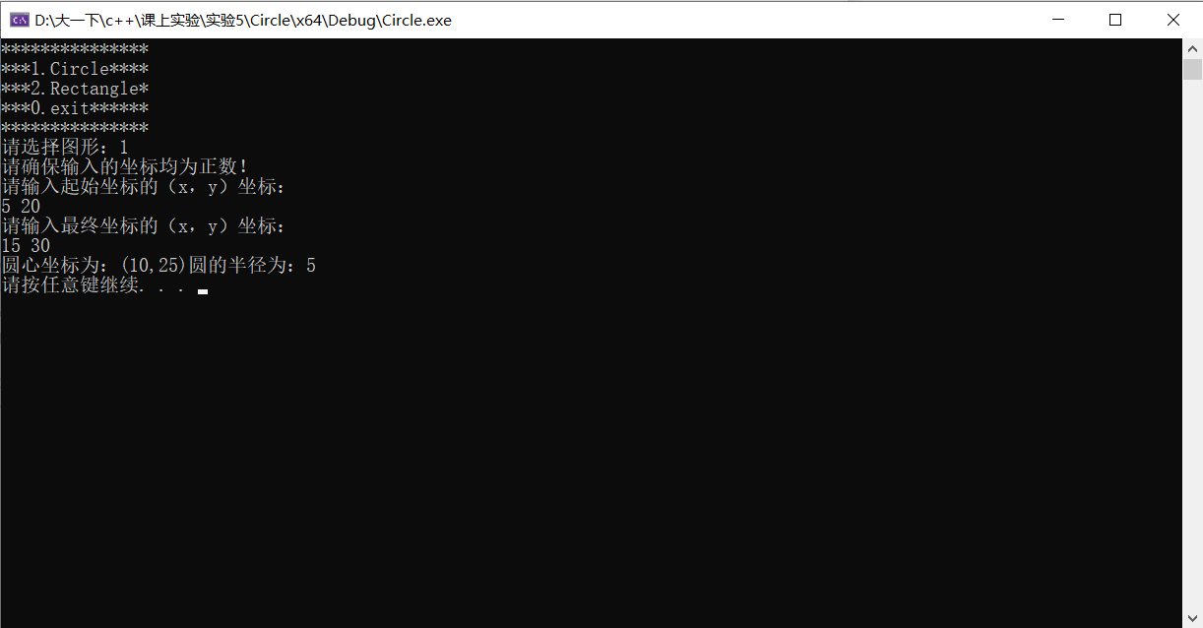
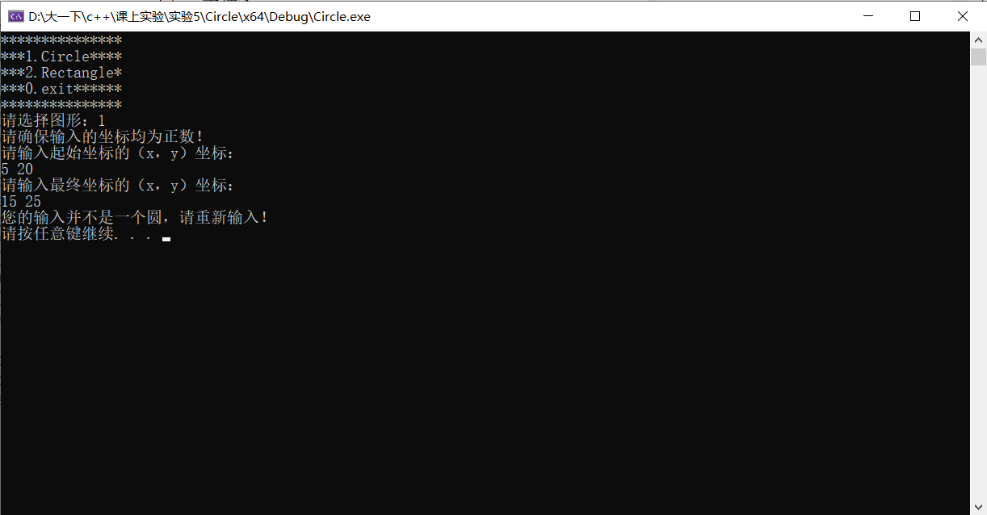
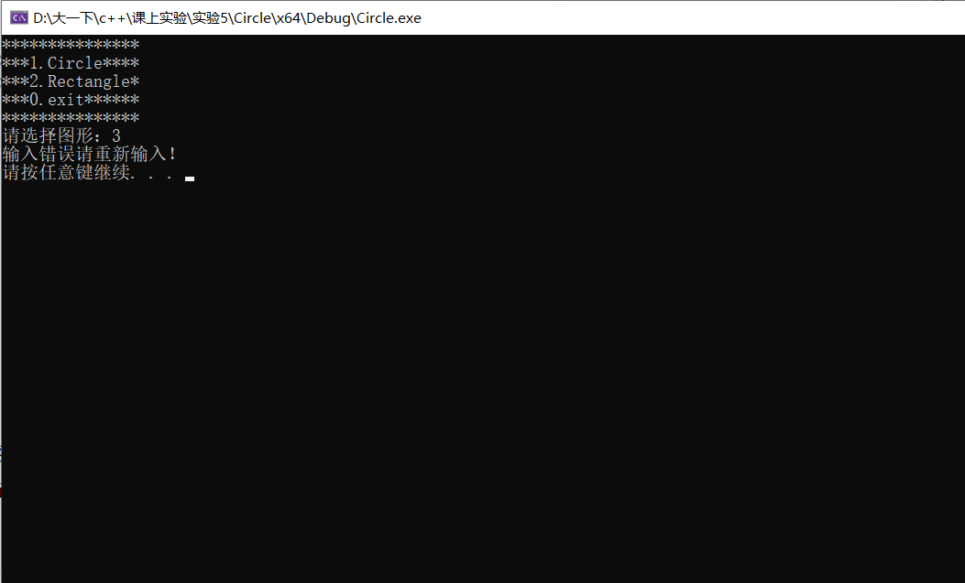
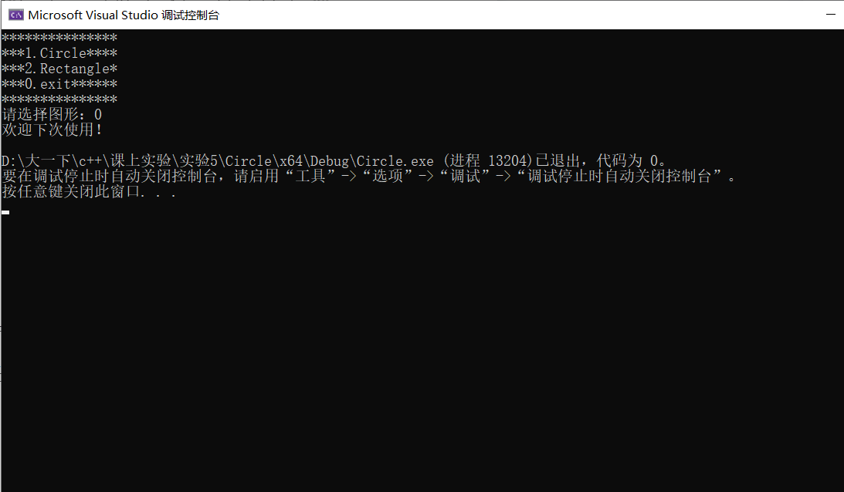

Revenue
#include<iostream>
#include<iomanip>
using namespace std;
struct Rule
{
int money;
int revenue;
};
void printRules(Rule* Rules,int step) {
cout << endl;
cout << "纳税规则如下：" << endl;
cout << "纳税线\t" << "税率" << endl;
for (int i = 0; i < step; i++)
{
cout << Rules[i].money << "\t" << Rules[i].revenue << endl;
}
}
void countRevenue(Rule* Rules,int sum,int step) {
int upper = 0;
float revenue = 0;
for (int i = 0; i < step; i++)
{
if (sum>=Rules[i].money)
{
upper = i;
}
}
//cout << upper << endl;
//revenue += 1.0;
//cout << revenue << endl;
if (sum <= Rules[0].money) {
cout << "您的收入是：0，应缴所得税：0.00元。" << endl;
}
else
{
if (upper==0)
{
revenue += (sum - Rules[upper].money) * Rules[upper].revenue * 0.01;
}
else
{
for (int i = 0; i < upper; i++)
{
revenue += (Rules[i + 1].money - Rules[i].money) * Rules[i].revenue * 0.01;
//cout << revenue << endl;
}
revenue += (sum - Rules[upper].money) * Rules[upper].revenue * 0.01;
}
cout << "您的收入是：" << sum << " , 应交所得税是：" << revenue << "元。" << endl;
}
}
int main() {
int num = 0;
int step = 0;
int choice = 0;
cout << "请输入规则的条数：" << endl;
cin >> num;
Rule* Rules = new Rule[num];
for (int i = 0; i < num; i++)
{
cout << "请输入第 " << i+1 << " 条规则：";
cin >> Rules[i].money;
cin >> Rules[i].revenue;
step++;
}
//cout << (sizeof(Rules) / sizeof(Rules[0])) << endl;
printRules(Rules, step);
while (true)
{
cout << "请输入您的收入：" << endl;
cin >> choice;
if (choice == -1) {
cout << "再见" << endl;
break;
}
else
{
countRevenue(Rules, choice, step);
}
}
return 0;
}
