实验六
#include<iostream>
using namespace std;
#include<string>
#include <ctime> // For time()
#include <cstdlib> // For srand() and rand()
#include<vector>
#include<iomanip>

const int MAX_TYPE = 62;

//class TravelWay {
//public:
// TravelWay(int Destination){
// this->Destination = Destination;
// }
// int Destination = 0;
//};
class TicketOffice {
public:
TicketOffice(int type) {
if (type == 1)
{
this->Destination = "DomesticShort";
this->money = 10;
}
else if (type == 2) {
this->Destination = "DomesticLong";
this->money = 100;
}
else if (type == 3) {
this->Destination = "International";
this->money = 500;
}
}
int getMoney() {
return this->money;
}
string getDestination() {
return this->Destination;
}
private:
int type = 0;
string Destination;
int money = 0;
};

class Team {
public:
Team() {

}
Team(int Destination) {
this->Destination = Destination;
}
void setDestination(int Destination) {
this->Destination = Destination;
}
int getDestination() {

return this->Destination;
}
void AddNum() {
this->num++;
}
int getNum() {
return this->num;
}
string getDestinationName() {
this->ticket = new TicketOffice(this->Destination);
return this->ticket->getDestination();
}
int SumMoney() {
int money = this->num * this->ticket->getMoney();
return money ;
}
int getMoney() {
int money = this->ticket->getMoney();
return money;
}
~Team() {
if (this->ticket!=NULL)
{
this->ticket = NULL;
}
}
private:
int Destination = 0;
int num = 0;
TicketOffice* ticket = NULL;
};

Team team[5];

class Luggage
{
public:
string getName() {
return this->name;
}
void setName(string name) {
this->name = name;
}
//Luggage(string name) {
// this->name = name;;
//};
//~Luggage();

private:
string name;
};

class Passenger
{
public:
Passenger(char name, int LuaggageNum, int Destination, int TravelWay) {
this->name = name;
this->LuaggageNum = LuaggageNum;
this->Destination = Destination;
this->TravelWay = TravelWay;
if (this->TravelWay == 0)
{
this->ChoseTravelWay = "旅行社";
for (int i = 0; i < 5; i++)
{
if (team[i].getDestination() == this->Destination && team[i].getNum() < 6) {
team[i].AddNum();
this->isteam = true;
break;
}
}
}
else
{
this->ChoseTravelWay = "自由行";
}
this->ticket = new TicketOffice(this->Destination);
};
int countMoney() {
//this->money = this->ticket->getMoney();
if (this->LuaggageNum <= 2 && this->Destination == 3)
{
this->money = 0;
}
else if (this->LuaggageNum == 3 && this->Destination == 3) {
this->money = 100;
}
else
{
this->money += this->LuaggageNum * 100;
}
return this->money;
}
void report() {
this->coutLuggage();
cout << "我是乘客" << this->name << ",选择" << this->ChoseTravelWay<<",目的地："<< this->ticket->getDestination()<< "\t携带" <<this->LuaggageNum<< "件行李，行李编号是";
for (int i = 0; i < this->LuaggageNum; i++)
{
cout << this->MyLuggage[i].getName();
}
cout << "\t买票需付" << this->ticket->getMoney() << "\t行李托运费" << this->countMoney() << "元" << endl;
}
int getMoney() {
return this->ticket->getMoney();
}
char getName() {
return this->name;
}
void coutLuggage() {
string namesand = { '1','2','3' };
this->MyLuggage = new Luggage[this->LuaggageNum];
for (int i = 0; i < this->LuaggageNum; i++)
{
string LuggageName = "0";
LuggageName[0]= this->name;
LuggageName += '0';
LuggageName += namesand[i];
MyLuggage[i].setName(LuggageName);
}
}
int getDestination() {
return this->Destination;
}
bool getIsteam() {
return this->isteam;
}
~Passenger() {
if (this->ticket!=NULL||this->MyLuggage!=NULL)
{
this->ticket = NULL;
this->MyLuggage = NULL;
}
}

private:
char name;
int LuaggageNum = 0;
int Destination = 0;
int money = 0;
int TravelWay = 0;
bool isteam = false;
string ChoseTravelWay;
TicketOffice* ticket = NULL;
Luggage* MyLuggage = NULL;
};

int main() {
srand(static_cast<unsigned> (time(NULL))); // 初始化随机数发生器
int PassengerNum = (rand() % (62)) + 1;
//int PassengerNum = 10;
int LuggageNum = (rand() % (3)) + 1;
//int remainder = number % MAX_TYPE;
int DestinationNum= (rand() % (3)) + 1;
int TravelWayNum = PassengerNum % 2;
string PassengerNameSand = "ABCDEFGHIJKLMNOPQRSTUVWXYZabcdefghijklmnopqrstuvwxyz0123456789";
string name = "Aa";
vector<Passenger>PassengerContainer1;
vector<Passenger>PassengerContainer2;
vector<Passenger>PassengerContainer3;
vector<Passenger>PassengerContainer4;
vector<Passenger>PassengerContainer5;
vector<Passenger>PassengerContainer6;
/*Passenger p1('A', 1, 1, 1);
p1.report();*/
//Team teams[5];
for (int i = 0; i < 5; i++)
{
int x = i+1;
if (x>3)
{
x -= 3;
}
team[i].setDestination((rand() % (3)) + 1);
}
/*team = teams;*/
for (int i = 0; i < PassengerNum; i++)
{
//PassengerNum = (rand() % (62)) + 1;
LuggageNum = (rand() % (3)) + 1;
DestinationNum = (rand() % (3)) + 1;
TravelWayNum = LuggageNum % 2;
char PassengerName = PassengerNameSand[i];
Passenger Randpassenger(PassengerName, LuggageNum, DestinationNum, TravelWayNum);
if (Randpassenger.getDestination()==1&&!Randpassenger.getIsteam())
{
PassengerContainer1.push_back(Randpassenger);
}
else if (Randpassenger.getDestination() == 2 && !Randpassenger.getIsteam()) {
PassengerContainer2.push_back(Randpassenger);
}
else if (Randpassenger.getDestination() == 3 && !Randpassenger.getIsteam()) {
PassengerContainer3.push_back(Randpassenger);
}
else if (Randpassenger.getDestination() == 1 && Randpassenger.getIsteam()) {
PassengerContainer4.push_back(Randpassenger);
}
else if (Randpassenger.getDestination() == 2 && Randpassenger.getIsteam()) {
PassengerContainer5.push_back(Randpassenger);
}
else if (Randpassenger.getDestination() == 3 && Randpassenger.getIsteam()) {
PassengerContainer6.push_back(Randpassenger);
}
Randpassenger.report();
}
cout << "……\n……" << endl;
cout << "旅行社开始报名。" << endl;
cout << "旅行社共计安排了5个旅行团，共计" <<PassengerContainer4.size() + PassengerContainer5.size() + PassengerContainer6.size()<< "人报名。" << endl;
cout << "出行的目的地分别是:" << "\t人数：" << "\t票价："<< endl;
/*for (int i = 0; i < 5; i++)
{
cout << teams[i].getDestinationName() << '\t' << team[i].getNum() << '/t' << team[i].SumMoney() << endl;
}
/*Passenger p2('B', 2, 2, 0);
p2.report();
Passenger p3('C', 2, 3, 0);
p3.report();*/
for (int i = 0; i < 5; i++)
{
cout << team[i].getDestinationName();
cout <<setfill(' ') << setw(7)<<'\t'<<" "<< team[i].getNum() <<'\t';
cout << team[i].getMoney() <<'\t';
cout << endl;
}
cout << "售票处开始售票。\n售票结束，营业额统计信息如下：" << endl;
cout << "国内短途自由行:";
if (PassengerContainer1.empty())
{
cout <<'\t'<< "0";
}
else {
cout << '\t' << PassengerContainer1.size() * PassengerContainer1[0].getMoney();
}
cout << "元" << "\t乘客姓名：";
if (!PassengerContainer1.empty())
{
for (int i = 0; i < PassengerContainer1.size(); i++)
{
cout << PassengerContainer1[i].getName() << ' ';
}
}
cout << endl;
cout << "国内长途自由行:";
if (PassengerContainer2.empty())
{
cout << '\t' << "0";
}
else {
cout << '\t' << PassengerContainer2.size() * PassengerContainer2[0].getMoney();
}
cout << "元" << "\t乘客姓名：";
if (!PassengerContainer2.empty())
{
for (int i = 0; i < PassengerContainer2.size(); i++)
{
cout << PassengerContainer2[i].getName() << ' ';
}
}
cout << endl;
cout << "国际游自由行:";
if (PassengerContainer3.empty())
{
cout << '\t' << "0";
}
else {
cout << '\t' << PassengerContainer3.size() * PassengerContainer3[0].getMoney();
}
cout << "元" << "\t乘客姓名：";
if (!PassengerContainer3.empty())
{
for (int i = 0; i < PassengerContainer3.size(); i++)
{
cout << PassengerContainer3[i].getName() << ' ';
}
}
cout << endl;
cout << "国内短途团购:";
if (PassengerContainer4.empty())
{
cout << '\t' << "0";
}
else {
cout << '\t' << PassengerContainer4.size() * PassengerContainer4[0].getMoney();
}
cout << "元" << "\t乘客姓名：";
if (!PassengerContainer4.empty())
{
for (int i = 0; i < PassengerContainer4.size(); i++)
{
cout << PassengerContainer4[i].getName() << ' ';
}
}
cout << endl;
cout << "国内长途团购:";
if (PassengerContainer5.empty())
{
cout << '\t' << "0";
}
else {
cout << '\t'<< PassengerContainer5.size() * PassengerContainer5[0].getMoney();
}
cout << "元"<<"\t乘客姓名：";
if (!PassengerContainer5.empty())
{
for (int i = 0; i < PassengerContainer5.size(); i++)
{
cout << PassengerContainer5[i].getName() << ' ';
}
}
cout << endl;
cout << "国际游团购:";
if (PassengerContainer6.empty())
{
cout << '\t' << "0";
}
else {
cout << '\t' << PassengerContainer6.size() * PassengerContainer6[0].getMoney();
}
cout << "元" << "\t乘客姓名：";
if (!PassengerContainer6.empty())
{
for (int i = 0; i < PassengerContainer6.size(); i++)
{
cout << PassengerContainer6[i].getName() << ' ';
}
}
cout << endl;
}

第一次运行截图：
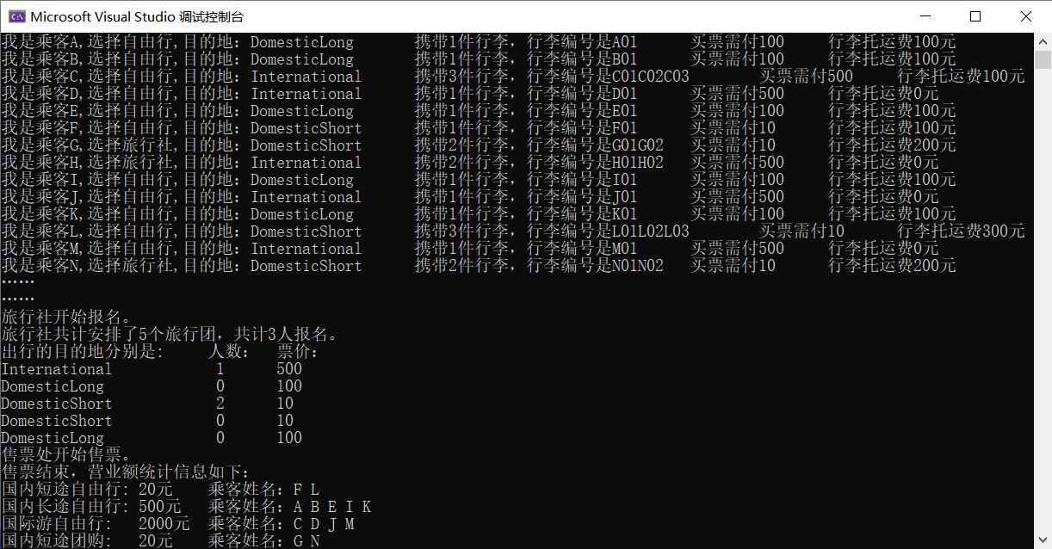
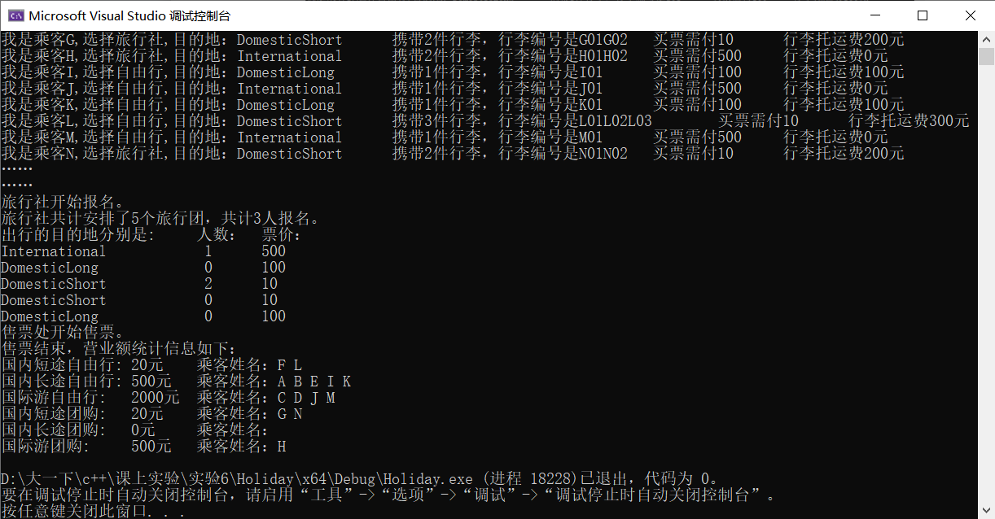

第二次运行截图：
