实验七

代码：
#include<iostream>
#include<string>
using namespace std;
class Park;
class Automobile {
public:
virtual void enter(Park* park) {

}
virtual void leave(Park* park) {

}
virtual string getNumber() {
return this->name;
}
virtual int getMoney() {
return this->money;
}
private:
string name;
int money;
};
class Park {
public:
Park(int N) {
this->spaces = new Automobile * [N];
for (int i = 0; i < N; i++)
{
this->spaces[i] = NULL;
}
this->Max = N;
}
void showInfo() {
cout << "停车场目前停放了" << this->num << "辆汽车：";
if (this->num != 0) {
for (int i = 0; i < this->num; i++)
{
cout << this->spaces[i]->getNumber() << ",";
}
}
cout << "共收入" << sumMoney << "元停车费" << endl;
}
void enter(Automobile *SomeCar) {
if (this->num<this->Max)
{
for (int i = 0; i < this->Max; i++) {
if (this->spaces[i]==NULL)
{
this->spaces[i] = SomeCar;
this->num++;
break;
}
}
cout << SomeCar->getNumber() << "进入停车场，分配停车位" << endl;
}
else {
cout << "无法为" << SomeCar->getNumber() << "分配停车位" << endl;
}
}
void leave(Automobile* SomeCar) {
cout << SomeCar->getNumber() << "离开停车场，缴纳停车费" << SomeCar->getMoney() << "元" << endl;
for (int i = 0; i < this->Max; i++)
{
if (this->spaces[i] == SomeCar) {
this->spaces[i] = NULL;
this->num--;
}
}
sumMoney += SomeCar->getMoney();
}
~Park() {
delete[] this->spaces;
}
private:
Automobile** spaces;
int num = 0;
int Max;
int sumMoney = 0;
};
class Truck :public Automobile {
public:
Truck(string name,int weight) {
this->name = name;
this->weight = weight;
}
void enter(Park* park) {
park->enter(this);
}
void leave(Park* park) {
park->leave(this);
}
string getNumber() {
return this->name;
}
int getMoney() {
return this->money;
}
private:
string name;
int money = 3;
int weight = 0;
};
class Car :public Automobile {
public:
Car(string name, string type) {
this->name = name;
this->type = type;
}
void enter(Park* park) {
park->enter(this);
}
void leave(Park* park) {
park->leave(this);
}
string getNumber() {
return this->name;
}
int getMoney() {
return this->money;
}
private:
string name;
int money = 1;
string type;
};
class Bus :public Automobile {
public:
Bus(string name, int people) {
this->name = name;
this->people = people;
}
void enter(Park* park) {
park->enter(this);
}
void leave(Park* park) {
park->leave(this);
}
string getNumber() {
return this->name;
}
int getMoney() {
return this->money;
}
private:
string name;
int money = 2;
int people = 0;
};
void main() {
int N = 0;
cout << "请输入停车位数量：";
cin >> N;// 输入停车位数量，此处输入2

Park* park = new Park(N);// 创建一个停车场对象

Car car1("鲁B-12345", "奥迪A6"); // 创建轿车对象
car1.enter(park); // car1进入停车场，分配停车位

Truck truck("鲁B-23456", 15); // 创建卡车对象
truck.enter(park); // truck进入停车场，分配车位

car1.leave(park); // car1离开停车场，缴纳停车费

Bus bus("鲁B-34567", 50); // 创建公交车对象
bus.enter(park); // bus进入停车场，分配车位

/* 显示当前停放的车辆的车牌号码，以及当前的全部停车费收入*/
park->showInfo();

Car car2("鲁B-45678", "宝马320"); // 创建轿车对象
car2.enter(park);
// car2进入停车场，分配停车位。因为没有空余停车位，所以无法分配

bus.leave(park); // bus离开停车场，缴纳停车费
truck.leave(park); // truck离开停车场，缴纳停车费

/* 显示当前停放的车辆的车牌号码，以及当前的全部停车费收入*/
park->showInfo();
delete park;

//return 0;
}

实验截图：
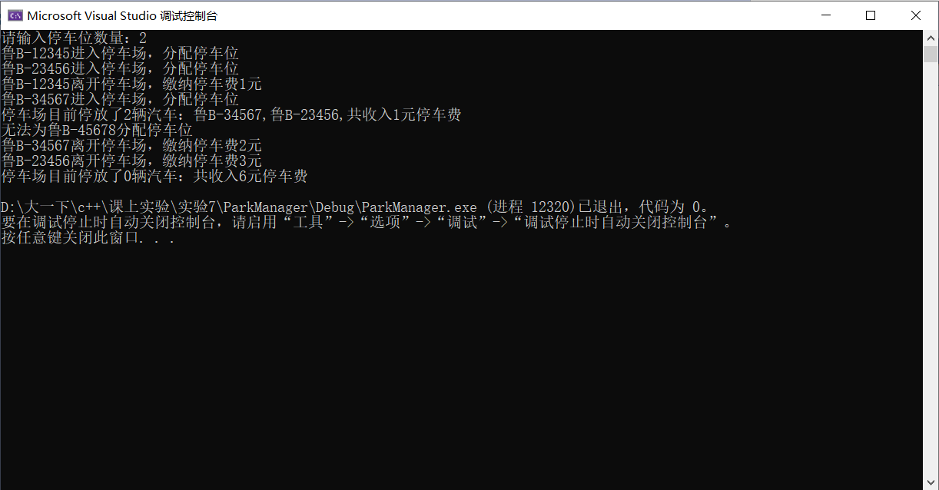

类图：

