实验报告

星图
代码：
#include<iostream>
using namespace std;
int numberGen(int gen) {
int ten = gen / 10;
gen = gen % 10;
gen = ten + gen;
return gen;
}
int main() {
int num[10][10] = { 0 };
for (int i = 1; i < 10; i++)
{
for (int j = 1; j < 10; j++) {
num[0][j] = j ;
}
num[i][0] = i ;
}
int gen = 0;
for (int i = 1; i < 10; i++) {
for (int j = 1; j < 10; j++) {
gen = num[i][0] * num[0][j];
if (gen > 9) {
while(gen>9)gen = numberGen(gen);
}
num[i][j] = gen;
}
}
int star ;
cin >> star;
string numStr[10][10];
for (int i = 1; i < 10; i++) {
for (int j = 1; j < 10; j++)
{
if (num[i][j]!= star)numStr[i][j]=' ';
else
{
numStr[i][j] = '*';
}
cout << numStr[i][j] << ' ';
if (j == 9)cout << endl;
}
}
}
运行结果：
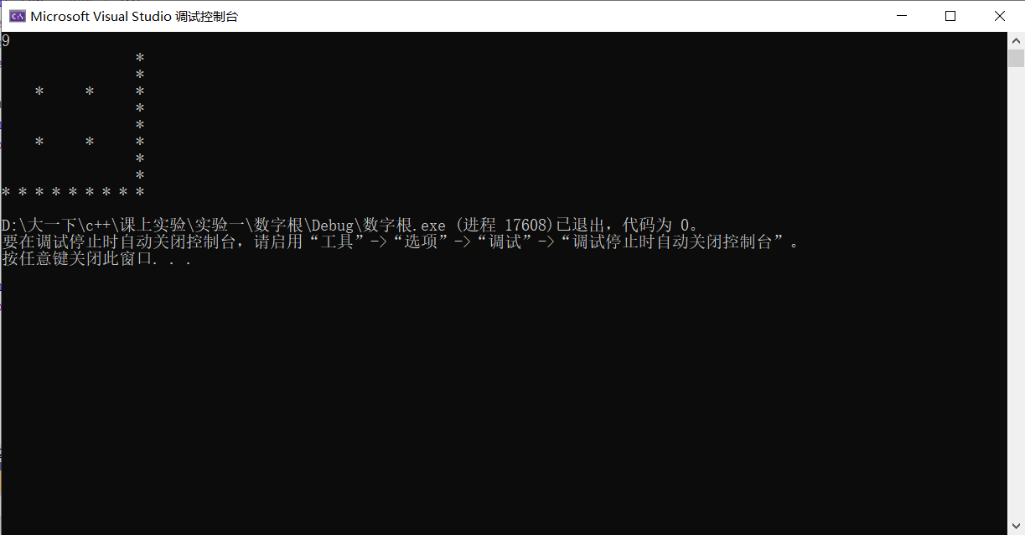
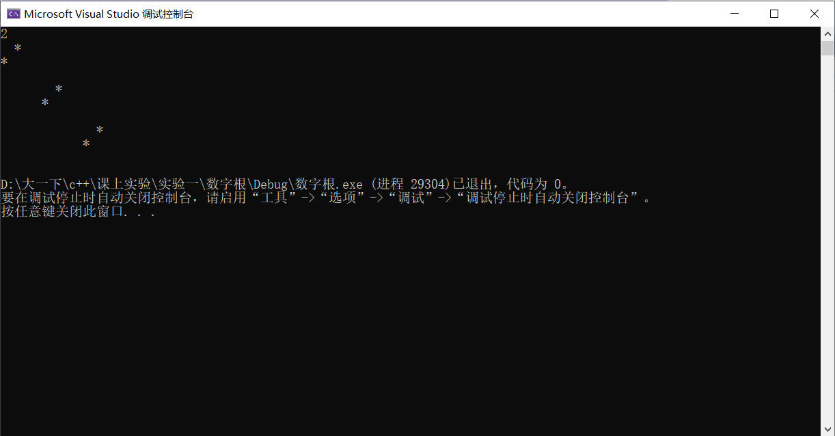

电梯
代码：
#include<iostream>
using namespace std;
#include<string>
int main() {
while (true)
{
int step = 0;
cin >> step;
if (step == 0)break;
int flool[100] = { 0 };
int up = 0;
int down = 0;
int stop = 0;
string list;
for (int i = 0; i < step; i++)
{
cin >> flool[i];
if (i == 0) {
int firstMove = flool[0] - 0;
up = firstMove * 6 + 5;
}
else
{
int nowStep = flool[i] - flool[i - 1];
if (nowStep > 0)
{
up += nowStep * 6 + 5;
}
else if (nowStep == 0) {
down += 0;
}
else {
down += -(nowStep) * 4 + 5;
}
}
}
cout << down + up;
for (int i = 0; i < step; i++) {
if (i == 0) {
cout << "(" << "6 * " << flool[0] - 0 << " + 5";
}
else
{
int coutStep = flool[i] - flool[i - 1];
if (coutStep > 0)
{
cout << " + 6 * " << flool[i] - flool[i - 1] << " + 5";
}
else
{
if (down != 0) {
cout << " + 4 * " << -(flool[i] - flool[i - 1]) << " + 5";
}
}
}
}
cout << ")" << endl;

}
system("pause");
return 0;
}
结果截图：
