**Reliance stock analysis (2000 - 2021)**

**A PROJECT REPORT**

**Submitted by**

**Bhumika G-1RVU23CSE111**

**Anirudh M-1RVU23CSE060**

**Aniketh Chakravarthy S-1RVU23CSE057**

**Bhuvan Madhusushan-1RVU23CSE116**

*in partial fulfillment for the award of the degree of*

**B.Tech (Hons) – Computer Science & Engineering**

*in* **Data Analysis with Python**

**to Dr. Sahana Prasad**



**School of Computer Science and Engineering**

**RV University**

**RV Vidyaniketan, 8th Mile, Mysuru Road, Bengaluru, Karnataka, India – 562112.**

**December 2023**

**TABLE OF CONTENTS**

|  |  |  |
| --- | --- | --- |
|  | **RELIANCE STOCK ANALYSIS** |  |
| **1.0** | **INTRODUCTION** | **3** |
|  |  |  |
|  |  |  |
| **2.0** | **METHODOLOGY** | **4** |
|  |  |  |
|  |  |  |
| **3.0** | **INFERENCE** | **3** |
|  |  |  |
|  |  |  |
| **4.0** | **RESULT AND DISCUSSION** | **4** |
|  |  |  |
|  |  |  |
| **5.0** | **CONCLUSION** | **5** |

1. **INTRODUCTION**

Reliance Industries Limited, often referred to simply as Reliance, is one of India's largest and most prominent conglomerates with significant influence in the stock market. Founded by Dhirubhai Ambani in 1966, the company has grown to become a major player in various industries, including petrochemicals, refining, oil and gas exploration, telecommunications, retail, and digital services.

The primary stock exchanges where Reliance is listed include the Bombay Stock Exchange (BSE) and the National Stock Exchange (NSE).

Our project contains a detailed analysis of Reliance stocks from the time period 2000 to 2021. The stock data can be obtained from financial markets, stock exchanges, or financial data providers. Common sources include NSE (National Stock Exchange) or BSE (Bombay Stock Exchange) for Indian stocks.

Historical stock data typically includes daily or intraday information on Open, High, Low, Last, Close (OHLC) prices, trading volume, and adjusted closing prices.

We have used python and its inbuilt libraries to do the statistical analysis, our aim is to visualize the data using graphs and statistical formulae for better analytics.

We’ll take you through a journey of analytics with numbers and graphs which at the end leaves you with a good conclusion about your investment in RIL.

1. **METHODOLOGY**

* Our first step was to identify a dataset, which is complete and did not have any missing values or duplicate values or other errors.
* We decided on this dataset keeping the purpose in our mind.
* We have used python and its libraries(modules) for generation of graphs and other statistical data.
* We have used a jupyter notebook to incorporate the data which we generated using python.
* We have used in built libraries of python like Pandas, matplotlib, seaborn, scipy, sklearn, numpy.
* Outlining the data points which are related to each other so we can understand the correlation between each other.
* We have chosen appropriate graphs for the corresponding data.
* Identifying the datapoints which stand out to generate a conclusion.
* Using the appropriate tools, we have identified if investing in this company is profitable or not.

Table 3.1: Reliance.csv (data set)

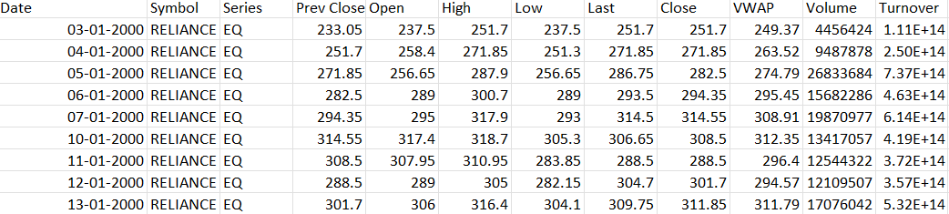

**Bar graph of Volume of stocks bought against the opening price**

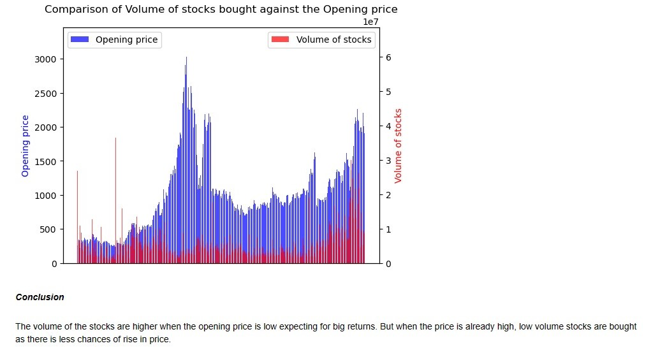

**Code**

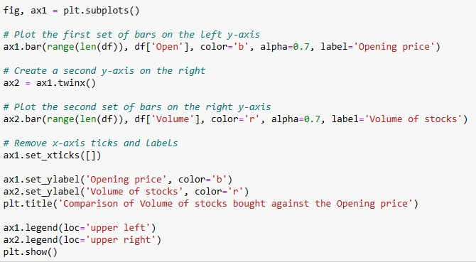

**Line plot of Closing prices over the months during the period of 21 years.**

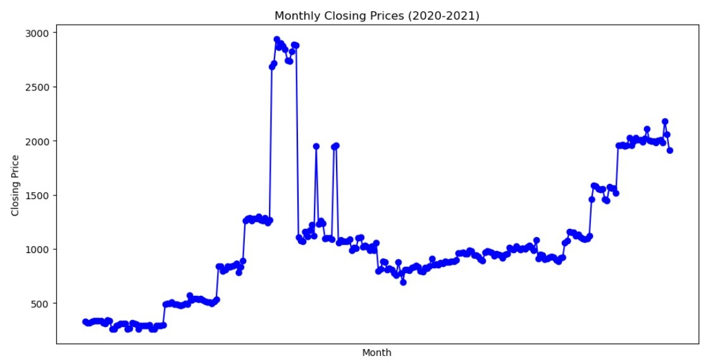

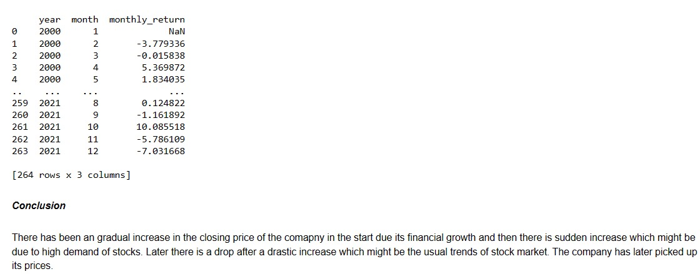

**Code**

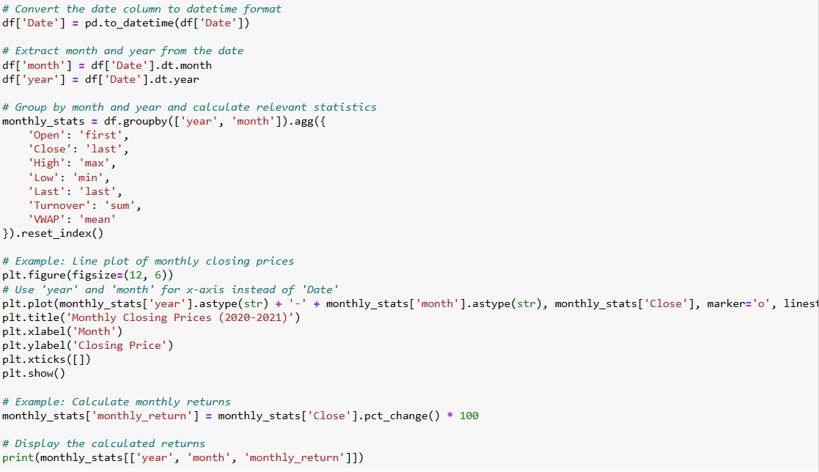

**Barplot of mean of opening prices over the years**

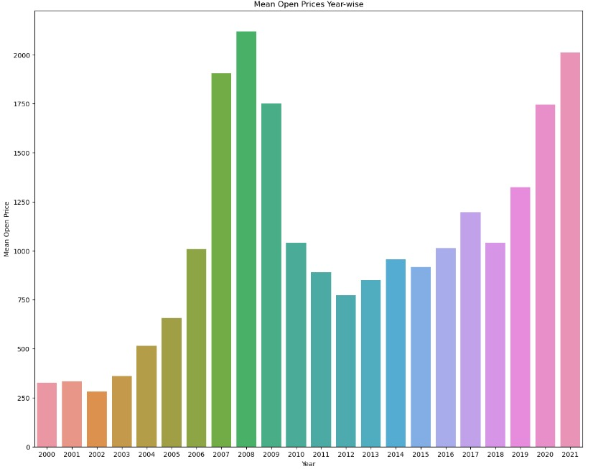

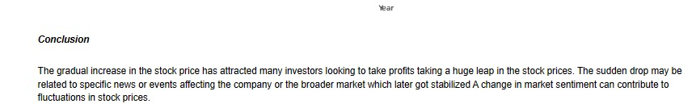

**Code**

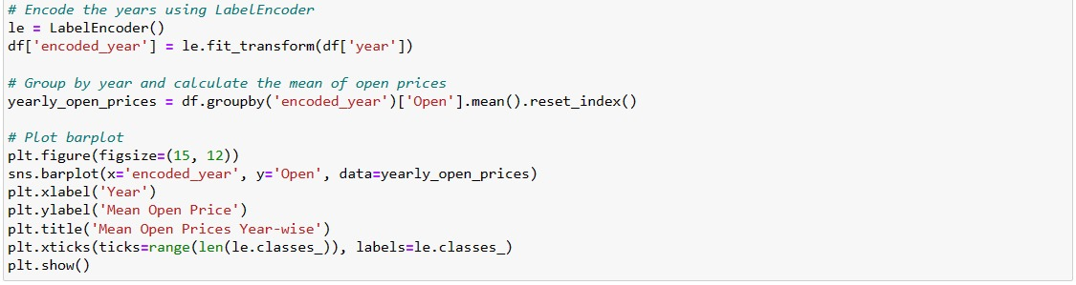

**Line plot comparing previous closing price and opening price over 21 years**

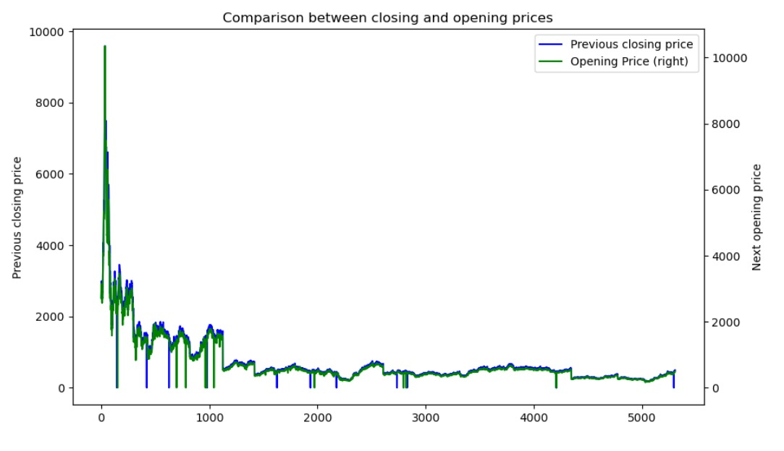



**Code**

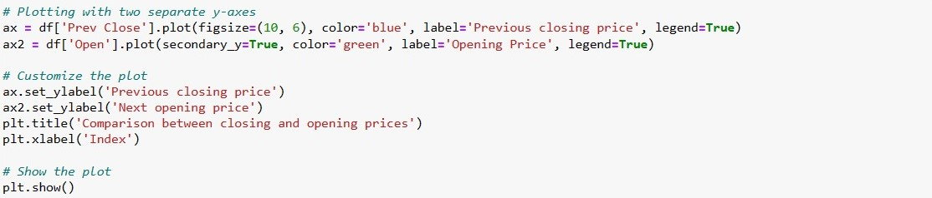

**Scatter plot showing comparison of opening and closing over the years**

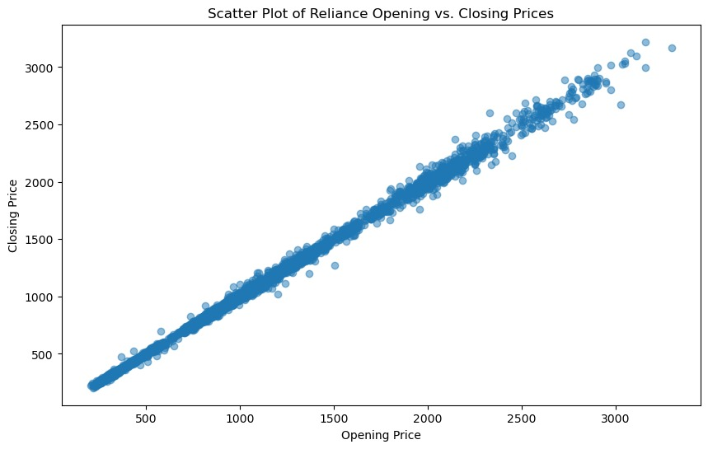



**Code**

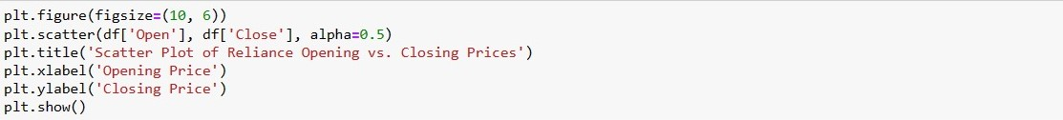

**Preforming min-max scaling to check if there is any change in distribution of data**

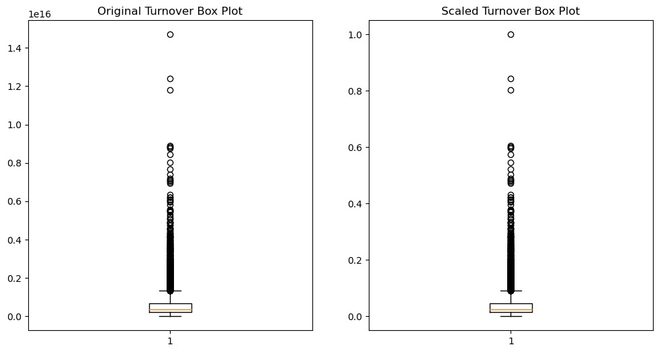

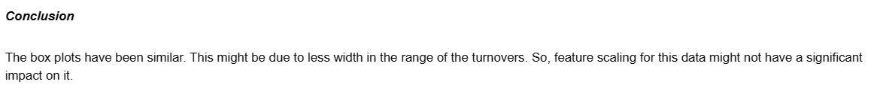

**Code**

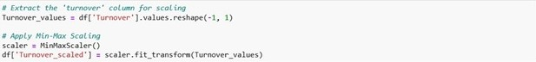

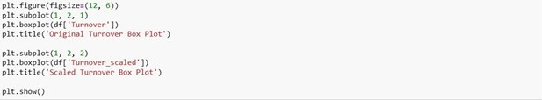

**To understand the profitability of the stock based on the skewness from the mean value across 20 years**

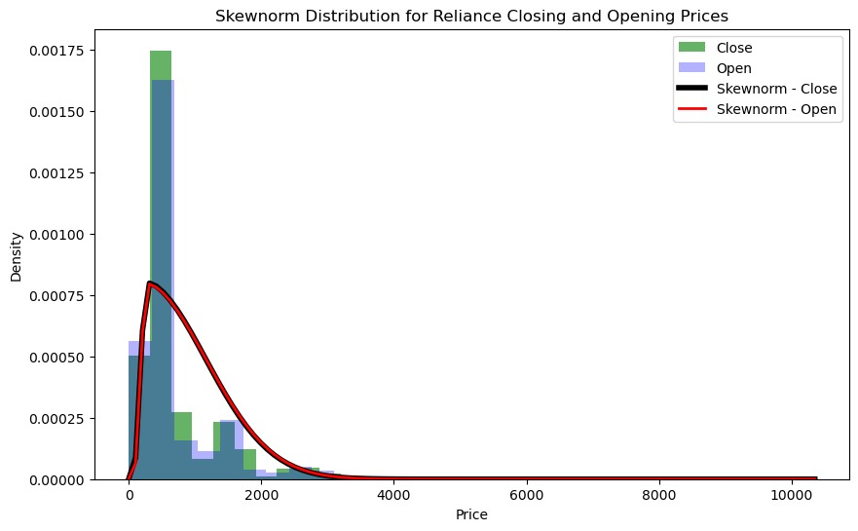

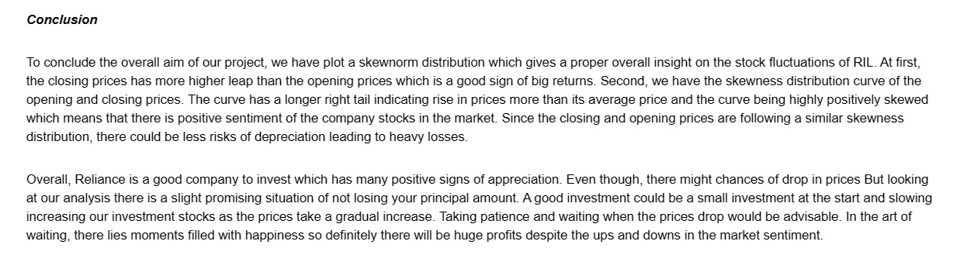

**Code**

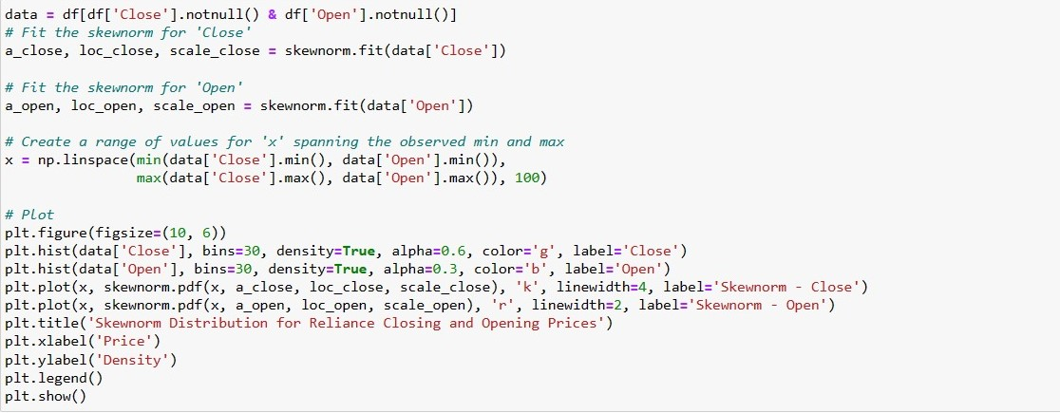

1. **DATA STORY TELLING**

A stock investment is a type of financial asset that represents a share of ownership in a public company. By investing in stocks, you can potentially earn a profit if the value of the company increases or if it pays dividends to its shareholders. The stock market is a place where buyers and sellers of stocks meet and trade. There are different types of stock markets, such as exchanges (like the Bombay Stock Exchange or the National Stock Exchange) and over-the-counter markets. The prices of stocks are determined by the forces of supply and demand, as well as by the expectations and sentiments of the market participants.

Stock investment is the buzzword of the moment in India. But the percentage of India’s population that invests in the stock market is very low compared to other countries.  [One source estimates that only 3% of Indian households are actively investing in stock market](https://choiceindia.com/blog/how-much-percentage-of-indian-population-investing-in-stock-market)[, while another source reports that only 3.7% of India’s population has invested in equities](https://blog.gwcindia.in/what-percentage-of-people-invest-in-the-indian-share-market/). [These numbers are much lower than the 12.7% of equity investors in China](https://blog.gwcindia.in/what-percentage-of-people-invest-in-the-indian-share-market/) or the 55% of Americans who own stocks.

Many of the people are afraid of investing in stocks due to these common myths.

* Investing in stocks equates to gambling.
* The stock market is exclusive to rich people and brokers.
* Investing is a way to get rich quick.
* You must pay off all your debt before investing.
* Now is not the right time to start investing.
* You should hire someone to manage your money.
* Investing is complicated.

So, we decided on the topic of stock analysis to help people understand that stock investment too is just a piece of cake and can be mastered through stock analysis. The word “STOCK ANALYSIS” definitely sounds very complicated. So, we have put down our analysis in layman terms to put aside all myths and misconceptions.

After wondering for a long time on which company to choose, we came up with RELIANCE as it is a common company known to all and has a strong hold on the stock market. People will easily be able to relate to it and attract more people as it is an Indian company owned by the world’s richest man.

When we talk about stock investment, these common questions come up in your mind.

1. How do I invest in stocks?
2. What Determines Stock Prices?
3. How Can I Mitigate Risks in Stock Investing?
4. How Much Money Do I Need to Start Investing in Stocks?
5. Should I Invest for the Short Term or Long Term?
6. How Do I Know When to Buy or Sell a Stock?
7. How Can I Recover from a Stock Market Loss?
8. Can I Invest in Stocks if I Have Limited Financial Knowledge?
9. **INFERENCE**

Our basic aim is to understand the behaviour of the reliance stocks throughout the year based on a time period of 21 years and learn how the stock market works through this analysis.

We look into how the stock behaves everyday by looking into the opening prices on the beginning of the day and then at maximum and minimum value the stock has attained in that particular day along with last bid of the day.

We compared the closing price of the previous day and opening price of the current day to see if the stock value is increased or decreased.

Another datapoint which we refer to is the last price

(i.e which is the last price at which the stock is that particular day) and the closing price (i.e which is the value of the stock at the end of the day)

Examination of volatility patterns provides insights into the stock's price fluctuations.

Identification of periods of high and low volatility, which may influence trading strategies.

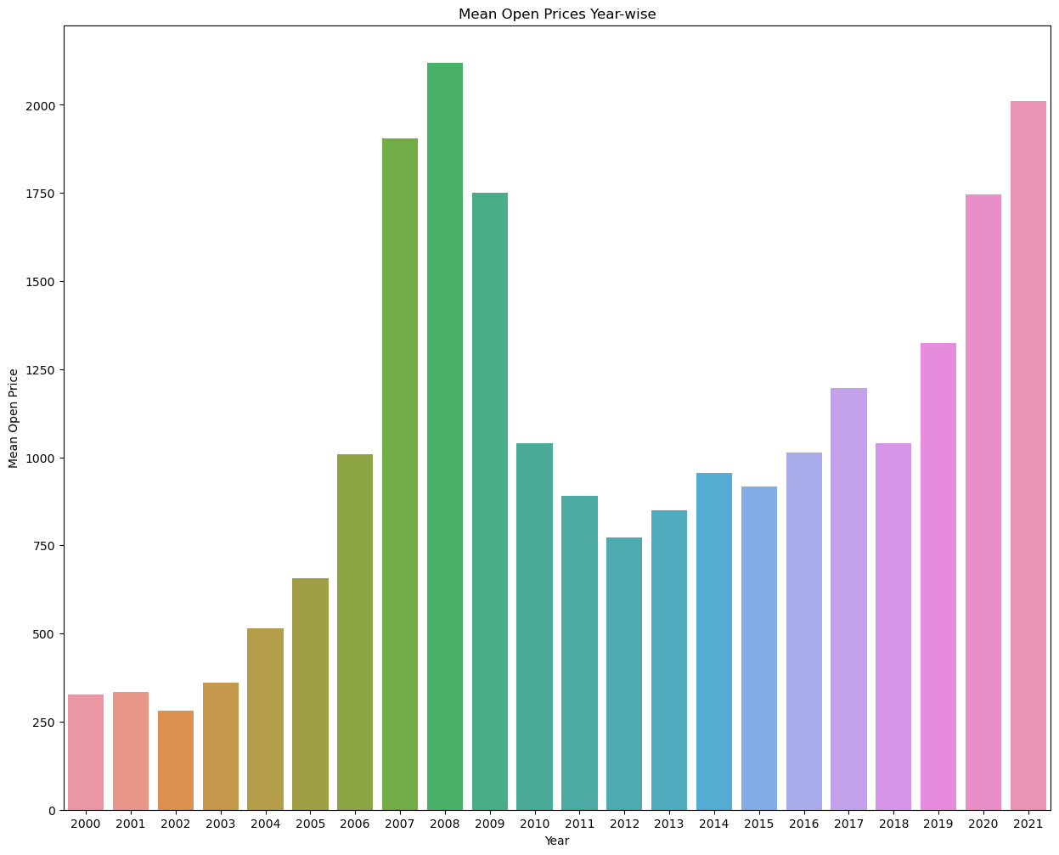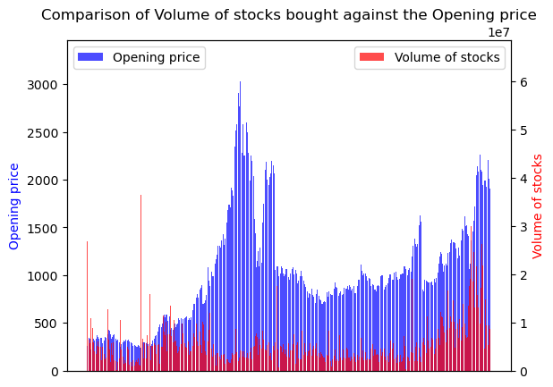

1. **RESULT AND DISCUSSION**

The usage of graphs and many statistical tools led to a conclusion after the analysis of RIL’s stock over 21 years.

A few key points which majorly stands out from our various steps of analysis are listed below.

Through the analysis of the RIL's turnovers, the standard deviation of the turnover was relatively high compared to its mean turnover which are signs of positive large fluctuations which might lead to high profit considering all circumstances. The large deviation of standard deviation from mean could potentially be a sign of increased risk of investment.

This contradicting situation made us inspire to make a more detailed analysis.

To be able to conclude the final statement on the stock analysis of RIL, we looked into the comparison graphs of the opening and closing prices and also the skewness distribution of the stock prices.

These key elements lead us to be able to make a more defining conclusion on the company.

**5. CONCLUSION**

Through this project, we are trying to understand how the reliance stock has behaved over the years, and what factors might have been affecting the valuation of the stock, also we can observe that the stock value of RIL has been consistently profitable.

The conclusions were made based on various tools like central tendencies, dispersion and various graphs for better analysis of the stocks. These tools helped us to give an intensive overall conclusion.

The correlation between the opening and last prices resulted in a strong relation between the 2 along with the scatter plot which indicated a direct relationship.

In the same fashion, we understood that when the volume of the stocks is higher during low open price expecting for big returns. But when the price is already high, low volume stocks are bought as there is less chances of rise in price.

The combination of kurtosis and skewness gave us an insight on the tendency for occasional higher prices, less volatility of prices and less risk of misinterpretation.