**Iteration 1**

2 October 2018

CSE 4361-001

Team 2:

Kyle Benjamin

Grace Yeon

Marc Al-ein Muteba

Linh Vu

Mohammed Ali

Dylan Forsyth

**List of Use Cases**

* create account
* **Submit event proposal**
* **Register for event**
* **Evaluate event proposal**
* submit booth lease request
* cancel event
* edit proposal
* Select booths
* Change status request
* Withdraw booth lease request
* Provide decision and feedback
* Registering for event
* Cancel registration
* Specify floor place

**Actors**

* User
* Event Organizer
* Staff
* Exhibitor

**Domain Model and Classification Sheet**

Requirement Brainstorming

The National Trade Show Services (NTSS) is a service provider that helps business customers/1 create/3, promote, organize, and run national and international trade shows. Business customers/1 contact NTSS for the services they need. Creating/3 a trade show involves the design for the trade show, including/7 professional services ranging from selection of a theme and a slogan to location/1 and duration/1. Promoting a trade show includes advertisement activities. Organizing a trade show includes all activities before the trade show except creation and promotion. For example, inviting speakers/1, registering/3 participants/1 and exhibitors/1. Running a trade show is the activity of on site registration, setting up/3 the booths/1, conference rooms/1 for seminars/1, reception/1, and distributing trade show materials. The NTSS creates/3 an account/1 for each customer/1 to record service charges, payments received, and maintain the account/1 balances. A trade show can be regarded as an event/9. For example, the 2008 Consumer Electronics Show took place in the Las Vegas Convention Center during January 7-10, 2008 and the 2008 MacWorld Conference took place at the Moscone Center, 747 Howard Street, San Francisco, CA 94103 during January 14-18, 2008.

An event/1 has an organizer/1, which can be a person/1 or an organization/1. For example, the CES was organized by/3 the Consumer Electronics Association while the MacWorld was organized by/3 Apple, Inc. An event/1 has contact information/1 and possibly a website/1 that provides further information about the event/1. An event/1 can belong to one or more/5 predefined domains. For example, the CES and MacWorld are belong to both Technology and Consumer Electronics. The list of predefined domains can change from time to time because new/4 domains need be added/3 and outdated domains need be removed. A trade show is attended by different types of participants/1 including the event organization staff/1, the invited and/or selected speakers/1, exhibitors/1, and observers/1. Except the event organization staff/1 and the event organizer/1, all participants/1 must register to/3 attend a trade show event/1. The registration/1 charges a fee/4, which is different for different trade show event/1. The event/1 organization staff/1 creates, prepares and runs the event/1. The invited speakers/1 are famous figures in the domain/1 who were invited to give a keynote address at the event/1. The selected speakers/1 are invited to speak at the event/1 based on the evaluation of their/3 proposals/1. The proposals/1 are usually reviewed by/3 a committee of reviewers/1,2, who are experts in the domain/1 and willing to help/3. The status of a proposal/1,2 includes pending review, accepted, and rejected. The exhibitors/1 come to/3 the trade show to exhibit/3 their/3 products or services. The exhibitors/1 have to pay/3 for the booths/1 depending on the size of the booth/1, e.g., large, medium, or small/4. Booths/1 are requested and rented for the whole/4 duration of the event/1. Finally, the observers/1 come to/3 visit the trade show for various purposes.

**Classification Table**



|  |  |  |
| --- | --- | --- |
| **Brainstorming List** | **Classification Result** | **Rule** |
| Customers | (C) Participants | 1(d) |
| Speakers | (A) Participants | 1(d) |
| Participants | (C) Participants | 1(a) |
| Exhibitors | (A) Participants | 1(d) |
| Trade show | (I) Event | 9 |
| Seminars | (V) Event | 1(e) |
| Conference Rooms | (V) Event | 1(e) |
| Reception | (V) Event | 1(e) |
| Account | (C) | 1(a) |
| Event | (C)Event | 1(a) |
| Event Organizer | (C)Participants | 1(d) |
| Organization | (C)Event | 1(d) |
| Staff | (C)Staff | 1(a) |
| Contact Information | (C)Participants | 1(d) |
| Observers | (A) Participants | 1(d) |
| Proposals | (C) Proposals | 1(a) |
| Booths | (C) Proposals | 1(e) |
| Reviewers | (C) Staff | 1(e) |
| Create | (AS) Event | 3 |
| Registration | (C) Registration | 1(a) |
| Fee | (V) Registration | 4 |
| Duration | (C) Event | 1(e) |
| Location | (C) Event | 1(e) |
| One or more(5) | (V) Create | 5(a) |
| Event | (C) Event | 1(a) |
| Reviewed by | (AS) Event | 3 |

**Domain Model**



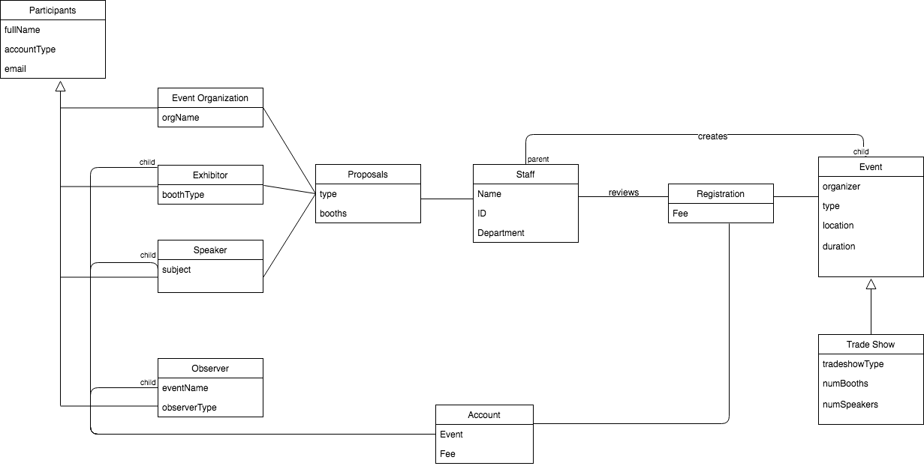

**Verb-Noun Requirements**

R1 The system shall allow a potential user to create an online account identified by a valid

email address.

R1.1 The system shall require the user to specify the account type (event organizer,

exhibitor, speaker, or observer). Different types of account shall have different privileges.

R1.2 The system shall send a temporary password to the email address. The temporary

password must comply to commonly adopted password security rules.

R1.3 The system shall require the user to change the temporary password at the first

login. The new password must comply to commonly adopted password security rules.

R2 The system shall allow an event organizer to submit an event proposal using an event

proposal form with fields that describe the event.

R2.1 Upon submission, the system shall generate a payment slip to be sent to the event

organizer along with the payment to NTSS.

R2.2 Upon reception of the payment for an event proposal,

R2.2.1 the system shall change the status of the event proposal to “Pending Review” from “Submitted,”

R2.2.2 the system shall email notify the event organizer that the payment has been received and the proposal is pending review.

R3 The system shall allow an event organizer to cancel an event with a 15% cancellation

charge.

R4 The system shall allow an event organizer to edit a “Submitted” or “Pending Review”

proposal without charge.

R5 The system shall allow an event organizer or NTSS staff to view an event proposal.

R6 The system shall allow an NTSS staff to evaluate an event proposal and enter feedback

and an acceptance decision of either “Accepted” or “Rejected.” If “Rejected,” then the

staff must also provide feedback explaining why the proposal is rejected.

R7 The system shall allow an exhibitor to submit a booth lease request.

R7.1 The system shall display a floor plan with available booths, their sizes and leasing

prices. The booth sizes are large, medium, and small, each of which is specified by

width and length.

R7.2 The system shall allow the exhibitor to select one or more available booths to be

Leased.

R7.3 The system shall generate a summary and total payment slip so that the exhibitor

can print and send along with the payment to NTSS.

R7.4 When the payment is received, the system shall change the status of the request

to pending review and notify the exhibitor of the status change.

R8 The system shall allow an exhibitor to withdraw a booth lease request with a 10% cancellation charge.

R9 The system shall allow an exhibitor or NTSS staff to view a booth lease request.

R10 The system shall allow an NTSS staff to evaluate a booth lease request.

R10.1 The system shall allow an NTSS staff to evaluate a booth request and enter feedback and an acceptance decision of either “Accepted” or “Rejected.” If “Rejected,” then the

staff must also provide feedback explaining why the proposal is rejected.

R10.3 The system shall change the status of the request accordingly and notify the

exhibitor of the change in request status.

R10.4 The system shall change the status of a booth to “unavailable” once it is leased

out.

R11 The system shall allow a potential participant to register for an event.

R11.1 The system shall allow the participant to select from a list of event of her/his

Interest.

R11.2 The system shall allow a participant to register for one or more events.

R11.3 The system shall generate a payment slip showing a summary and the total payment.

R11.4 The system shall allow the participant to print the payment slip to be sent together

with the payment.

R11.5 Once the payment is received, the system shall change the participants’ registrations to “Paid” and notify the registering participant of this change.

R12 The system shall allow a registering participant to cancel a registration without charge

one week before the event and with a 10% cancellation charge afterwards.

R13 The system shall allow an NTSS staff to specify a floor plan with predefined sizes.

R14 The system shall allow payment by credit card, cashier check, personal check, money

order, or PayPal.

R15 The system shall allow the user to log in with an existing account.

R15.1 The system shall allow the user to log out after after logging in.

R15.2 The system shall allow the user to change password after logging in.

**Use Case Brainstorming List**

*Event organizer, exhibitor, speaker, observer are users with .

|  |  |  |  |  |  |  |  |  |  |
| --- | --- | --- | --- | --- | --- | --- | --- | --- | --- |
| Reqmt | Use Case | Business Process | Initiated by actor | End with actor | Task for Actor | Is use case | Actor | System | UC ID |
| R1 | Create account online | Y | Y | Y | Y | Y | User | NTSS/Account Management | UC1 |
| R1.1 | Specify Account type | N | - | - | - | N | - | - | - |
| R1.2 | Send Temp Password | N | - | - | - | N | - | - | - |
| R1.3 | Change temporary password | N | - | - | - | N | - | - | - |
| R.2 | Submit Event Proposal | Y | Y | Y | Y | Y | Event Organizer | NTSS/Event Management | UC2 |
| R 2.1 | Generate Payment slip | N | - | - | - | - |  | - | - |
| R 2.2.1 | Change the status of the event proposal | N | - | - | - | - | - | - | - |
| R 2.2.2 | Notify Event Organizer | - | - | - | - | - | - | - | - |
| R 3 | Cancel Event | Y | Y | Y | Y | Y | Event Organizer | NTSS/Event Management | UC3 |
| R 4 | Edit proposal | Y | Y | Y | Y | Y | Event Organizer | NTSS/Event Management | UC4 |
| R 5 | View Event Proposal | Y | Y | Y | Y | Y | Event Organizer/ NTSS Staff | NTSS/Event Management | UC5 |
| R 6 | Evaluate Event Proposal | Y | Y | Y | Y | Y | NTSS Staff | NTSS/Event Management | UC6 |
| R 7 | Submit Booth Lease Request | Y | Y | Y | Y | Y | Exhibitor | NTSS/Booth Management | UC7 |
| R 7.1 | Display Floor Plan | N | - | - | - | - | - | NTSS/ Floor Management | - |
| R 7.2 | Select Booths | N | - | - | - | - | - | - | - |
| R 7.3 | Generate Summary | Y | N | N | N | N | - | - | - |
| R 7.4 | Change Status Request | Y | Y | Y | Y | Y | Exhibitor | NTSS/Booth Management | UC8 |
| R 8 | Withdraw booth lease Request | Y | Y | Y | Y | Y | Exhibitor | NTSS/Booth Management | UC9 |
| R 9 | View A booth Lease Request | Y | Y | Y | Y | Y | Exhibitor/ NTSS Staff | NTSS/Booth Management | UC10 |
| R 10 | Evaluate a booth Lease Request | Y | Y | Y | Y | Y | NTSS Staff | NTSS/Booth Management | UC11 |
| R 10.1 | Provide decision and Feedback (Booth Request) | N | - | - | - | - | - | - | - |
| R 10.2 | Change status of request | N | - | - | - | - | - | - | - |
| R 10.3 | Notify the Exhibitor | N | - | - | - | N | - | - | - |
| R 11 | Allow Event Registration | N | - | - | - | - | - | - | - |
| R 11.1 | Select Event | N | - | - | - | - | - | - | - |
| R 11.2 | Registering for an event | Y | Y | Y | Y | Y | User | NTSS/Event Management | UC12 |
| R 11. 3 | Generate Payment Slip | N | - | - | - | - | - | - | - |
| R11.4 | Print Payment Slip | N | - | - | - | - | - | - | - |
| R 11.5 | Change User Registration | N | - | - | - | - | - | - | - |
| R 12 | Cancel Registration | Y | Y | Y | Y | Y | User | NTSS/Event Management | UC13 |
| R 13 | Specify floor plan | Y | Y | Y | Y | Y | NTSS Staff | NTSS/Floor Management | UC14 |
| R 14 | Allow Payment | Y | N | N | N | N | - | - | - |
| R 15 | Log In | Y | Y | Y | Y | Y | User | NTSS/Account Management | UC15 |
| R 15.1 | Log Out | Y | Y | Y | Y | Y | User | NTSS/Account Management | UC16 |
| R 15.2 | Change Password | Y | Y | Y | Y | Y | User | NTSS/Account Management | UC17 |

**Use Case Diagrams**

**Sub-systems:**

1. **Floor Management**
2. **Booth Management**
3. **Account Management**
4. **Event Management**
5. **Payment Management**

**Floor Management**

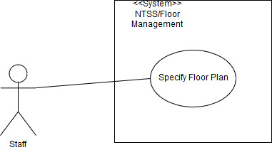

**Booth Management**

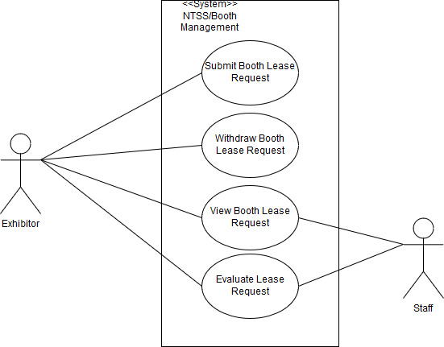

**Account Management**

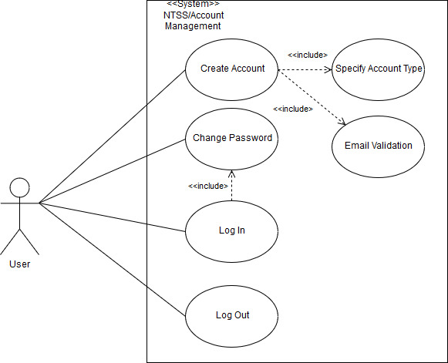

**Event Management**

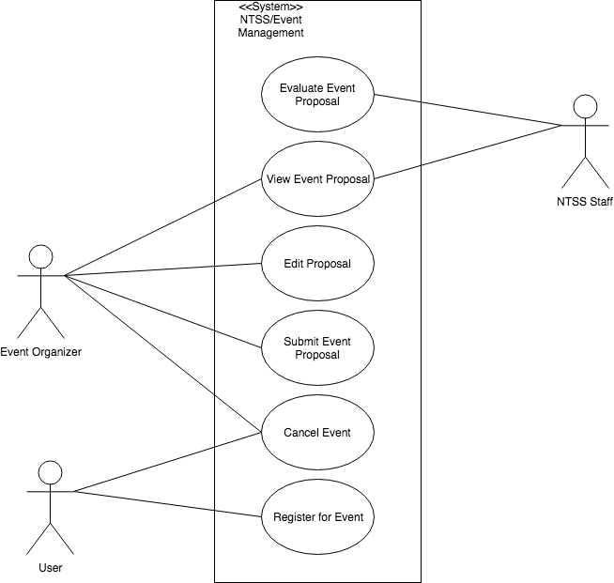

**Payment Management**

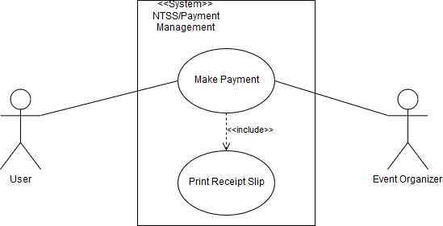

**TUCBW/TUCEW Clauses**



|  |  |  |  |
| --- | --- | --- | --- |
| **Use Case #** | **Application** | **Use Case** | **Description** |
| **UC1** | Account Management | Create Account online | TUCBW a user clicks on create account button  TUCEW account has been created |
| **UC2** | Event Management | Submit Event Proposal | TUCBW user clicks on submit event button  TUCEW user receives confirmation that proposal has been submitted |
| **UC3** | Event Management | Cancel Event | TUCBW user clicks cancel event  TUCEW user receives event cancelation confirmation |
| **UC4** | Event Organizer | Edit Proposal | TUCBW ever organizer clicks edit button    TUCEW event organizer confirms changes |
| **UC5** | Event Management | View Event Proposal | TUCBW event organizer clicks on view Event Proposal Button  TUCEW system displays event proposal |
| **UC6** | Event Management | Evaluate Event Proposal | TUCBW NTSS staff clicks on Evaluate Event Proposal Button  TUCEW staff accepts/reject event proposal |
| **UC7** | Booth Management | Submit Booth Lease Request | TUCBW Exhibitor submits booth Request  TUCEW Exhibitor Receives submission confirmation |
| **UC8** | Booth Management | Change Status Request | TUCBW Exhibitor clicks on “change status” button  TUCEW Exhibitor saves changes |
| **UC9** | Booth Management | Withdraw Booth lease Request | TUCBW Exhibitor clicks on the withdraw booth button  TUCEW Exhibitor receives a confirmation message |
| **UC10** | Booth Management | View A booth Lease Request | TUCBW Exhibitor/Staffs clicks on View Booth Lease Request Button  TUCEW Exhibitor/staffs sees the booth Lease Request |
| **UC11** | Booth Management | Evaluate A Booth Lease Request | TUCBW Staff clicks on Evaluate Booth Request  TUCEW staff accepts or reject booth Request |
| **UC12** | Event Management | Registering for An Event | TUCBW user clicks on Register for event button  TUCEW the user receives a registration confirmation message |
| **UC13** | Event Management | Cancel Registration | TUCBW user clicks on cancel Registration button  TUCEW user receives a cancel reservation confirmation message |
| **UC14** | Floor Management | Specify Floor Plan | TUCBW Staffs clicks on “specify floor plan” button  TUCEW Staffs receives message of floor specification confirmation |
| **UC15** | Account Management | Login | TUCBW User clicks on Login button  TUCEW user is logged in the system |
| **UC16** | Account Management | Logout | TUCBW user clicks on log out button  TUCEW user is logged out of the system |
| **UC17** | Account Management | Change Password | TUCBW user clicks on change password button  TUCEW user receives a password confirmation change |

**Expanded Use Cases / Scenarios / Scenario Tables**

**Submit an Event Proposal**



**Expanded Use Case**

|  |  |
| --- | --- |
| **Submit an Event Proposal** |  |
| **Actor: Event Organizer** | **System: NTSS** |
|  | 0. NTSS displays Event Organizer Home Page. |
| 1. TUCBW the event organizer clicks the "Event Proposal" Button | 2. NTSS displays the Event Proposal form |
| 3. The event organizer fills out the form and clicks the submit form button | 4. *NTSS displays a Confirmation message |
| 5. TUCEW the event organizers sees the confirmation messages and clicks "confirm" |  |

**Scenario:**

3. The event organizer submits the form and in the EventProposalGUI.

4.1 The event EventProposalGUI sends the form data to the EventProposalController

4.2 The EventProposalController creates the event e  
4.3 The EventProposalController sends the event to the DBMgr.

4.4 The DBMgr saves the event proposal to the DB  
4.5 The DBMgr sends a confirmation message to the EventProposalController

4.6 The EventProposalController sends a confirmation message to the EventProposalGUI

4.7 The EventProposalGUI displays the confirmation message to the event organizer

**Scenario Table:**

|  |  |  |  |  |
| --- | --- | --- | --- | --- |
|  | **Subject** | **Action of Subject** | **Other Data Objects** | **Object Acted Upon** |
| 1 | Event Organizer | submits | Filled out form | System |
| 2 | EventProposalGUI | sends | form data | EventProposalController |
| 3 | EventProposalController | creates | event | Event |
| 4 | EventProposalController | sends | event | DBMgr |
| 5 | DBMgr | saves | event | DB |
| 6 | DBMgr | sends | confirmation message | EventProposalController |
| 7 | EventProposalController | sends | confirmation message | EventProposalGUI |
| 8 | EventProposalGUI | displays | confirmation message | Event Organizer |

**Evaluate an Event Proposal**



|  |  |
| --- | --- |
| **Evaluate an Event Proposal** |  |
| **Actor: NTSS Staff** | **System: NTSS** |
|  | 0. NTSS displays the staff Home Page. |
| 1. TUCBW the staff member clicks the "Evaluate Proposals" Button | 2. NTSS display a list of event proposals. |
| 3. The staff selects their chosen event for evaluation | 4. *NTSS displays the staff’s chosen event |
| 5. The staff enters feedback on the event and chooses to either accept or reject. | 6. *NTSS displays the event staff's choice for the event. |
| 7. TUCEW The staff see the confirmation of the events status |  |

**Scenario:**

3. The staff submits their chosen event to the EvaluateProposalsGUI

4.1 The EvaluateProposalsGUI sends the form data to the EvaluateProposalsController

4.2 The EvaluateProposalsController sends the request for event data to the DBMgr

4.3 The DBMgr queries the DB for the requested event data

4.4 The DB returns the event e to the DBMgr

4.5 The DBMgr returns the event e the EvaluateProposalsController

4.6 The EvaluateProposalsController returns the event object to EvaluateProposalsGUI

4.7 The EvaluateProposalsGUI displays the event to the staff

5. The Staff enters feedback, accepts/rejects the proposal and submits the form to the EvaluateProposalsController

6.1 The EvaluateProposalsController sends the user’s proposal data to the DBMgr

6.2 The DBMgr sends user’s proposal data to the DB

6.3 The DB updates the event as requested

6.4 The DBMgr returns a confirmation message to the EvaluateProposalsController

6.5 The EvaluateProposalsController returns a confirmation message to the EvaluateProposalsGUI

6.6 The EvaluateProposalsGUI displays the confirmation of the events status to the staff.

**Scenario Table:**

|  |  |  |  |  |
| --- | --- | --- | --- | --- |
|  | **Subject** | **Action of Subject** | **Other Data Objects** | **Object Acted Upon** |
| 1 | Staff | submits | event proposal | EvaluateProposalsGUI |
| 2 | EvaluateProposalsGUI | sends | form data | EvaluateProposalsController |
| 3 | EvaluateProposalsController | requests | event | DBMgr |
| 4 | DBMgr | queries | event | DB |
| 5 | DB | returns | event | DBMgr |
| 6 | DBMgr | returns | event | EvaluateProposalsController |
| 7 | EvaluateProposalsController | returns | event | EvaluateProposalsGUI |
| 8 | EvaluateProposalsGUI | displays | event | Staff |
| 9 | Staff | submits | form | EvaluateProposalsController |
| 10 | EvaluateProposalsController | sends | proposal data | DBMgr |
| 11 | DBMgr | sends | proposal data | DB |
| 12 | DB | updates | event | Event |
| 13 | DBMgr | returns | confirmation message | EvaluateProposalsController |
| 14 | EvaluateProposalsController | returns | confirmation message | EvaluateProposalsGUI |
| 15 | EvaluateProposalsGUI | displays | confirmation | Staff |

**Register for Event**



|  |  |
| --- | --- |
| **Register an event** |  |
| **Actor: User** | **System: NTSS** |
|  | 0. NTSS displays the user Home Page. |
| 1. TUCBW The user clicks the "View events" button | 2. NTSS displays a list of events. |
| 3. The user selects their event interests and selects "Filter" | 4. *NTSS filters the events to reflect the users interests. |
| 5. The user selects their chosen event and selects "register" | 6. *NTSS displays the registration confirmation. |
| 7. TUCEW The user sees the registration confirmation. |  |

**Scenario:**

3 The user submits event preferences to the EventRegistrationGUI

4.1 The EventRegistrationGUI sends filter preferences to the EventRegistrationController

4.2 The EventRegistrationController sends filter preferences to the DBMgr  
4.3 The DBMgr queries the DB for the requested events

4.4 The DB returns the requested Events to the DBMgr

4.5 The DBMgr returns the requested Events to the EventRegistrationController

4.6 The EventRegistrationController returns requested Events to the EventRegistrationGUI   
5 The user selects an event submits there registration.  
6.1 The EventRegistrationGUI sends the users registration request to the EventRegistrationController

6.2 The EventRegistrationController creates the registration object, r

6.3 The EventRegistrationController sends the registration to the DBMgr

6.4 The DBMgr adds the registration to the DB

6.5 The DBMgr returns a confirmation message to the EventRegistrationController  
6.6 The EventRegistrationController returns the confirmation message to the EventRegistrationGUI

6.7 The EventRegistrationGUI displays the confirmation message to the user

**Scenario Table:**

|  |  |  |  |  |
| --- | --- | --- | --- | --- |
|  | **Subject** | **Action of Subject** | **Other Data Objects** | **Object Acted Upon** |
| 1 | user | submits | event preferences | EventRegistrationGUI |
| 2 | EventRegistrationGUI | sends | preferences | EventRegistrationController |
| 3 | EventRegistrationController | sends | preferences | DBMgr |
| 4 | DBMgr | queries | events | DB |
| 5 | DB | returns | requested Events | DBMgr |
| 6 | DBMgr | returns | requested Events | EventRegistrationController |
| 7 | EventRegistrationController | returns | requested Events | EventRegistrationGUI |
| 8 | user | submits | registration | EventRegistrationGUI |
| 9 | EventRegistrationGUI | sends | registration | EventRegistrationController |
| 10 | EventRegistrationController | creates |  | registration |
| 11 | EventRegistrationController | sends | registration | DBMgr |
| 12 | DBMgr | adds | registration | DB |
| 13 | DBMgr | returns | confirmation message | EventRegistrationController |
| 14 | EventRegistrationController | returns | confirmation message | EventRegistrationGUI |
| 15 | EventRegistrationGUI | displays | confirmation message | User |

**Sequence Diagrams / Design Sequence Diagrams**

**Submit an Event Proposal**



**Sequence Diagram**

[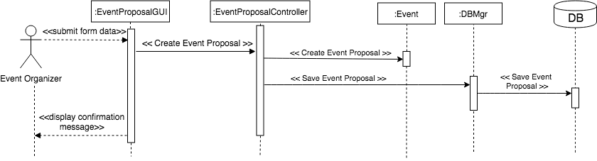](https://www.draw.io/#G1zIN12eIdYdSPs39seMQinugUveOAmz1t)

**Design Sequence Diagram**

[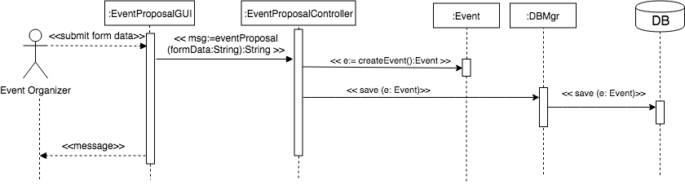](https://www.draw.io/#G1HCQB6EiQHrHW7QIGcmIzDVXpltPR78A-)

**Evaluate an Event Proposal**



**Sequence Diagram**

[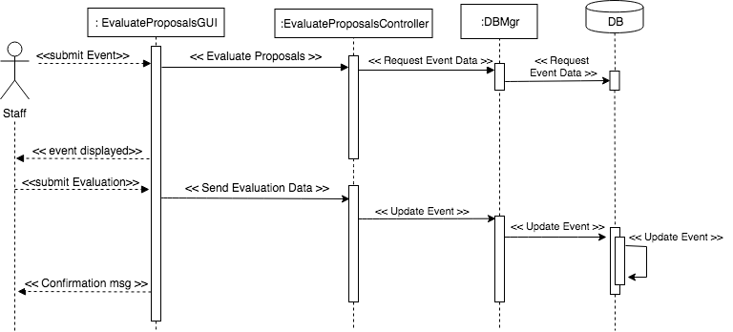](https://www.draw.io/#G1hswryA7WTtSDSpXBzAhWBr2gnJ2-eA2P)

**Design Sequence Diagram**

[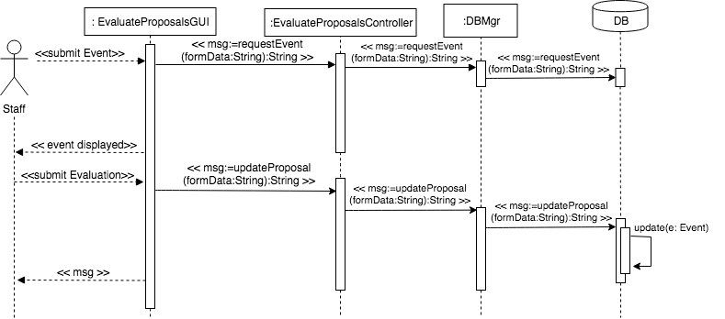](https://www.draw.io/#G1y033uGR5KMQscM1kBk2aGe7I7Rto_ova)

**Register for Event**



**Sequence Diagram**

[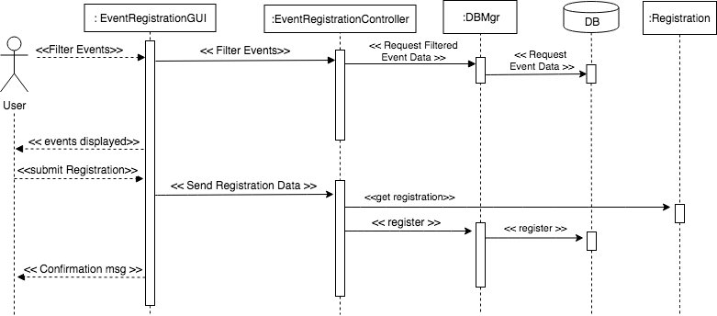](https://www.draw.io/#G1-KggoEbQJonB8qfXUBpqDaysbZhhej2r)

**Design Sequence Diagram**

[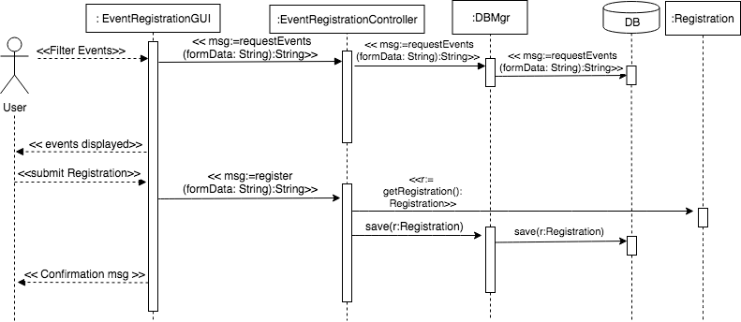](https://www.draw.io/#G1Big_C14vq8sb-RnvVBNiMYrXeApPW1aS)

**Design Class Diagram**



[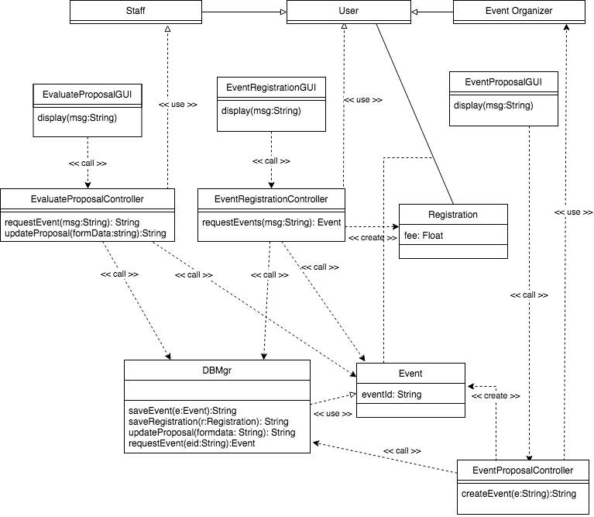](https://www.draw.io/#G1jN3RqkMjkcOi5IxUtDHrnGCaRQ0IDuA0)