# Introduction

I decided to do my web project on the R%B / Hip Hop artist Frank Ocean.

My website will be about the Early Life, albums, cultural impact and the future of recording artist Frank Ocean’s said work.

My objective was to educate our generation about Frank because he has been incredibly secretive and has close to no online presence as most people don’t know about him outside of streaming his music on Spotify and YouTube.

The target audience is 18-30-year olds, and people who listen to R&B. This is the demographic that most consistently streams Frank Ocean’s music the most on websites like Spotify, Apple Music and YouTube.

# GitHub URL

<https://boomerandy.github.io/FO-WebProject/>

URL of GitHub repo

<https://github.com/boomerAndy/FO-WebProject>

# Original Mockup of Website Homepage

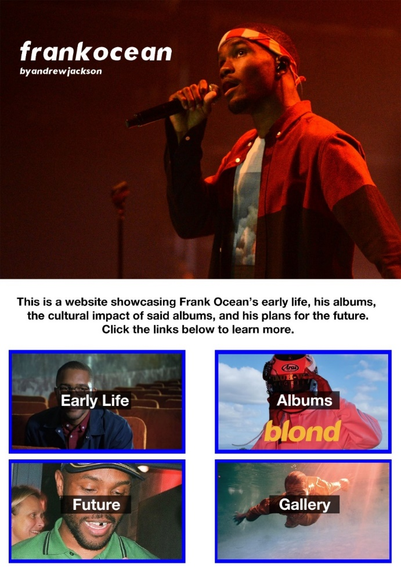

# Website Described