Output:
Question 1
Book class — constructors and exception handling
Compiled successfully; no warnings. Runtime exit status: 0. The negative-copy test is caught and printed as an exception message.
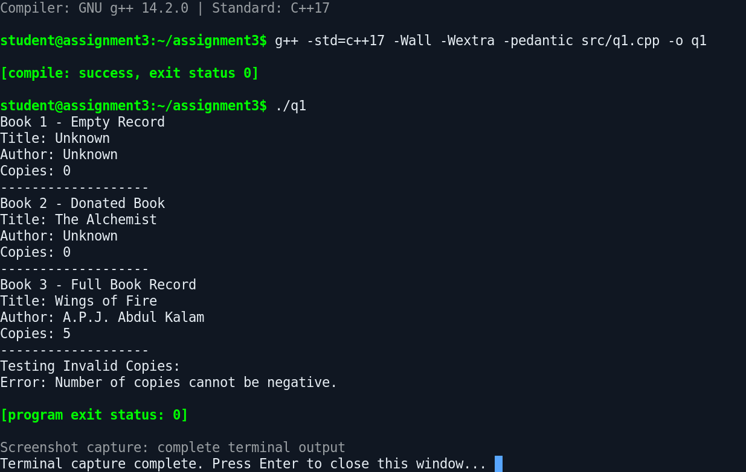

Question 2
Prescription class — deep copy and copy assignment
Compiled successfully; no warnings. Runtime exit status: 0. The output demonstrates independent copies after modifying the original and copied objects.
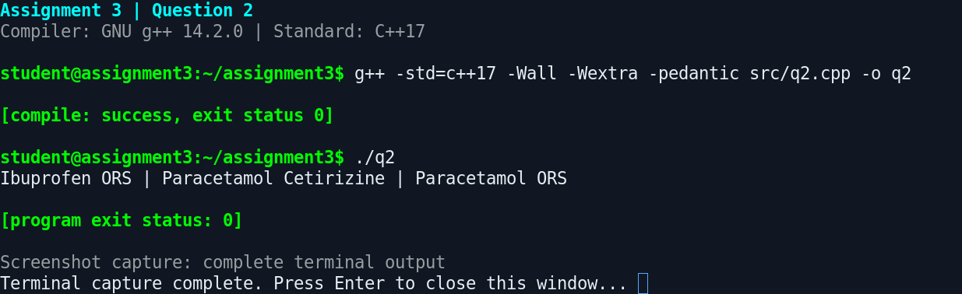

Question 3
Auditorium — dynamic allocation, booking, destruction, and Logger
Compiled successfully; no warnings. Runtime exit status: 0. The terminal output includes stack, block, heap, zero-row, destructor, and Logger lifecycle output.
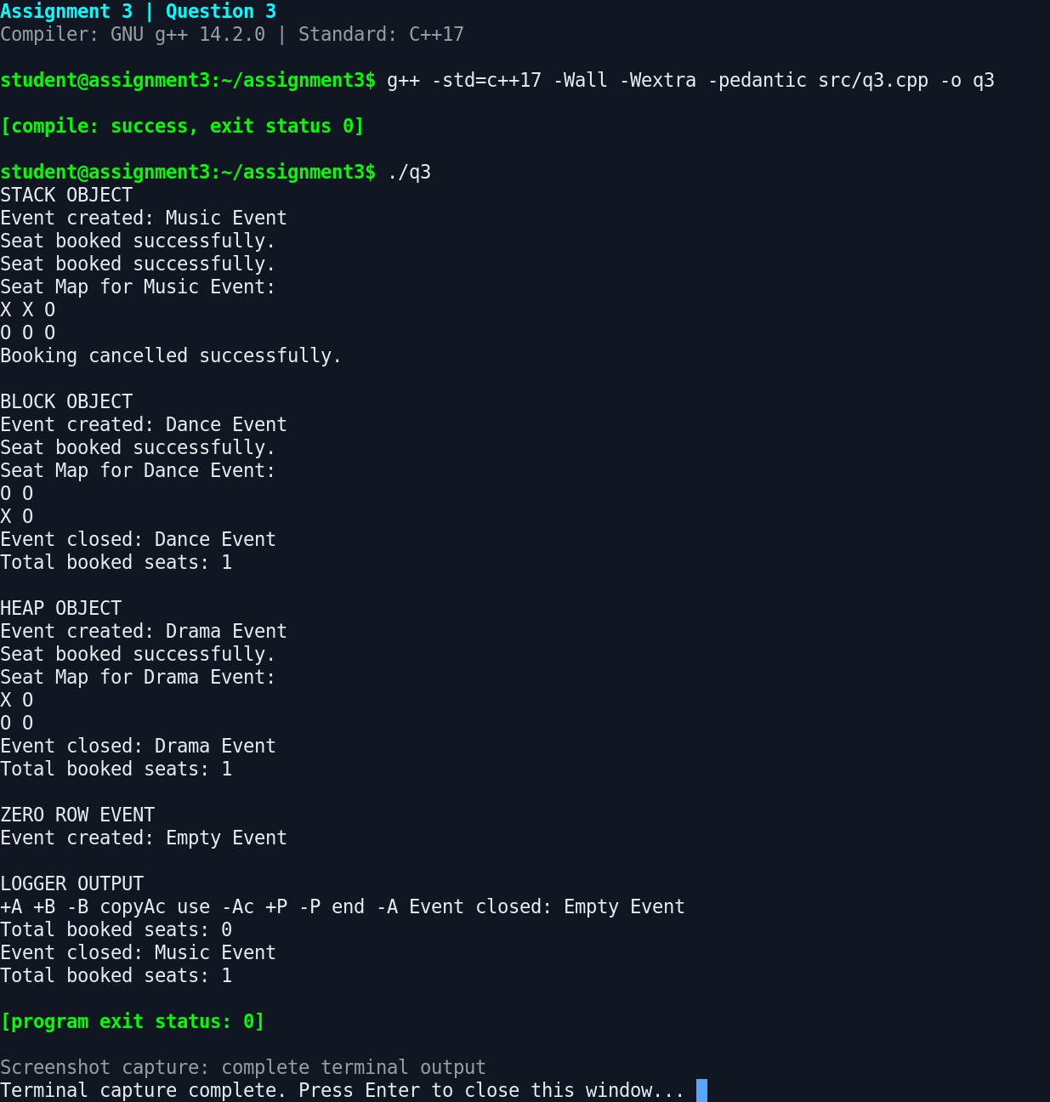

Question 4
Money class — overloaded arithmetic and comparison operators
Compiled successfully; no warnings. Runtime exit status: 0. Output includes paise carry and a negative amount.
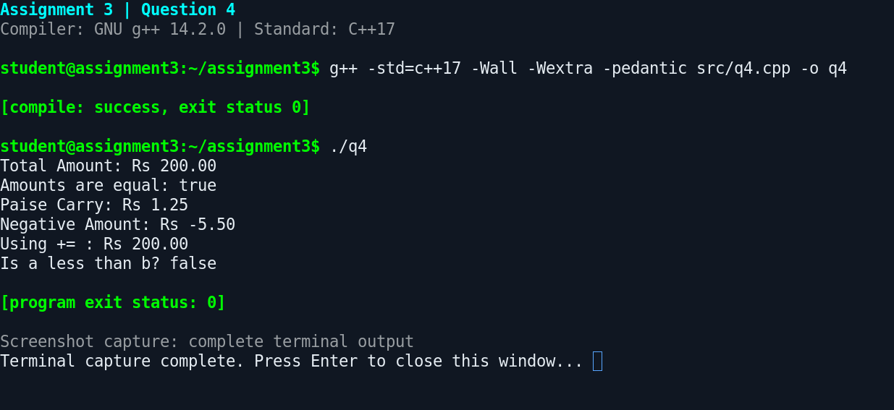

Question 5
Text class — dynamic character storage and overloaded operators
Compiled successfully; no warnings. Runtime exit status: 0. Copy constructor output appears during the explicit copy demonstration.
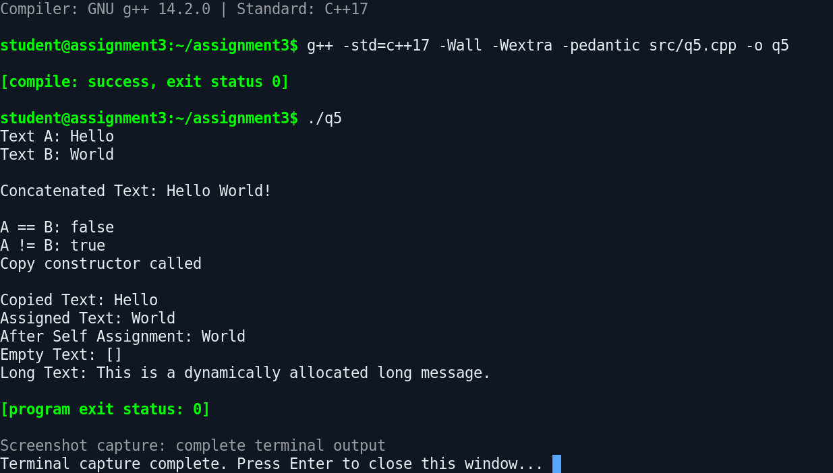

Question 6
Text class — duplicate source submission
Compiled independently; no warnings. Runtime exit status: 0. Source code is identical to Question 5; this is a separate build and execution capture.
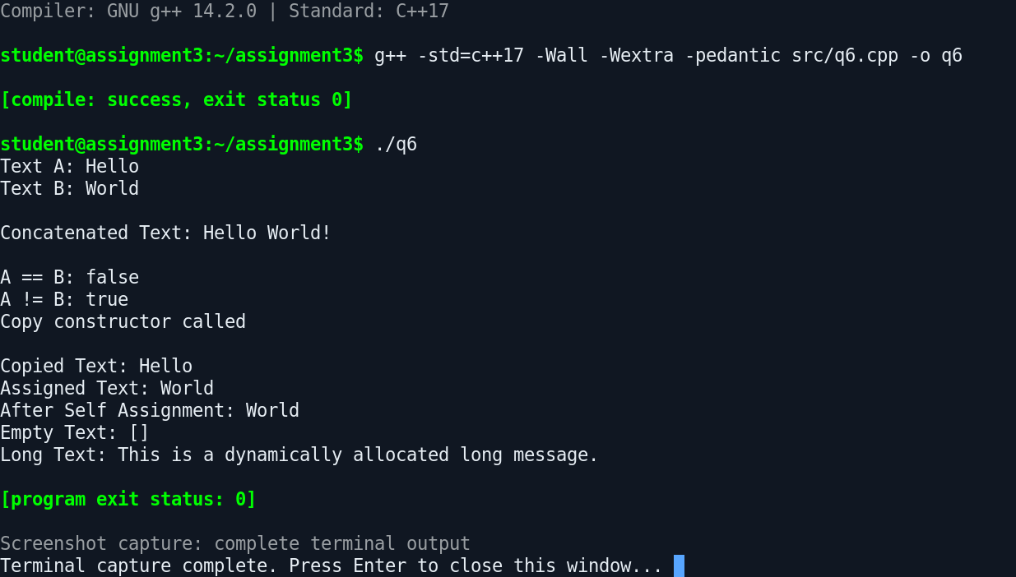

Question 7
Complex class — arithmetic and electrical impedance calculations
Compiled successfully; no warnings. Runtime exit status: 0. The division-by-zero exception is caught and its message is printed as intended.


