TASK 10 – Compare expectations with execution
The assignment asks for measured totals at three workload sizes and a comparison between integer paise, double rupees and int/long long accumulators. Use a repeatable experiment with a fixed fare so the expected result can be calculated by hand.
Journeys | If every journey is Rs.30 | Total in paise
20,000 | Rs.600,000 | 60,000,000
500,000 | Rs.15,000,000 | 1,500,000,000
3,000,000 | Rs.90,000,000 | 9,000,000,000

The last total is greater than the usual 32-bit signed int maximum (2,147,483,647) when stored in paise. Therefore int is unsafe for this example; long long is suitable. The rupee total is also well within the normal integer range, but storing paise is more precise.
Reproducible total-collection experiment
#include <iostream>
#include <iomanip>
int main() {
const long long farePaise = 3000;
const long long counts[] = {20000, 500000, 3000000};
for (long long n : counts) {
long long totalPaise = n * farePaise;
double totalRupees = n * 30.0;
std::cout << n << " journeys: "
<< totalPaise << " paise, Rs "
<< std::fixed << std::setprecision(2)
<< totalRupees << '\n';
}
}

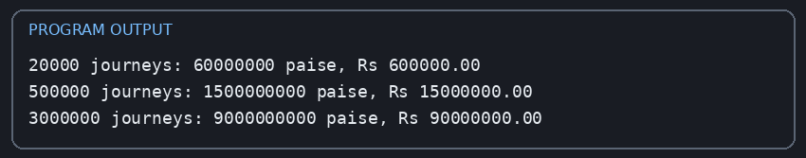
For this particular fixed fare of Rs.30, double can represent the displayed whole-rupee totals exactly. This does not prove that all decimal fare calculations are exact. Test repeated decimal additions such as 0.1 to expose binary floating-point approximation. With -Wall -Wextra, read each warning carefully; warnings depend on the compiler and exact code. The code should compile without warnings before submission.
Each addition is O(1) for int, long long and double. The total loop is O(n). The space for the accumulator is O(1). On common platforms int is 4 bytes and long long/double are 8 bytes; measure with sizeof on your system.

