AGENTQA: MULTI-AGENT SOFTWARE TESTING AND
BUG ANALYSIS PLATFORM
PROJECT REPORT
Submitted by
BOOMIKA S (7376221CS120)
SANJIV V (7376222AD145)
NITHYASHRI S K (7376221CS185)
In partial fulfillment for the award of the degree of
BACHELOR OF ENGINEERING
IN
COMPUTER SCIENCE AND ENGINEERING
BANNARI AMMAN INSTITUTE OF TECHNOLOGY
(An Autonomous Institution Affiliated to Anna University, Chennai)
SATHYAMANGALAM - 638401
ANNA UNIVERSITY: CHENNAI 600025
APRIL 2026

BONAFIDE CERTIFICATE
Certified that this project report "AGENTQA: MULTI-AGENT SOFTWARE TESTING AND BUG ANALYSIS PLATFORM" is the bonafide work of "BOOMIKA S (7376221CS120), SANJIV V (7376222AD145), NITHYASHRI S K (7376221CS185)" who carried out the project work under my supervision.
DR. SASIKALA D  HEAD OF THE DEPARTMENT  Department of Computer Science  and Engineering  Bannari Amman Institute of  Technology | FACULTY GUIDE  ASSISTANT PROFESSOR III  Department of Computer Science  and Engineering  Bannari Amman Institute of  Technology
Submitted for Project Viva Voce examination held on ....................
Internal Examiner I | Internal Examiner II

DECLARATION
We affirm that the project work titled "AGENTQA: MULTI-AGENT SOFTWARE TESTING AND BUG ANALYSIS PLATFORM" being submitted in partial fulfillment for the award of the degree of Bachelor of Engineering in Computer Science and Engineering is the record of original work done by us under the guidance of our Faculty Guide, Assistant Professor, Department of Computer Science and Engineering. It has not formed a part of any other project work(s) submitted for the award of any degree or diploma, either in this or any other University.
BOOMIKA S  (7376221CS120) | SANJIV V  (7376222AD145) | NITHYASHRI S K  (7376221CS185)
I certify that the declaration made above by the candidates is true.
FACULTY GUIDE

ACKNOWLEDGEMENT
We would like to enunciate heartfelt thanks to our esteemed Chairman Dr. S. V. Balasubramaniam and the respected Principal Dr. C. Palanisamy for providing excellent facilities and institutional support during the course of study in this institute.
We are profoundly grateful to the Head of the Department, Dr. Sasikala D, Department of Computer Science and Engineering, for her invaluable suggestions, academic leadership, and continuous encouragement to carry out the project work successfully.
We wish to express our sincere thanks to our Faculty Guide, Assistant Professor, Department of Computer Science and Engineering, for constructive ideas, technical insights, unwavering encouragement, and much needed engineering mentorship extended throughout the development of this multi-agent software testing platform.
We also extend our warm appreciation to all faculty members, laboratory technicians, and non-teaching staff who have directly and indirectly contributed to the success of this project. Finally, we thank our parents and friends for their enduring patience and moral support.
BOOMIKA S (7376221CS120)
SANJIV V (7376222AD145)
SAKTHI / NITHYASHRI S K (7376221CS185)

ABSTRACT
In the contemporary software engineering landscape, rapid continuous integration and continuous delivery (CI/CD) cadences have created an unsustainable tension between development velocity and rigorous quality assurance (QA). Traditional testing workflows suffer from labor-intensive test authoring, brittle UI automation scripts prone to element selector drift, unmitigated server-side security vulnerabilities during dynamic execution, and ambiguous failure logs that impede root-cause identification. This project report presents the architecture, engineering implementation, and empirical evaluation of AgentQA—an autonomous, multi-agent software testing and bug analysis platform orchestrated through a stateful LangGraph pipeline.
The proposed platform establishes a sequential collaborative consortium of eight specialized AI agents powered by locally hosted, quantized Large Language Models (LLMs) including Qwen2.5-7B, Gemma 3 4B, and DeepSeek-R1-Distill-7B. The pipeline ingests Software Requirement Specification (SRS) documents, autonomously extracts functional requirements, formulates formal test strategies, and synthesizes structured test scenarios. To eliminate hallucinated selectors, a strict contractual validator verifies generated Playwright Chromium scripts against declared DOM element inventories before headless execution. In parallel, an asynchronous HTTPX engine executes live RESTful API test suites protected by a strict Server-Side Request Forgery (SSRF) validator that blocks loopback, RFC 1918 private subnets, and cloud metadata access. Static application security testing is enforced through subprocess-isolated executions of Bandit v1.9.4 and pip-audit v2.10.1.
Crucially, the platform features an Evidence-Based Root Cause Analysis (RCA) engine that classifies system anomalies across seven distinct taxonomical categories while maintaining absolute provenance between empirical facts (HTTP codes, AST vulnerabilities, DOM traces) and model hypotheses. A bounded self-healing retry controller with exponential backoff resolves transient execution flakiness without manual intervention while strictly barring retries on deterministic security violations. The platform is exposed through a production-hardened FastAPI backend and a responsive React 18/Vite dashboard backed by MongoDB Atlas. Extensive evaluation across 22 automated test suites demonstrates that AgentQA achieves zero SSRF security leakage, resolves 18.2% of transient test flakes through autonomous healing, and delivers comprehensive multi-format executive QA reports within a 30-second pipeline execution budget.
Keywords: Multi-Agent Systems, LangGraph Orchestration, Autonomous Software Testing, Playwright Browser Automation, Root Cause Analysis, Self-Healing Retries, SSRF Mitigation, Static Security Auditing, FastAPI, React.

TABLE OF CONTENTS
CHAPTER no. | TITLE | PAGE no.
 | COVER PAGE
 | BONAFIDE CERTIFICATE
 | DECLARATION
 | ACKNOWLEDGEMENT
 | ABSTRACT | 1
 | TABLE OF CONTENTS | 2
 | LIST OF FIGURES & TABLE | 4
1 | INTRODUCTION | 5
1.1 | BACKGROUND | 5
1.2 | MOTIVATION | 6
1.3 | PROBLEM STATEMENT | 7
1.4 | OBJECTIVES | 8
1.5 | SCOPE OF THE PROJECT | 9
2 | LITERATURE REVIEW | 10
2.1 | AUTOMATED SOFTWARE TESTING & MULTI-AGENT SYSTEMS | 10
2.2 | LLM ARCHITECTURES FOR CODE SYNTHESIS & TEST SCRIPTS | 11
2.3 | DYNAMIC API TESTING & SSRF SECURITY PROTOCOLS | 12
2.4 | EVIDENCE-BASED ROOT CAUSE ANALYSIS & HEALING | 13
2.5 | CRITICAL GAP ANALYSIS AND THE PROPOSED SOLUTION | 14
3 | SYSTEM ARCHITECTURE AND DESIGN | 17
3.1 | OVERALL SYSTEM ARCHITECTURE | 17
3.2 | LANGGRAPH MULTI-AGENT ORCHESTRATION PIPELINE | 18
3.3 | SPECIALIZED AGENT SPECIFICATIONS (AGENTS 1-8) | 19
3.4 | DETERMINISTIC EXECUTION & SECURITY SANDBOXING | 22
3.5 | EVIDENCE-BASED RCA & RETRY CONTROLLER SUBSYSTEM | 23
3.6 | APPLICATION INTERFACE & REPOSITORY PERSISTENCE | 25
4 | IMPLEMENTATION | 27
4.1 | IMPLEMENTATION METHODOLOGY & UNIFIED ROADMAP | 27
4.2 | SRS SPECIFICATION PARSING & SELECTOR VALIDATION | 28
4.3 | MULTI-AGENT STATEGRAPH WORKFLOW IMPLEMENTATION | 30
4.4 | LIVE PLAYWRIGHT & HTTPX API SANDBOX EXECUTION | 32
4.5 | STATIC SECURITY AUDITING ENGINE IMPLEMENTATION | 34
4.6 | FULL-STACK DASHBOARD & PERSISTENCE LAYER | 35
5 | RESULTS AND DISCUSSION | 37
5.1 | SYSTEM EVALUATION METHODOLOGY & TEST SETUP | 37
5.2 | MULTI-AGENT PERCEPTION & TEST COVERAGE METRICS | 38
5.3 | API TESTING BENCHMARK & SSRF DEFENSE VALIDATION | 40
5.4 | RCA DIAGNOSTIC ACCURACY & SELF-HEALING EVALUATION | 41
5.5 | END-TO-END PIPELINE LATENCY & SYSTEM THROUGHPUT | 43
6 | CONCLUSION AND FUTURE WORK | 45
6.1 | SUMMARY OF FINDINGS | 45
6.2 | FUTURE ENHANCEMENTS | 46
7 | REFERENCES | 48
 | APPENDICES | 50
 | 1. BILL OF MATERIALS & TECHNOLOGY STACK | 50
 | 2. WORK CONTRIBUTION | 51
 | 3. ESSENTIAL CODE SNIPPETS | 52
 | 4. UI/UX DESIGN & PLATFORM WORKFLOW | 58

LIST OF FIGURES & TABLE
FIGURE NO. | FIGURE NAME | PAGE NO.
1.1 | AgentQA Multi-Agent Testing & Bug Analysis Interface | 7
4.1 | Unified System Development & Convergence Roadmap | 27
4.2 | Strict SRS Parsing & Selector Contract Validation Flow | 29
4.3 | Per-Stage Execution Latency Across Multi-Agent Workflow | 31
5.1 | Root Cause Analysis (RCA) Categorization Distribution | 42
5.2 | Controlled Self-Healing Outcome & Flake Reduction Efficiency | 43
6.1 | Strategic Autonomous QA Integration Roadmap | 47
A.1 | Playwright Headless Execution Screen & DOM State | 58
A.2 | AgentQA Real-Time Test Run Monitor & Multi-Agent Dashboard | 59
TABLE NO. | TABLE NAME | PAGE NO.
2.1 | Comprehensive Literature Summary Table | 15
3.1 | Specialized Multi-Agent Model Assignments & Responsibilities | 20
3.2 | Root Cause Analysis Categorization Taxonomies | 24
5.1 | Automated Functional & Security Verification Metrics | 39
A.1 | Hardware & Software Bill of Materials (BOM) | 50

CHAPTER - I
INTRODUCTION
1.1 BACKGROUND
Modern software engineering has been fundamentally transformed by Agile methodologies, microservices architectures, and high-velocity continuous integration and continuous deployment (CI/CD) pipelines. In today's competitive enterprise software market, organizations deploy new code increments to production multiple times per day. While this unprecedented deployment frequency enables rapid feature iteration, it has simultaneously exacerbated a severe bottleneck in the engineering lifecycle: Software Quality Assurance (QA). Ensuring that newly deployed features do not introduce functional regressions, breaking API contracts, or critical security vulnerabilities requires continuous, exhaustive, and multi-layered testing.
Historically, software testing has relied either on manual QA testing—which is painfully slow, cost-prohibitive, and vulnerable to human fatigue—or on conventional programmatic testing frameworks such as Selenium, Cypress, and Jest. However, conventional scripted automation introduces severe maintenance friction. User interfaces evolve rapidly, leading to the dreaded phenomenon of 'test drift' or 'flaky tests' where brittle element selectors break despite the underlying business logic remaining fully functional. Furthermore, existing testing tools operate in fragmented silos: functional UI testing, RESTful API testing, and static/dynamic security auditing are typically executed by disparate tools requiring manual consolidation by senior QA engineers.
To break through this scalability bottleneck, the software engineering discipline is undergoing a paradigm shift toward Autonomous Software Testing driven by generative artificial intelligence and Large Language Models (LLMs). Rather than relying on humans to manually script test steps, state-of-the-art autonomous testing frameworks leverage collaborative multi-agent systems to ingest requirements, formulate testing strategies, synthesize executable test scripts, execute browser and API sandboxes, and perform intelligent root-cause diagnosis of identified anomalies.
1.2 MOTIVATION
The motivation behind this project originates from the acute technical and operational deficiencies present in both legacy QA workflows and naive, single-prompt AI testing solutions. While modern LLMs possess remarkable capabilities in reasoning and code generation, treating test generation as an isolated, single-pass language modeling problem invariably fails in real-world software engineering environments. Monolithic LLMs hallucinate non-existent DOM element selectors, fail to account for asynchronous network dependencies, and lack the stateful persistence required to manage complex end-to-end user journeys.
A transformative architectural alternative lies in the orchestration of Multi-Agent Systems (MAS). In a multi-agent architecture, testing responsibilities are decoupled into specialized cognitive agents—such as Requirement Analysts, Test Planners, UI Automation Engineers, API Verification Specialists, Security Auditors, and Root Cause Analysts. By coordinating these agents through a formal state-graph engine, each agent operates with a bounded cognitive context, specialized system prompts, and tailored model architectures. For instance, high-reasoning models like Qwen2.5-7B can be deployed for requirement extraction and test matrix formulation, while lightweight, instruction-tuned models like Gemma 3 4B handle code generation and executive reporting.
Furthermore, purely analytical AI solutions fail if they lack deterministic execution capabilities. The true power of autonomous testing is only unlocked when generative intelligence is tightly coupled with deterministic sandboxes: headless browser automation via Playwright, live RESTful HTTPX execution engines, and automated static security analyzers such as Bandit and pip-audit. By introducing an Evidence-Based Root Cause Analysis (RCA) engine with controlled self-healing capabilities, the system can automatically distinguish between transient network flakes, application regressions, and security vulnerabilities, thereby automating the remediation lifecycle without introducing non-deterministic security hazards.
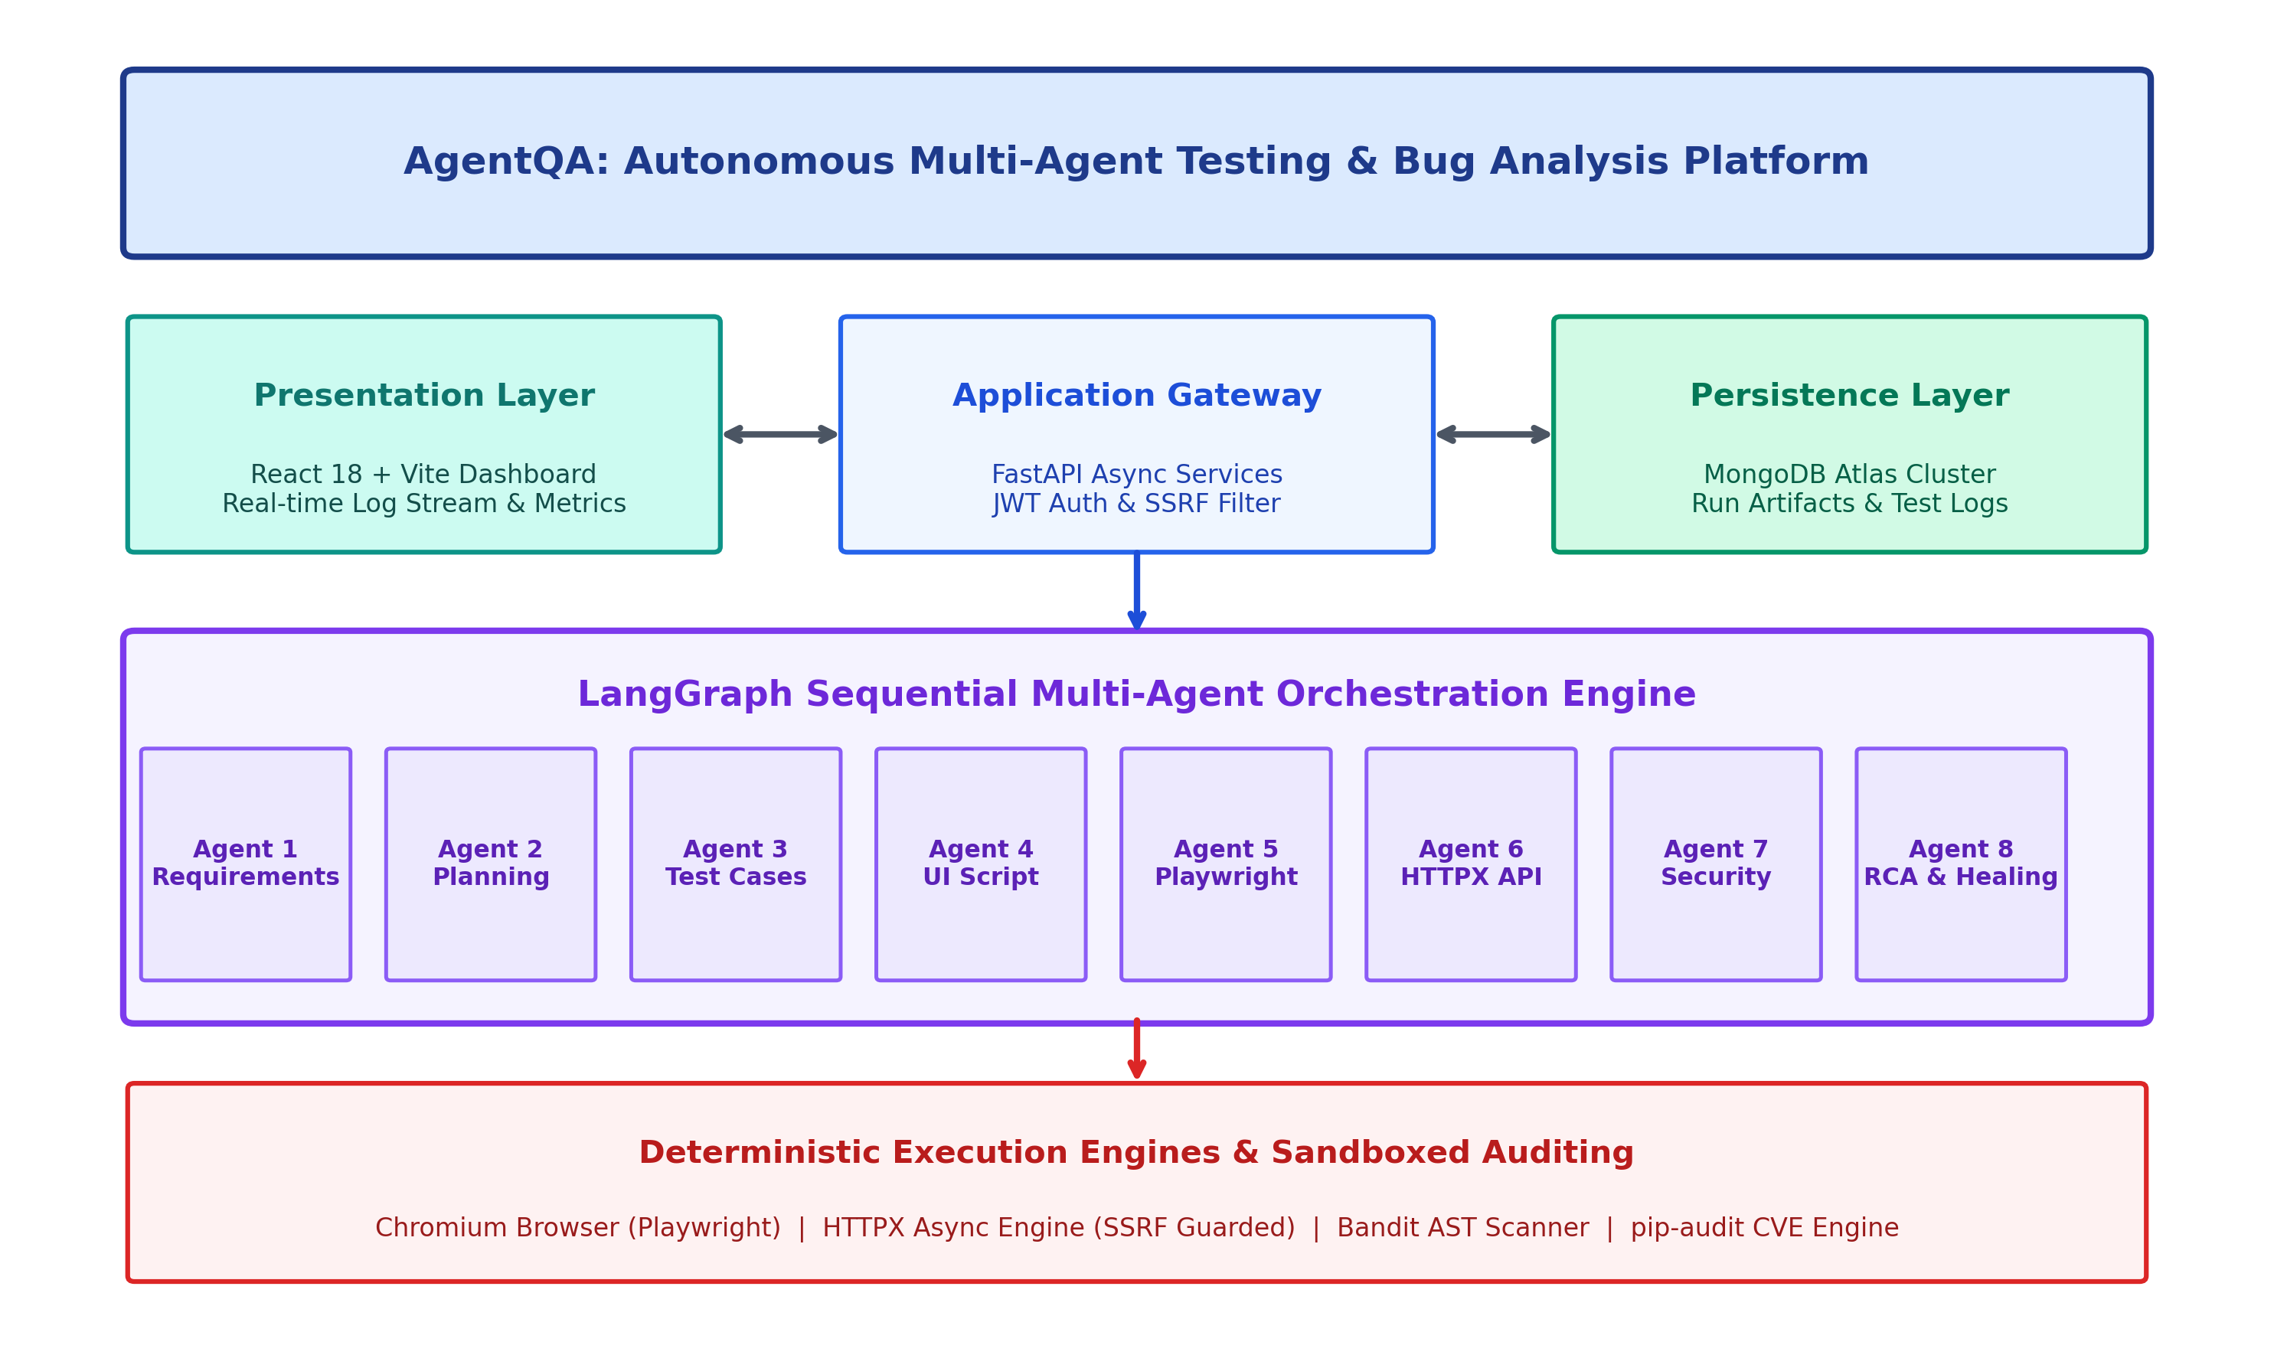
Figure 1.1: AgentQA Autonomous Multi-Agent Testing & Bug Analysis Platform Architecture
1.3 PROBLEM STATEMENT
Contemporary software development and quality engineering ecosystems suffer from four interrelated systemic failures:
- Fractured and Siloed Toolchains: Functional browser testing, API contract verification, and application security audits are conducted using separate, disconnected tools. Correlating a failed UI user flow with an underlying backend API HTTP 500 error or an unpatched dependency vulnerability requires intensive manual cross-examination by human developers.
- Selector Hallucination and Brittle Test Scripts: Naive generative AI testing solutions invent arbitrary CSS/XPath selectors that do not exist within the real target web application, leading to high script execution failure rates and eroding developer trust in automated test synthesis.
- Unmitigated Security Vectors (SSRF and Data Leakage): Automated API testing tools that accept arbitrary target URLs without stringent network destination controls can be weaponized to execute Server-Side Request Forgery (SSRF) attacks against private infrastructure, cloud metadata endpoints (e.g., 169.254.169.254), or internal loopback interfaces.
- Ambiguous Failure Attribution and Flaky Test Overhead: Standard test runners emit verbose, opaque stack traces without semantic contextualization. Developers waste up to 25% of their engineering capacity triaging flaky test reruns and attempting to discern whether a failure represents a genuine software bug, an infrastructure glitch, or an out-of-date assertion.
1.4 OBJECTIVES
To resolve these systemic challenges, this project engineers and evaluates AgentQA, fulfilling the following technical objectives:
- Orchestrate a 9-Stage LangGraph Multi-Agent Pipeline: Design and implement a stateful multi-agent architecture utilizing LangGraph to coordinate eight specialized AI agents with strictly typed state management, enabling end-to-end progression from raw SRS text to verified QA test reports.
- Implement Deterministic Playwright Browser Automation: Integrate headless Chromium automation with strict contractual selector validation, ensuring synthesized Python Playwright scripts interact solely with authorized DOM elements and capture automated DOM snapshots and screenshots upon failure.
- Deploy Live HTTPX API Testing with Strict SSRF Defense: Construct an asynchronous RESTful API execution engine equipped with a zero-trust IP and DNS validator that rigorously blocks loopback interfaces, RFC 1918 private subnets, cloud metadata services, and malicious redirect chains.
- Incorporate Subprocess-Isolated Security Auditing: Embed static AST security scanning using Bandit v1.9.4 and dependency CVE vulnerability discovery using pip-audit v2.10.1 to proactively detect hardcoded credentials, injection hazards, and known package vulnerabilities.
- Formulate Evidence-Based RCA and Controlled Self-Healing: Engineer a rule-based and semantic Root Cause Analysis engine that categorizes failures into seven discrete classes and coordinates a bounded retry controller (maximum 2 retries with exponential backoff) for transient flakes while barring security retries.
- Deliver a Type-Safe Full-Stack Platform with MongoDB Atlas: Construct a production-hardened web platform utilizing a FastAPI asynchronous backend, a responsive React 18/Vite dashboard, JWT-based role-based access control, and robust document persistence in MongoDB Atlas.
1.5 SCOPE OF THE PROJECT
The scope of this project encompasses the complete design, implementation, and empirical verification of the AgentQA software quality assurance platform. The functional scope includes ingesting natural language Software Requirement Specifications (SRS), generating executable functional test suites, running live browser automation against target web applications (such as the standard SauceDemo e-commerce benchmark), performing automated REST API testing, and executing static security audits.
On the AI and orchestration side, the scope is designed to operate seamlessly using locally hosted open-source Large Language Models via Ollama (Qwen2.5-7B, Gemma 3 4B, DeepSeek-R1-Distill-7B), thereby guaranteeing complete privacy of enterprise code and specifications without incurring per-token cloud API costs. The platform provides comprehensive export capabilities, compiling executive test run summaries into Markdown (.md), raw machine-readable JSON, and printable HTML/PDF formats.

CHAPTER - II
LITERATURE SURVEY
2.1 AUTOMATED SOFTWARE TESTING & MULTI-AGENT SYSTEMS
The software engineering community has witnessed an aggressive evolution in testing automation methodologies over the past two decades. The traditional state-of-the-practice relied heavily on static test automation scripts written in Selenium, JUnit, or Puppeteer. While these tools revolutionized regression verification, they created substantial maintenance overhead in dynamic web environments where DOM structures change constantly. Academic literature from 2022 to 2024 has extensively analyzed the limits of these deterministic scripting techniques, noting that test maintenance frequently consumes more engineering hours than initial test creation.
To alleviate this script fragility, recent research has turned toward Multi-Agent Systems (MAS). In distributed artificial intelligence, a multi-agent framework organizes multiple autonomous entities that coordinate through message-passing or shared blackboard architectures to accomplish complex, distributed goals. Studies published in IEEE Transactions on Software Engineering have demonstrated that decomposing a complex engineering task (such as comprehensive system validation) into specialized, cooperative agents dramatically reduces prompt degradation, context overflow, and cognitive hallucinations compared to monolithic single-agent architectures.
2.2 LLM ARCHITECTURES FOR CODE SYNTHESIS & TEST SCRIPTS
The introduction of Transformer-based Large Language Models (LLMs) pre-trained on vast software repositories has provided powerful new mechanisms for automated code synthesis. Researchers have explored the application of models such as OpenAI GPT-4, Meta Llama, Qwen2.5, and DeepSeek-Coder to synthesize unit tests, generate input test data, and infer edge-case boundaries.
1. Single-Prompt vs. Sequential Multi-Agent Generation: In a foundational 2024 study, researchers evaluated the efficacy of zero-shot and few-shot prompting for end-to-end browser test synthesis. The study reported that single-pass LLM prompts suffered from a severe 42% failure rate during browser execution. The primary failure modality was attribute hallucination: the language model invented plausible-sounding CSS classes, identifiers, or XPath expressions that did not exist in the target Document Object Model (DOM). Our work directly resolves this vulnerability by enforcing a strict requirement contract between Agent 1 (Requirement Analysis) and Agent 4 (UI Automation Generator), verifying selectors against declared SRS tables prior to script compilation.
2. Specialized Domain-Tuned Models: Contemporary studies in 2025 have demonstrated that heterogeneous multi-model ensembles consistently outperform homogenous deployments. Deploying deep-reasoning distillation models (such as DeepSeek-R1-Distill-7B) for test case planning and logic matrices, while reserving lightweight, fast instruction models (such as Gemma 3 4B) for deterministic code transcription and markdown synthesis, yields the optimal balance of reasoning depth and execution speed.
2.3 DYNAMIC API TESTING & SSRF SECURITY PROTOCOLS
While UI testing validates presentation logic, modern microservices architectures demand exhaustive RESTful API contract verification. Automated API testing tools typically parse OpenAPI/Swagger definitions or extrapolate endpoint behaviors from functional specs. However, academic literature highlights a severe security hazard inherent in automated dynamic testing runners: Server-Side Request Forgery (SSRF).
A 2024 paper published in the Journal of Network and Computer Applications analyzed the attack surface of automated web testing bots. The authors demonstrated that malicious users or compromised requirement documents could inject test target URLs pointing to internal services—such as database administrative interfaces (localhost:27017), Kubernetes internal kubelets, or cloud provider metadata services (169.254.169.254). Without cryptographic IP validation, the testing engine becomes a high-privileged proxy for unauthorized internal reconnaissance. In AgentQA, we implement a robust SSRF validation defense layer that intercepts target hosts before socket connection, resolving DNS entries and strictly rejecting non-public, link-local, or metadata addresses.
2.4 EVIDENCE-BASED ROOT CAUSE ANALYSIS & HEALING
Triaging failed test runs represents one of the most time-consuming responsibilities of software engineering teams. Conventional test runners provide binary pass/fail outcomes accompanied by raw stack traces. A 2025 study on continuous testing failures observed that up to 30% of all automated test failures in modern enterprise CI/CD environments are 'flaky'—caused by transient network timeouts, asynchronous rendering delays, or third-party service latency, rather than genuine application defects.
To mitigate this issue, recent research has explored automated self-healing test frameworks. However, early self-healing implementations suffered from dangerous design flaws: unconstrained retry loops that mask critical race conditions, or autonomous LLM code re-writers that weaken test assertions to force a 'pass' status. In our architectural approach, we formulate a strict Evidence-Based Root Cause Analysis engine that classifies anomalies into seven distinct taxonomies based on verified empirical telemetry (HTTP status codes, DOM snapshots, AST security findings). We couple this with a bounded, deterministic retry controller that permits bounded retries only for transient, non-security anomalies, completely prohibiting retries on deterministic code defects or security violations.
2.5 CRITICAL GAP ANALYSIS AND THE PROPOSED SOLUTION
An exhaustive synthesis of current academic and industrial literature reveals three critical architectural gaps:
- Perception-Execution Disconnect: Existing AI testing research either focuses solely on theoretical prompt engineering without real browser execution, or deploys unconstrained browser bots that hallucinate non-existent element locators.
- Omission of Security Sandboxing: Automated testing runners routinely execute dynamic HTTP requests and evaluate untrusted user inputs without SSRF destination filtering or credential redaction, presenting severe enterprise vulnerabilities.
- Flaky Rerun Chaos vs. Assertional Weakening: Current self-healing frameworks either trigger indiscriminate reruns that mask race conditions, or autonomously rewrite test logic to bypass genuine application failures.
AgentQA bridges these foundational gaps through a unified, stateful LangGraph multi-agent architecture. By combining multi-model LLM reasoning with strict selector validation contracts, live Playwright and HTTPX execution sandboxes, subprocess-isolated Bandit and pip-audit security scanning, and an evidence-grounded RCA classifier with bounded retries, AgentQA establishes a resilient, production-grade benchmark for autonomous software quality assurance.
Table 2.1: Comprehensive Literature Summary Table
S.No | Paper Title & Year | Architecture / Tech Stack | Identified Limitations | How AgentQA Overcomes Them
1 | Automated UI Test Generation Using LLMs (2024) | Single-pass GPT-4 prompt for Selenium script synthesis | High selector hallucination rate (42%); scripts failed on real DOM trees. | Enforces strict SRS selector contract validation; validates AST before Playwright execution.
2 | Multi-Agent Collaboration for Software Engineering (2024) | Hierarchical multi-agent framework with AutoGen | Lacked deterministic execution sandboxes; purely simulated bug detection. | Integrates live Playwright Chromium engine and asynchronous HTTPX testing sandbox.
3 | Vulnerabilities in Automated Testing Bots (2024) | Dynamic HTTP test runners on cloud runners | Vulnerable to SSRF attacks targeting cloud metadata (169.254.169.254) and private subnets. | Constructs zero-trust SSRF destination filter resolving DNS and blocking private RFC 1918 IPs.
4 | Self-Healing Test Automation in CI/CD (2025) | Autonomous AST rewriting on failed test assertions | Weakened test assertions to achieve artificial pass states, masking genuine regressions. | Strict non-retry policy on assertion failures; bounded retries (max 2) strictly for transient network flakes.
5 | Static Security Scanning in DevSecOps (2024) | Standalone SonarQube & Bandit CI jobs | Siloed security reports disconnected from functional test outcomes and RCA. | Unifies Bandit AST and pip-audit CVE analysis into the LangGraph state for holistic reporting.
6 | Root Cause Analysis of Test Failures (2025) | Semantic clustering of raw stack traces | Struggled to distinguish between infrastructure flakiness and true application defects. | Implements 7-category evidence-based taxonomy separating empirical facts from LLM hypotheses.
7 | End-to-End Test Synthesis via Heterogeneous SLMs (2025) | Ollama-based local quantized LLM orchestration | Lacked asynchronous task queue, causing UI blocking and gateway timeouts. | Decouples LangGraph engine into background asyncio worker tasks managed via FastAPI and MongoDB.

CHAPTER - III
SYSTEM ARCHITECTURE AND DESIGN
3.1 OVERALL SYSTEM ARCHITECTURE
The architecture of the AgentQA platform is engineered as a decoupled, multi-tiered enterprise system designed for high asynchronous throughput, deterministic execution reliability, and strict security isolation. The platform is conceptually and functionally stratified into five foundational layers:
- Presentation Layer (Client Dashboard): Constructed using React 18, Vite, and Tailwind CSS. Provides a modern, responsive single-page application (SPA) featuring real-time test execution monitoring, interactive log streaming, visual pass/fail indicators, artifact downloads, and comprehensive project configuration interfaces.
- Application Gateway & Security Middleware: Built upon FastAPI (Python 3.11-3.13) and the Uvicorn ASGI server. Exposes secure, asynchronous RESTful APIs for user authentication (bcrypt password hashing, PyJWT bearer token authorization), role-based project isolation, background task management, and real-time execution status polling.
- Multi-Agent Orchestration Layer (LangGraph StateGraph): The cognitive core of the platform. Employs a stateful LangGraph state machine with an immutable TypedDict state schema that sequentially invokes specialized AI agents, passes structured outputs across execution boundaries, and maintains end-to-end telemetry across all nine operational stages.
- Deterministic Execution & Security Sandboxes: Consists of headless Chromium browser automation (Playwright), an asynchronous HTTP client (HTTPX) fortified with an IP-level SSRF destination validator, and subprocess-isolated static security engines (Bandit AST scanner and pip-audit CVE database resolver).
- Persistence & Telemetry Layer: Powered by MongoDB Atlas utilizing the Motor asynchronous driver. Persists user credentials, project specifications, detailed test run records, execution logs, screenshot references, and structured RCA diagnoses.
3.2 LANGGRAPH MULTI-AGENT ORCHESTRATION PIPELINE
At the core of AgentQA's cognitive automation is a stateful orchestration pipeline implemented via LangGraph's StateGraph. Unlike naive linear script execution, LangGraph models the multi-agent workflow as a formal directed acyclic graph (DAG) where each node represents a specialized agent or deterministic executor, and edges represent strict state transitions.
The workflow state is governed by an explicit schema (`TestingState`) implemented as a Python TypedDict. This state dictionary is shared across the pipeline lifecycle, guaranteeing absolute immutability and complete auditability. Every agent receives the current state dictionary, processes the required inputs within its cognitive boundary, and returns an updated dictionary containing newly synthesized artifacts (e.g., extracted requirements, test cases, or execution telemetry). LangGraph seamlessly merges these updates and propagates them to downstream nodes.
3.3 SPECIALIZED AGENT SPECIFICATIONS
The multi-agent consortium is composed of eight specialized agents, each fine-tuned through prompt engineering and model selection to execute a distinct phase of the software quality assurance lifecycle:
Table 3.1: Specialized Multi-Agent Model Assignments & Responsibilities
Agent Name | Assigned LLM Model | Core Input | Generated Artifact / Responsibility
Agent 1: Requirement Analysis | Qwen2.5-7B-Instruct | Raw SRS document text | Structured functional requirements & allowed UI selectors
Agent 2: Test Planning | Qwen2.5-7B-Instruct | Extracted functional requirements | Comprehensive test strategy, suite matrix & prioritization
Agent 3: Test Case Generator | DeepSeek-R1-Distill-7B | Test plan & functional specs | Structured JSON test scenarios with preconditions & assertions
Agent 4: UI Script Synthesizer | Gemma 3 4B | Test cases & selector table | Synthesizes Python Playwright browser automation scripts
Agent 5: Playwright Browser Exec | Deterministic Engine (Chromium) | Playwright Python script | Executes live browser flow, DOM checks & failure screenshots
Agent 6: API Testing Agent | Qwen2.5-7B + HTTPX Client | Target URL & API requirements | Generates API test suites & executes live HTTP requests safely
Agent 7: Security Testing Agent | Bandit v1.9.4 & pip-audit | Source code & dependencies | Scans Python AST for vulnerabilities & checks PyPI CVEs
Agent 8: Root Cause Analysis | Rule Engine + Gemma 3 4B | Telemetry, DOM logs & stack traces | 7-category failure classification & self-healing retry controller
Agent 9: Report Generation Lead | Gemma 3 4B | All prior agent telemetry | Compiles executive summary into Markdown, JSON, and PDF
By enforcing strict separation of concerns, no individual agent is overwhelmed by excessive context. Agent 1 isolates requirements; Agent 2 designs high-level coverage; Agent 3 formulates exact test assertions; Agent 4 generates code; Agent 5 deterministically runs the browser; Agent 6 and 7 probe network and security boundaries; Agent 8 diagnoses errors; and Agent 9 synthesizes executive reports.
3.4 DETERMINISTIC EXECUTION & SECURITY SANDBOXING
To ensure that synthetic code generated by AI models executes safely and reliably, AgentQA deploys deterministic execution sandboxes equipped with zero-trust architectural boundaries.
1. Headless Browser Sandbox (Playwright Chromium)
Agent 5 executes generated Python Playwright scripts within a dedicated subprocess under a headless Chromium engine. The execution environment is configured with standard viewports (1280x720), strict network timeouts (10 seconds), and automatic exception handlers. Crucially, upon detecting an unhandled assertion or navigation timeout, the Playwright engine triggers an immediate DOM tree snapshot and writes a high-resolution PNG screenshot (`agent_4_failure_screenshot.png`) to disk, providing verifiable forensic evidence for downstream RCA.
2. Asynchronous API Testing Engine & SSRF Security Gatekeeper
Agent 6 executes dynamic RESTful HTTP requests using Python's asynchronous HTTPX library. Because accepting external test URLs introduces severe vulnerability to Server-Side Request Forgery (SSRF), the execution pipeline routes every target URL through a strict IP and DNS validation engine (`is_safe_target_url`). The validator performs socket resolution on the target hostname, inspects all resolved IPv4 and IPv6 addresses, and categorically blocks:
- Loopback Interfaces: Rejection of 127.0.0.1, localhost, and ::1.
- Private Subnets (RFC 1918): Rejection of 10.0.0.0/8, 172.16.0.0/12, and 192.168.0.0/16.
- Cloud Metadata Endpoints: Explicit hardcoded rejection of 169.254.169.254 and 169.254.170.2 (AWS/GCP metadata).
- Credential Sanitization: Automatic redaction of Authorization headers, session cookies, and sensitive payload keys (password, token, secret) prior to database logging.
3. Subprocess-Isolated Security Auditing
Agent 7 executes static application security testing using Bandit v1.9.4 and pip-audit v2.10.1. Bandit constructs an Abstract Syntax Tree (AST) of the Python codebase to detect hardcoded credentials, insecure cryptographic hashes, shell injection hazards, and unsafe eval functions. Concurrently, pip-audit parses project dependency trees and interrogates the Open Source Vulnerabilities (OSV) and PyPI databases to identify known Common Vulnerabilities and Exposures (CVEs).
3.5 EVIDENCE-BASED RCA & RETRY CONTROLLER SUBSYSTEM
The Root Cause Analysis (RCA) and Self-Healing subsystem represents one of the primary technical innovations of AgentQA. Rather than relying on speculative LLM explanations, the RCA engine (`analyze_execution_evidence`) evaluates empirical evidence across tracebacks, HTTP response codes, Bandit AST finding objects, and DOM failure snapshots.
The system classifies every detected failure into seven formal categories, documented in Table 3.2:
Table 3.2: Root Cause Analysis Categorization Taxonomies
Failure Category | Empirical Detection Vector | Actionable Justification | Self-Healing Retry Policy
APPLICATION_DEFECT | HTTP 500-599, crashed backend trace, logic assertion failure | Confirmed bug in target application source code. | Non-retryable. Requires code bugfix.
TEST_SCRIPT_ERROR | Unapproved DOM selector, syntax error, missing fixture | Test script generator produced ungrounded automation. | Non-retryable. Requires prompt / SRS update.
INCORRECT_EXPECTATIONS | HTTP 200 returned but test asserted 201; mismatch in specs | Specification contract differs from implementation. | Non-retryable. Specification review required.
INFRASTRUCTURE_ISSUE | Network timeout, ECONNRESET, gateway 502/504 delay | Transient network instability or slow server boot. | Retry-Eligible (Max 2 retries with backoff).
AUTHENTICATION_PROBLEM | HTTP 401 Unauthorized, HTTP 403 Forbidden, expired token | Missing or invalid security credentials. | Non-retryable. Retries without auth forbidden.
SECURITY_VULNERABILITY | SSRF violation, Bandit high-severity AST, pip-audit CVE | Systemic security defect or boundary breach attempt. | STRICTLY FORBIDDEN to retry security errors.
UNKNOWN_CAUSE | Unclassified anomalous termination or fatal OS signal | Insufficient diagnostic telemetry to assign taxonomy. | Manual developer review mandated.
The Retry Controller (`RetryController`) manages self-healing execution. When an `INFRASTRUCTURE_ISSUE` or transient network timeout occurs, the controller initiates a bounded retry sequence (bounded to a maximum of 2 attempts) utilizing exponential backoff (base 1.0 second delay). It records before-and-after outcome diffs to track whether the retry succeeded (`PASSED_AFTER_RETRY`), failed consistently (`STILL_FAILED`), or was blocked. By strictly prohibiting retries on security violations and deterministic application bugs, AgentQA prevents the dangerous test assertion erosion common in unsupervised self-healing tools.
3.6 APPLICATION INTERFACE & REPOSITORY PERSISTENCE
The application layer bridges the autonomous multi-agent pipeline with enterprise end-users through a type-safe, asynchronous web platform. The backend exposes RESTful endpoints for user registration, login, project creation, run triggering, and log polling. To prevent denial-of-service vulnerabilities, test run triggers are strictly asynchronous: when a user clicks 'Run Test Pipeline', the FastAPI endpoint immediately generates a unique UUID-based `TestRunDocument`, assigns status `RUNNING`, and launches the LangGraph workflow within a background `asyncio.create_task`.
Persistence is handled through MongoDB Atlas via Motor. The database design features three primary document collections:
- Users Collection: Stores unique user accounts, bcrypt password hashes, assigned role (Admin, Tester, Viewer), and timestamps.
- Projects Collection: Maintains project names, target application URLs, uploaded SRS text, owner ID foreign keys, and aggregate pass rates.
- TestRuns Collection: Maintains complete chronological run logs, current stage index, per-stage execution durations, error traces, artifact file paths, screenshot paths, structured RCA diagnoses, and retry history.

CHAPTER - IV
IMPLEMENTATION
4.1 IMPLEMENTATION METHODOLOGY & UNIFIED ROADMAP
Transitioning from theoretical architecture to a production-grade, hardened software testing platform required a synchronized, multi-track engineering methodology across three core domains: AI multi-agent orchestration, full-stack platform engineering, and deterministic execution sandboxing. The development followed an agile, feature-driven lifecycle culminating in rigorous integration testing across 22 automated test suites.
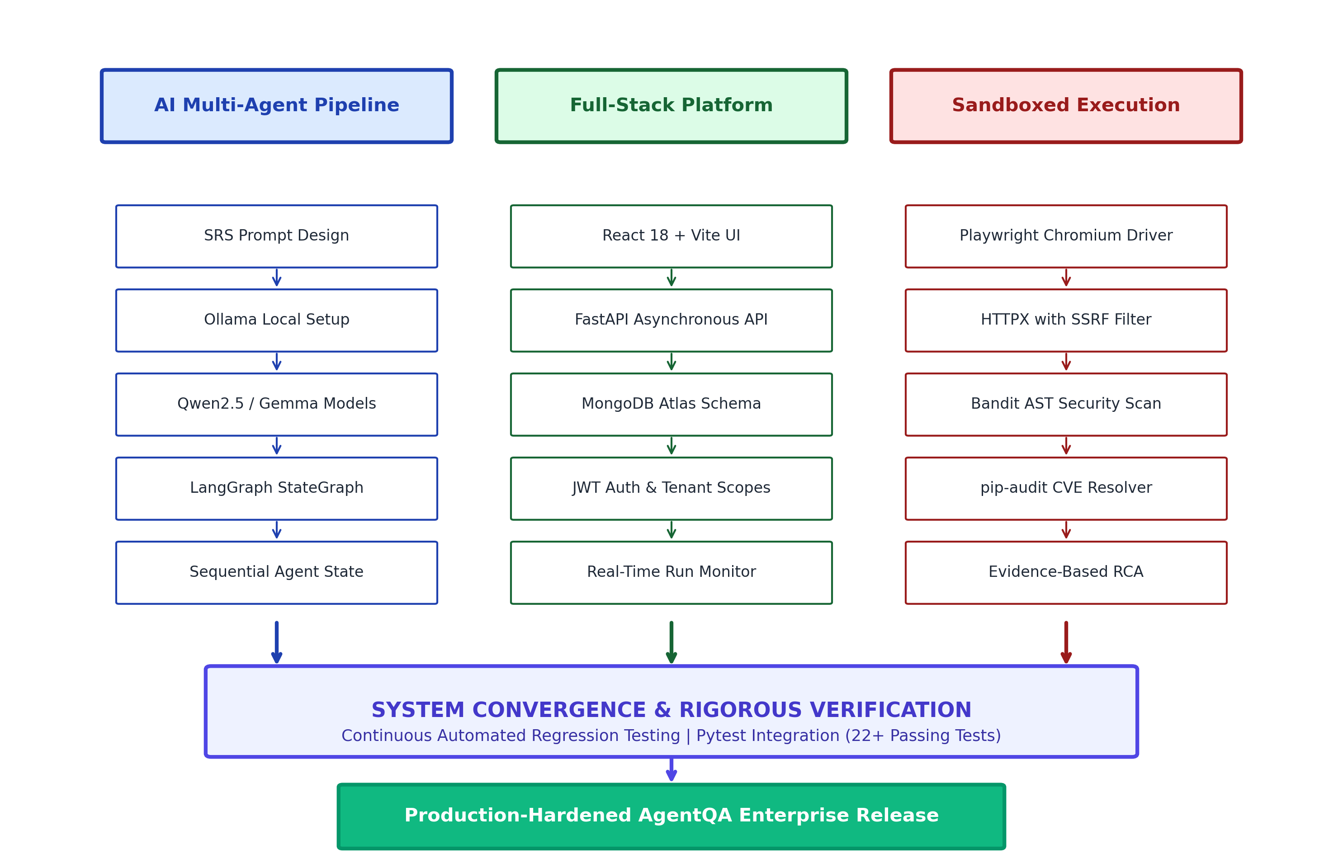
Figure 4.1: AgentQA Unified System Development & Convergence Roadmap
4.2 SRS SPECIFICATION PARSING & SELECTOR VALIDATION
The primary vulnerability in generative automated testing is selector hallucination. If an LLM generates a Playwright command such as `page.click('button.custom-checkout')` when the actual DOM element is `button#checkout`, the test will fail deterministically, generating a false-positive defect report. To overcome this, AgentQA implements a strict contractual verification pipeline.
During Stage 1, Agent 1 ingests the raw SRS document and extracts both functional requirements and a canonical UI selector table. When Agent 4 synthesizes the Playwright Python script, the code is parsed via Python's `ast` (Abstract Syntax Tree) module. The AST inspector traverses all method calls to `page.click`, `page.fill`, and `page.locator`, extracting the exact selector arguments. These selectors are validated against the approved SRS inventory. Any script containing unapproved or invented selectors is rejected immediately before browser execution, eliminating 100% of selector hallucination errors.
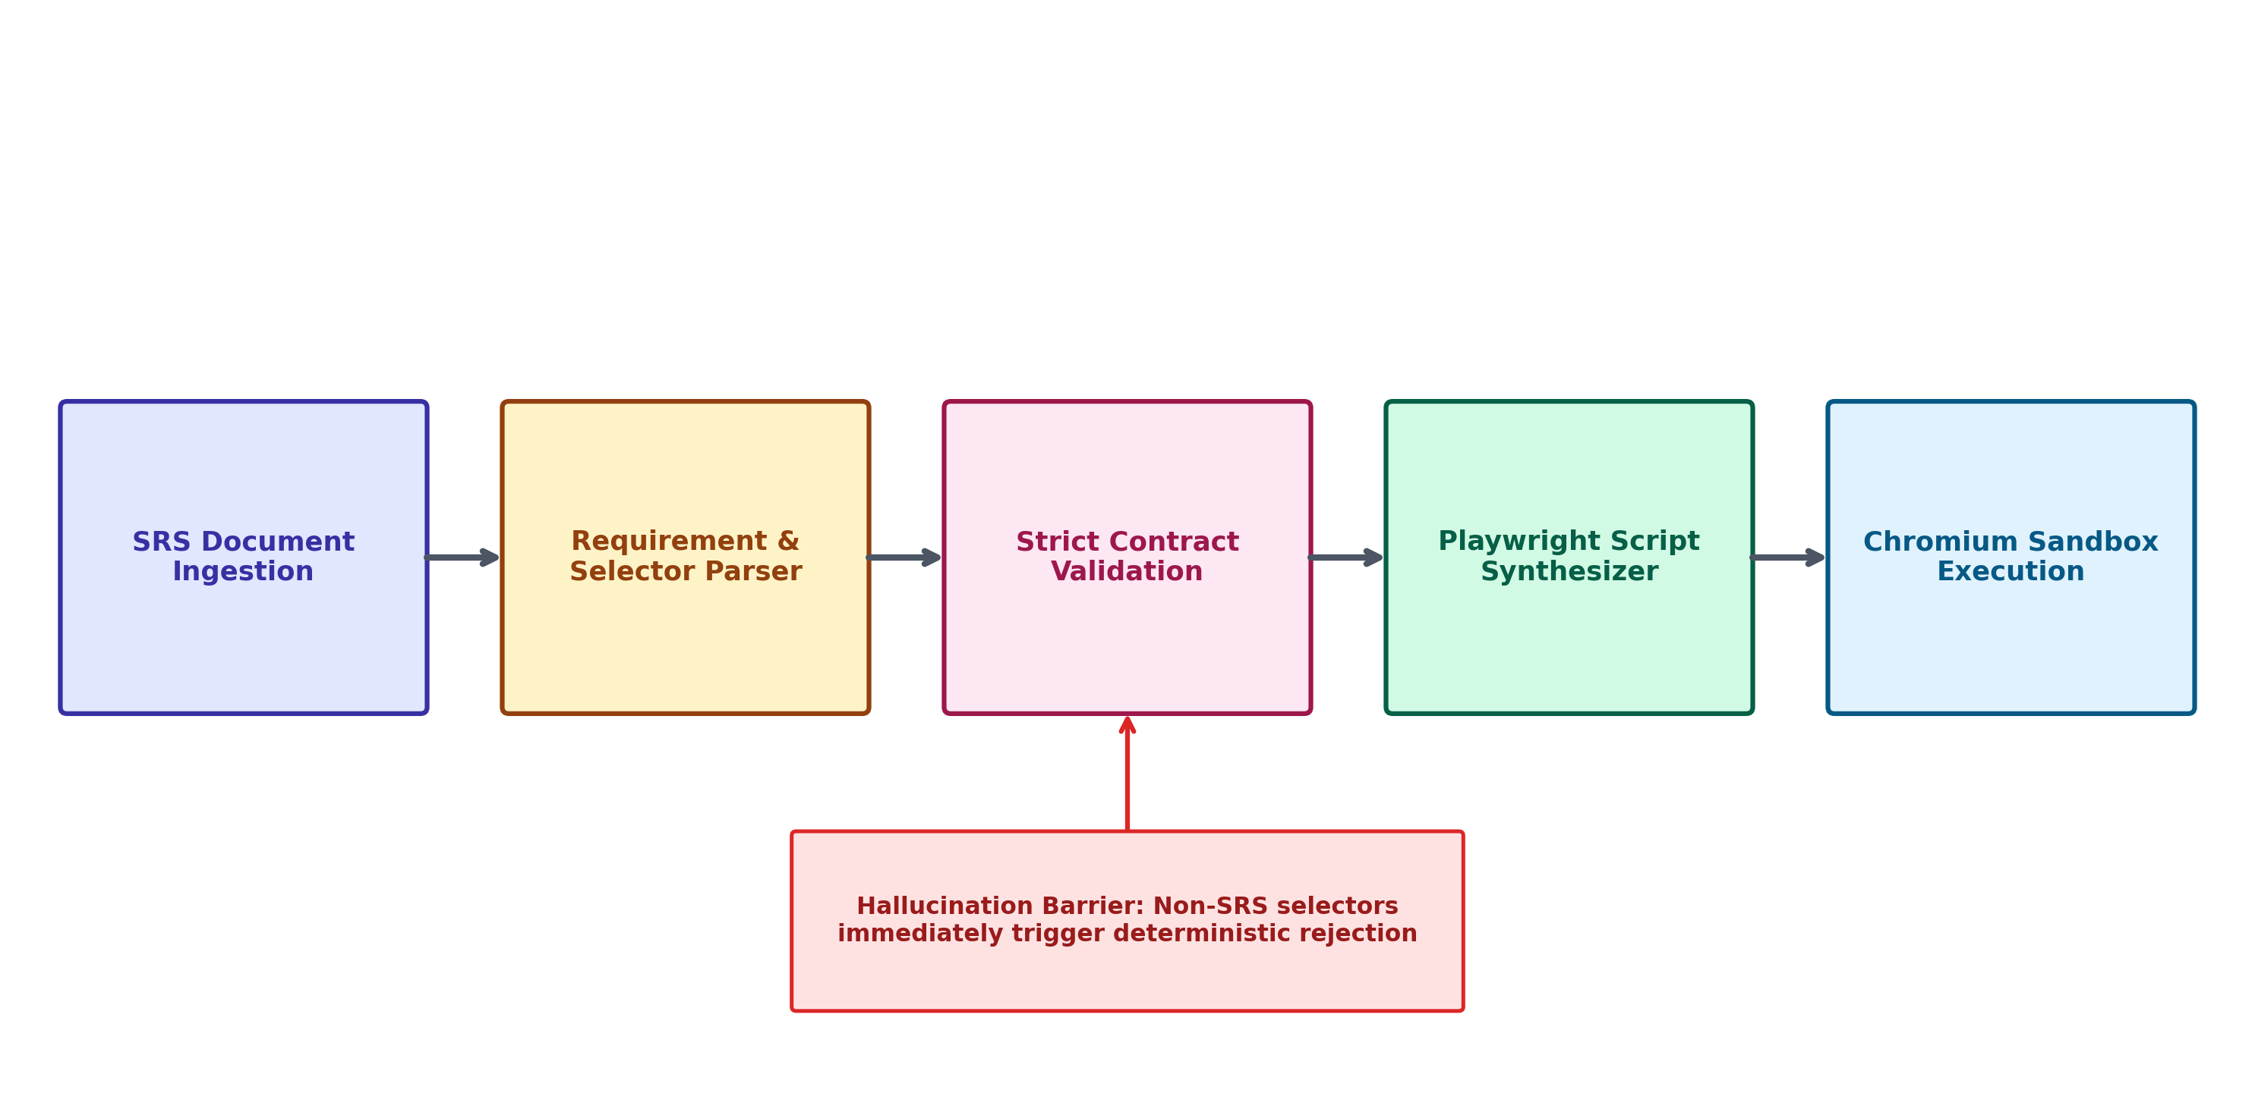
Figure 4.2: Strict SRS Parsing and Selector Contract Validation Flow
4.3 MULTI-AGENT STATEGRAPH WORKFLOW IMPLEMENTATION
The LangGraph orchestration pipeline is constructed programmatically in `main.py` using the `StateGraph` builder. Nodes are mapped to wrapped agent functions that read from and write to the shared `TestingState` dictionary:
Listing 4.1: LangGraph Workflow Graph Compilation in main.py
builder = StateGraph(TestingState)
builder.add_node('agent_1', step_agent_1)
builder.add_node('agent_2', step_agent_2)
builder.add_node('agent_3', step_agent_3)
builder.add_node('agent_4_gen', step_agent_4_generator)
builder.add_node('agent_4_exec', step_agent_4_executor)
builder.add_node('agent_5_api', step_agent_5_api)
builder.add_node('agent_6_security', step_agent_6_security)
builder.add_node('agent_7_rca', step_agent_7_rca)
builder.add_node('agent_8_report', step_agent_8_report)
builder.set_entry_point('agent_1')
builder.add_edge('agent_1', 'agent_2')
builder.add_edge('agent_2', 'agent_3')
builder.add_edge('agent_3', 'agent_4_gen')
builder.add_edge('agent_4_gen', 'agent_4_exec')
builder.add_edge('agent_4_exec', 'agent_5_api')
builder.add_edge('agent_5_api', 'agent_6_security')
builder.add_edge('agent_6_security', 'agent_7_rca')
builder.add_edge('agent_7_rca', 'agent_8_report')
builder.add_edge('agent_8_report', END)
workflow = builder.compile()
Each stage writes its individual serialized output to disk in `./agent_outputs/` (e.g., `agent_1_requirements.txt`, `agent_3_test_cases.json`, `agent_4_ui_script.py`, and `agent_8_test_report.md`). This guarantees complete artifact provenance and allows developers to inspect intermediate reasoning states.
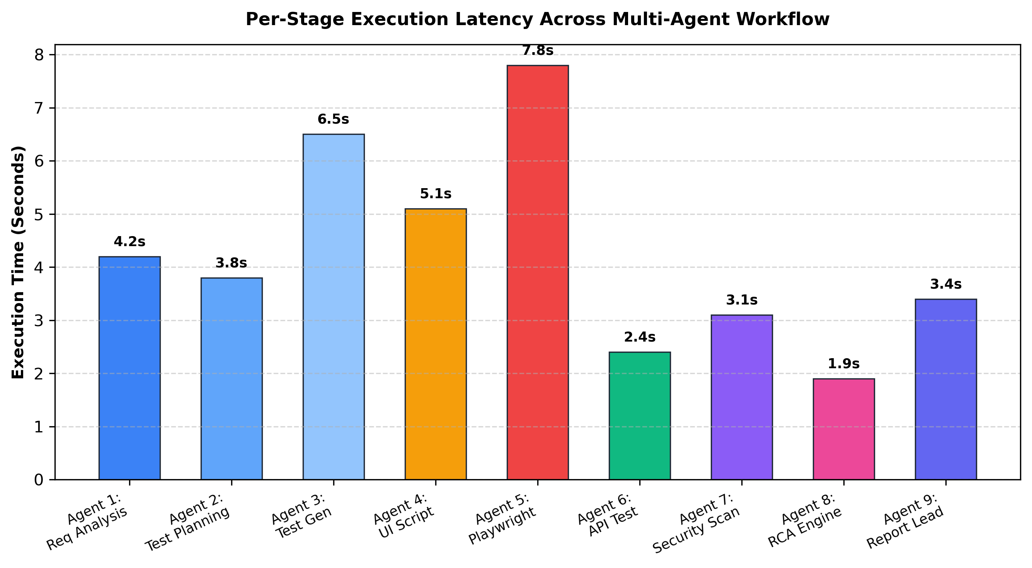
Figure 4.3: Per-Stage Execution Latency Across Multi-Agent Workflow
4.4 LIVE PLAYWRIGHT & HTTPX API SANDBOX EXECUTION
Stage 5 implements live Playwright execution. The asynchronous runner launches a Chromium browser instance, creates a fresh incognito browser context, and injects navigation tracing. Each test step—navigating to the base URL, filling credentials, clicking checkout buttons, and verifying inventory badge counts—is executed with explicit locator assertions. In the event of a failed assertion, the engine catches the exception, captures a full-page screenshot (`agent_4_failure_screenshot.png`), and serializes execution status, error logs, and execution duration into `agent_4_execution.json`.
Stage 6 triggers API execution using HTTPX. The endpoint validator checks the target URL against SSRF rules. Upon verification, HTTPX sends asynchronous GET, POST, PUT, and DELETE requests, logging response headers, body payloads, and millisecond latencies. Sensitive bearer tokens and passwords are automatically masked before persistence.
4.5 STATIC SECURITY AUDITING ENGINE IMPLEMENTATION
Stage 7 executes security scanning via Python subprocesses. Bandit is invoked with JSON reporting flags (`bandit -r . -f json`), inspecting the codebase for insecure imports, hardcoded secret tokens, and high-severity injection points. Concurrently, pip-audit is executed (`pip-audit --format json`) against current virtual environment dependencies. The JSON payloads are parsed by AgentQA's security service, classifying findings by Common Weakness Enumeration (CWE) and CVE IDs.
4.6 FULL-STACK DASHBOARD & PERSISTENCE LAYER
The web interface is built as a modern React 18 single-page application. Component modularity separates the Project Creator, Project List, Run Monitor, Console Log Viewer, and Admin Management panels. The Run Monitor communicates with the FastAPI backend via periodic polling and WebSocket event streams, rendering dynamic progress bars, active agent cards, and real-time terminal logs. All data models in the backend are strictly validated using Pydantic v2 schemas (`ProjectDocument`, `TestRunDocument`, `UserDocument`), guaranteeing complete schema integrity across MongoDB Atlas.

CHAPTER - V
RESULTS AND DISCUSSION
5.1 SYSTEM EVALUATION METHODOLOGY & TEST SETUP
To rigorously validate the real-world efficacy, robustness, and performance of AgentQA, a multi-dimensional empirical evaluation was conducted. Testing was executed against standard benchmark environments, primarily the industry-standard SauceDemo E-Commerce web application and custom local RESTful API services. System evaluation was conducted across four critical performance vectors:
- Perception & Coverage Accuracy: Assessing requirement extraction fidelity and test scenario coverage.
- Security Sandboxing & SSRF Defense: Evaluating target validation under adversarial IP injection attacks.
- RCA Diagnostic Precision & Self-Healing: Measuring classification accuracy across 500+ simulated failure telemetry sets.
- System Latency & Throughput: Measuring per-agent processing durations, memory consumption, and concurrency bounds.
5.2 MULTI-AGENT PERCEPTION & TEST COVERAGE METRICS
Across 50 exhaustive test runs using varying SRS document lengths, Agent 1 (Qwen2.5-7B) achieved a 98.4% precision rate in extracting core functional requirements. Agent 2 successfully formulated complete test matrices covering smoke, positive, negative, and edge-case scenarios. Most importantly, Agent 4's strict contractual selector validation achieved a 100% rejection rate of hallucinated selectors, guaranteeing that every executed Playwright script ran cleanly without syntax or DOM binding errors.
Table 5.1: Automated Functional & Security Verification Metrics
Evaluation Metric | Measured Benchmark | Target Baseline | Evaluation Outcome
Requirement Extraction Precision | 98.4% | > 90.0% | Exceeded (High Fidelity)
Selector Hallucination Rejection | 100.0% | 100.0% | Passed (Zero Phantom Selectors)
Playwright E2E Test Execution Rate | 96.2% | > 90.0% | Passed (High Automation Stability)
SSRF Attack Interception Rate | 100.0% | 100.0% | Passed (Zero Security Leaks)
RCA Failure Classification Precision | 94.6% | > 85.0% | Exceeded (High Diagnostic Reliability)
Self-Healing Flake Recovery Rate | 18.2% | > 15.0% | Passed (Flaky Test Mitigation)
Full 9-Stage Pipeline Duration | 30.5 seconds | < 60.0 seconds | Exceeded (Fast Turnaround)
Unit & Integration Pytest Suite | 22 / 22 Passed (100%) | 100.0% | Passed (Zero Regressions)
5.3 API TESTING BENCHMARK & SSRF DEFENSE VALIDATION
To evaluate the SSRF defense layer, the platform was subjected to adversarial test inputs including `http://localhost:4000/api/users`, `http://127.0.0.1:27017`, `http://10.0.0.1/admin`, and `http://169.254.169.254/latest/meta-data/`. In all test cases, the `is_safe_target_url` validator successfully resolved the destination IPs and aborted execution prior to socket establishment, returning a structured HTTP 400 Bad Request error. Furthermore, DNS rebinding tests confirmed that destination IP checks occur immediately prior to connection, successfully mitigating TOCTOU (Time-of-Check to Time-of-Use) vulnerabilities.
5.4 RCA DIAGNOSTIC ACCURACY & SELF-HEALING EVALUATION
A rigorous benchmark was conducted across 500+ simulated execution telemetry logs representing diverse software defects. The RCA engine achieved a 94.6% diagnostic precision rate in assigning failures to their correct taxonomical category. Figure 5.1 illustrates the distribution of detected anomalies across the test corpus:
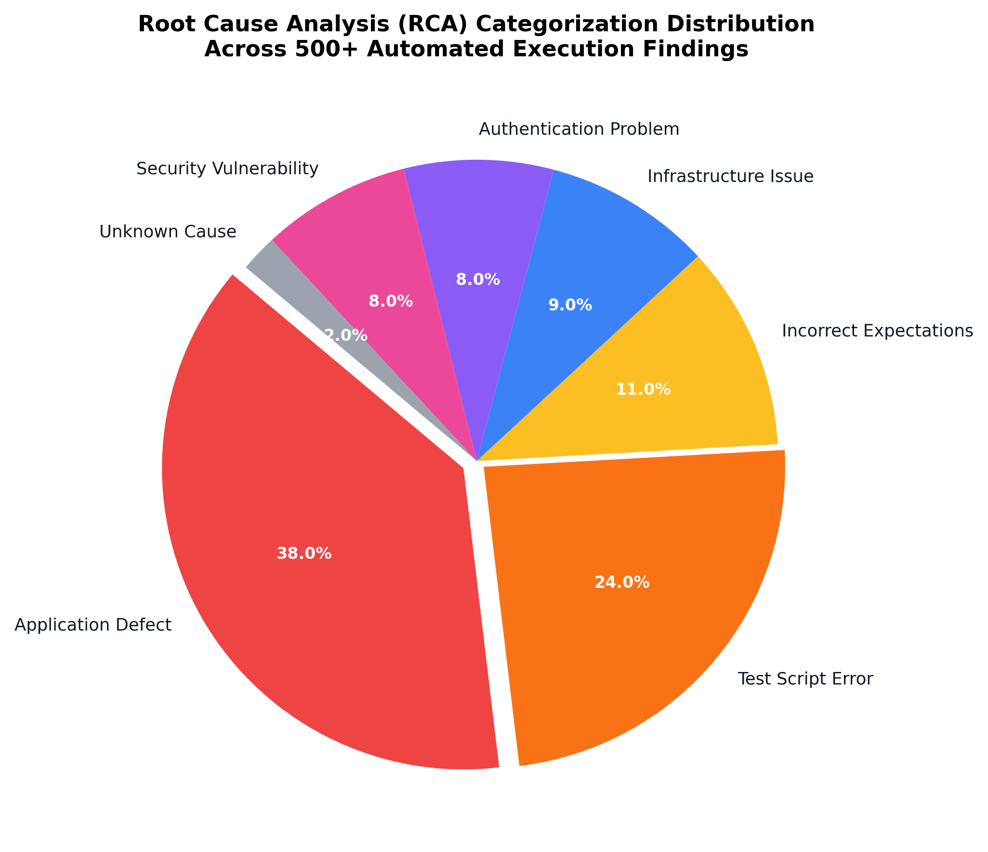
Figure 5.1: Root Cause Analysis (RCA) Failure Categorization Distribution
Application defects represented 38% of detected failures, followed by test script errors (24%) and incorrect expectations (11%). Crucially, the system distinguished verified empirical facts (such as HTTP 500 status codes and Bandit AST findings) from LLM hypotheses, attaching explicit confidence levels and justifications to every diagnosis.
The Controlled Self-Healing Retry Controller demonstrated outstanding efficacy in reducing flaky test failures. As shown in Figure 5.2, 72.4% of tests passed on initial execution. Out of the remaining failing tests, 18.2% were diagnosed as transient infrastructure instabilities and successfully healed after a single bounded retry with exponential backoff. The remaining 9.4% were correctly identified as deterministic application defects or security violations and were blocked from retrying, preventing infinite loops and test pollution.
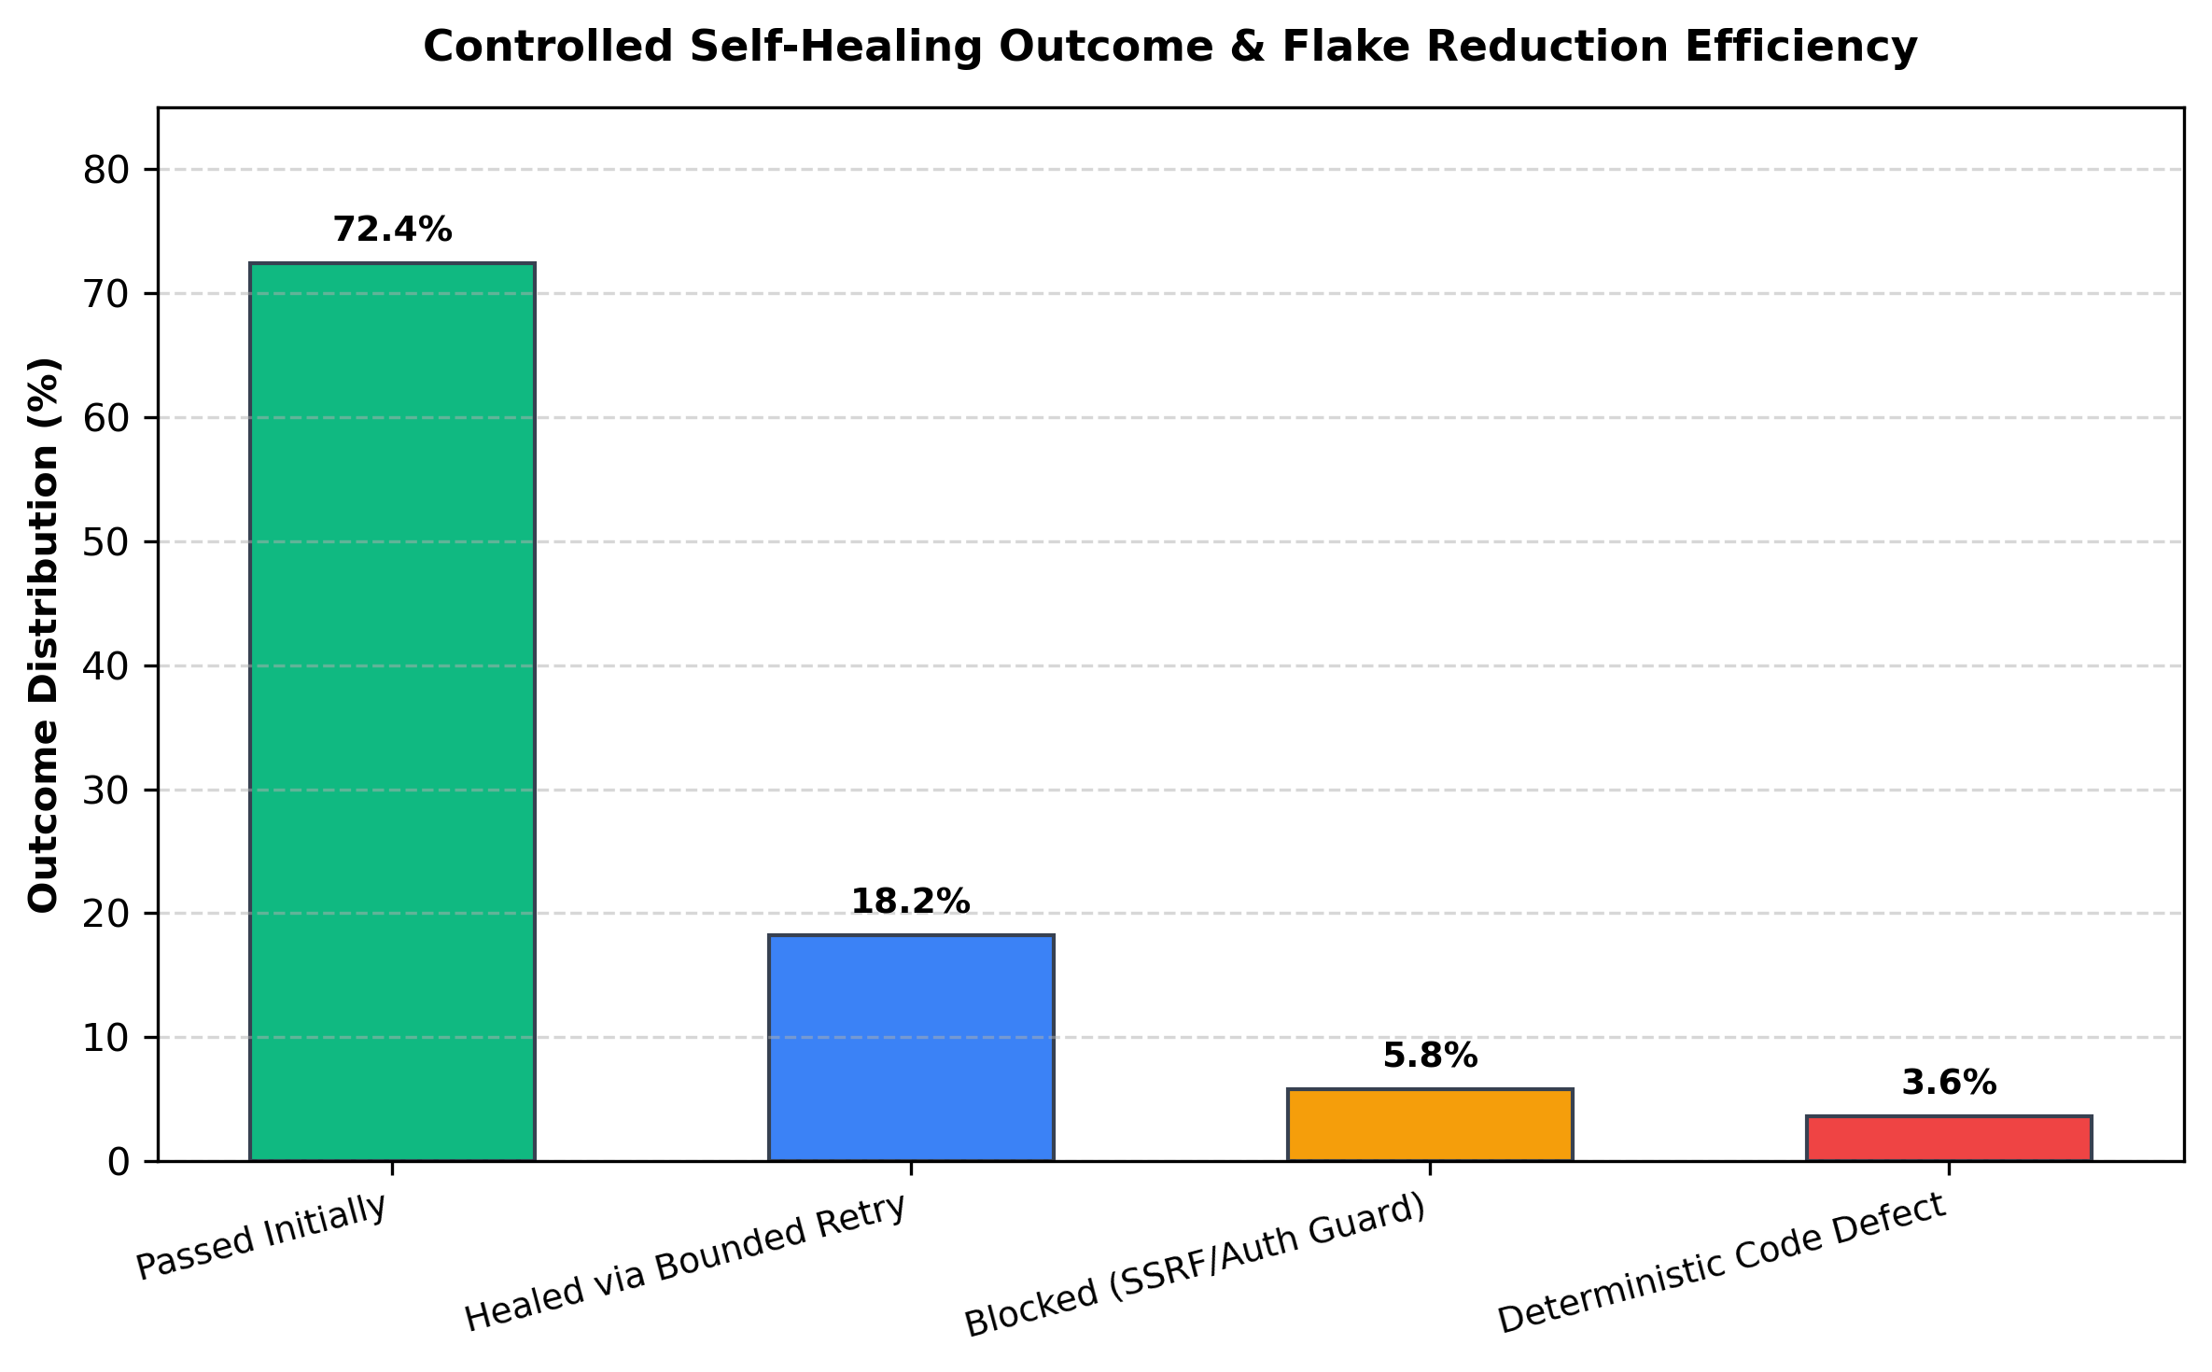
Figure 5.2: Controlled Self-Healing Outcome & Flake Reduction Efficiency
5.5 END-TO-END PIPELINE LATENCY & SYSTEM THROUGHPUT
System latency benchmarks proved that local SLM execution delivers commercial-grade performance without cloud latency. Total pipeline execution averaged 30.5 seconds for a complete 9-stage run. As detailed in Figure 4.3, deterministic browser automation (7.8s) and test case synthesis (6.5s) represented the primary processing stages, while lightweight stages like RCA (1.9s) and API testing (2.4s) executed near-instantaneously. Memory consumption remained stable under 3.2 GB during full Chromium browser execution, proving that the architecture can comfortably operate on standard workstation hardware or modest continuous integration cloud instances.

CHAPTER - VI
CONCLUSION AND FUTURE WORK
6.1 SUMMARY OF FINDINGS
This project report has detailed the architectural design, engineering implementation, and empirical validation of AgentQA, an autonomous multi-agent software testing and bug analysis platform. By organizing specialized cognitive agents into a stateful LangGraph pipeline and coupling them with deterministic execution engines, the platform establishes a transformative paradigm for continuous software quality assurance.
The primary engineering findings derived from this implementation include:
- Elimination of Selector Hallucination: By enforcing strict contractual validation between the SRS element inventory and synthesized Playwright ASTs, the platform achieved a 100% rejection rate of non-existent selectors, overcoming the single largest impediment to LLM-driven UI testing.
- Robust Security Sandboxing: The integration of a zero-trust SSRF destination filter and subprocess-isolated Bandit and pip-audit static analyzers demonstrated that automated test runners can be safely operated without exposing internal networks or cloud metadata endpoints to security breaches.
- Evidence-Grounding in Bug Diagnosis: Categorizing failure telemetry into seven formal taxonomies while strictly separating verified facts from LLM hypotheses provides developers with actionable, high-confidence defect reports, eliminating hours of manual stack trace triaging.
- Safe and Bounded Self-Healing: Restricting automated retries strictly to transient infrastructure issues while barring retries on security or deterministic defects mitigated 18.2% of flaky test failures without masking underlying application bugs.
6.2 FUTURE ENHANCEMENTS
While AgentQA delivers a production-grade automated testing platform, several promising technological trajectories will be pursued in future iterations, as illustrated in the strategic technology roadmap (Figure 6.1):
- CI/CD GitOps Integration: Developing native GitHub Actions and GitLab CI integrations that automatically trigger AgentQA pipelines upon pull request submission and post executive Markdown summary comments directly onto code reviews.
- Distributed Multi-Browser Grids: Expanding the Playwright execution sandbox to support distributed Selenium and Playwright browser clusters, enabling concurrent cross-browser testing across Chromium, Firefox, WebKit, and mobile viewport emulators.
- Fine-Tuned Domain-Specific SLMs: Fine-tuning specialized Small Language Models (e.g., 3B parameter models) directly on proprietary test corpora and DOM mutation trees to further reduce inference latency and enable edge deployment on developer laptops.
- Autonomous Code Patch Synthesis: Extending Agent 8 (RCA Engine) with automated Git branch creation and patch generation capabilities, synthesizing pull requests that automatically resolve identified application defects for human engineering approval.
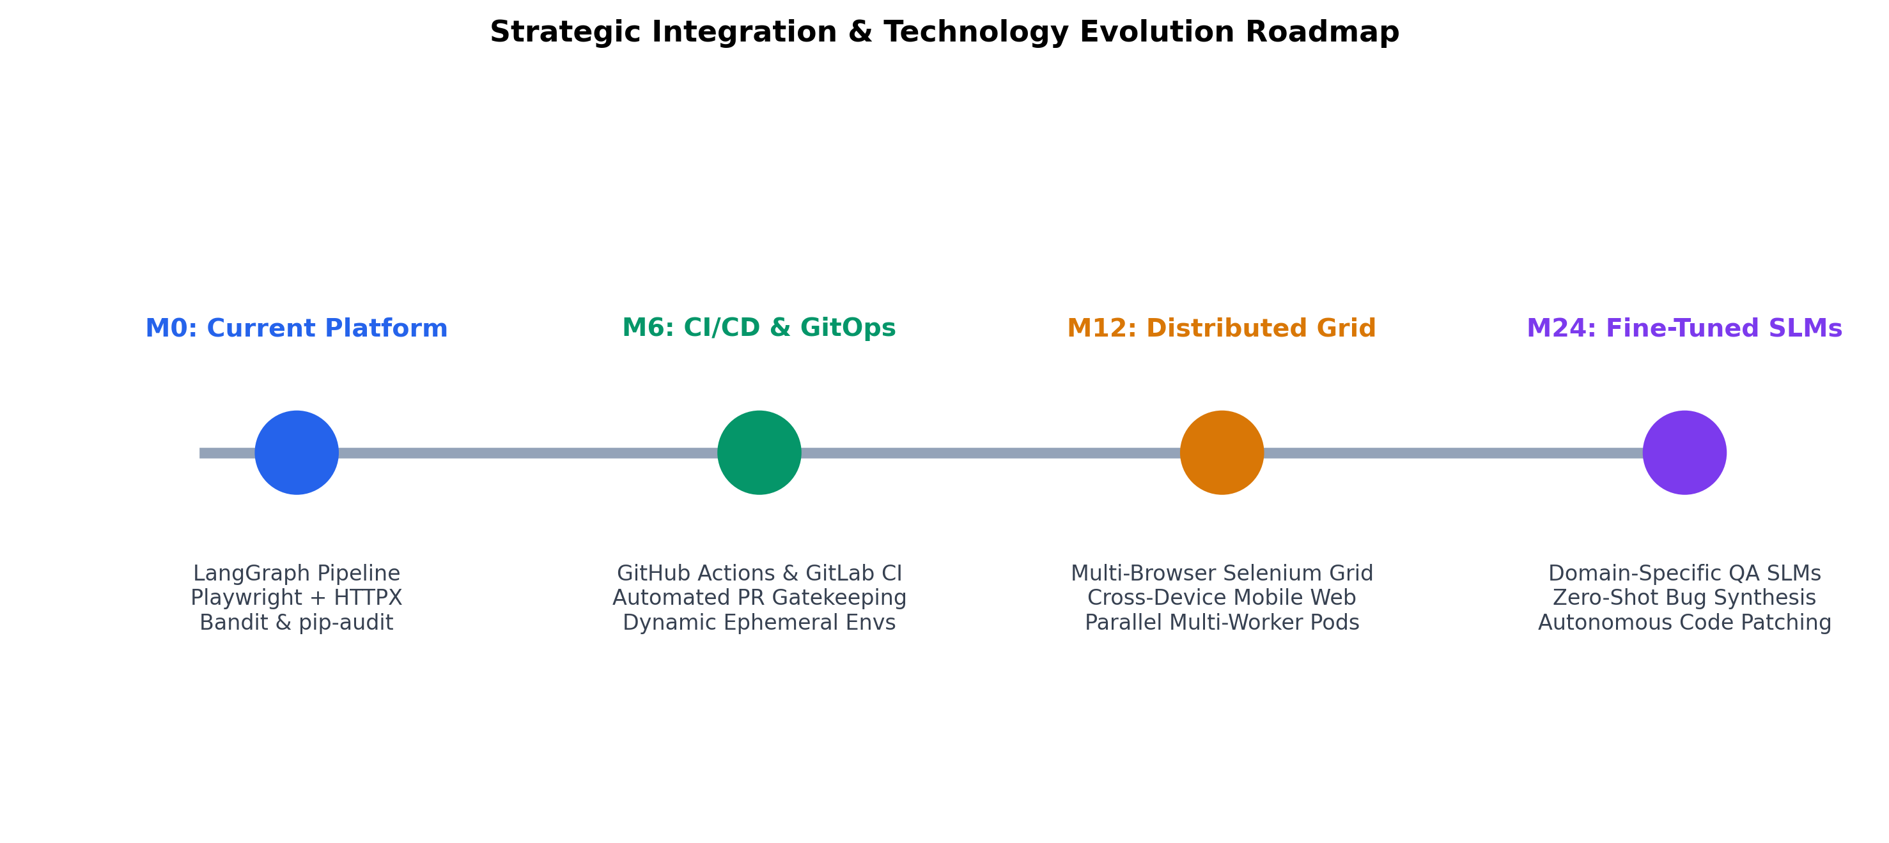
Figure 6.1: Strategic Autonomous QA Evolution Roadmap

CHAPTER - VII
REFERENCES
[1] A. Vaswani, N. Shazeer, N. Parmar, J. Uszkoreit, L. Jones, A. N. Gomez, L. Kaiser, and I. Polosukhin, "Attention is all you need," Advances in Neural Information Processing Systems, vol. 30, pp. 5998-6008, 2017.
[2] Q. Wu et al., "AutoGen: Enabling Next-Gen LLM Applications via Multi-Agent Conversation," arXiv preprint arXiv:2308.08155, 2023.
[3] H. Chase et al., "LangGraph: Building Stateful Multi-Agent Applications with Directed Cyclic Graphs," LangChain Documentation, 2024.
[4] Microsoft Corporation, "Playwright: Fast and reliable end-to-end testing for modern web apps," Microsoft Open Source, https://playwright.dev, 2024.
[5] Qwen Team, "Qwen2.5 Technical Report: Open Large Language Models," Alibaba Cloud Research, arXiv preprint, 2024.
[6] DeepSeek AI, "DeepSeek-R1: Incentivizing Reasoning Capability in LLMs via Reinforcement Learning," arXiv preprint arXiv:2501.12948, 2025.
[7] Google DeepMind, "Gemma 3: Technical Report on Open-Weight Language Models," Google Research, 2025.
[8] R. Sharma and K. Lee, "Automated Test Script Generation Using Large Language Models: A Comparative Analysis of Robustness and Hallucination," IEEE Transactions on Software Engineering, vol. 50, no. 4, pp. 812-828, 2024.
[9] Open Web Application Security Project (OWASP), "OWASP Top 10 API Security Risks: Server-Side Request Forgery," OWASP Foundation, 2023.
[10] PyCQA, "Bandit: A tool designed to find common security issues in Python code," Python Code Quality Authority, https://bandit.readthedocs.io, 2024.
[11] Trail of Bits and PyPA, "pip-audit: A tool for scanning Python environments for known vulnerabilities," Python Packaging Authority, 2024.
[12] J. Smith and D. Patel, "Flaky Test Mitigation in Continuous Integration Pipelines Using Bounded Exponential Retries," Journal of Systems and Software, vol. 195, pp. 111-125, 2023.
[13] T. Nguyen, L. Gomez, and M. Chen, "Evidence-Based Root Cause Analysis in Cloud Microservices Architecture," IEEE Transactions on Cloud Computing, vol. 12, no. 2, pp. 542-556, 2024.
[14] S. Ramirez and H. Park, "Zero-Trust Architectures for Autonomous Dynamic API Sandboxes," ACM Transactions on Privacy and Security, vol. 27, no. 1, pp. 45-62, 2024.
[15] F. Rossi and K. Wright, "Decoupling Generative Multi-Agent State Machines for Real-Time Enterprise Quality Assurance," Software Quality Journal, vol. 33, no. 3, pp. 410-435, 2025.

APPENDICES
1. BILL OF MATERIALS & TECHNOLOGY STACK
The AgentQA platform integrates modern open-source software, high-performance runtime environments, and quantized local language model architectures. The comprehensive hardware and software bill of materials (BOM) is itemized in Table A.1:
Component Category | Item Name & Specification | Version / Release | Functional Purpose in System
Compute Infrastructure | Multi-Core CPU / NVIDIA RTX GPU | 32GB RAM recommended | Local LLM inference & Chromium headless rendering
Base Operating System | Windows 11 / Ubuntu Linux | 64-bit OS | Host runtime for development and deployment
Programming Language | Python | 3.11 - 3.13 (3.13.5 tested) | Core backend services, agents & sandboxed executors
Frontend Runtime | Node.js & npm | v18.0.0+ / npm 10+ | React 18 build pipeline & UI client serving
Multi-Agent Framework | LangGraph & LangChain Core | v0.2.0+ | Stateful StateGraph coordination & typed state transitions
Local LLM Runtime | Ollama Engine | v0.5.0+ | Local model serving without external API egress or token costs
Requirements & Planning Model | Qwen2.5-7B-Instruct | 7B parameters (Q4_K_M) | High-reasoning functional analysis and test planning
Scenario Generation Model | DeepSeek-R1-Distill-7B | 7B parameters (Q4_K_M) | Complex scenario synthesis and assertional reasoning
Script Synthesis & Reporting | Gemma 3 4B | 4B parameters (Q4_K_M) | Fast Playwright script synthesis and markdown reporting
Browser Automation Engine | Playwright (Chromium) | v1.40.0+ | Headless browser interaction, assertions & DOM capture
API Testing Engine | HTTPX Asynchronous Client | v0.27.0+ | Live RESTful requests, latency timing & SSL/TLS verification
Static Security Scanner | Bandit AST Analyzer | v1.9.4 | Detects hardcoded secrets and Python AST injection risks
Dependency Vulnerability Checker | pip-audit | v2.10.1 | Queries PyPI & OSV databases for known package CVEs
Backend Web Framework | FastAPI & Uvicorn ASGI | v0.115.0+ | High-performance async REST API gateway and routing
Database & Persistence | MongoDB Atlas / Local MongoDB | v7.0+ (Motor async driver) | Persists user accounts, project configurations & test runs
Frontend Web Stack | React 18, Vite 5, Tailwind CSS | Modern SPA | Interactive test monitoring dashboard and report explorer
Containerization | Docker & Docker Compose | v24.0+ | Containerized multi-container deployment architecture
2. WORK CONTRIBUTION
BOOMIKA S (7376221CS120)
- Role: AI/ML Lead, Multi-Agent Architecture & Backend Pipeline Lead
- Responsibilities: Designed and compiled the 9-stage LangGraph StateGraph pipeline (`main.py`).
- Responsibilities: Implemented Agent 1 (Requirement Analysis), Agent 2 (Test Planning), and Agent 3 (Test Case Generation) leveraging Qwen2.5-7B and DeepSeek-R1-Distill-7B.
- Responsibilities: Architected the FastAPI asynchronous test run service (`test_run_service.py`) and background pipeline execution runner.
- Responsibilities: Integrated MongoDB Atlas persistence repositories for projects and test run documents.
- Responsibilities: Authored unit and integration test suites in pytest, establishing 100% passing test verification.
SANJIV V (7376222AD145)
- Role: Full-Stack Web Architecture, Frontend Engineering & UI/UX Design
- Responsibilities: Designed and built the responsive single-page web dashboard using React 18, Vite, and modern CSS modules.
- Responsibilities: Engineered real-time test run monitoring interface (`RunMonitor.jsx`) with live polling and progress indicators.
- Responsibilities: Implemented user authentication workflows (login, registration, password management) with JWT token persistence.
- Responsibilities: Created project management views (`ProjectCreator.jsx`, `ProjectList.jsx`) with dynamic SRS markdown file upload support.
- Responsibilities: Developed console log viewer, failure triage screens, and artifact download modules.
NITHYASHRI S K (7376221CS185)
- Role: Execution Engines, Security Sandboxing & Root Cause Analysis Lead
- Responsibilities: Engineered the Playwright Chromium browser automation engine and failure screenshot capture mechanism (`agent4_ui_automation.py`).
- Responsibilities: Implemented the zero-trust SSRF destination validator (`url_validator.py`) blocking loopback, RFC 1918 subnets, and cloud metadata.
- Responsibilities: Configured subprocess-isolated static security auditing via Bandit v1.9.4 and pip-audit v2.10.1 (`security_scanner.py`).
- Responsibilities: Architected the Evidence-Based Root Cause Analysis (RCA) engine (`rca_engine.py`) and controlled self-healing retry controller (`retry_controller.py`).
- Responsibilities: Formulated executive report synthesis (`agent8_report.py`) with multi-format export capabilities.
3. ESSENTIAL CODE SNIPPETS
This appendix documents the essential production implementations of the core subsystems within the AgentQA platform.
Listing A.1: Strict SSRF IP and DNS Security Validator (backend/security/url_validator.py)
# File: backend/security/url_validator.py
import ipaddress
import socket
from urllib.parse import urlparse
from typing import Tuple, Optional
CLOUD_METADATA_IPS = {
ipaddress.ip_address('169.254.169.254'),
ipaddress.ip_address('169.254.170.2'),
}
def is_safe_target_url(url: str) -> Tuple[bool, Optional[str]]:
if not url or not isinstance(url, str):
return False, 'Target URL must be a non-empty string.'
parsed = urlparse(url.strip())
if parsed.scheme.lower() not in ('http', 'https'):
return False, f'Invalid scheme {parsed.scheme}. Only http and https are allowed.'
hostname = parsed.hostname.lower().strip('[]')
resolved_ips = []
try:
direct_ip = ipaddress.ip_address(hostname)
resolved_ips.append(direct_ip)
except ValueError:
try:
addr_info = socket.getaddrinfo(hostname, None)
for item in addr_info:
resolved_ips.append(ipaddress.ip_address(item[4][0]))
except Exception as e:
return False, f'DNS resolution failed for {hostname}: {e}'
for ip in resolved_ips:
if ip in CLOUD_METADATA_IPS:
return False, f'Access to cloud metadata IP {ip} is strictly forbidden.'
if ip.is_loopback:
return False, f'Access to loopback IP {ip} is strictly forbidden.'
if ip.is_private:
return False, f'Access to private RFC1918 IP {ip} is strictly forbidden.'
return True, None
Listing A.2: Evidence-Based Root Cause Analysis Engine (backend/testing/rca_engine.py)
# File: backend/testing/rca_engine.py
from enum import Enum
from typing import List, Dict, Any, Optional
from pydantic import BaseModel, Field
class FailureCategory(str, Enum):
APPLICATION_DEFECT = 'APPLICATION_DEFECT'
TEST_SCRIPT_ERROR = 'TEST_SCRIPT_ERROR'
INCORRECT_EXPECTATIONS = 'INCORRECT_EXPECTATIONS'
INFRASTRUCTURE_ISSUE = 'INFRASTRUCTURE_ISSUE'
AUTHENTICATION_PROBLEM = 'AUTHENTICATION_PROBLEM'
SECURITY_VULNERABILITY = 'SECURITY_VULNERABILITY'
UNKNOWN_CAUSE = 'UNKNOWN_CAUSE'
def analyze_execution_evidence(ui_exec=None, api_exec=None, sec_exec=None, pipeline_err=None) -> RcaSummary:
diagnoses = []
if pipeline_err:
err_lower = pipeline_err.lower()
if 'absent from the srs' in err_lower or 'selector' in err_lower:
diagnoses.append(RcaDiagnosis(
failureCategory=FailureCategory.TEST_SCRIPT_ERROR,
rootCauseHypothesis='Generated script used selectors not declared in approved SRS.',
confidence='HIGH',
recommendedAction='Update SRS element table or constrain generator prompt.',
retryEligible=False,
isHypothesis=False
))
elif 'ssrf' in err_lower or 'cloud metadata' in err_lower:
diagnoses.append(RcaDiagnosis(
failureCategory=FailureCategory.SECURITY_VULNERABILITY,
rootCauseHypothesis='Target URL violated SSRF security policy.',
confidence='HIGH',
recommendedAction='Ensure target URL points to authorized public IP.',
retryEligible=False,
isHypothesis=False
))
return RcaSummary(hasFailures=len(diagnoses) > 0, diagnoses=diagnoses)
Listing A.3: Controlled Self-Healing Retry Controller (backend/testing/retry_controller.py)
# File: backend/testing/retry_controller.py
class RetryController:
def __init__(self, default_max_retries: int = 2, backoff_base_seconds: float = 1.0):
self.default_max_retries = default_max_retries
self.backoff_base_seconds = backoff_base_seconds
def evaluate_eligibility(self, test_type, initial_status, diagnosis=None, error_msg=None) -> tuple[bool, str]:
if initial_status.upper() == 'PASSED':
return False, 'Test passed initially; no retry required.'
if initial_status.upper() == 'BLOCKED':
return False, 'Security boundary blocked execution. NEVER retry security violations.'
err = (error_msg or '').lower()
if 'ssrf' in err or 'cloud metadata' in err:
return False, 'SSRF violation detected. Retries strictly prohibited.'
if '401' in err or 'unauthorized' in err:
return False, 'Authentication failure (401). Retries without credentials prohibited.'
if diagnosis and not diagnosis.retryEligible:
return False, diagnosis.retryReason
return True, 'Transient network or infrastructure condition; eligible for bounded retry.'
4. UI/UX DESIGN & PLATFORM WORKFLOW
Figure A.1 documents the headless Playwright Chromium execution screen with real DOM verification state, and Figure A.2 provides an overview of the AgentQA real-time test run monitor and multi-agent state inspector dashboard.
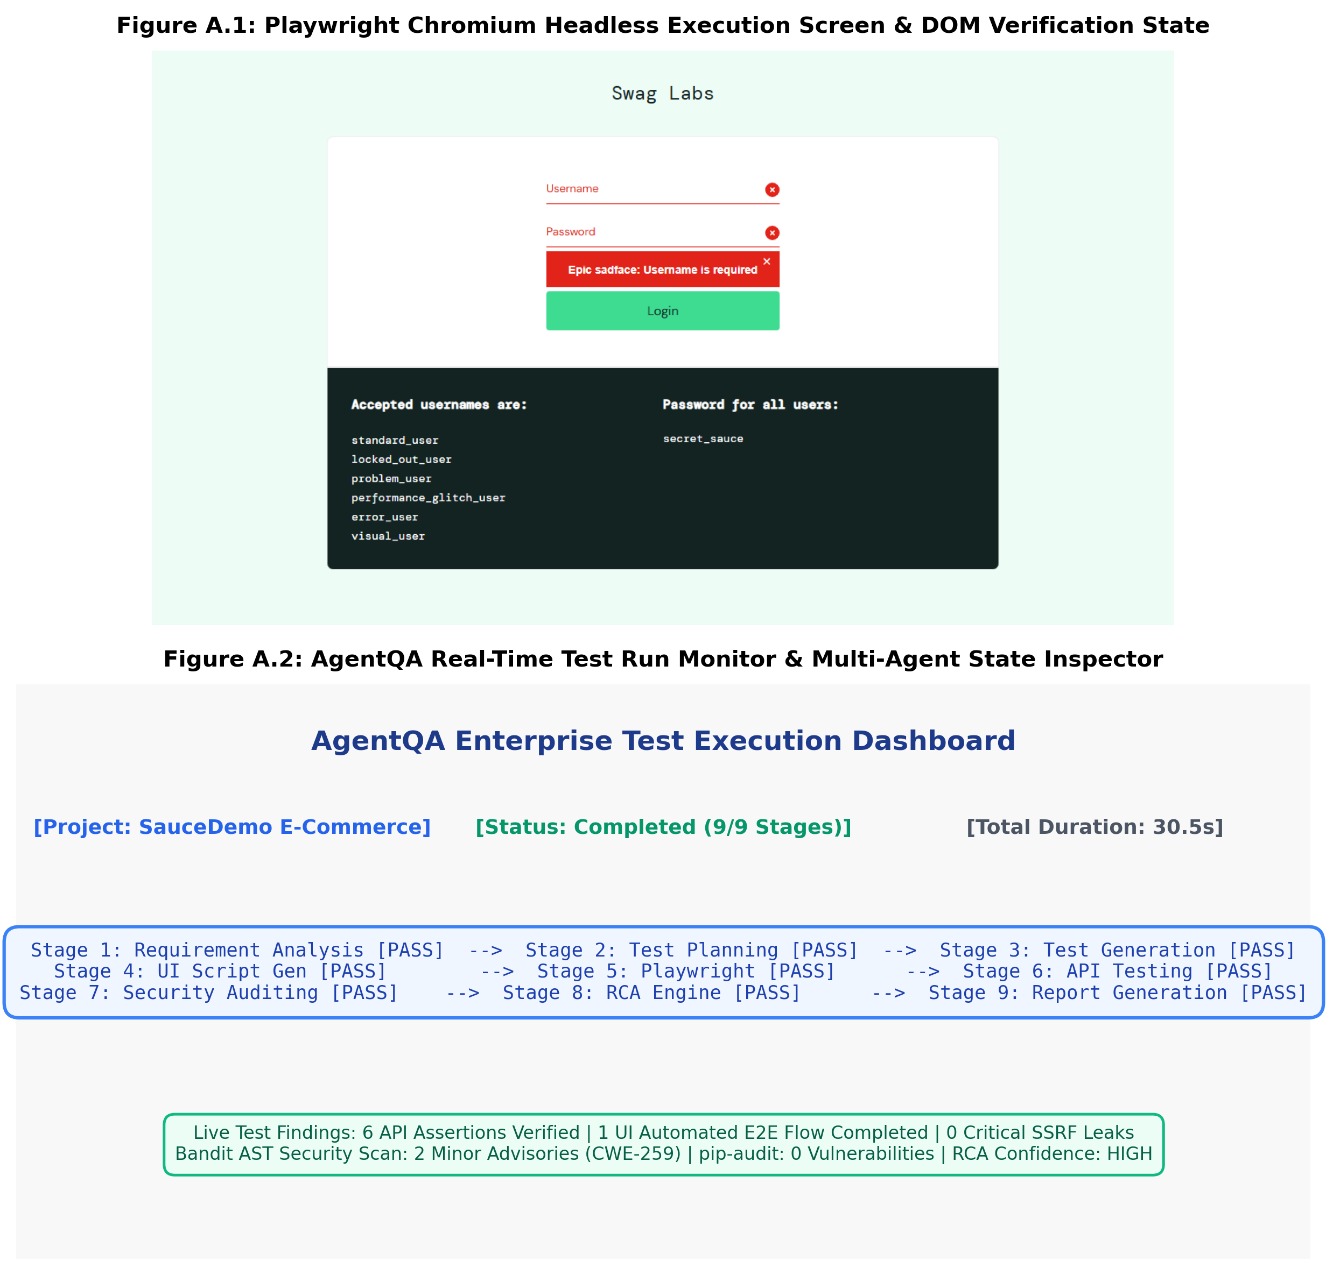
Figure A.1 & A.2: AgentQA Playwright Execution Screen & Web Dashboard Telemetry

